Research and Data Science Hub

A collaborative platform centralizing IPA’s research and data science tools and resources.

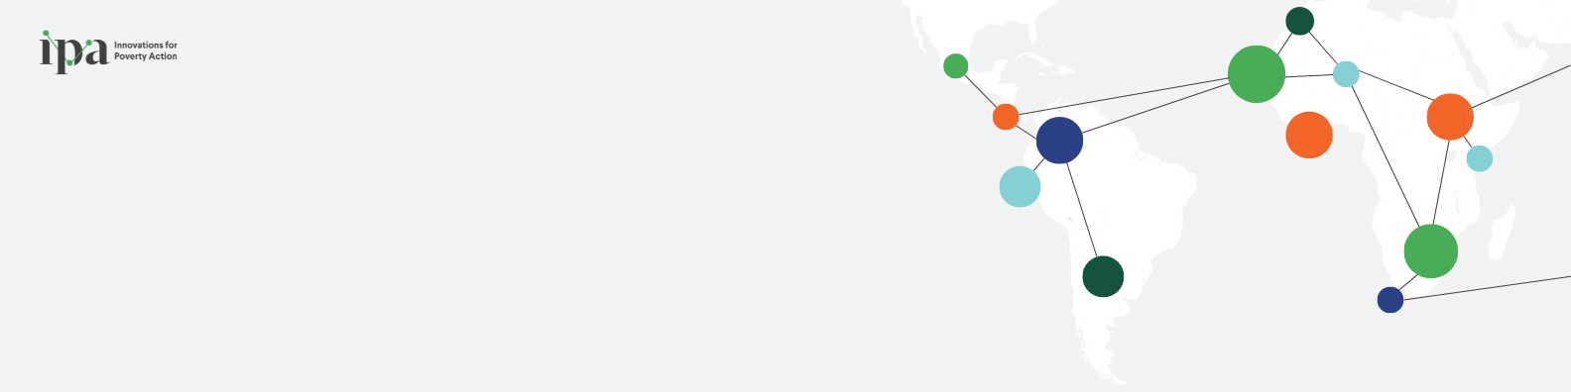

|  |  |  |  |
| --- | --- | --- | --- |
| Research Design | Ethics and IRB |  | Data Collection |
| Theory of Change  Randomization  Measurement and Survey Design  Sample and Power Calculations | About IPA IRB  The IRB Life Cycle  IRB Forms and Documentation  IRB FAQs  Reliance Agreements | Primary Data Collection  Using Secondary Data  Data Quality  Remote Data Collection  Qualitative Methods | |
| Data Management | Software |  |  |
| Data Storage and Security  Data Cleaning  Data Analysis  Data Visualization  Data Publication  Version Control | Stata  SurveyCTO  Cryptomator  Python  Git and GitHub  Visual Studio Code  Quarto  SQL |  |  |