Table of Contents

Software Architecture Document
Field | Value
Document ID | NOVA-SAD-001
Version | 0.1
Status | Draft
Owner | Laxmi Poudel
Date | 2026-09-08
Conforms to | arc42 v9, C4 model, ISO/IEC/IEEE 42010:2022

1. Introduction and goals
NOVA converts a natural-language software requirement into a structured test plan, and retains the user's corrections as durable memory so that later work does not repeat the same errors.
Generation is not the architecturally interesting part. The design problem is the loop around it:
- Converting a freeform correction into a durable, retrievable rule without creating a persistent prompt-injection vector.
- Retrieving the right rules without an ever-growing prompt that degrades silently.
- Establishing whether any of it works.

1.1 Requirements overview
The authoritative requirement set is NOVA-SRS-001. The architecturally significant subset:
ID | Requirement | Architectural consequence
FR-2 | Schema-conformant generation via constrained decoding | Schema is a first-class shared artifact, not a post-hoc validator
FR-4 | Scored retrieval with scores exposed | Retrieval must be explainable, not merely correct
FR-6.3 | No memory stored without explicit confirmation | A human gate sits on the highest-risk write path
FR-8 | Complete execution trace, including on failure | Tracing is a structural concern, written incrementally
FR-10.1 | Configuration activation requires a passing evaluation | Enforced as a data-layer constraint
NFR-16 | Tenant scoping applied at the data access layer | Isolation is structural, not a per-caller convention
NFR-20 | The model has no file, command, or network capability | The absence of a tool surface is a designed property
NFR-2 | Task duration measured in tens of seconds | Execution is asynchronous and durable

1.2 Quality goals
Ordered. Where two conflict, the higher-ranked prevails.
Rank | Quality goal | Motivation | Scenario reference
1 | Security of the memory path | A confirmed memory is replayed into every future prompt that retrieves it. Compromise is persistent, not transient | QS-1, QS-2
2 | Analysability | The value of the system depends on being able to show why an output was produced, and on separating retrieval failure from generation failure | QS-3, QS-4
3 | Testability | Improvement claims are only meaningful if they are measurable and gated | QS-5, QS-6
4 | Confidentiality | Requirements and test data must not leave the host in the default configuration | QS-7
5 | Reliability | A task must not vanish, hang, or lose its trace on failure | QS-8, QS-9
Performance is deliberately absent from this list. Measurement established substantial headroom against the stated target, so it does not currently constrain design.

1.3 Stakeholders
Stakeholder | Concern | Consumed views
Implementing engineer | Buildability, decision rationale | All
Technical reviewer | Engineering judgment, measurement rigour | 4, 8, 9, 10, 11
Operator | Deployment, failure diagnosis | 7, 8
Primary user | Explainability of output | 6, 8

2. Architecture constraints
ID | Constraint | Consequence
CON-1 | Approximately 130 to 180 engineering hours | One datastore, no framework, no infrastructure that is not load-bearing
CON-2 | Single engineer, no external review | Automated gates substitute for peer review where they can
CON-3 | Local inference within a 6 GB VRAM budget | Structured-output reliability becomes a primary engineering problem. Model class is 4B parameters, not 8 to 9B
CON-4 | Local deployment only | Container composition is the deployment artifact. Inference runs on the host, not in a container
CON-5 | Synthetic and open-source data only | Evaluation data is committable. Privacy controls are designed and tested rather than compliance-bound
CON-6 | No model training | All adaptation occurs through retrieval and configuration, not weights
CON-7 | Single user, multi-tenant-capable schema | Tenant identifier present from the first migration; authentication deferred

3. Context and scope

3.1 Business context (C4 level 1)
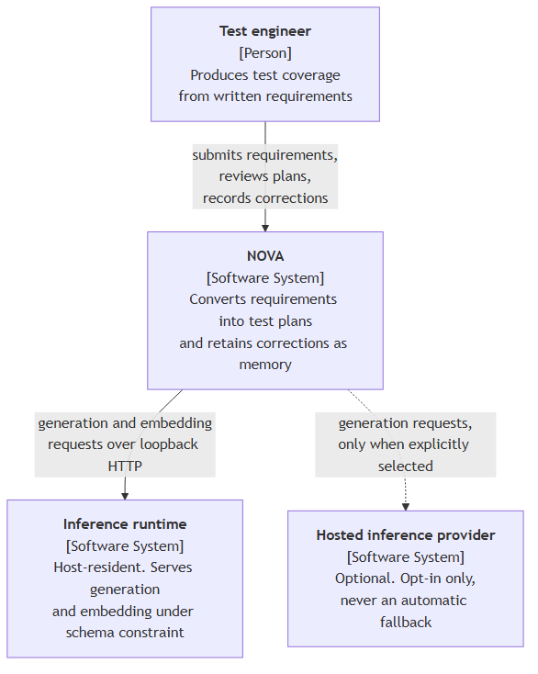
External entity | Interface | Notes
Test engineer | Browser, HTTP | The only human actor. No administrative role exists
Inference runtime | HTTP on the host loopback interface | Supplies a JSON Schema per request; returns a conformant completion plus token and timing telemetry
Hosted inference provider | HTTPS | Optional. Selecting it is the only path by which data leaves the host, and it requires an explicit user action

3.2 Technical context
Channel | Protocol | Payload | Trust
Browser to API | HTTP/1.1, JSON | Requirements, feedback, memory operations | Untrusted input
API to datastore | PostgreSQL wire protocol | All persistent state | Internal
Worker to inference runtime | HTTP/1.1, JSON with JSON Schema | Prompts and completions | Output untrusted
API to inference runtime | HTTP/1.1, JSON | Extraction and embedding requests | Output untrusted
Services bind to the loopback interface. The system has no inbound network surface beyond the host.

4. Solution strategy
Quality goal | Approach | Rationale
Security of the memory path | Two independent controls in series: a mechanical validation screen, then mandatory human confirmation. Combined with a total absence of tool capability for the model | A screen against an open-ended attack surface will miss cases. A successful injection can produce a poor test case but cannot take an action, because no action exists. See ADR-0004
Analysability | Trace steps written incrementally, including retrieval scores for candidates that were evaluated and rejected | A trace persisted only on success is useless, because failure is when it is needed. Scores for non-selected candidates are what separate retrieval failure from generation failure
Testability | Deterministic checks first, model-based review confined to the residual. Evaluation dataset versioned by content hash. Configuration activation blocked at the data layer without a passing run | Model-based evaluation makes every metric dependent on a component whose reliability must itself be established
Confidentiality | Local inference by default. Provider changes require explicit user action. Logs carry identifiers and digests, never content | Automatic provider substitution would silently change where data goes
Reliability | Durable job records claimed under row-level locks with lease expiry. Every retry bounded with a defined terminal state | An agent that retries without bound consumes a GPU and presents as a hang
Technology selection follows from the constraints rather than preference: a single datastore holding both relational and vector data (ADR-0001), a job table rather than a broker (ADR-0002), and no agent framework (ADR-0003).

5. Building block view

5.1 Level 1: containers (C4 level 2)
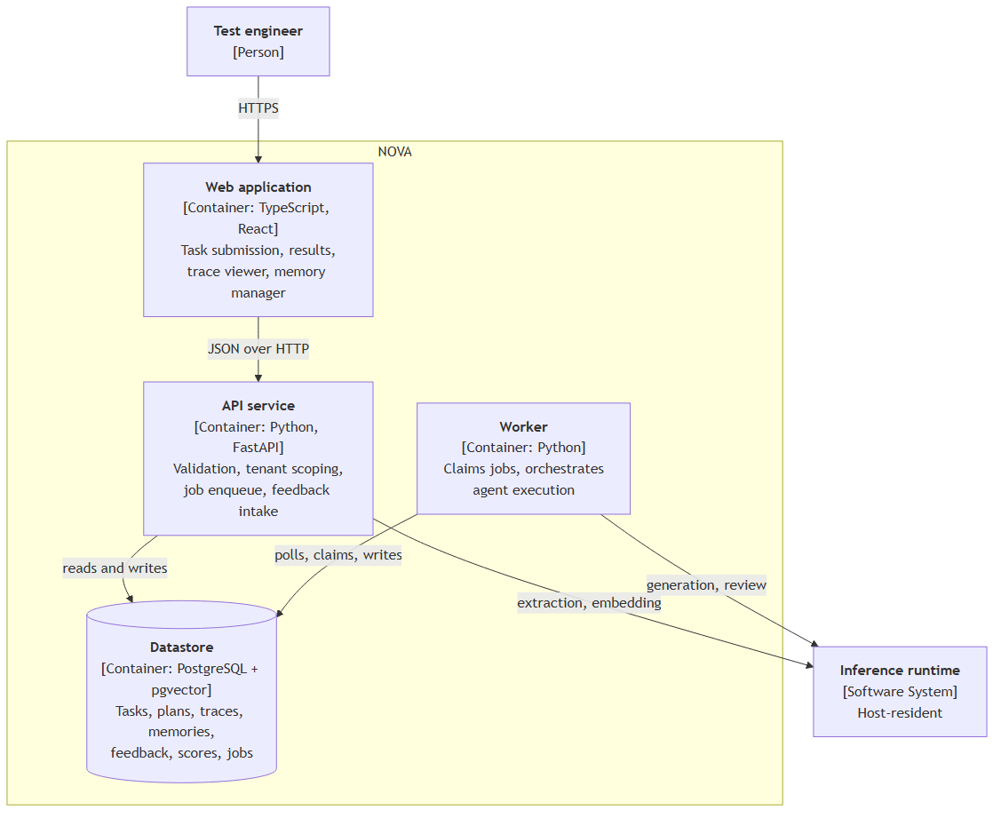

5.2 Level 2: API service and worker components
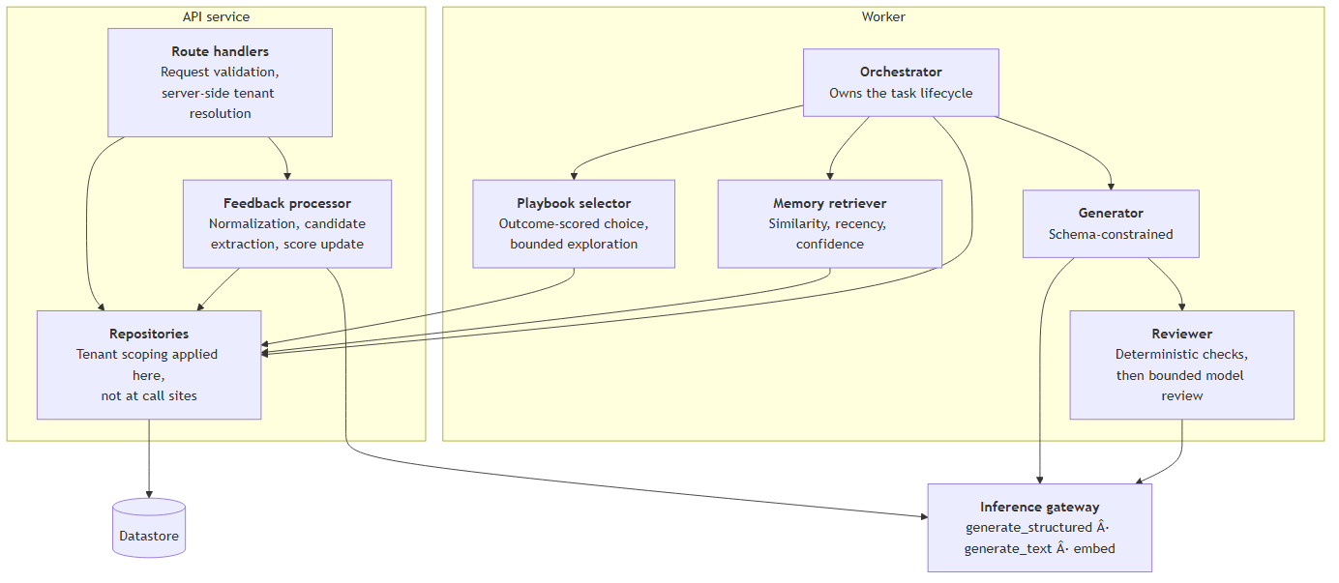

5.3 Component responsibilities
Component | Responsibility | Principal failure mode and response
Web application | Submission, results with per-case actions, trace viewer, memory manager, evaluation results | API unreachable, long task appearing stalled, large trace rendering slowly. Explicit error states, polling backoff, trace pagination. Renders untrusted content, so no unsanitized markup
Route handlers | Validation, server-side tenant resolution, job enqueue | Validation failure returns a structured error. Datastore failure returns 503 with no partial write
Repositories | All data access, tenant-scoped by construction | A query path that omits tenant scoping is prevented structurally rather than by convention
Feedback processor | Normalization, candidate extraction, score update | Extraction failure retains the raw correction rather than discarding it. Highest-risk path in the system
Orchestrator | Task lifecycle: select, retrieve, generate, check, review, persist | Any step failure records the failing step by name and persists the trace to that point
Playbook selector | Outcome-scored choice with bounded exploration | Cold start falls back to a static mapping. Bounded step size and clamping prevent a single event from changing the selection
Memory retriever | Ranked retrieval with explainable component scores | Embedding failure fails the task explicitly. A silent empty retrieval is the worst available outcome, because the system continues to appear healthy while no longer learning
Generator | Schema-conformant plan production | Bounded repair retry with every attempt counted. Context pressure reduces retrieved memory before requirement text
Reviewer | Deterministic checks, then bounded model review | The model review stage is optional by design. Deterministic verdicts return regardless, flagged partial. The pre-review plan is retained so any regression is visible
Inference gateway | Three operations over two provider implementations | Startup health check returns an actionable message. No silent provider substitution
Job store and worker loop | Durable asynchronous execution | Lease expiry permits reclamation after worker termination. Bounded attempts, then terminal failure. Partial trace always retained
The gateway exposes three operations, not a general abstraction layer. Anything wider would be speculative.

6. Runtime view

6.1 Nominal task execution
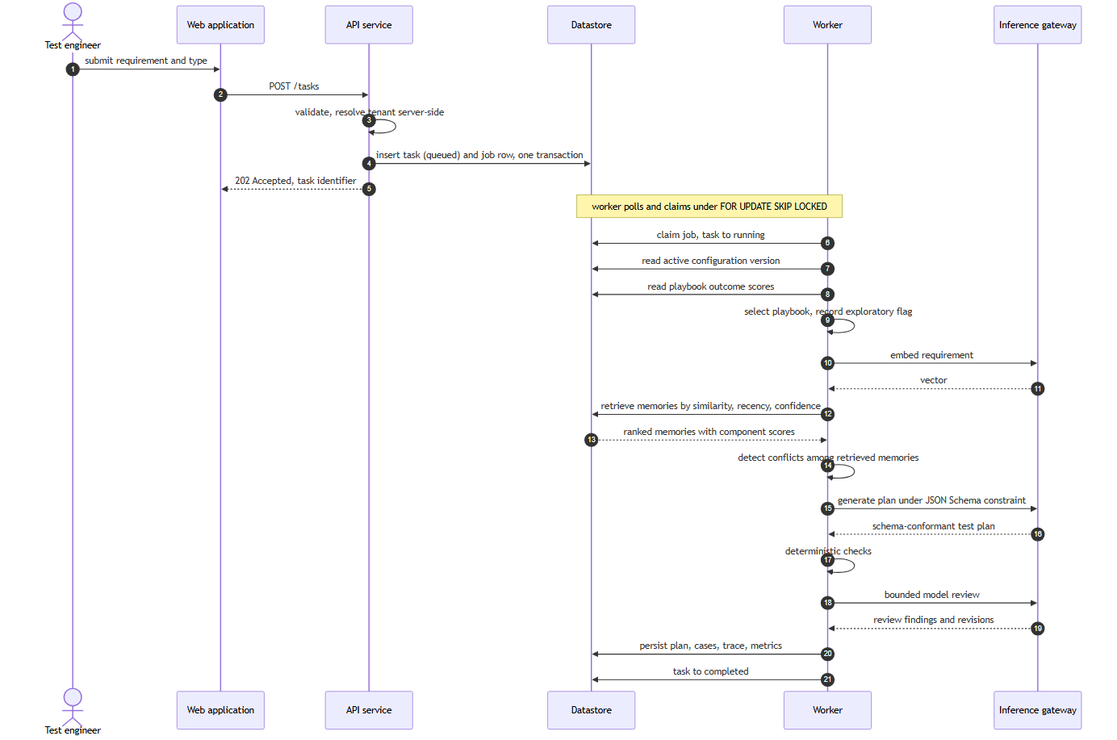

6.2 Correction to durable memory
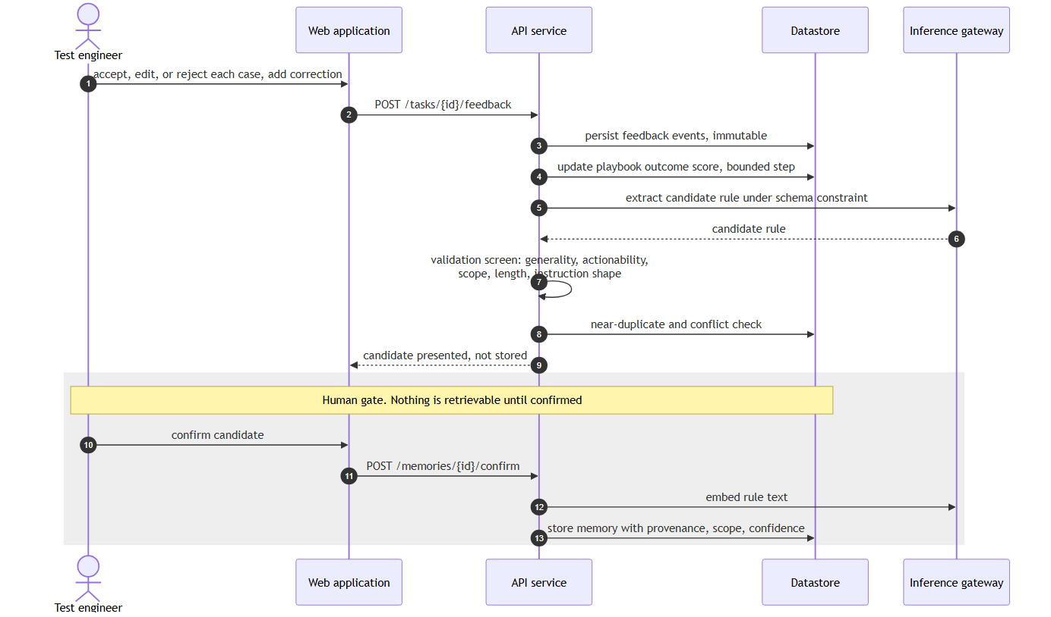

6.3 Worker termination and recovery
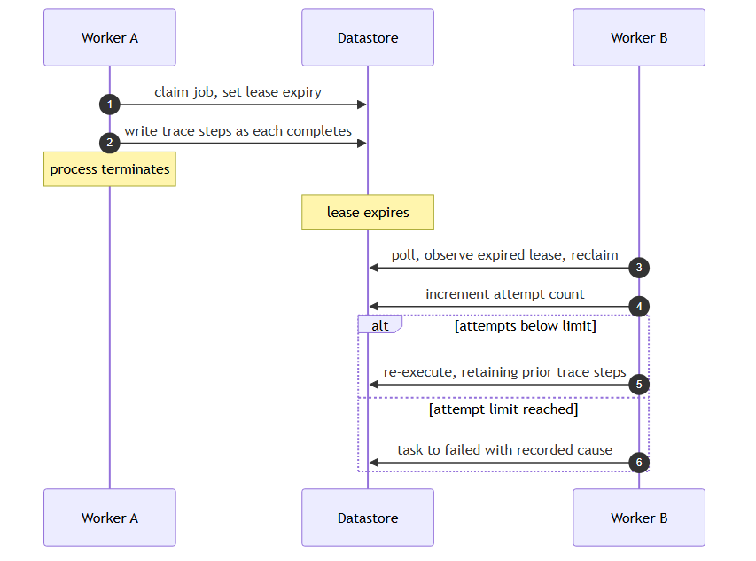

6.4 Synchronous and asynchronous boundaries
Operation | Mode | Rationale
Task submission | Synchronous, returns identifier | Execution takes tens of seconds
Task execution | Asynchronous worker | Durability and observable status
Status and result retrieval | Synchronous polling | Server-sent events only if polling proves inadequate
Feedback submission | Synchronous | Write-only, fast
Candidate extraction | Synchronous, within the feedback request | A single short call, and the user is awaiting the candidate
Embedding on confirmation | Synchronous | Sub-second locally
Evaluation runs | Asynchronous, offline | Minutes in duration. Never in a request path

7. Deployment view
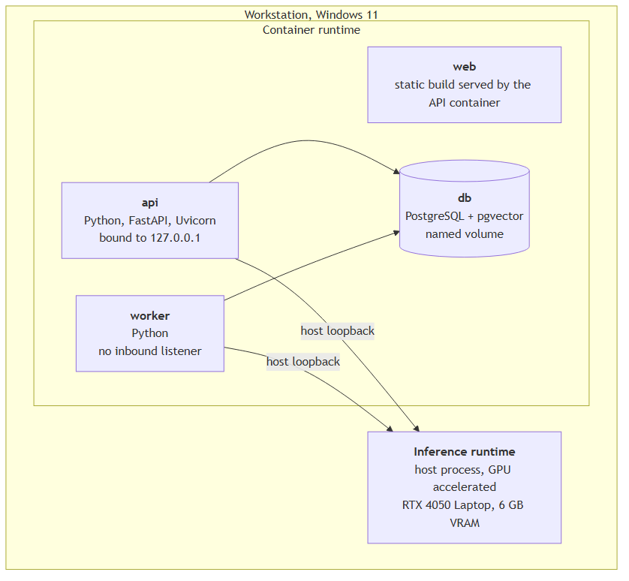
Node | Rationale
Application containers | Reproducible startup from a clean checkout by a single command
Datastore container with a named volume | State survives container replacement. Backup is a documented dump and restore
Inference on the host, not containerized | GPU passthrough on this platform adds operational friction without benefit. The container-to-host path requires verification and documentation, and is the most likely first-run obstacle for anyone cloning the repository

8. Crosscutting concepts

8.1 Domain model
Concept | Definition
Task | One execution of the requirement-to-plan workflow. The anchor for plan, trace, and feedback
Test plan | A summary and an ordered set of test cases, conforming to a versioned schema
Memory | A durable rule derived from a correction, carrying provenance, scope, confidence, and lifecycle state
Playbook | A named generation strategy: required case types, prompt fragment, check configuration. Versioned repository data, not code
Feedback event | An immutable record of one user judgment. The authoritative source from which scores are derived
Execution trace | The ordered record of every step, model call, and score for one task

8.2 Trust boundaries and security
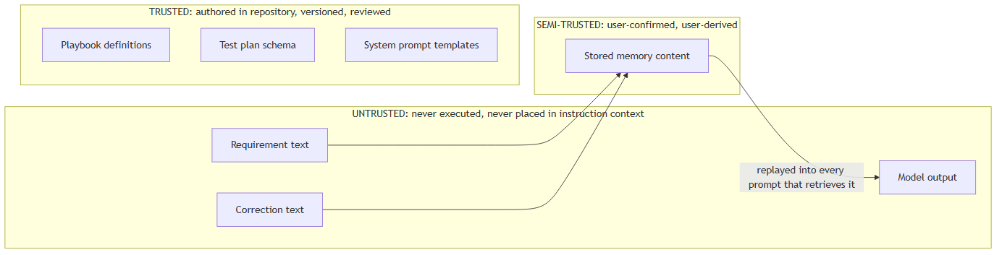
Stored memory is a persistent injection vector. A single injected requirement affects one task. An injection surviving extraction and confirmation is replayed into every subsequent prompt that retrieves it, which is structurally equivalent to stored cross-site scripting.
Seven layers apply, none relied upon alone: structural separation of untrusted content, constrained decoding bounding the output shape, output validation, instruction-shape screening on candidates, human confirmation, absence of any tool surface, and an adversarial regression suite. The sixth is the strongest, and it derives from the architecture rather than from a filter.
Full analysis in NOVA-TM-001.

8.3 The learning mechanism
Adaptation occurs at five levels. None involves model weights.
Level | Mechanism | Persistence
L0 | Working context, assembled per task | None
L1 | Episodic records of tasks, outputs, outcomes | Database rows
L2 | Semantic rules extracted from corrections | Database rows with provenance
L3 | Scored retrieval over those rules | Query-time
L4 | Outcome-scored playbook selection | Derived scores
L5 | Evaluation-gated configuration change | Versioned records
Feedback normalization. Events map to a bounded score in [-1, +1]: unedited acceptance +1.0, minor edit +0.5, major edit 0.0, rejection -1.0, user-added case -0.5, abandonment -0.2, export +0.3. The task outcome is the clamped mean of case-level contributions.
Three choices carry rationale. Clamping prevents a single large plan from dominating. A missed case is penalized less than an incorrect one, because omission is cheaper to remedy than a false positive. A major edit scores zero rather than negative, because the structure remained useful.
Implicit signals (abandonment, export) are weighted well below explicit feedback and never independently create or modify a memory. Abandonment is inherently ambiguous.
Retrieval. score = w_sim Â· similarity + w_rec Â· recency + w_conf Â· confidence, initially 0.6 / 0.2 / 0.2. Scope and tenant apply as filters before ranking. Pinned in-scope memories return unconditionally. Component scores for every evaluated candidate, selected or not, are written to the trace.
Conflict handling. Two in-scope memories that are semantically similar but prescriptively opposed are surfaced, never merged. At confirmation the user chooses; at retrieval the higher product of confidence and recency prevails and the conflict is flagged. Silent averaging would make the memory store untrustworthy, because the user could no longer determine what the system holds to be true.
Strategy selection. Greedy over recorded outcome scores with probability 1 - Îµ, uniform random otherwise, Îµ starting at 0.1 with a floor of 0.05. Updates are bounded and clamped, so no single feedback event alters a selection. Below a minimum observation count the static default prevails.
This is a bounded contextual bandit over four fixed options. It is not reinforcement learning and is not described as such. Four arms and a scalar reward is a modest mechanism, but it is real, scoreable, and explainable.
Outcome scores are derived, never authoritative, and are recomputable from the immutable feedback log. A poisoning incident or a change to the weighting scheme is therefore recoverable.

8.4 Persistence
A single datastore holds relational and vector data. The determining argument is correctness rather than performance: with separate stores, writing a memory requires two writes to two systems, and a partial failure yields either orphaned vector data or a memory that exists but can never be retrieved. The second fails silently and is indistinguishable from a system that has stopped learning. Within one transaction the failure mode does not arise.
The embedding dimension is fixed at schema creation. Changing the embedding model requires re-embedding every memory and rebuilding the index. This is documented rather than discovered, and is the reason the embedding decision is treated as blocking.

8.5 Asynchronous execution
Jobs are rows claimed under SELECT ... FOR UPDATE SKIP LOCKED with a lease that expires. Because the job row shares a transaction with the task record, no window exists in which a task is present without its job. Diagnosis of a stalled job is a query rather than an operational investigation.

8.6 Error handling
Errors are returned in RFC 9457 problem-detail form, giving one shape for every failure and one rendering component. Every retry loop is bounded with a defined terminal state.
Trace steps are written as they complete, so a task failing at generation still exposes its playbook selection and retrieval results.

8.7 Observability
Spans correlate across API, worker, and inference calls. Logs carry identifiers and prompt digests, never requirement text or memory content, and an automated assertion enforces this. Content logging exists only as an explicit debug mode. Logging failure degrades to standard output and never blocks task execution.
Content-free logging is not incidental. Local inference is the confidentiality property, and logs are the most probable route by which it would be undermined.

8.8 Configuration and versioning
Prompt templates, retrieval weights, exploration rate, and model configuration are held as versioned records. A version reaches active status only with an associated passing evaluation run, enforced as a data-layer constraint rather than an interface check.
Every task pins the configuration version under which it executed. Without that pin, historical results are uninterpretable and regression comparison is meaningless.

8.9 Testability
Deterministic checks precede model-based review. Integration tests execute against a real datastore and a fake inference provider, because they exist to verify wiring, and model behaviour is the evaluation layer's concern. Both provider implementations satisfy a shared contract suite.

9. Architecture decisions
Significant decisions are recorded as ADRs in MADR 4.0 format. Remaining decisions are held in NOVA-DL-001.
ADR | Decision | Status
0001 | PostgreSQL with pgvector as the sole datastore | Accepted
0002 | Job table and polling worker rather than a message broker | Accepted
0003 | No agent framework | Accepted
0004 | Mandatory human confirmation for memory writes | Accepted
0005 | Embedding model and vector dimension | Proposed

10. Quality requirements

10.1 Quality tree
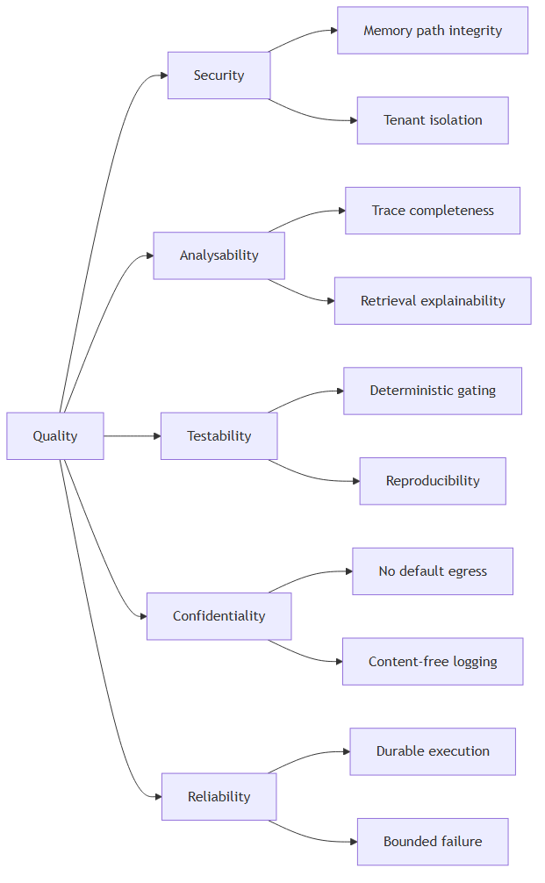

10.2 Quality scenarios
ID | Scenario | Stimulus | Required response
QS-1 | A correction is submitted whose text is shaped as a system instruction | Malicious or accidental input | Screened and flagged. Never stored without explicit user action on the flagged item
QS-2 | Retrieval is performed for one tenant while another holds highly similar memories | Query execution | Zero records from the other tenant. Verified as an unconditional gate
QS-3 | A task fails during generation | Provider timeout | Playbook selection and retrieval results remain inspectable in the persisted trace
QS-4 | Output omits an expected test case | User review | The trace distinguishes a memory that was never retrieved from one retrieved and not applied
QS-5 | A prompt change degrades output quality | Configuration change submitted | The regression gate blocks activation before merge
QS-6 | A prior execution must be reproduced | Same input, seed, model, configuration version | Equivalent output
QS-7 | A hosted provider becomes selected | Configuration action | Only through explicit user action. Never as a fallback. Visible in the interface
QS-8 | The worker process terminates mid-task | Process failure | The job is reclaimed after lease expiry. The partial trace survives
QS-9 | The inference runtime is unavailable | Dependency failure | Submission still succeeds and queues. Readiness reports unhealthy. The error names the required action

11. Risks and technical debt
ID | Risk or debt | Severity | Response
R-01 | Correction extraction may not reach usable precision on a local model | High | Measured at a defined checkpoint before dependent interface work. Fallback is user-authored rules with model assistance
R-04 | The embedding model and dimension remain unselected, and the dimension is fixed in the schema | High | Blocking. A dedicated spike precedes schema definition
R-03 | Inference nondeterminism may exceed evaluation gate margins | High | Variance measured before any threshold is set. Dataset grows rather than thresholds loosening
R-05 | The Correction Recurrence Rate depends on a structural similarity threshold that is difficult to defend | Medium | Threshold fixed from measured distributions, documented, held constant, and always reported alongside retrieval precision
R-08 | The 8B model class may not fit the VRAM budget, and was not measured | Medium | Two candidates retrieved and awaiting measurement
R-09 | Container-to-host inference reachability is unverified on this platform | Medium | Verified before deployment work. Resolution documented
R-11 | Persistent injection defences are unproven | Medium | The adversarial suite establishes a floor, not a guarantee, and is described as such
R-13 | The model review stage may not justify its latency | Low | Designed to be removable. Measured before and after
R-16 | Introducing any tool capability would invalidate the security model | Low | Recorded so that the consequence is not overlooked. Such a change requires rewriting NOVA-TM-001 rather than amending it
D-01 | Trace volume has no pruning policy | Low | Acceptable at single-user scale. Named so it is not discovered later
D-02 | Memory conflict resolution is manual | Low | Does not scale beyond a moderate memory count. Acceptable at expected volume
Full register: NOVA-RR-001.

12. Glossary
See NOVA-SRS-001 section 1.4.

Revision history
Version | Date | Author | Change
0.1 | 2026-09-08 | Laxmi Poudel | Initial draft

