Created by RustamA. 04.07.2016

Simple Manual on how to deploy Node.js Application to the AWS.

1. Don’t forget to update application version in package.json. AWS may complain if it detects the version that already exists in it’s lists.
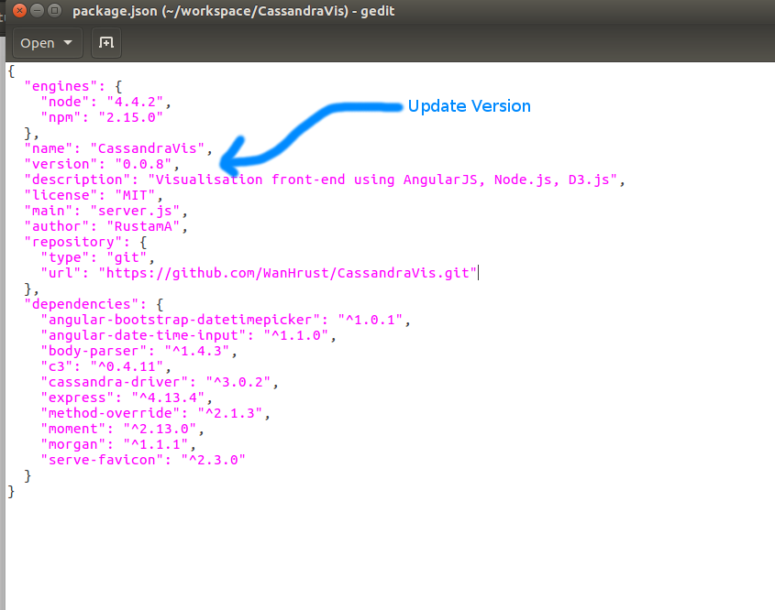

2. Go INSIDE the root folder select ALL files and zip them into archive. The trick is that package.json has to be in the ROOT (TOP) directory, otherwise AWS complains that it cannot find package.json or it is configured inappropriately.

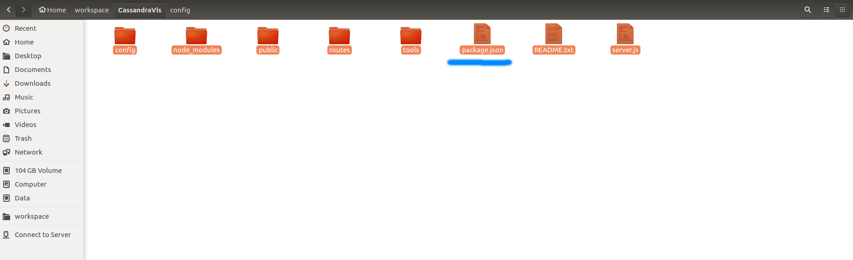

3.Aftere you login into the system. Choose the application and environment. In our case click on small link cassandra-env in the green area.

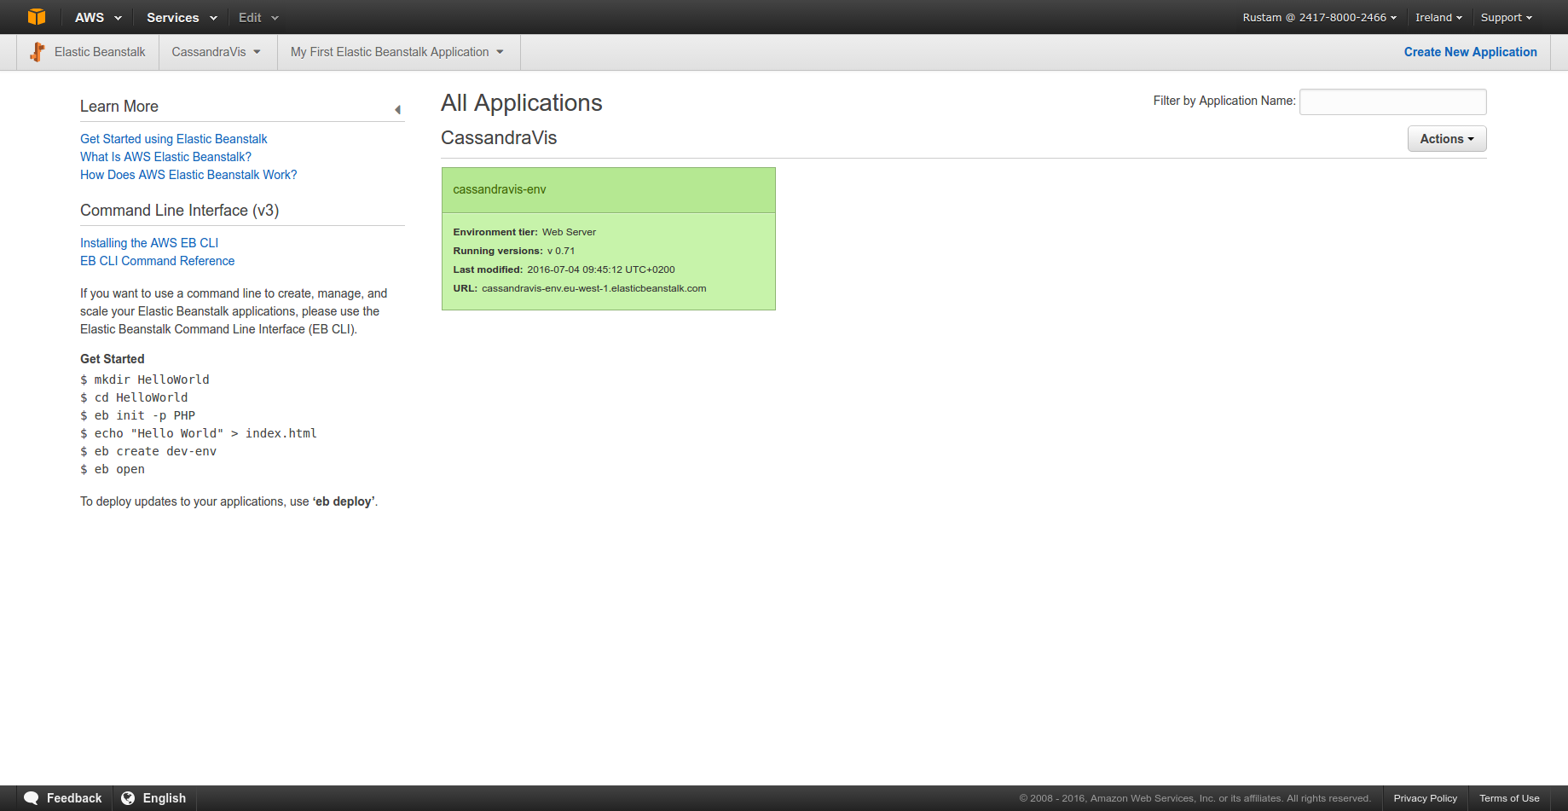

4. After step 3 you should see the following. Press on the button shown by BLUE ARROW. This should create a pop-up window where you can upload previously created archive and give it a local (AWS) label.

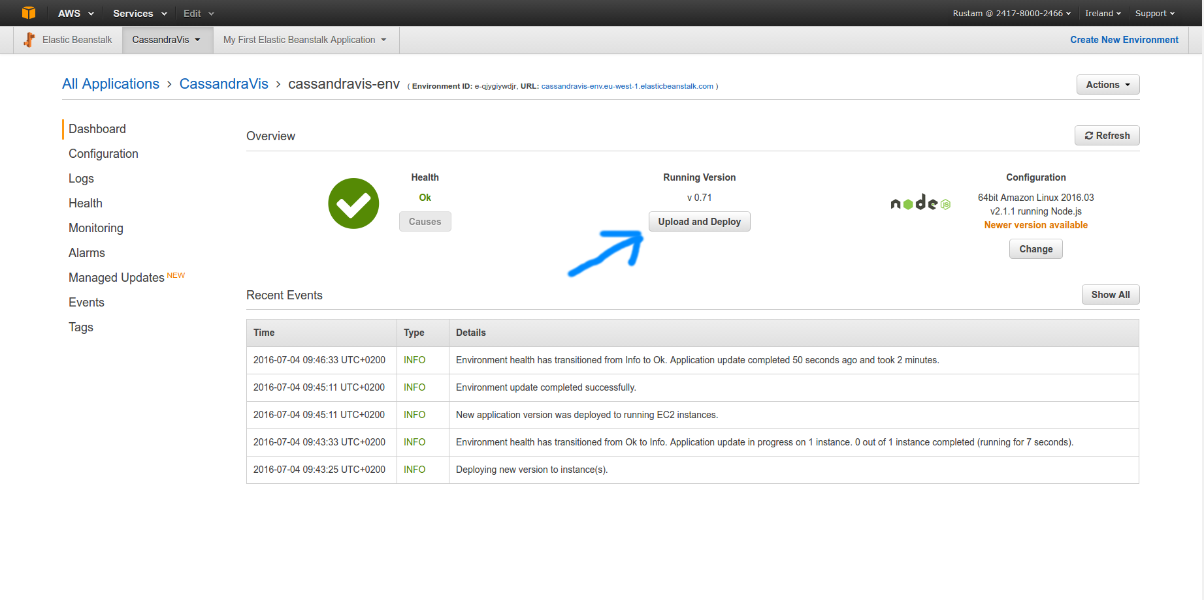

5. In case if any of the steps went wrong and you uploaded the version you were not supposed to upload. You may click on the application name. (Marked blue). There is should be easy to navigate to Application Versions where you will see the history of all the previous version uploads.

