Version [1.0]

January 1, 2018

Presented by: Power

powerware.site

cairo-egypt



Html template

How to CUSTOMIZ ZAČETEK TEMPLATE ?

# Introduction & Feature

 ZAČETEK is a Creative & Modern One Page Template is a perfect template for Business Startups, web studio and creative agencies. Responsive based on Bootstrap. This is one page for placing your information. All files and code has been well organized and nicely commented for easy to customize.

## Why Html & Bootstarp?

Why we're exporting HTML in the first place.…It's an open standard, so it's not goanna taken away…by any one, single company.…It's the language of the web, … so it's already viewable on every modern browser.…It's text-based, so it's easy to open, easy to edit, …it's not really hiding much from you.…In addition to HTML being universal at its core, …it's also an easy format to port…into other formats such as mobile apps…

Bootstrap is an open-source JavaScript framework developed by the team at Twitter. It is a combination of HTML, CSS, and JavaScript code designed to help build user interface components. Bootstrap was also programmed to support both HTML5 and CSS3.

Also it is called Front-end-framework.

Bootstrap is a free collection of tools for creating a websites and web applications.

## Main Features

* Valid HTML5, CSS3, jQuery.
* W3C Validated.
* HTML5, CSS3, jQuery.
* Free Google Fonts.
* Fully Customizable.
* Clean Code.
* Fully Responsive.
* Bootstrap 3.3.7.
* Font-awesome-4.7.0.
* Well Documented & More……

## Compatible Browsers

* IE6. IE7, IE8, IE9, IE10, IE11.
* Firefox.
* Safari.
* Opera.
* Chrome.
* Edge.

## Files Included

* HTML Files.
* CSS Files.
* JS Files.

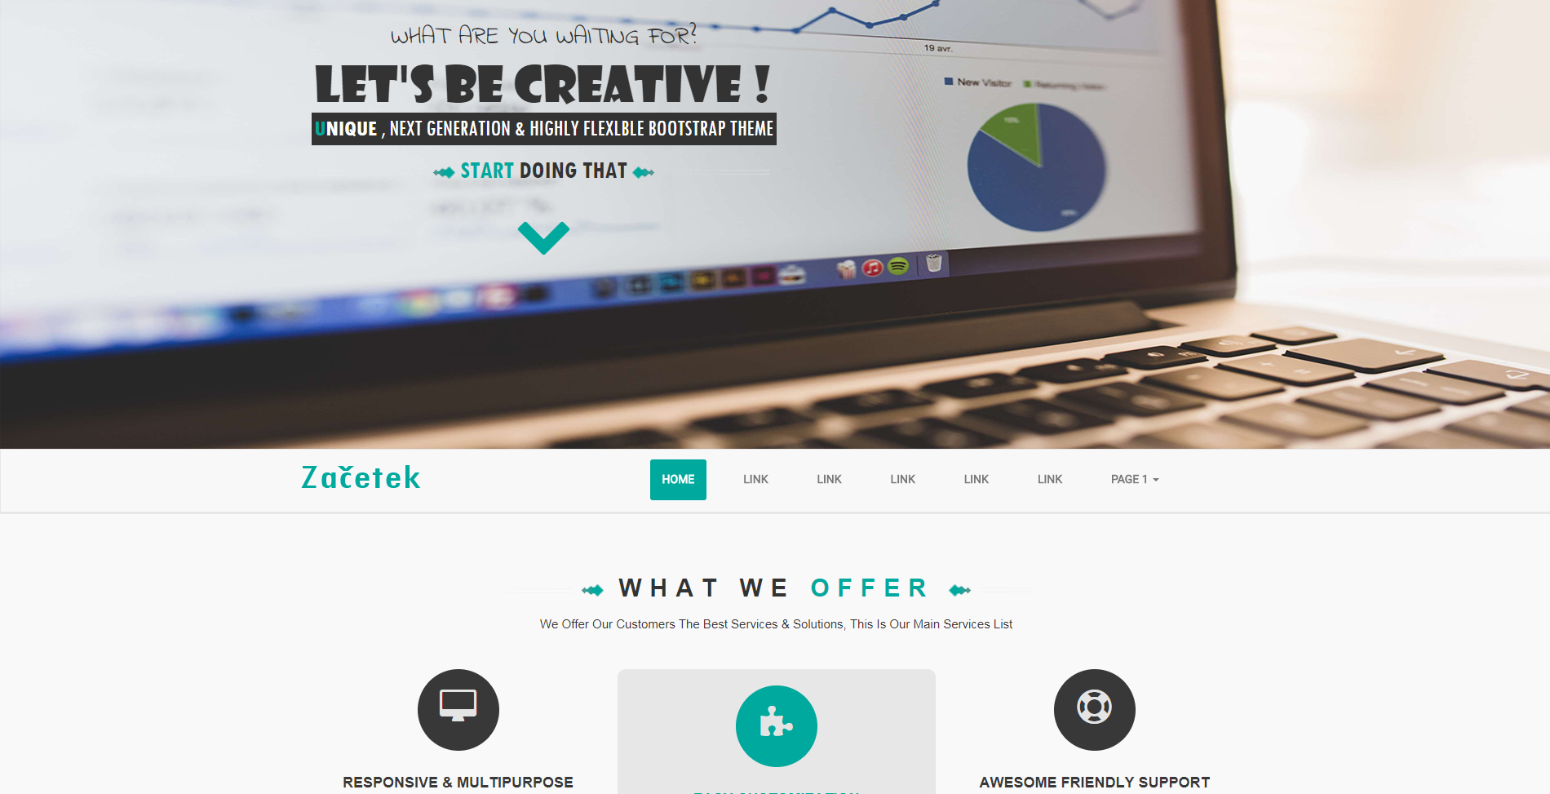

# How to customiz ZAČETEK template?

This is version [1.0].

## What I need to customiz ZAČETEK and upload?

You don't need match, or any knowledge in web languages … You just need to

1. Code editor like:

* [Brackets](http://brackets.io/)
* [Notepad++](https://notepad-plus-plus.org/download/)
* [Atom](https://atom.io/)
* [Komodo Edit](https://www.activestate.com/komodo-ide/downloads/edit)
* [Adobe Dreamweaver](https://www.adobe.com/products/dreamweaver.html?sdid=KKQTJ&mv=search&s_kwcid=AL!3085!3!247426822490!e!!g!!adobe%20dreamweaver&ef_id=Wj5PzQAAAH5V3kmn:20180322064326:s)

You need just one of that, you don't need the all.

1. Browser like:

* [Google Chrome](https://www.google.com/chrome/)
* [Firefox](https://www.mozilla.org/en-US/firefox/new/)
* [Opera](https://www.opera.com/)
* Edge (Windows OS)
* Internet Explorer (Windows OS)
* Safari (Mac OS)

You need just one of that, you don't need the all.

1. Domain & host .

Contents

Introduction & Feature 1

Why Html & Bootstarp? 1

Main Features 1

Compatible Browsers 2

Files Included 2

How to customiz ZAČETEK template? 3

What I need to customiz ZAČETEK and upload? 3