# Salesforce User-Owns-Data Embedding App

This sample project named [**SalesforceUserOwnsDataApp**](https://github.com/PowerBiDevCamp/SalesforceUserOwnsDataEmbedding/tree/main/SalesforceUserOwnsDataApp) consists of a very simple Single Page Application (SPA) that implements User-Owns-Data embedding with Power BI reports. The solution is built using three essential files which include [**index.html**](https://github.com/PowerBiDevCamp/SalesforceUserOwnsDataEmbedding/blob/main/Dist/index.html), [**app.css**](https://github.com/PowerBiDevCamp/SalesforceUserOwnsDataEmbedding/blob/main/Dist/App/app.css) and [**app.js**](https://github.com/PowerBiDevCamp/SalesforceUserOwnsDataEmbedding/blob/main/Dist/App/app.js). This solution contains an option fourth file named **loading.gif** which is used to demonstrate a white-label loading technique in which the developer can display a custom loading image instead of the standard Power BI branded loading image.

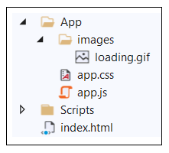

The **SalesforceUserOwnsDataApp** project uses three different JavaScript libraries which include [jQuery](https://jquery.com/), [Microsoft Authentication Library for JavaScript v2](https://github.com/AzureAD/microsoft-authentication-library-for-js/tree/dev/lib/msal-browser) (**msal-browser.js**) and the [Power BI JavaScript library](https://docs.microsoft.com/en-us/javascript/api/overview/powerbi/) (**powerbi.js**).

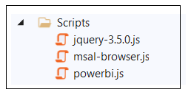

Once this SPA application has been deployed and configured, you can integrated it into a Salesforce environment using iFrame tags. This techniques makes it possible to embed Power BI report in VisualForce pages, Lighting Applications and Lighting Aura components.

A central motivation for this project is to provide a User-Owns-Data embedding experience in the Salesforce environment with more flexibility than the out-of-the-box [Secure Embed feature](https://docs.microsoft.com/en-us/power-bi/collaborate-share/service-embed-secure). In particular, when embedding a Power BI report using an iFrame generated for the Secure Embed feature, the user must click the Sign-in button each time they begin a new browser session.

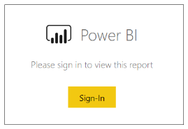

This continual requirement for user interaction to load a Power BI report has the potential to make our end users a bit cranky. A embedding solution using **SalesforceUserOwnsDataApp** provides the following advantages over implementing User-Owns-Data embedding using the Secure Embed feature.

* When users log in the first time, their credentials are cached in the browser using refresh tokens.
* Once user credentials are cached, embed reports will automatically load without requiring interaction.
* This app uses a white-labelling technique to hide the Power BI logo which is exchanged for an animated GIF with a custom loading image.

## Setting Up the **SalesforceUserOwnsDataApp** Sample

To configure the **SalesforceUserOwnsDataApp** sample, you must follow these steps.

* Find a place to publish the application files where they're accessible through HTTPS.
* Create an Azure AD application for a Single Page Application
* Download the [application files](https://github.com/PowerBiDevCamp/SalesforceUserOwnsDataEmbedding/archive/main.zip) and configure **app.js** to use your application ID and tenant.
* Upload the application files to the publish location where they're accessible through an HTTPS URL.
* Update the Azure AD application with the URL for the domain where you published application files.
* Test embedding a Power BI report by going directly to the application's URL.
* Embed the report in Salesforce by adding iFrames to a VisualForce page.

## Find a location to publish the application files

There are many different places you can publish the application files where they are accessible through a URL that uses the HTTPS protocol. For example, let's say you create a new Azure App Service which has a base URL of <https://salesforceuserownsdataapp.azurewebsites.net>. Once you upload the application files to this location, the index.html file should then be accessible through the following URL.

## Creating the Azure AD application

The setup process includes creating a new Azure AD application in the same tenant which contains the Power BI reports you'd like to embed. Begin by navigating to the [App registration](https://portal.azure.com/#blade/Microsoft_AAD_IAM/ActiveDirectoryMenuBlade/RegisteredApps) page in the Azure portal and click the **New registration** link.

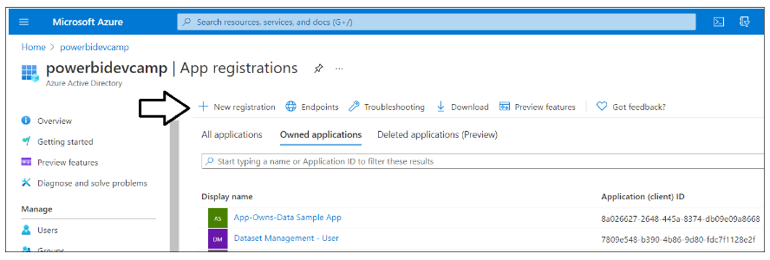

On the **Register an application** page, enter an application name such as **Salesforce User-OwnsData Embedding App** and accept the default selection for **Supported account types** to restrict users to a single tenant.

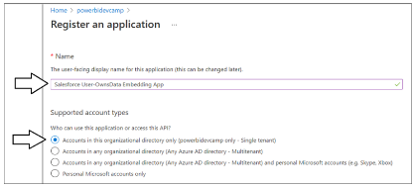

In the **Redirect URL (optional)** section, select **Single Page Application (SPA)** from the dropdown list on the left and enter the base URL where you will publish your application files followed by the HTML page name of **index.html** as shown in the following screenshot. Next, click the Register button to create the new Azure AD application.

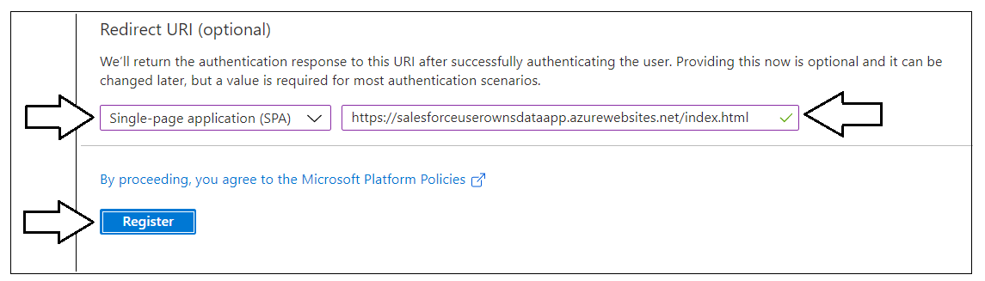

Once you have created the new Azure AD application, the Azure portal should display the application's overview page which display GUID for the **Application ID**. You will need to copy the Application ID and paste it into **app.js**.

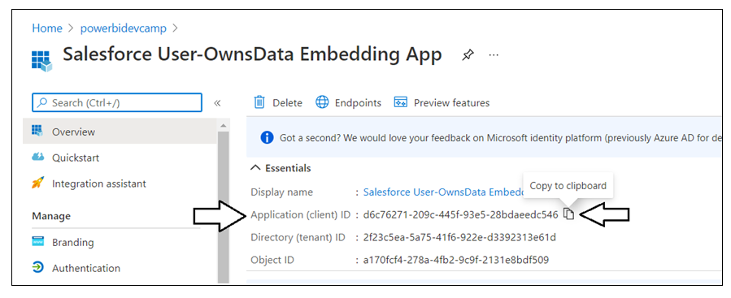

Test

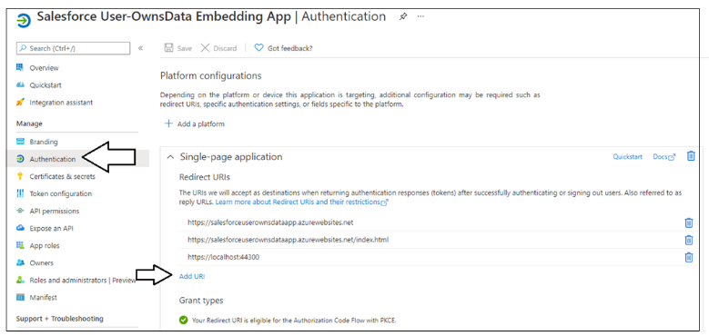

Test

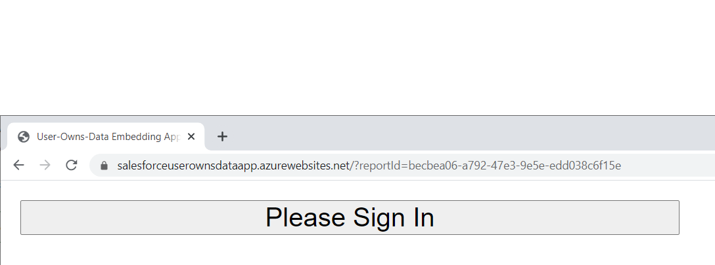

Test

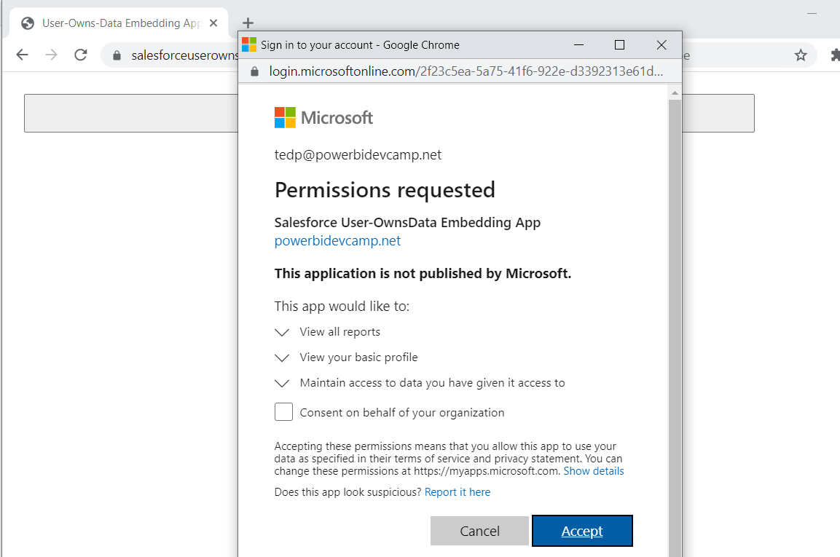

Test

