# The Tenant Management Application

You can follow the steps in this document to set up the [TenantManagement](https://github.com/PowerBiDevCamp/TenantManagement/tree/main/TenantManagement) for testing. To complete these steps, you will require a Microsoft 365 tenant in which you have permissions to create and manage Azure AD applications and security groups. You will also need Power BI Service administrator permissions to configure Power BI settings to give service principals to ability to access the Power BI Service API. If you do not have a Microsoft 365 environment for testing, you can create one for free by following the steps in [Create a Development Environment for Power BI Embedding](https://github.com/PowerBiDevCamp/Camp-Sessions/raw/master/Create%20Power%20BI%20Development%20Environment.pdf).

## Setting up your development environment

To set up the TenantManagement application doe testing, you will need to configure a Microsoft 365 envviroment with the following tasks.

1. Create a Security Group in Azure AD named Power BI Apps
2. Configure Power BI Tenant-Level Settings for Service Principal Access
3. Create the Azure AD Application for the TenantManagement Application

The following three sections will step through each of these setup tasks.

### Create an Azure AD security group named Power BI Apps

Begin by navigating to the [Groups management page](https://portal.azure.com/#blade/Microsoft_AAD_IAM/GroupsManagementMenuBlade/AllGroups) in the Azure portal. Once you get to the **Groups** page in the Azure portal, click the **New group** link.

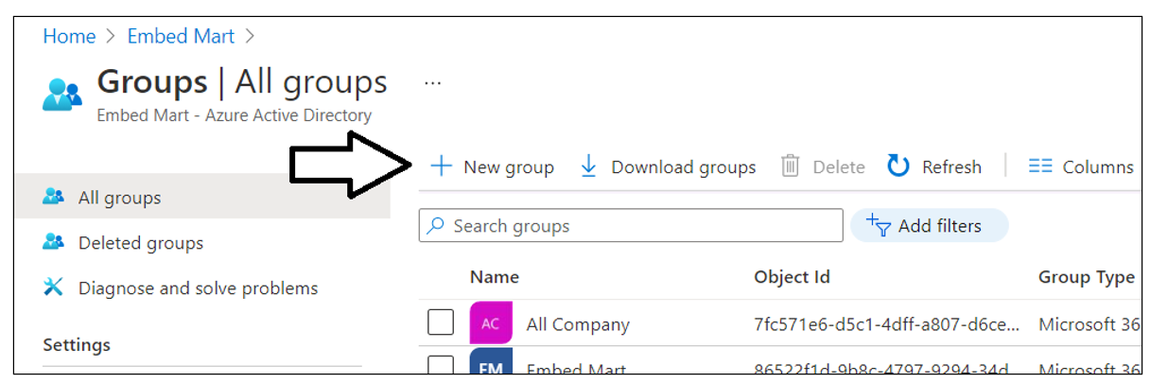

In the **New Group** dialog, Select a **Group type** of **Security** and enter a **Group name** of **Power BI Apps**. Click the **Create** button to create the new Azure AD security group

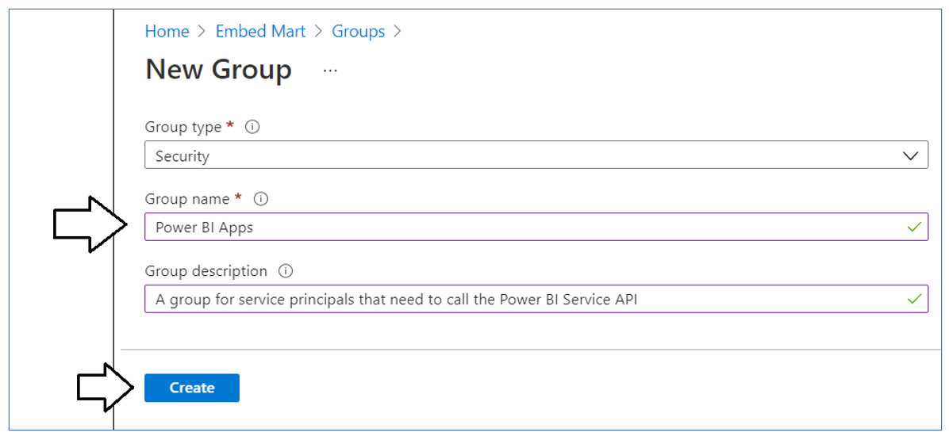

Verify that you can see the new security group named **Power BI Apps** on the Azure portal **Groups** page.

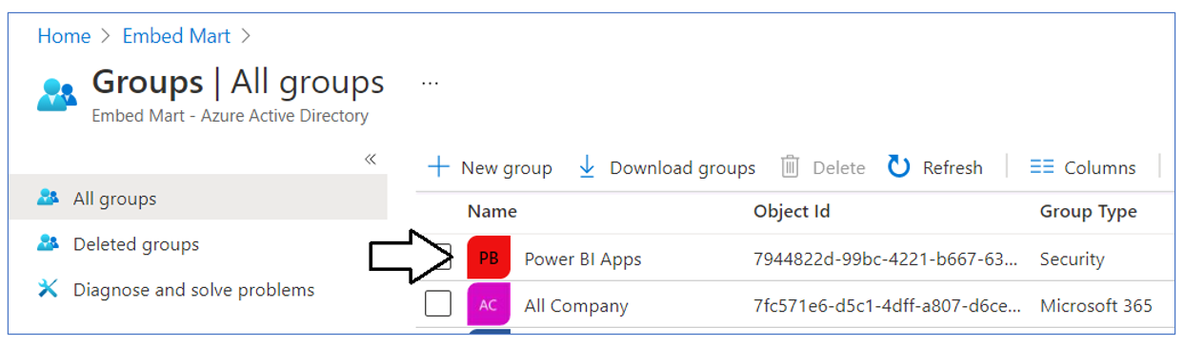

### Configure Power BI tenant-level settings for service principal access

Next, you need you enable a tenant-level setting for Power BI named **Allow service principals to use Power BI APIs**. Navigate to the Power BI Service admin portal at <https://app.powerbi.com/admin-portal>. In the Power BI Admin portal, click the **Tenant settings** link on the left.

Move down in the **Developer settings** section and expand the **Allow service principals to use Power BI APIs** section.

Note that the **Allow service principals to use Power BI APIs** setting is initially set to **Disabled**.

Change the setting to **Enabled**. After that, set the **Apply to** setting to **Specific security groups** and add the **Power BI Apps** security group as shown in the screenshot below. Click the **Apply** button to save your configuration changes.

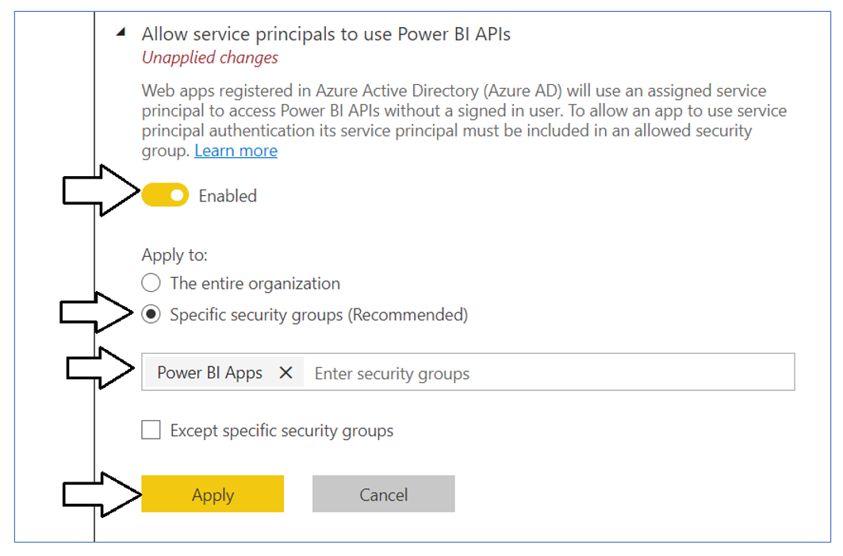

You will see a notification indicating it might take up to 15 minutes to apply these changes to the organization.

Now scroll upward in the **Tenant setting** section of the Power BI admin portal and locate the **Workspace settings** section.

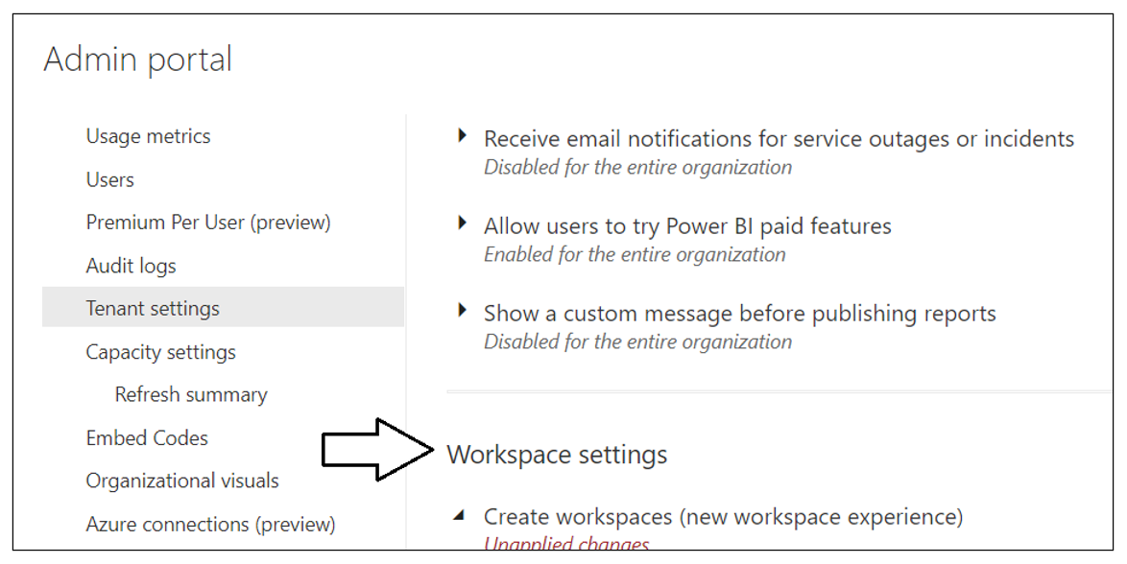

Note that a new Power BI tenant has an older policy where only users who have the permissions to create Office 365 groups can create new Power BI workspaces. You must reconfigure this setting so that service principals in the **Power BI Apps** group will be able to create new workspaces.

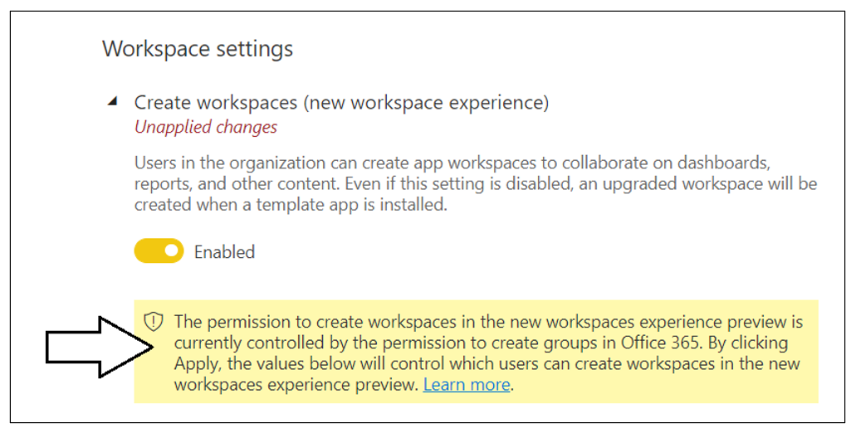

In the **Workspace settings** section, set the **Apply to** setting to **Specific security groups** and add **Power BI Apps** security group as shown in the screenshot below. Click the **Apply** button to save your configuration changes.

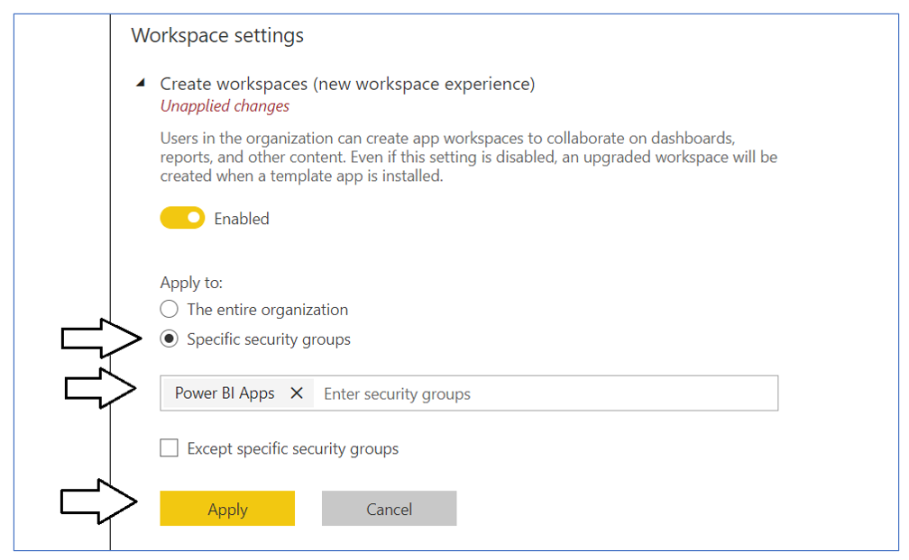

You have now completed the configuration of Power BI tenant-level settings.

### Create the Azure AD Application for the TenantManagement Application

When you login to the Azure portal to create the new Azure AD application, make sure you log in using a user account in the same tenant which contains the Power BI reports you'd like to embed. Begin by navigating to the [App registration](https://portal.azure.com/#blade/Microsoft_AAD_IAM/ActiveDirectoryMenuBlade/RegisteredApps) page in the Azure portal and click the **New registration** link.

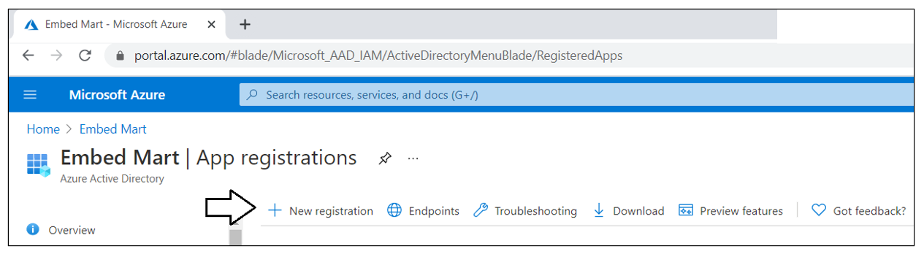

On the **Register an application** page, enter an application name such as **Power BI Tenant Management Application** and accept the default selection for **Supported account types** of **Accounts in this organizational directory only**.

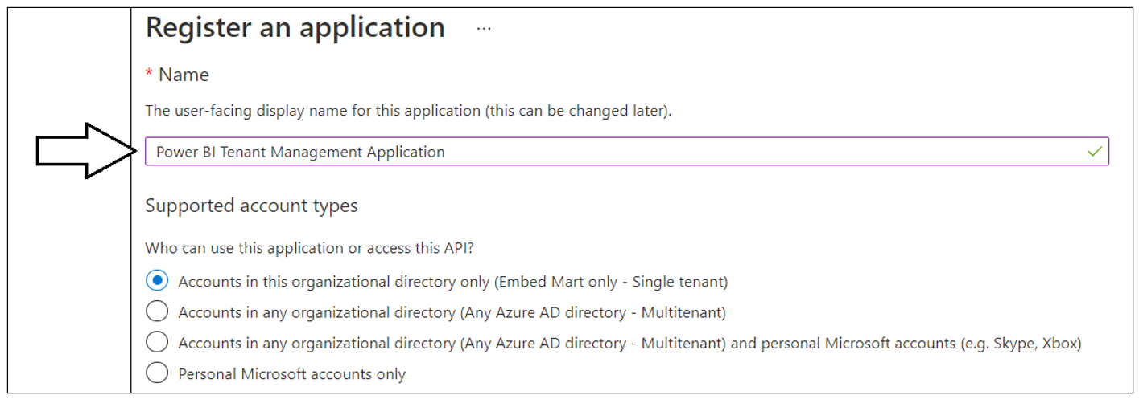

In the **Redirect URI** section leave the default selection of **Web** in the dropdown box. In the textbox to the right of the dropdown, enter a Redirect URI of **https://localhost:44300/signin-oidc**. Click the **Register** button to create the new Azure AD application.

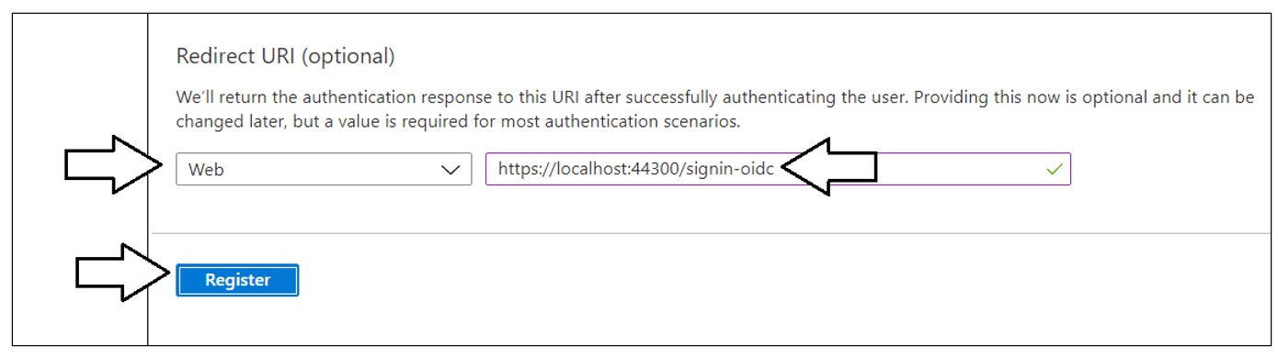

After creating a new Azure AD application in the Azure portal, you should see the Azure AD application overview page which displays the **Application ID**. Note that the ***Application ID*** is often called the ***Client ID***, so don't let this confuse you. You will need to copy this Application ID and store it so you can use it later to configure the project's support for Client Credentials Flow.

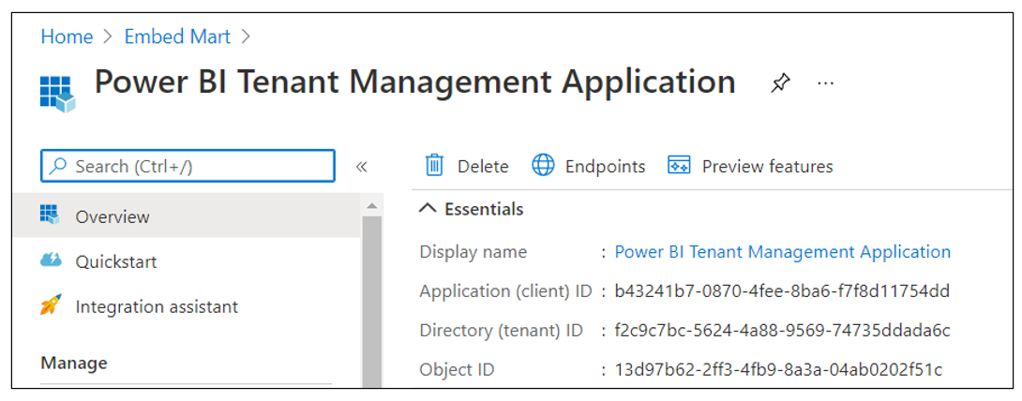

Copy the **Client ID** (aka Application ID) and paste it into a text document so you can use it later in the setup process. Note that this is the **Client ID** value that will be used by **TenantManagement** project to authenticate users.

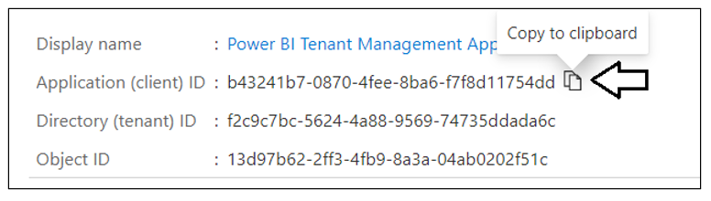

Next, repeat the same step by copying the **Tenant ID** and copying that into the text document as well.

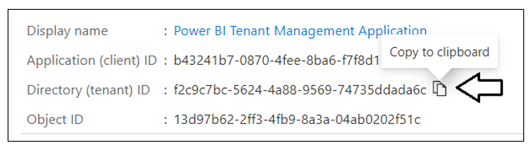

Your text document should now contain the **Client ID** and **Tenant ID** as shown in the following screenshot.

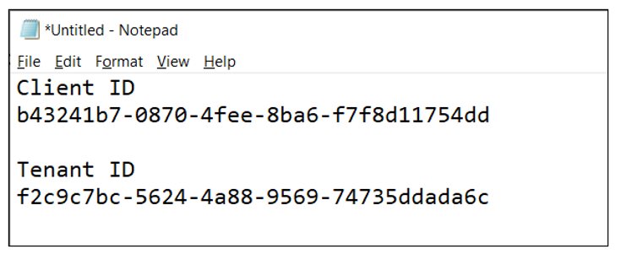

Next, you need to create a Client Secret for the application. Click on the **Certificates & secrets** link in the left navigation to move to the **Certificates & secrets** page. On the **Certificates & secrets** page, click the **New client secret** button as shown in the following screenshot.

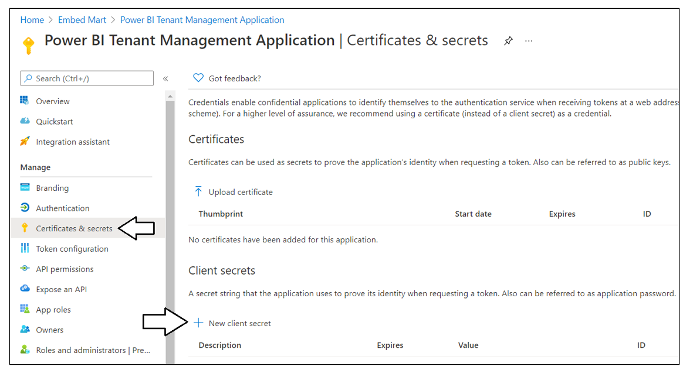

In the **Add a client secret** dialog, add a text description such as **Test Secret** and then click the **Add** button to create the new Client Secret.

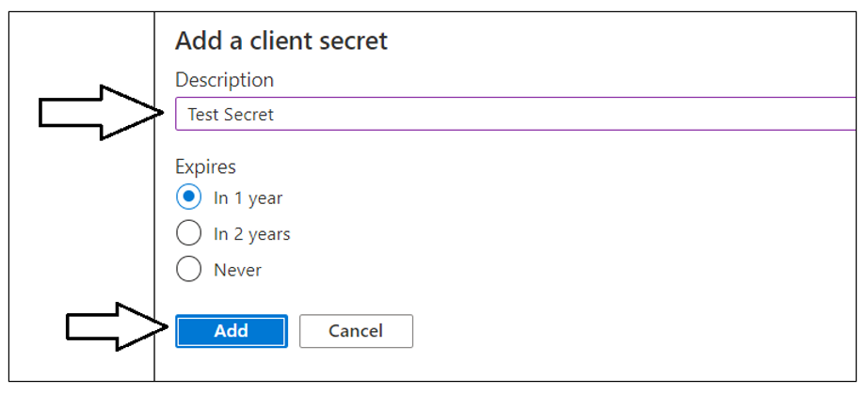

Once you have created the Client Secret, you should be able to see its **Value** in the **Client secrets** section. Click on the **Copy to clipboard** button to copy the Client Secret into the clipboard.

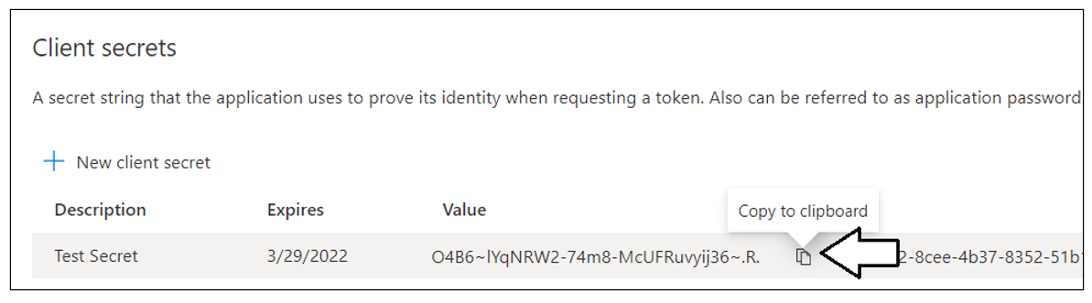

Paste the **Client Secret** into the same text document with the **Client ID** and **Tenant ID**.

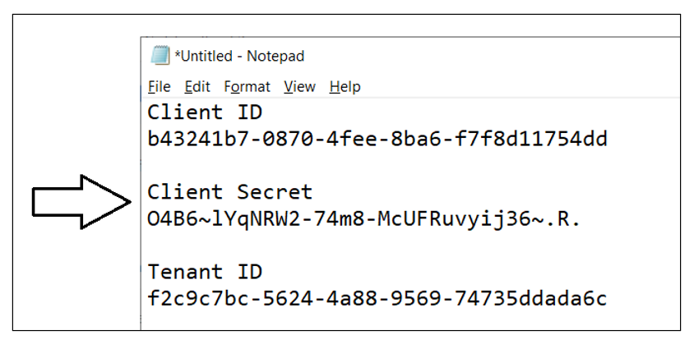

## Setting Up the Tenant Management Application for Testing

xxxx

### Download the Source Code

xxxx

### Open the Project in Visual Studio 2019

Xxxxx

### Update application settings in the appsettings.json file

ssss

### Create the TenantManagementDB database

Xxxxx

## Test the Tenant Management Application

Xxxx

