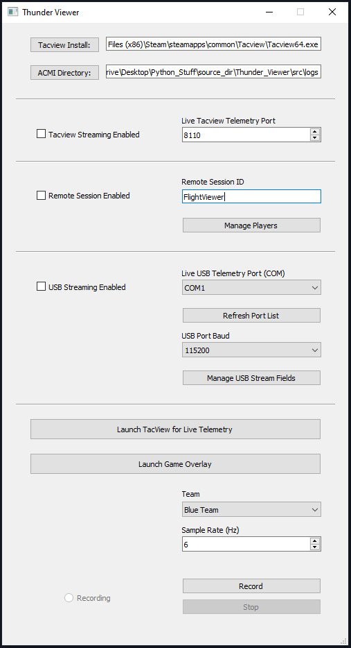
File paths to Tacview.exe and directory to save ACMI logs to
Set telemetry sample rate. Range of values are 2-10Hz. Higher the sample rate, higher the telemetry fidelity, but also higher the throughput if using a remote session
Select team (specifies color of player’s vehicle in Tacview stream/replay)
Click check box to enable live TCP telemetry stream to Tacview – port must not be 8111
Click check box to connect to other players with the same remote session ID. This allows users to share realtime War Thunder telemetry data between allied users. Make sure all users have the EXACT same session ID!
Click check box to stream personal War Thunder telemetry data to an IoT/USB device (i.e. an Arduino). Select the proper USB/Serial port, baud rate (bps), and telemetry values (see “Manage USB Stream Fields” button) to stream to the device.
Launch Tacview at the path specified at the top of the GUI
Buttons to begin/stop recording/streaming War Thunder telemetry data based on the options selected above
Launch the in-game overlay for live-view of War Thunder telemetry data

