P2 – Perform Simulations of Examples
Dielectric Slab
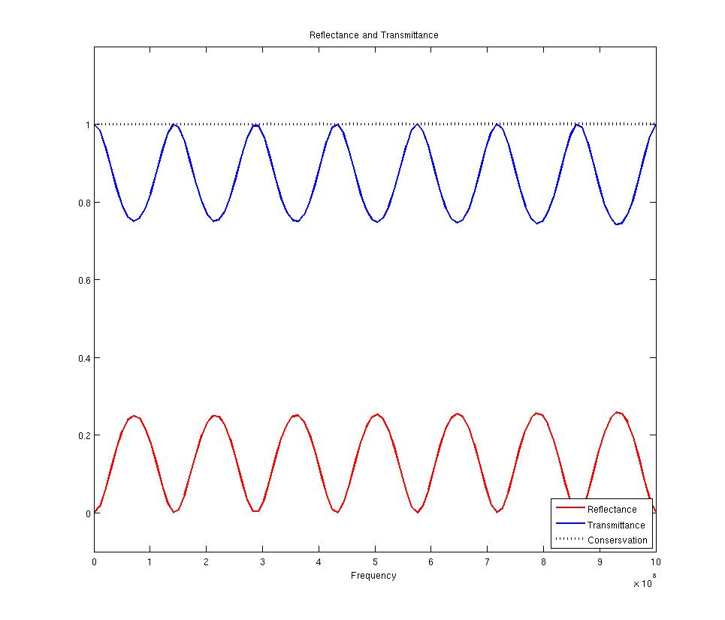
Invisible Slab
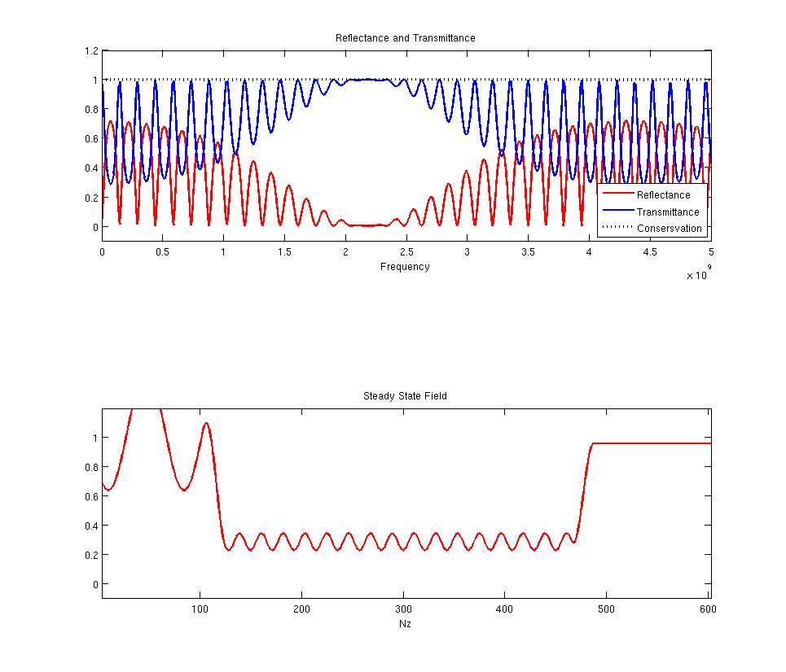

Blinded Missle
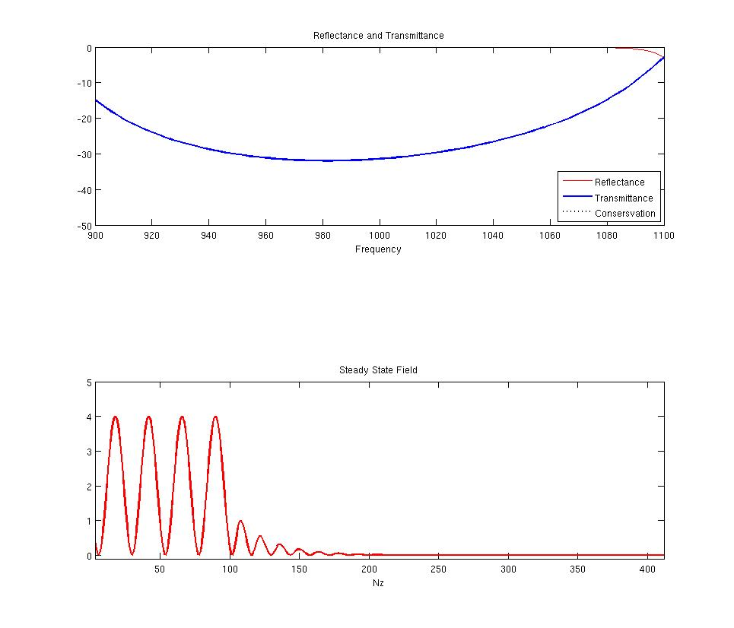

Appendix

GetNlambda.m

function [ N_lambda ] = GetNlambda( ER, UR )
%GETNLAMBDA Summary of this function goes here
% Detailed explanation goes here

nmax = Getnmax(ER, UR);

if(nmax < 10)
N_lambda = 20;
end

if((nmax > 10) && (nmax<=40))
N_lambda = 30;
end

if((nmax > 40) && (nmax <= 60))
N_lambda = 60;
end

if(nmax > 60)
N_lambda = 200;
end

end

Getnmax.m

function [ nmax ] = Getnmax( ER, UR )
%GETNMAX Method calculates the nmax for a materials array for 1D
% Detailed explanation goes here

if(length(ER) ~= length(UR))
MException('ArraySize', 'Materials arrays are not the same size');
end

n = zeros([1 size(ER)]);
n = sqrt(ER.*UR); % Calculate refractive index of each material
nmax = max(n);
end

DielectricSlab.m

%%%%%%%%%%%%%%%%%%%%%%%%%%%%%%%%%%%%%%%%%
% Dielectric Slab Model
%%%%%%%%%%%%%%%%%%%%%%%%%%%%%%%%%%%%%%%%%

% Initialize MATLAB
close all; clc;
clear all;

% Dimensions
% Slab is 12 inches thick surrounded by air on each side
d = 12 * 2.54; %cm thick
dc = d/100; %meters Our critical dimension in this case is the whole slab
rNz = ceil(d); %This Nz represents real world size
rNz = rNz + 2; % We are going to add air on each side of the problem.

%Material Vectors Initialized at Air
rER = ones([1 rNz]);
rUR = ones([1 rNz]);

% Add our Slab materials to the model
rER(1:rNz) = 6;
rUR(1:rNz) = 2;

% Frequency

freq_start = 0; %DC
freq_end = 1e9; %1Ghz

NFREQ = freq_end / 10e6; %Frequencies every 100Mhz upto 10Ghz
FREQ = linspace(freq_start, freq_end, NFREQ); %FREQ List

FDTD1D( dc, dc, rER, rUR, -1, -1, FREQ, NFREQ, 1000, -1, 'HW#6-P2-Dielectric Slab' );

InvisibleSlab.m

%%%%%%%%%%%%%%%%%%%%%%%%%%%%%%%%%%%%%%%%%
% Invisible Slab Model
%%%%%%%%%%%%%%%%%%%%%%%%%%%%%%%%%%%%%%%%%

% Initialize MATLAB
close all; clc;
clear all;

%%%%%%%%%%%%%%%%%%%%%%%%%%%%%%%%%%%%%%%%%
% Problem
% A radome is being deigned to protect an antenna.
% Antenna operates at 2.4Ghz
% radome is 1ft thick with a dielectric constant = 12
% We want to maximize transmission through dome
%%%%%%%%%%%%%%%%%%%%%%%%%%%%%%%%%%%%%%%%%

% Constants
c0 = 299792458;

% Frequency we want to transmit
f_trans = 2.4e9; %2.4Ghz
lambda_trans = c0/f_trans;

% Dimensions
% Radome is 12 inches thick
d_radome = 12 * 2.54/100; %cm thick

% We need to place a Anti-Reflective Layer on each side of the Radome
e_radome = 12;
e_air = 1;
e_nonreflective = sqrt(e_radome*e_air);

n_nonreflective = sqrt(e_nonreflective);
d_nonreflective = lambda_trans/(4*n_nonreflective);

dc = d_nonreflective; %meters Our critical dimension in this case the anti-reflectivelayer
rNz = ceil((round(d_radome*100) + 2*round(d_nonreflective*100)))+2; %This Nz represents real world size

% Material Vectors Initialized at Air
rER = ones([1 rNz]);
rUR = ones([1 rNz]);

% Add our Materials to the model
zstart = 1;
zend = ceil(d_nonreflective*100);
rER(zstart: zend) = e_nonreflective;

zstart = zend + 1;
zend = zstart + floor(d_radome*100);
rER(zstart:zend) = e_radome;

zstart=zend+1;
zend = zstart + floor(d_nonreflective*100);
rER(zstart:zend) = e_nonreflective;

% Frequency

freq_start = 0; %DC
freq_end = 5e9;%f_trans*2; %1Ghz

NFREQ = freq_end / 10e6; %Frequencies every 100Mhz upto 5Gz
FREQ = linspace(freq_start, freq_end, NFREQ); %FREQ List

FDTD1D( dc, (d_radome+2*d_nonreflective), rER, rUR, 35000, 100, FREQ, NFREQ, 1000, 2.4e9, 'HW#6-P2-Invisible Slab');

FDTD1D.m

function FDTD1D( dc, Length, rER, rUR, Steps, Buffer, FREQ, NFREQ, Update, SSFREQ, Title )
%FDTD1D Method executes a FDTD1D Model
% Detailed explanation goes here

%%%%%%%%%%%%%%%%%%%%%%%%%%%%%%%%%%%%%%%%%
% Pre-Program Work
%%%%%%%%%%%%%%%%%%%%%%%%%%%%%%%%%%%%%%%%%

%Constants
c0 = 299792458; %m/s
e0 = 8.854187817*10^-12; %F/m
u0 = 1.256637061*10^-6; %H/m

%%%%%%%%%%%%%%%%%%%%%%%%%%%%%%%%%%%%%%%%%
% Initialization of Parameters
%%%%%%%%%%%%%%%%%%%%%%%%%%%%%%%%%%%%%%%%%

f_max = FREQ(length(FREQ));
nmax = Getnmax(rER, rUR);

%Compute Grid Resolution
% Wave Length Rsolution
N_lambda = GetNlambda(rER, rUR);
lambda_min = c0 / (f_max);
d_lambda = lambda_min/N_lambda/nmax;

% Structure Resolution
N_d = 4;
d_d = dc/4;

% Calculate grid resolution dz
dz = min(d_lambda, d_d);
N_prime = ceil(dc/dz);
dz = dc/N_prime;

% Calculate Grid Size
Nz = ceil(Length/dz);

% Add free space buffer and TF/SF
if(Buffer == -1)
buffer = ceil(d_lambda/dz) * 5;
buffert = buffer*2 + 3;
else
buffer = Buffer;
buffert = buffer*2;
end

Nz = Nz + buffert;

%Compute Time Steps
dt = dz/(2*c0); %secs

% Source Parameters
nzc = 2; %Position of Sources at our TF/SF boundary
tau = 0.5/f_max; % tau parameter
t0 = 6*tau; % Delay/Pulse Position

%%%%%%%%%%%%%%%%%%%%%%%%%%%%%%%%%%%%%%%%%
% Model
%%%%%%%%%%%%%%%%%%%%%%%%%%%%%%%%%%%%%%%%%
cf = floor((Nz - buffert)/length(rER)); % Conversion factor to convert our real grid to our numerical grid

%Material Vectors
ER = zeros([1 Nz]);
UR = zeros([1 Nz]);

% We Need to lay our real materials vectors over our numerical material
% grid

% Lets place our real grid in proper location on numerical grid
for i = 0 : length(rER)-1
index = buffer+2 + i*cf+1;
% disp(['i: ' num2str(i) ' i2: ' num2str(index)]);
ER(index) = rER(i+1);
UR(index) = rUR(i+1);
end

% Need to backfill in our values
ER(1:buffer+2) = 1;
ER(length(ER)-buffer-1:length(UR)) = 1;
UR(1:buffer+2) = 1;
UR(length(UR)-buffer-1:length(UR)) = 1;

for i=buffer+2 : length(ER-buffer-1)
if(ER(i) == 0)
ER(i) = ER(i-1);
end

if(UR(i) == 0)
UR(i) = UR(i-1);
end
end

%%%%%%%%%%%%%%%%%%%%%%%%%%%%%%%%%%%%%%%%%
% Calculate STEPS
%%%%%%%%%%%%%%%%%%%%%%%%%%%%%%%%%%%%%%%%%

STEPS = Steps;
if(STEPS == -1)
tprop = (nmax*Nz*dz)/c0; % Wave Propagation time;
T = 12*tau + 5*tprop;
STEPS = ceil(T/dt);
end

ta = [0:STEPS-1]*dt; % Time Axis;

%%%%%%%%%%%%%%%%%%%%%%%%%%%%%%%%%%%%%%%%%
% Source
%%%%%%%%%%%%%%%%%%%%%%%%%%%%%%%%%%%%%%%%%
s = dz/(2*c0) + dt/2; % Delay between E and H
Esrc = exp(-((ta-t0)/tau).^2); % E Source
A = -sqrt(ER(nzc)/UR(nzc)); % H Amplitude
Hsrc = A*exp(-((ta-t0+s)/tau).^2); % H Source

%%%%%%%%%%%%%%%%%%%%%%%%%%%%%%%%%%%%%%%%%%%%%%%%
%FDTD Initialization
%%%%%%%%%%%%%%%%%%%%%%%%%%%%%%%%%%%%%%%%%%%%%%%%

%Grid Axis
za=[0:Nz-1]*dz;

% Compute Update Coefficients
mER = (c0*dt/dz)./ER;
mHR = (c0*dt/dz)./UR;

% Initialize Feilds
Ey = zeros([1 Nz]);
Hx = zeros([1 Nz]);

%PAB Parameters
h1 = 0; h2 = 0; h3 = 0;
e1 = 0; e2 = 0; e3 = 0;

%Power Measurements
REF = zeros(1, NFREQ);
TRN = zeros(1, NFREQ);
SRC = zeros(1, NFREQ);
K = exp(-1i*2*pi*dt*FREQ);

SSFK = exp(-1i*2*pi*dt*SSFREQ);
SSFPOWER = zeros(1, Nz);
SSFSRC = zeros(1, Nz);

disp('%%%%%%%%%%%%%%%%%%%%%%%%%%%%%%%%%%%%%%%%%%');
disp('% Parameters');
disp('%%%%%%%%%%%%%%%%%%%%%%%%%%%%%%%%%%%%%%%%%%');

disp(['f_max' num2str(f_max)]);
disp(['lamda_min: ' num2str(lambda_min)]);
disp(['d_lambda: ' num2str(d_lambda)]);
disp(['nmax: ' num2str(nmax)]);
disp(['dc: ' num2str(dc)]);
disp(['d_d: ' num2str(d_d)]);
disp(['Nz: ' num2str(Nz)]);
disp(['buffer: ' num2str(buffer)]);
disp(['dz: ' num2str(dz)]);
disp(['Length: ' num2str(Nz*dz)]);
disp(['dt: ' num2str(dt)]);
disp(['tau: ' num2str(tau)]);
disp(['t0: ' num2str(t0)]);
disp(['STEPS: ' num2str(STEPS)]);
disp(['s: ' num2str(s)]);
disp(['A: ' num2str(A)]);
% disp(['ER: ' num2str(length(ER))]);
% disp(ER);
% disp(['UR: ' num2str(length(UR))]);;
% disp(UR);
% return;

%%%%%%%%%%%%%%%%%%%%%%%%%%%%%%%%%%%%%%%%%%%%%%%%
% Execute Simulation
%%%%%%%%%%%%%%%%%%%%%%%%%%%%%%%%%%%%%%%%%%%%%%%%

for t = 1:STEPS

% Calculate H
for nz = 1:Nz-1
Hx(nz) = Hx(nz) + mHR(nz)*(Ey(nz+1)-Ey(nz));
end

Hx(Nz) = Hx(Nz) + mHR(Nz)*(e3 - Ey(Nz));

%H Sources
Hx(nzc-1) = Hx(nzc-1) - mHR(nzc-1)*Esrc(t);

h3 = h2; h2 = h1; h1 = Hx(1); % Boundary Params;

% Calculate E
Ey(1) = Ey(1) + mER(1)*(Hx(1) - h3);
for nz = 2:Nz
Ey(nz) = Ey(nz) + mER(nz)*(Hx(nz)-Hx(nz-1));
end

%Inject Source
Ey(nzc) = Ey(nzc) - mER(nzc)*Hsrc(t);

e3=e2; e2=e1; e1=Ey(Nz); % Boundary Params;

%Update Fourier Transforms
for nf = 1: NFREQ
REF(nf) = REF(nf) + (K(nf)^t)*Ey(1)*dt;
TRN(nf) = TRN(nf) + (K(nf)^t)*Ey(Nz)*dt;
SRC(nf) = SRC(nf) + (K(nf)^t)*Esrc(t)*dt;
end

if(SSFREQ ~= -1)
for n = 3 : Nz-1
SSFPOWER(n) = SSFPOWER(n) + (SSFK^t)*Ey(n)*dt;
SSFSRC(n) = SSFSRC(n) + (SSFK^t)*Esrc(t)*dt;
end
end

if(mod(t,Update) == 0 || t == 1)
h = subplot(11,1,1:4);
Draw1D(ER, Ey, Hx, dz);
axis([za(1) za(Nz) -1.5 1.5]);
xlabel('z');
title(['Field at Step ' num2str(t) ' of ' num2str(STEPS)]);

R = abs(REF./SRC).^2;
T = abs(TRN./SRC).^2;

subplot(11,1,8:11)
plot(FREQ, R, '-r'); hold on;
plot(FREQ, T, '-b');
plot(FREQ, R+T, ':k', 'LineWidth', 2); hold off;
axis([FREQ(1) FREQ(NFREQ) -0.1 1.5]);
xlabel('Frequency');
title('Reflectance and Transmittance');
drawnow();
end

%if(mod(t,50) == 0)
% saveas(h, ['images/' num2str(t) '.jpg'], 'jpg');
%end
end

%%%%%%%%%%%%%%%%%%%%%%%%%%%%%%%%%%%%%%%%%%%%%%%%
% Compute Values
%%%%%%%%%%%%%%%%%%%%%%%%%%%%%%%%%%%%%%%%%%%%%%%%

REF = abs(REF./SRC).^2;
TRN = abs(TRN./SRC).^2;
CON = REF+TRN;

if(SSFREQ ~= -1)
SSFPOWER = abs(SSFPOWER./SSFSRC).^2;
end

%%%%%%%%%%%%%%%%%%%%%%%%%%%%%%%%%%%%%%%%%%%%%%%%
% Plot Fields
%%%%%%%%%%%%%%%%%%%%%%%%%%%%%%%%%%%%%%%%%%%%%%%%
fig = figure;
SetFigure(fig, Title, [500 274 965 826]);

if(SSFREQ ~= -1)
subplot(11,1,1:4);
end;

plot(FREQ, REF, '-r', 'LineWidth', 2); hold on;
plot(FREQ, TRN, '-b', 'LineWidth', 2);
plot(FREQ, CON, ':k', 'LineWidth', 3); hold off;
axis([FREQ(1) FREQ(NFREQ) -0.1 1.2]);
xlabel('Frequency');
title('Reflectance and Transmittance');
legend('Reflectance','Transmittance','Consersvation','Location','SouthEast');

if SSFREQ ~= -1
subplot(11,1,8:11)
plot(SSFPOWER, '-r', 'LineWidth', 2);
axis([3 Nz-1 -0.1 1.2]);
xlabel('Nz');
title('Steady State Field');
end

end

BlindedMissile.m

%Blinded Missle

%%%%%%%%%%%%%%%%%%%%%%%%%%%%%%%%%%%%%%%%%
% Pre-Program Work
%%%%%%%%%%%%%%%%%%%%%%%%%%%%%%%%%%%%%%%%%

% Initialize MATLAB
close all; clc;
clear all;

%Constants
c0 = 299792458; %m/s
e0 = 8.854187817*10^-12; %F/m
u0 = 1.256637061*10^-6; %H/m

nanometers = 1e-9;

%%%%%%%%%%%%%%%%%%%%%%%%%%%%%%%%%%%%%%%%%
% Initialization
%%%%%%%%%%%%%%%%%%%%%%%%%%%%%%%%%%%%%%%%%

%Simulated Environment Settings
NLAM = 5e9; % 5Ghz
lambda_0 = 980*nanometers; % Anti-reflective frequency;
lambda_min = 900*nanometers;
PERIODS = 15;

nSiN = 2.0;
erSiN = nSiN^2;

nSiO2 = 1.5;
erSiO2 = nSiO2^2;
nmax = nSiN;

%Calculate the Length of our layers.
LSiN = lambda_0/(4*nSiN);
LSiO2 = lambda_0/(4*nSiO2);

dc = LSiN;%meters Our critical dimension in this case is the width of one period.

%Compute Grid Resolution
N_lambda = 20;
d_wl = lambda_min/N_lambda/nmax;
N_d = 4;
d_d = dc/4; % since we are only working with freespace we will set d to 1;
dz = min(d_wl, d_d);
Nprime = ceil(dc/dz);
dz = dc/Nprime;

Nz = PERIODS*ceil((LSiN+LSiO2)/dz);

Nz = Nz + 2*(100) + 3;

%Grid Axis
za=[0:Nz-1]*dz;

%Compute Time Steps
dt = dz/(2*c0); %secs

% Source Parameters
nzc = 2; %Position of Sources
NLAM = 100;
LAMBDA = linspace(900, 1100, NLAM)*nanometers; %FREQ List
tau = 0.5/(c0/lambda_min); % tau parameter
t0 = 6*tau; % Delay/Pulse Position

T = 12*tau + 5*(nmax*Nz*dz/c0);
STEPS = ceil(T/dt);
STEPS=20000;

ta = [0:STEPS-1]*dt; % Time Axis;

%%%%%%%%%%%%%%%%%%%%%%%%%%%%%%%%%%%%%%%%%
% Model
%%%%%%%%%%%%%%%%%%%%%%%%%%%%%%%%%%%%%%%%%

%Material Vectors
ER = ones([1 Nz]);
UR = ones([1 Nz]);

nstart = 100+2;
nend = nstart;

for p = 1:PERIODS
nend = nstart + round(LSiN/dz)-1;
ER(nstart:nend) = erSiN;

nstart = nend+1;
nend = nstart+ round(LSiO2/dz) -1;
ER(nstart:nend) = erSiO2;

nstart = nend+1;
end;

%%%%%%%%%%%%%%%%%%%%%%%%%%%%%%%%%%%%%%%%%
% Source
%%%%%%%%%%%%%%%%%%%%%%%%%%%%%%%%%%%%%%%%%
s = dz/(2*c0) + dt/2; % Delay between E and H
Esrc = exp(-((ta-t0)/tau).^2); % E Source
A = -sqrt(ER(nzc)/UR(nzc)); % H Amplitude
Hsrc = A*exp(-((ta-t0+s)/tau).^2); % H Source

%%%%%%%%%%%%%%%%%%%%%%%%%%%%%%%%%%%%%%%%%%%%%%%%
%FDTD Initialization
%%%%%%%%%%%%%%%%%%%%%%%%%%%%%%%%%%%%%%%%%%%%%%%%

% Compute Update Coefficients
mER = (c0*dt/dz)./ER;
mHR = (c0*dt/dz)./UR;

% Initialize Feilds
Ey = zeros([1 Nz]);
Hx = zeros([1 Nz]);

%PAB Parameters
h1 = 0; h2 = 0; h3 = 0;
e1 = 0; e2 = 0; e3 = 0;

%Power Measurements
REF = zeros(1, NLAM);
TRN = zeros(1, NLAM);
SRC = zeros(1, NLAM);
K = exp(-1i*2*pi*dt*(c0./LAMBDA));

SSFK = exp(-1i*2*pi*dt*c0./lambda_0);
SSFPOWER = zeros(1, Nz);
SSFSRC = zeros(1, Nz);

disp('%%%%%%%%%%%%%%%%%%%%%%%%%%%%%%%%%%%%%%%%%%');
disp('% Parameters');
disp('%%%%%%%%%%%%%%%%%%%%%%%%%%%%%%%%%%%%%%%%%%');

disp(['lamda_min: ' num2str(lambda_min)]);
disp(['d_lambda: ' num2str(d_wl)]);
disp(['nmax: ' num2str(nmax)]);
disp(['dc: ' num2str(dc)]);
disp(['d_d: ' num2str(d_d)]);
disp(['Nz: ' num2str(Nz)]);
disp(['dz: ' num2str(dz)]);
disp(['Length: ' num2str(Nz*dz)]);
disp(['dt: ' num2str(dt)]);
disp(['tau: ' num2str(tau)]);
disp(['t0: ' num2str(t0)]);
disp(['STEPS: ' num2str(STEPS)]);
disp(['s: ' num2str(s)]);
disp(['A: ' num2str(A)]);
% disp(['ER: ' num2str(length(ER))]);
% disp(ER);
% disp(['UR: ' num2str(length(UR))]);;
% disp(UR);
% return;

%%%%%%%%%%%%%%%%%%%%%%%%%%%%%%%%%%%%%%%%%%%%%%%%
% Execute Simulation
%%%%%%%%%%%%%%%%%%%%%%%%%%%%%%%%%%%%%%%%%%%%%%%%

for t = 1:STEPS

% Calculate H
for nz = 1:Nz-1
Hx(nz) = Hx(nz) + mHR(nz)*(Ey(nz+1)-Ey(nz));
end

Hx(Nz) = Hx(Nz) + mHR(Nz)*(e3 - Ey(Nz));

%H Sources
Hx(nzc-1) = Hx(nzc-1) - mHR(nzc-1)*Esrc(t);

h3 = h2; h2 = h1; h1 = Hx(1); % Boundary Params;

% Calculate E
Ey(1) = Ey(1) + mER(1)*(Hx(1) - h3);
for nz = 2:Nz
Ey(nz) = Ey(nz) + mER(nz)*(Hx(nz)-Hx(nz-1));
end

%Inject Source
Ey(nzc) = Ey(nzc) - mER(nzc)*Hsrc(t);

e3=e2; e2=e1; e1=Ey(Nz); % Boundary Params;

%Update Fourier Transforms
for nf = 1: NLAM
REF(nf) = REF(nf) + (K(nf)^t)*Ey(1)*dt;
TRN(nf) = TRN(nf) + (K(nf)^t)*Ey(Nz)*dt;
SRC(nf) = SRC(nf) + (K(nf)^t)*Esrc(t)*dt;
end

for n = 3 : Nz-1
SSFPOWER(n) = SSFPOWER(n) + (SSFK^t)*Ey(n)*dt;
SSFSRC(n) = SSFSRC(n) + (SSFK^t)*Esrc(t)*dt;
end

if(mod(t,1000) == 0)
h = subplot(11,1,1:4);
Draw1D(ER, Ey, Hx, dz);
axis([za(1) za(Nz) -1.5 1.5]);
xlabel('z');
title(['Field at Step ' num2str(t) ' of ' num2str(STEPS)]);

R = abs(REF./SRC).^2;
T = abs(TRN./SRC).^2;

subplot(11,1,8:11)
plot(LAMBDA/nanometers, 10*log10(R), '-r'); hold on;
plot(LAMBDA/nanometers, 10*log10(T), '-b');
plot(LAMBDA/nanometers, 10*log10(R+T), ':k', 'LineWidth', 2); hold off;
axis([LAMBDA(1)/nanometers LAMBDA(NLAM)/nanometers -50 0]);
xlabel('Frequency');
title('Reflectance and Transmittance');
drawnow();
end

%if(mod(t,50) == 0)
% saveas(h, ['images/' num2str(t) '.jpg'], 'jpg');
%end
end

%%%%%%%%%%%%%%%%%%%%%%%%%%%%%%%%%%%%%%%%%%%%%%%%
% Compute Values
%%%%%%%%%%%%%%%%%%%%%%%%%%%%%%%%%%%%%%%%%%%%%%%%

REF = abs(REF./SRC).^2;
TRN = abs(TRN./SRC).^2;
CON = REF+TRN;

SSFPOWER = abs(SSFPOWER./SSFSRC).^2;

%%%%%%%%%%%%%%%%%%%%%%%%%%%%%%%%%%%%%%%%%%%%%%%%
% Plot Fields
%%%%%%%%%%%%%%%%%%%%%%%%%%%%%%%%%%%%%%%%%%%%%%%%
fig = figure;
SetFigure(fig, 'HW#6-P2-Blinded Missle', [500 274 965 826]);

subplot(11,1,1:4);
plot(LAMBDA/nanometers, 10*log10(R), '-r'); hold on;
plot(LAMBDA/nanometers, 10*log10(T), '-b', 'LineWidth', 2);
plot(LAMBDA/nanometers, 10*log10(R+T), ':k', 'LineWidth', 2); hold off;
axis([LAMBDA(1)/nanometers LAMBDA(NLAM)/nanometers -50 0]);
xlabel('Frequency');
title('Reflectance and Transmittance');
legend('Reflectance','Transmittance','Consersvation','Location','SouthEast');

subplot(11,1,8:11)
plot(SSFPOWER, '-r', 'LineWidth', 2);
axis([3 Nz-1 -0.1 5]);
xlabel('Nz');
title('Steady State Field');

