# Downloading Instructions

Access the IPEDS Data Center by entering the following URL into your browser: <http://nces.ed.gov/ipeds/datacenter/>

## Step 1 – Request Custom Data File Download

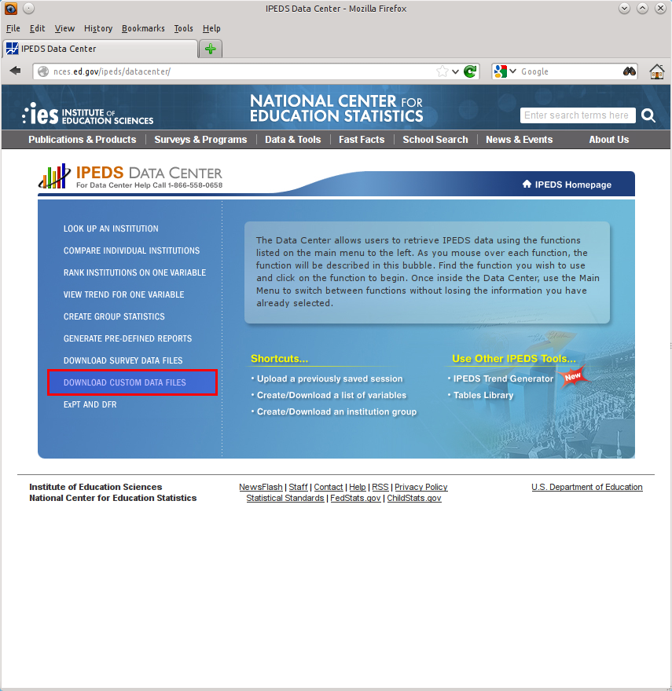

Click “Download Custom Data Files”

## Step 2 – Selecting Provisional or Final Release Data

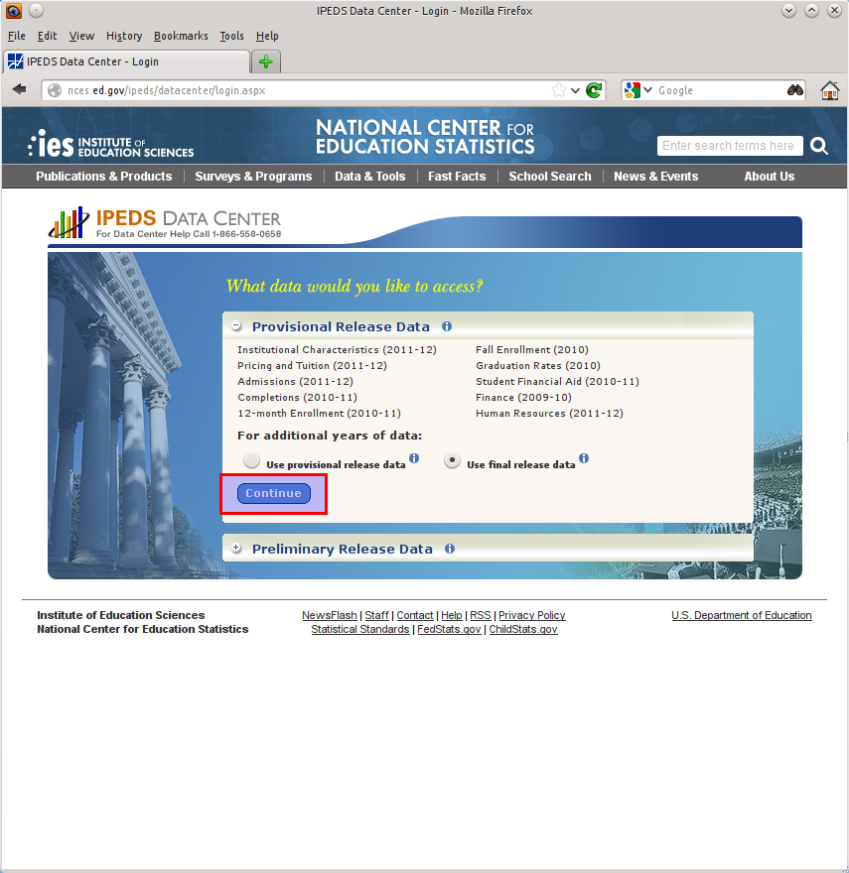

Ensure that “Use Final release data” is selected (the default) and click “Continue”

## Step 3 – Selecting All Institutions

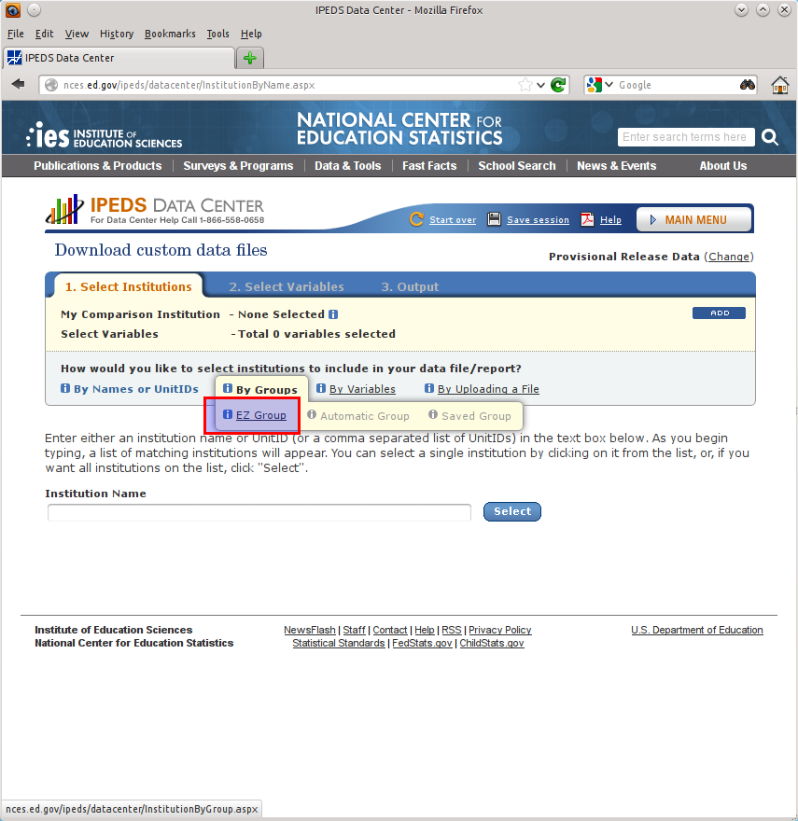

Hover over “By Groups” and click “EZ Group”

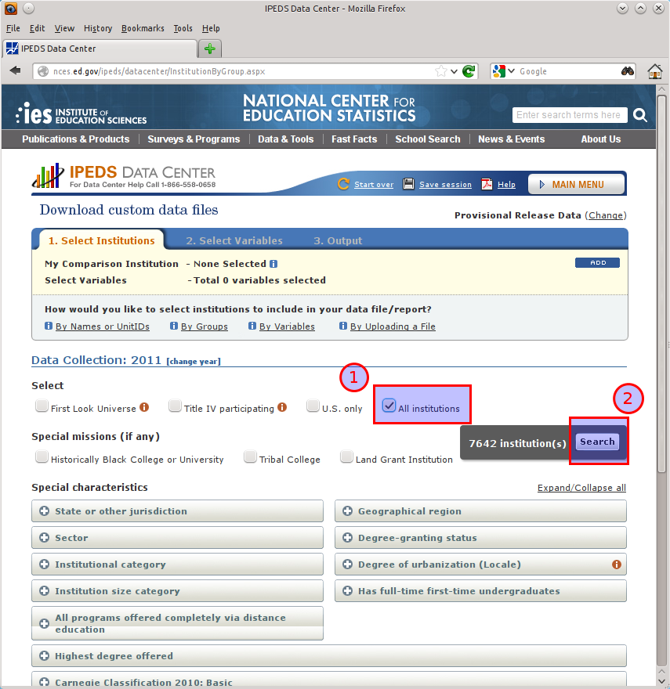

Check “All Institutions” and then click “Search”

## Step 4 – Selecting Export Variables

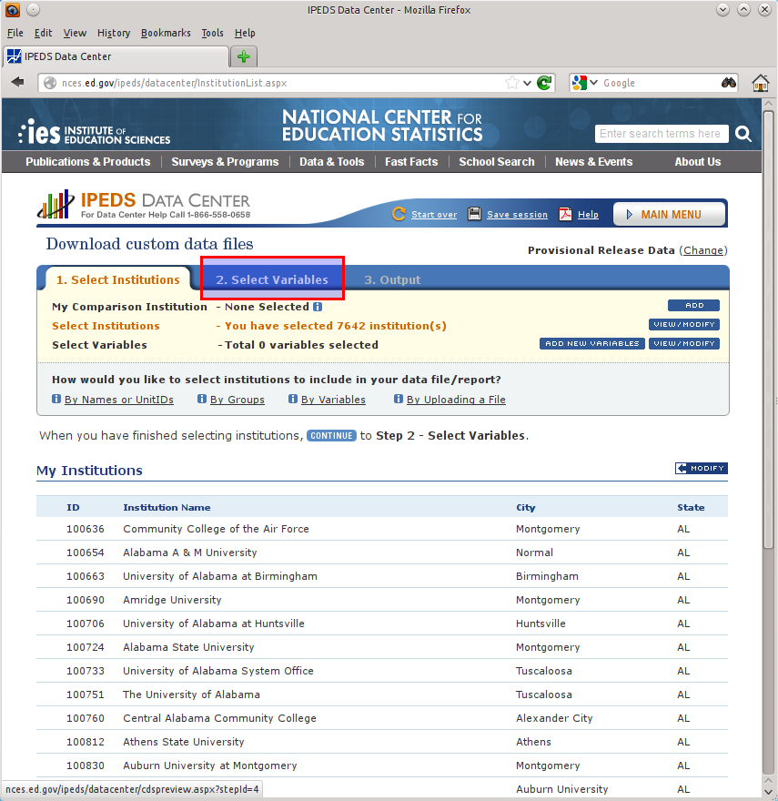

Click “Select Variables”

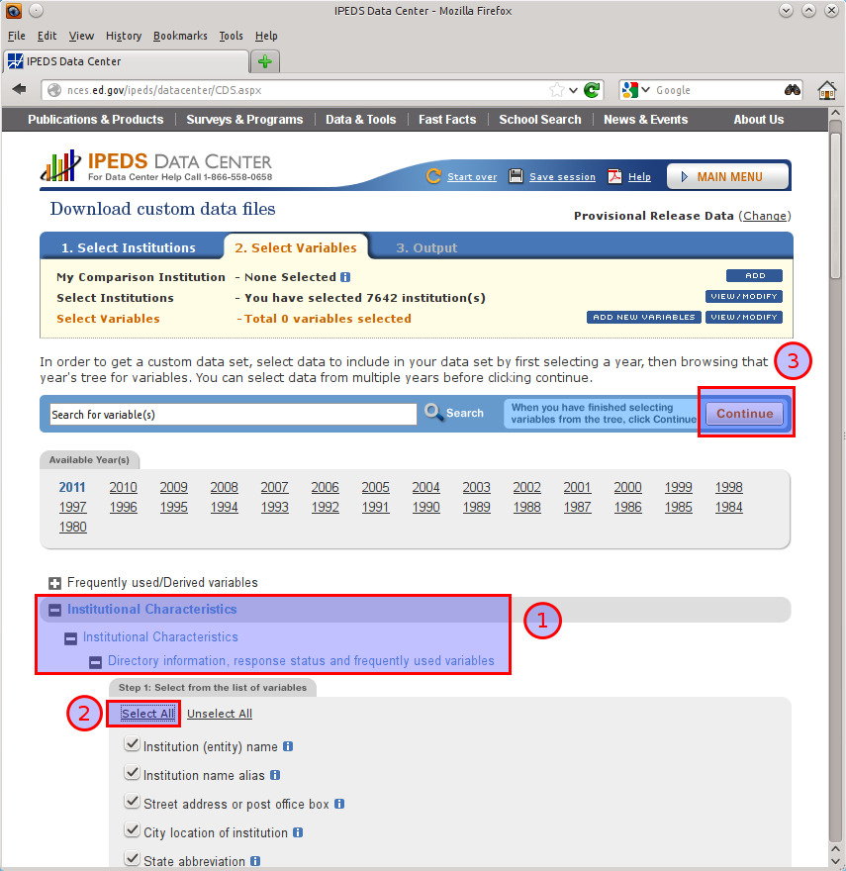

Ensure that the most recent year is selected (the screenshot reflect the 2011-2012 school year). Expand all levels under the “Institutional Characteristics” tree until the variables are displayed. Click “Select All” followed to pick all of the variables. Click “Continue” when done.

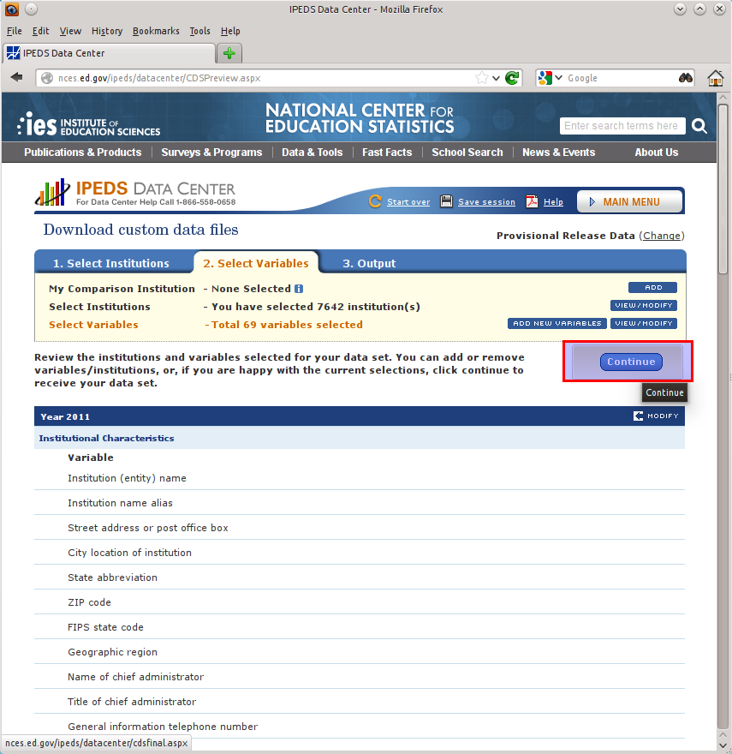

Click “Continue” to advance to the Output step.

## Step 5 – Exporting Data

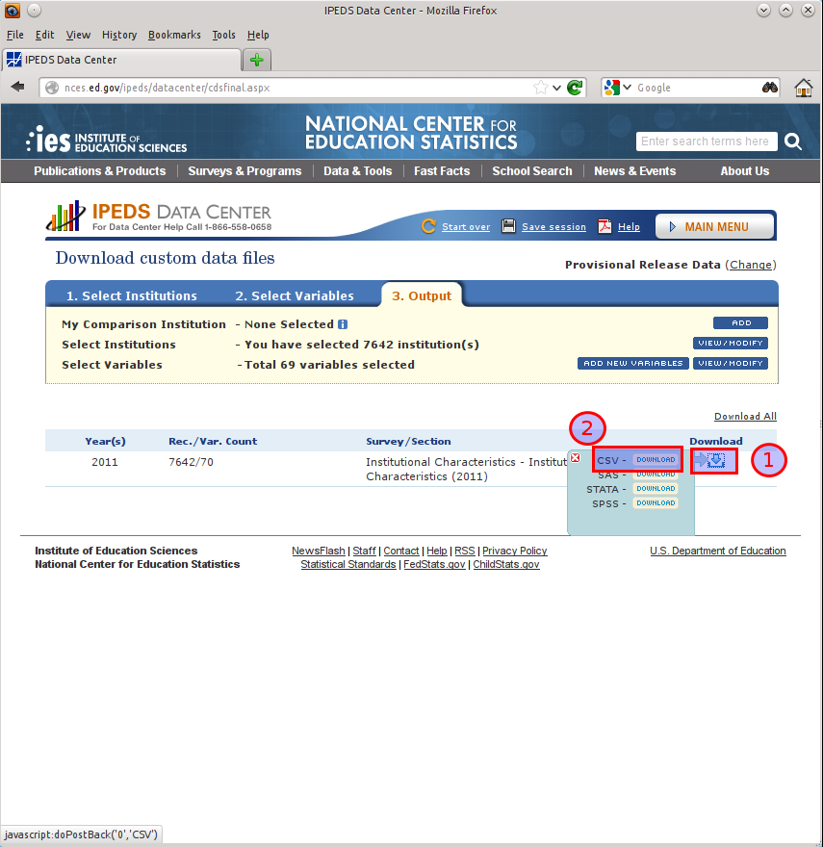

Click the download icon to expose the export formats in a flyout window. Click the “Download” link next to the CSV option (the only format we support).