# Flyback´s user manual:

## Necessary items:

1. Zybo board
2. Flyback board
3. USB to microUSB wire
4. 19Vdc @ 4A power supply
5. Oscilloscope and probes
6. SmartCtrl with “export to FPGA capabilities” and flyback.tro files

## Setup:

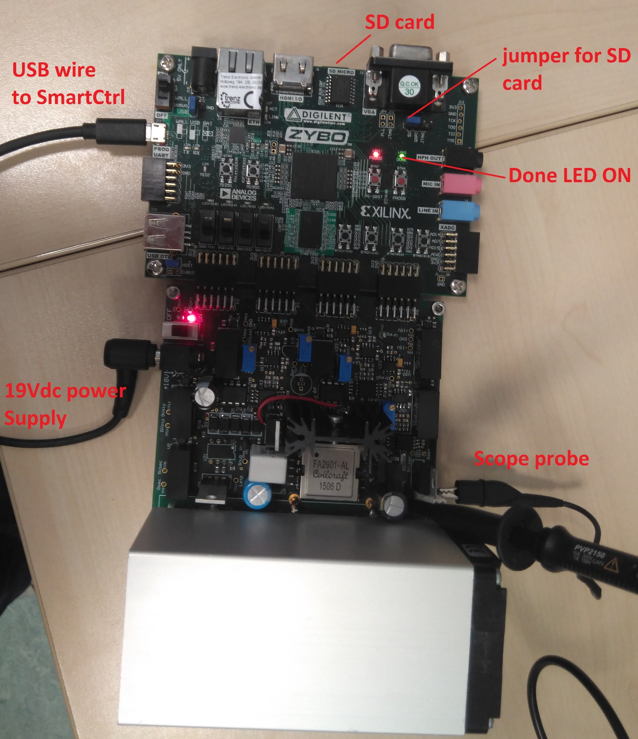

## SmartCtrl configuration:

1. Load file “flyback_PID_vin19.tro” of “flyback_PID_vin19.tro”
2. Select a point in the solution map

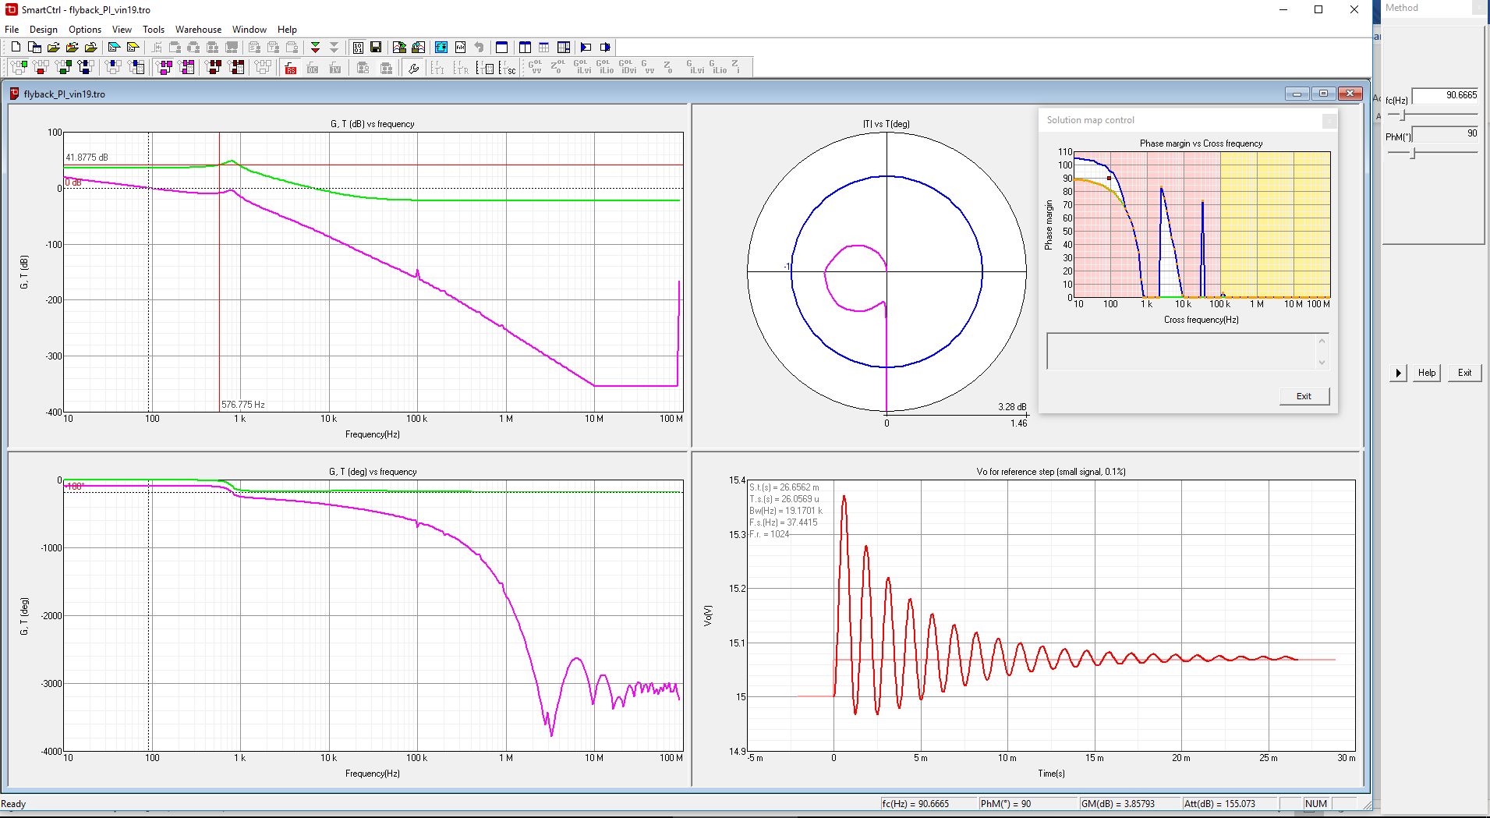

1. Open Windows device administrator and check what COM port is being used by the ZYBO

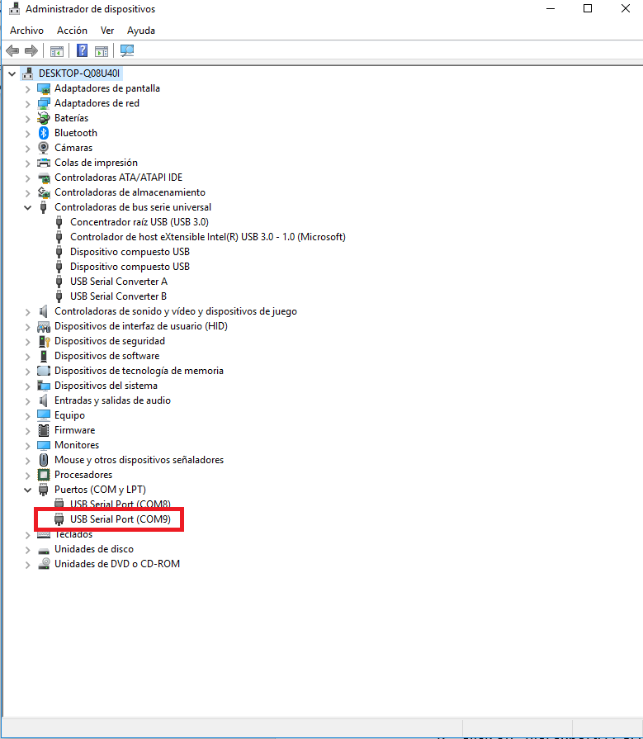

1. Click on “file/export/FPGA” or click ‘SHIFT+A’ and export digital compensator

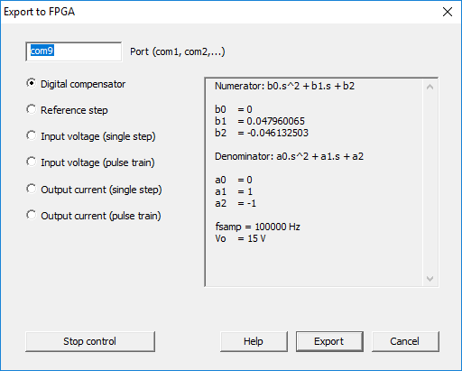

1. Place the probes and measure in TP17 (output voltage) and R40 lead (output current)

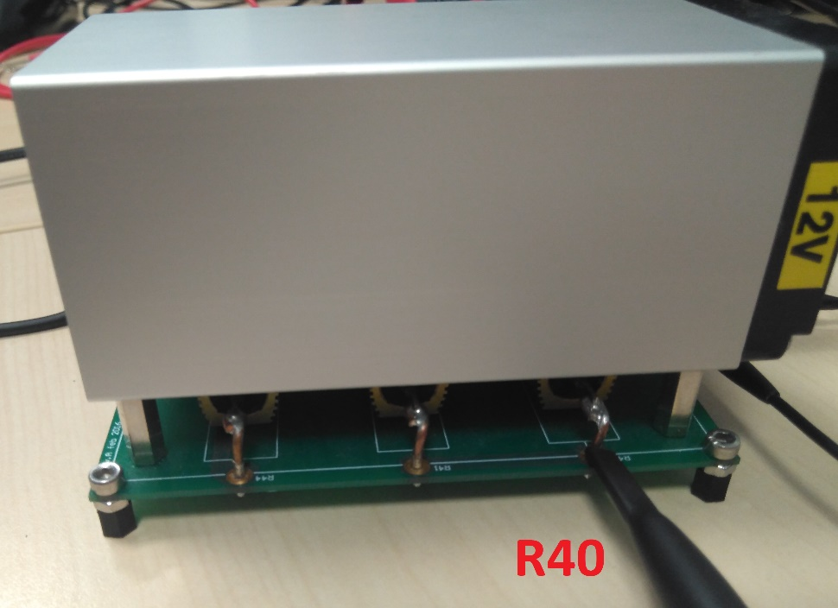

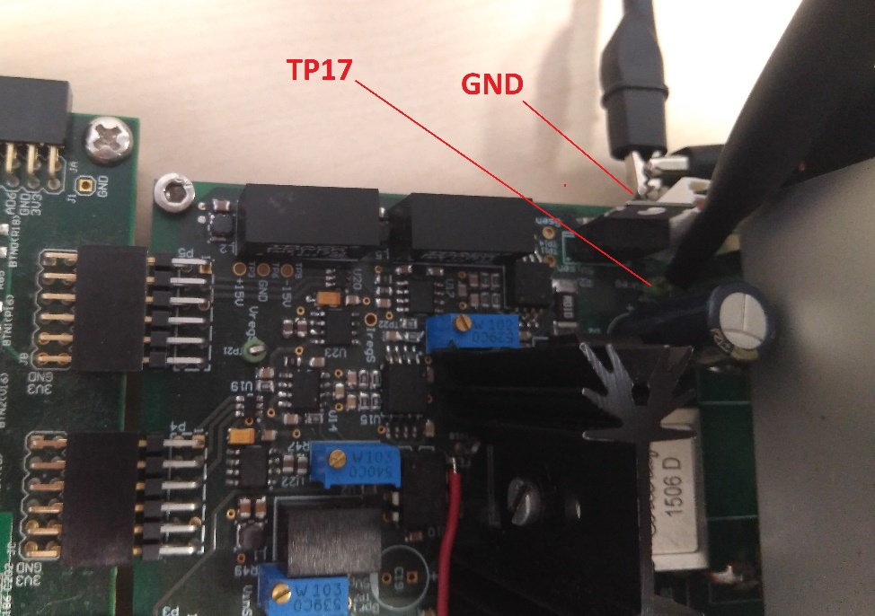

1. Create an output current step and

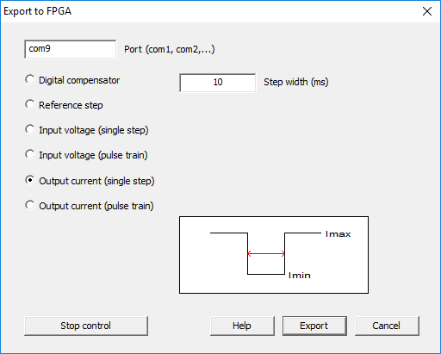

1. Capture the step with single trigger

