INDUCTION MOTOR THEORY
Contents

INDUCTION MOTOR THEORY 1
1 Introduction 4
2 The Magnetic Field 5
2.1 The Stator Magnetic Field 5
2.2 The Rotor Magnetic Field 6
3 Induction Motor Torque 7
4 Terminal Voltage Equations 8
4.1 Simplification of Circuit Equations 13
4.1.1 Stator Sequence Voltages 15
4.1.2 Stator Sequence Currents 15
4.1.3 Equivalent Circuit 16
4.1.4 Transient Analysis 17
5 Motor Performance Steady State 22
6 Special Rotor Designs 26
6.1 Double Cage Rotors 27
6.2 Deep Bar Rotors 29
6.3 Examples of Special Rotors 32
6.4 The Effect of the Design Ratio 33
6.5 The Effect of the Deep Bar Factor 33
6.6 Leakage Inductance Saturation 34
6.6.1 Wound or Single Cage Rotor 35
6.6.2 Double Cage 36
6.6.3 Deep Bar 37
7 Motor Transient Performance 39
7.1 Singular Perturbations 42
7.2 Motor Starting 44
7.2.1 Starting on an infinite bus 44
7.2.2 A power system example 46
7.3 Small Signal Stability 50
8 Appendix 1 Data Files 57
8.1 Transient Simulation 57
8.2 Small Signal Stability 59
9 Appendix 2 Bibliography 64

Introduction
This discussion of induction motor theory concentrates on the modelling of balanced three phase induction motors. Induction motors are ingenious devices which rely on the interaction between the magnetic field created by an ac stator winding and the magnetic field created by currents induced into the motor's rotor conductors. Both magnetic fields rotate in synchronism, and the torque produced, as in all electric motors, depends on the angular displacement between the stator and rotor fields. In the following, it is shown how the induction motor produces torque, and a dynamic model, suitable for practical simulation of an induction motor's characteristics, is developed,.

The Magnetic Field

In a three phase motor, the stator windings are designed to produce a magnetic field which is almost sinusoidally distributed around the circumference of the motor's air gap. Because the air gap is typically small, this field is almost radial. It rotates with an angular speed of 4πf/p, where f is the supply frequency and p is the number of poles of the stator winding. For a two pole motor, the field rotates at ω = 2πf radians per second.

The Stator Magnetic Field
Each phase winding produces a pulsating, sinusoidally distributed air gap field. In a two pole winding, the axes of the three windings are displaced by 120o. The radial air gap field at an angle θ from the axis of field winding 1 with an air gap length is
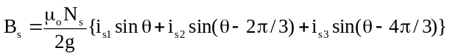

where N_{s} is the number of stator conductors.

With a balanced three phase supply of frequency f, and with 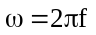
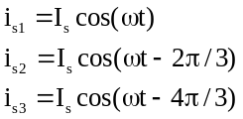

Thus the magnetic field is
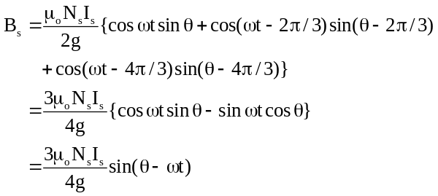

The stator magnetic field rotates at an angular speed ω with amplitude 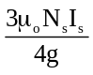.

The Rotor Magnetic Field

In most induction motors, the rotor windings consist of solid conductors distributed evenly around the rotor periphery. The ends of the bars are connected by conducting rings at each end of the rotor. This form of winding is called a squirrel cage, or just a cage, winding. Theoretically, cage windings have as many phases as the number of rotor bars. However, it has been shown (Rogers, 1975) that the fundamental field may be modelled as though it was produced by a three phase winding having the same number of poles as the stator winding. For dynamic studies of well designed induction motors, the harmonic fields can be neglected, so in the remainder of this document, it is assumed that the rotor has an equivalent three phase winding.

When the rotor angular speed is constant at an angular speed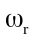, then at any point on the rotor, measured from a point corresponding at t = 0 to the origin of the stator angle, the magnetic field due to the stator currents is (from 2.3)
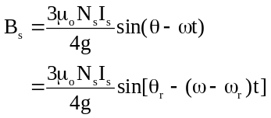

since 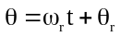

Thus, the frequency of the stator magnetic field as seen by the rotor conductors is reduced from f to fr, where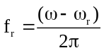. fr is called the slip frequency, and the speed of the magnetic field relative to the rotor is called the slip speed. The slip (s) is defined as
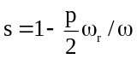

where p is the number of poles.

A sinusoidally distributed three phase rotor winding is assumed for analysis, with the rotor conductors distributed on the rotor surface as: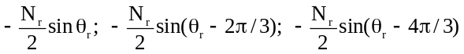.
The currents induced into the equivalent rotor winding will be balanced and sinusoidal at a frequency of fr. The induced rotor currents produce a magnetic field
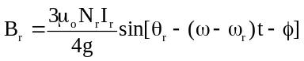
where some phase shift and N_{r} is is the number of rotor conductors.

Induction Motor Torque

In the steady state, the stator and rotor magnetic fields both rotate at a speed of ω with respect to the stator, and at a speed of sω with respect to the rotor. This is just the condition necessary to produce a steady torque. The torque produced may be calculated by summing up the forces on each rotor conductor.

The ampere conductor distribution is
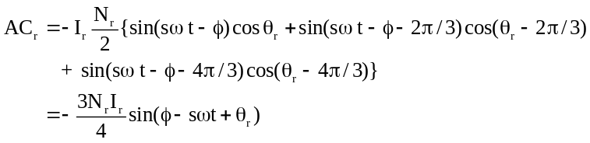

The force on the conductors in a small section 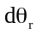 at a rotor position θr is given by
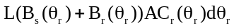, where L is the length of each rotor conductor.

The torque on the rotor is the total of the forces on the conductors multiplied by the radius of the rotor R, i.e.,
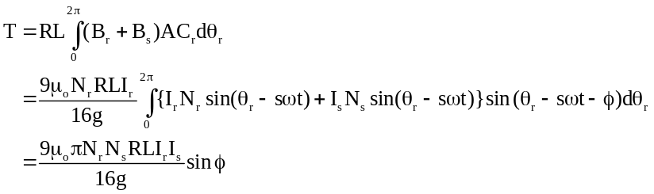

The forces due to the rotor field and the rotor currents sum to zero, but a steady torque is produced by the interaction of the stator field with the rotor currents.

This is to be expected since the stator and rotor fields rotate at the same speed but with a relative displacement. The direction of the torque is such as to try to reduce the displacement between the two fields. When the displacement is zero, the torque is also zero.

Terminal Voltage Equations

The terminal voltage equations of the stator and the equivalent rotor windings are required to analyze a motors performance. Normally, motor analysis is performed using a set of equivalent circuit equations, and these are derived here.

By assuming an equivalent three phase winding on the rotor, we obtain very similar equations for both stator and rotor. The fundamental equations will have one equation for each stator and rotor winding. The windings will have resistance, self inductance and mutual inductance. In this section we will determine expressions for the inductances in terms of the magnetic fields.

With only the first stator winding excited, the air gap flux density will be

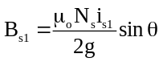
Consider the conductors in the small angle dν at an angle ν+π from the winding axis. The return conductors lie in the corresponding angle dν at ν from the winding axis. The total flux linking these conductors is

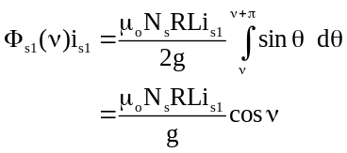

The voltage induced into this section of the first winding is
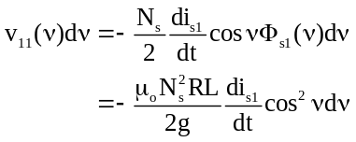
The total voltage induced into the first stator winding is
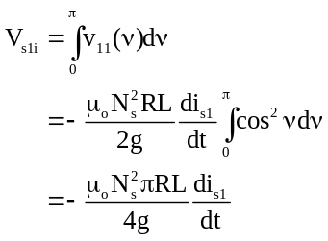

The terminal voltage plus the induced voltage gives a resultant voltage, which is just sufficient to drive the current i_{s1} through the resistance (r_{s}) and the leakage inductance (l_{s}) of the winding.
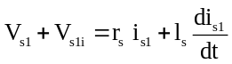

The winding’s self inductance is
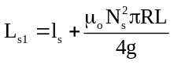

and
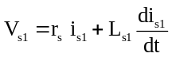

The voltage induced by the current in winding 1 into the other windings will define the mutual inductances between the windings. The stator winding self inductances may be inferred from the symmetry of the motor windings.

The voltage induced by the current in the first stator winding into the second stator winding is determined by calculating the rate of change of flux linkage with this winding.
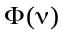is unaltered. The voltage induced into an element of the second winding at ν is
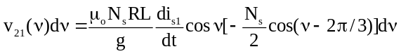

Thus, the total voltage induced into the second stator winding by the current in the first stator winding is
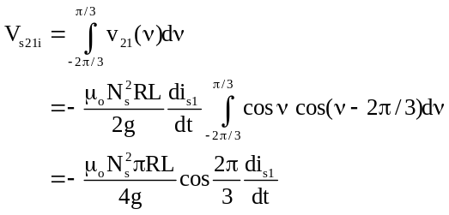

The voltage induced by the current in the first stator winding into the third stator winding is determined by calculating the rate of change of flux linkage with this winding. is unaltered. The voltage induced into an element of the third winding at ν is
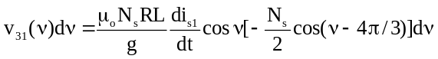

Thus, the total voltage induced into the third stator winding by the current in the first stator winding is
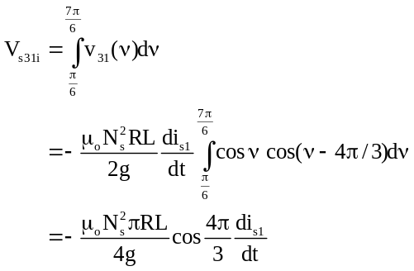
Also, by symmetry the self inductances of each stator winding will be identical. Thus, when there are no rotor currents, the terminal voltage equations for the three stator windings will have the form
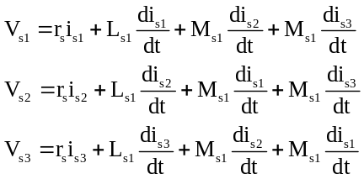
With
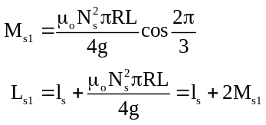
If the stator and rotor axes are separated by 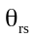, and the rotor is stationary, then 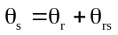.
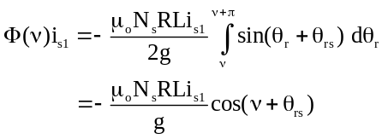
The voltages induced into the rotor windings by a changing current in the first stator winding is
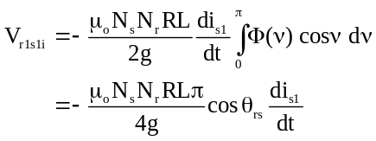
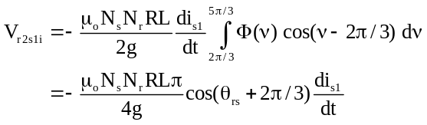
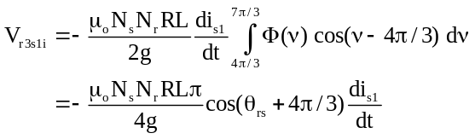
The flux produced by the first rotor winding is
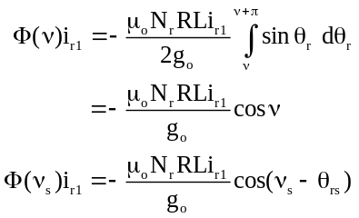

The voltages induced into the stator windings by the current in rotor winding 1 are
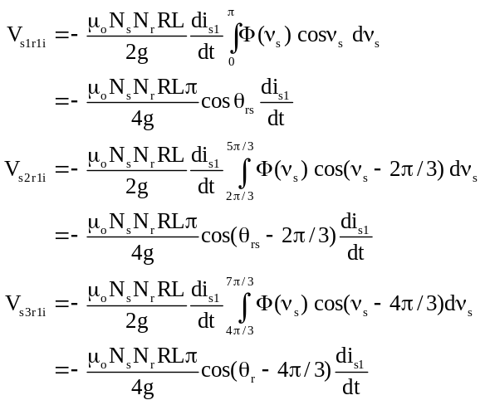

The voltages induced into the rotor windings by a changing current in rotor winding 1 are
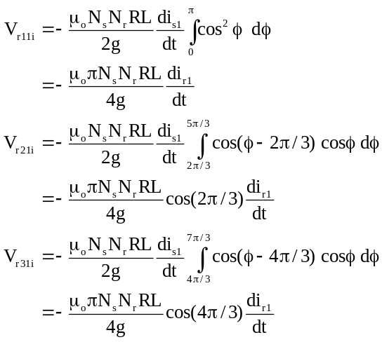
The flux produced by the second rotor winding is
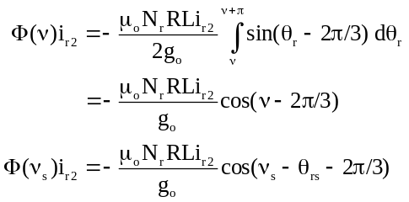
The voltages induced into the stator windings by the current in rotor winding 2 are
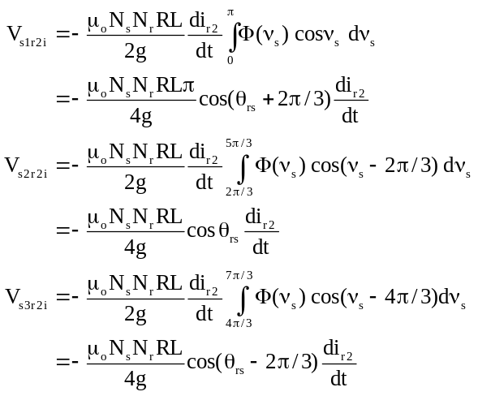
The voltages induced into the rotor windings by the current in rotor winding 2 are
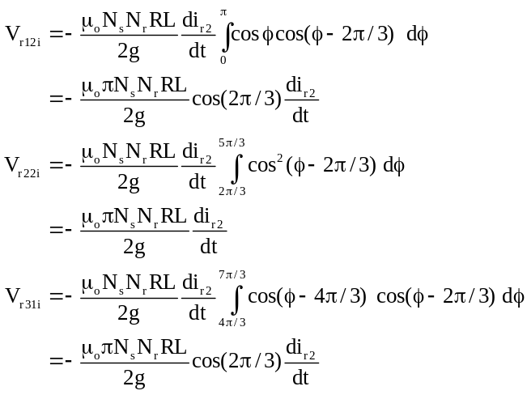
The flux produced by the third rotor winding is
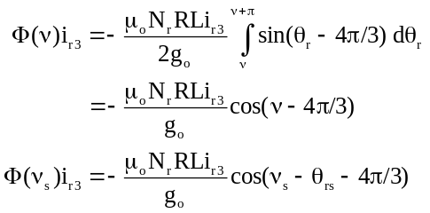
The voltages induced into the stator windings by the current in rotor winding 3 are
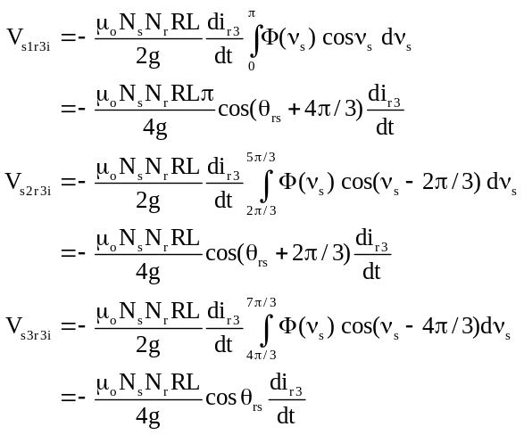
The voltages induced into the rotor windings by the current in rotor winding 3 are
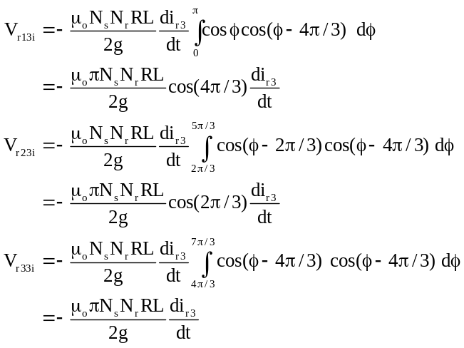
The self inductance of the rotor phase winding is

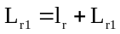

with

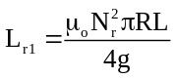

The mutual inductances between the rotor winding phases is -L_{r1}/2.

The circuit equations of the three stator windings, and the three rotor windings, with the rotor rotating, can be put in matrix form as
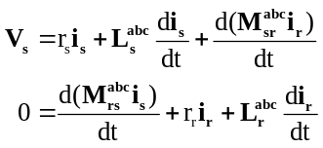

where
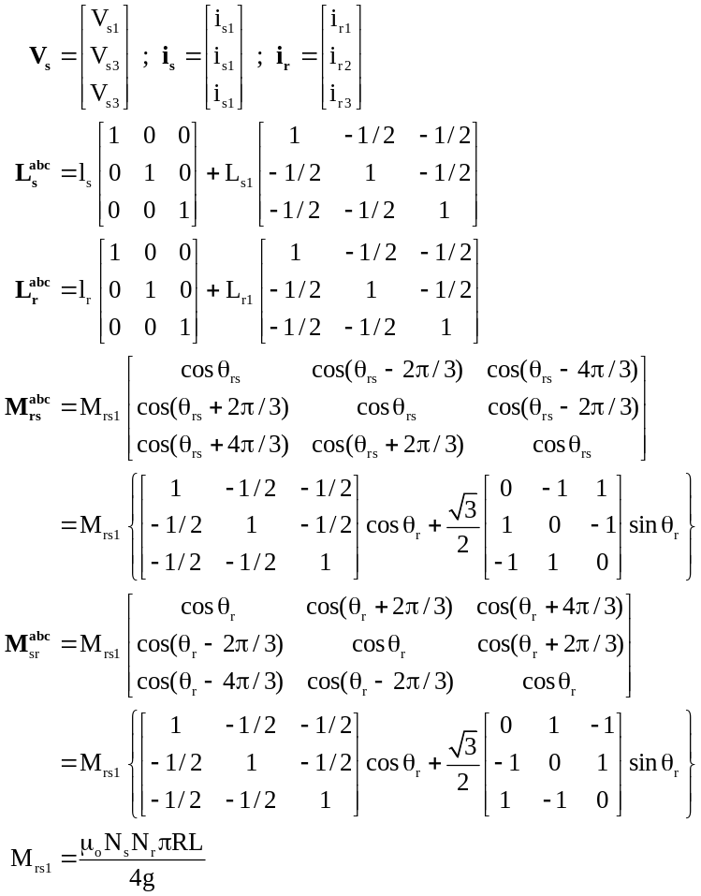

Simplification of Circuit Equations

While these circuit equations describe the action of the stator and rotor in terms of the natural variables of the stator and rotor windings, they are not very convenient for analysis. They are nonlinear and, even with constant rotor speed, have time varying parameters. They are also redundant. Since, with the three wire supply to the stator used for induction motors, the stator currents add to zero. As a first stage in simplifying the circuit equations, a symmetrical component transformation is applied. In this transformation (change of variables), forward and reverse currents are introduced as new variables to replace the actual winding currents. The transformation is
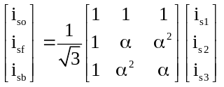

where 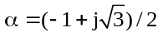*

The inverse transformation is

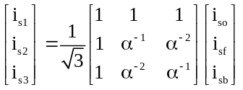

The transformation, when applied to the stator and rotor voltages and the rotor currents, results in three sets of decoupled equations:

Zero Sequence
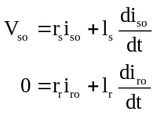

Forward Sequence

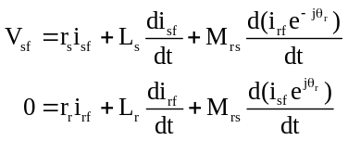
Backward Sequence
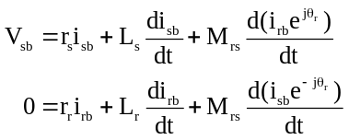

In the above

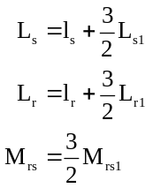

Both the stator and rotor zero sequence currents are zero, and hence, the zero sequence equations may be dropped. If the stator voltages are balanced, the backward sequence equations are just the complex conjugate of the forward equations. Consequently, an induction motor in normal operation may be analyzed using only the forward sequence equations.

Stator Sequence Voltages

If the three phase stator voltages are

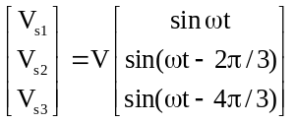

V is the phase voltage magnitude.
The corresponding sequence voltages are

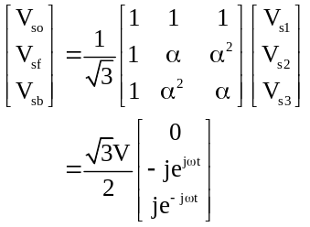

Stator Sequence Currents

Using the same transformation the stator and rotor sequence currents are

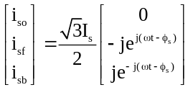

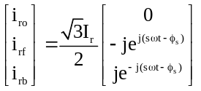

Substituting into the forward sequence equations

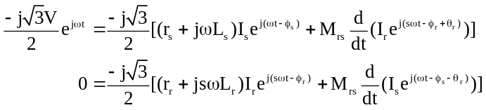

The slip s is defined as 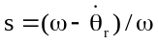.

Assuming constant rotor speed and integrating , with θrs zero at time zero
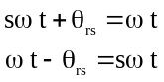

The common factor 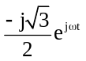 can be removed from the stator equation and 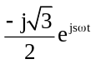 can be removed from the rotor equation giving

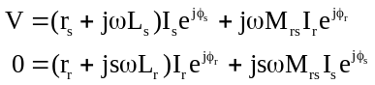

Equivalent Circuit

Dividing the first (stator) equation of 4.39 by 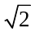 and the second (rotor) equation by 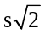, converts the motor steady state equations into a form which has an equivalent circuit. The equivalent has the form of a transformer, but with the secondary resistance varying with the inverse of the motors slip, i.e., rr/s.

To draw the normal equivalent circuit, we must first refer the rotor resistance and reactance to the stator. This is done by defining a new rotor current,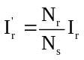;
and a new rotor voltage,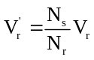. Substituting into the circuit equations gives
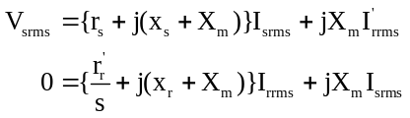

where

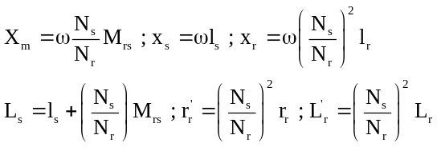

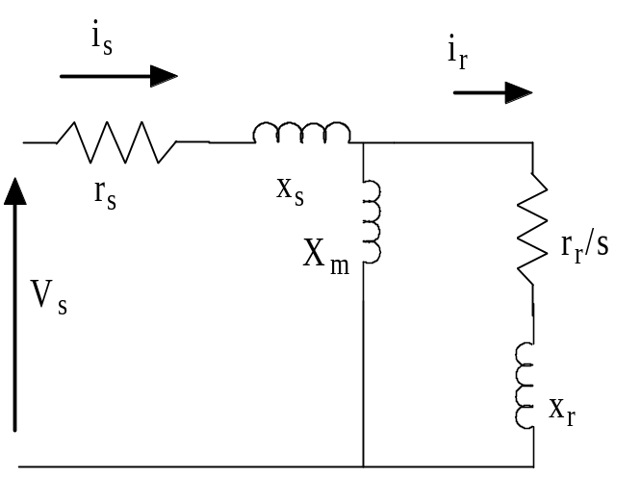
Figure 1 Induction motor equivalent circuit

These equations can be represented by the equivalent circuit shown in Figure 1. It is general practice to ignore the changes in variable that we have used to refer the rotor variables to the stator. Thus, in the equivalent circuit has rr and not rr'. The transformation is, however, implicit.

Transient Analysis

For the analysis of induction motor transients, the equations produced by the symmetrical component transformation are still too complicated. They contain mutual inductances which vary with the rotor position.

There are two commonly used models; both use two-axis equivalents. The first was formulated by Stanley. In Stanley's model, the stator variables are unchanged, but new rotor variables are introduced which are associated with an ideal commutator. The commutator is fixed to the rotor and the brushes are fixed to the stator. The second model was formulated by Kron. This model changes both the stator and rotor variables. It introduces two commutators, one fixed to the stator, and one fixed to the rotor. The brushes for both commutators rotate at synchronous speed.

Conversion to Two Phase

The first step in deriving both Stanley’s and Kron’s induction motor models is to convert the symmetrical component equations to those of an equivalent two phase motor. To do this, the zero sequence equations are ignored, and the following changes of variables are made:

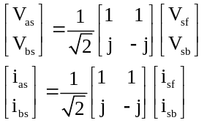

The rotor voltages and currents transform similarly giving the equivalent two phase equations shown in 4.27.

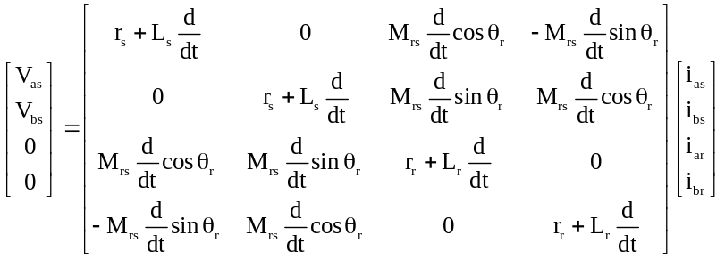

Stanley’s Model
In Stanley’s model the rotor currents are transformed again using what is termed an ideal commutator transformation.

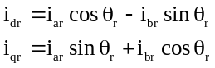

The commutator transformation has the effect of introducing equivalent windings carrying currents at a changed frequency. In this model, the steady state currents in the new equivalent rotor windings will be at the supply frequency. The rotor voltages are transformed in the same way as the currents to give the final terminal voltage equations.

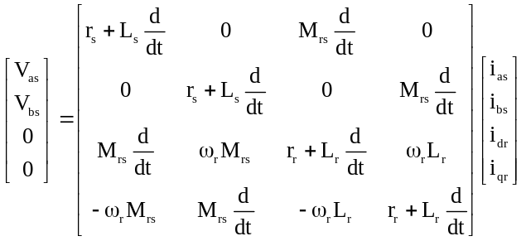

It can be seen that the equations are simpler and contain no sinusoidally varying coefficients. The motion of rotor is modelled by the "rotational voltages" which appear in the rotor equations and which depend on the rotor speed (ω_{r}).

Stanley's model has been used for induction motor transient analysis. However, the currents are at the supply frequency in the steady state, and this makes the model awkward to use.

Kron’s Model
Both stator and rotor variables are changed in Kron’s model. The transformations for the currents are

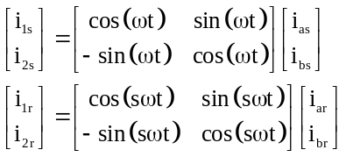
The voltages transform similarly. In this model all currents are at zero frequency in the steady state. The resulting terminal voltage equations are
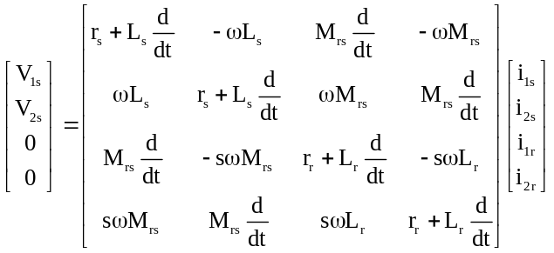
The variables may be confirmed to be at zero frequency in the steady state in Kron's model as follows:

The symmetrical component voltages are
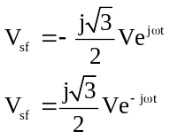
The equivalent two phase voltages are

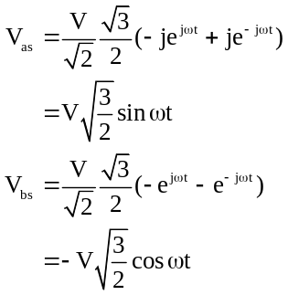

The stator voltages in Kron’s model are

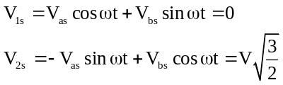

Since the equivalent supply voltages are at zero frequency, it follows that the equivalent currents will be at zero frequency in the steady state.

Motor Torque from the Circuit Equations

The motor torque may be calculated from the partial derivative of the magnetic stored energy with respect to the rotor angle θr in the two-phase model.

The energy stored in the windings is
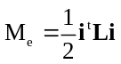

where
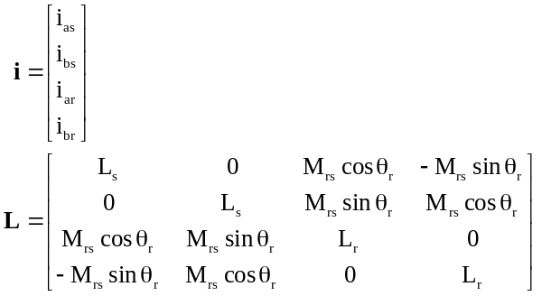

The motor torque is then calculated as

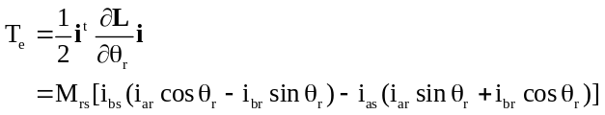

By inspection of 4.32, the torque in Stanley’s model is
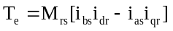
In Kron’s model
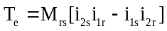

The transient equations are completed by the shaft torque equation
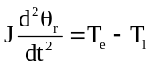

where J is the combined moment of inertia of the motor and its load, and Tl is the load torque.

Per Unit System

The equations derived above have parameters in physical units: resistances are in ohms, inductances are in henries, voltages are in volts and currents are in amperes. In electric machine analysis it is more usual to work in per unit quantities. To do this, the voltages and currents are scaled by defined base values and consistent scaling factors are introduced for resistance, inductance, torque and moment of inertia.

In Kron’s model, the original phase voltages and currents have been transformed. The stator voltages are
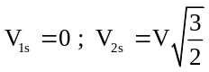
and, assuming steady state, the currents are
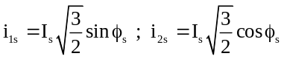
V is the amplitude of the stator phase voltage, I_{s} is the amplitude of the stator phase current, and φ_{s} is the current phase lag. The stator base voltages and currents are taken to be
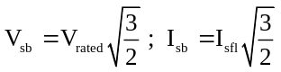
Where V_{rated} is the rated value of the stator phase voltage; and I_{sfl} is the value of I_{s} at full load with the rated voltage applied to the stator.

The rotor base quantities are

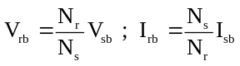

Scaling the stator and rotor variables with their respective base values gives the per unit terminal voltage equations
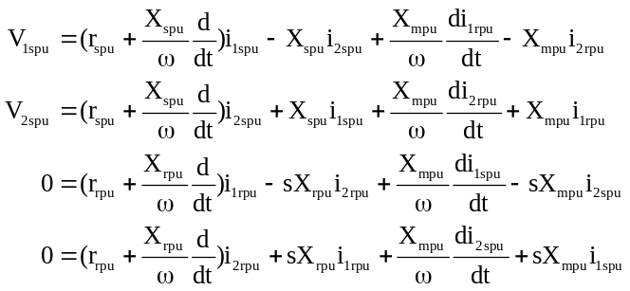

The base power is
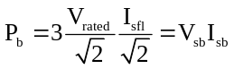
Per Unit Torque is defined as

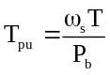
The Per Unit electrical torque is

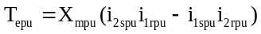
The shaft torque equation becomes

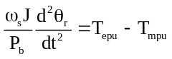

The per unit inertia constant (H) is defined as
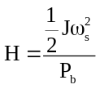

This is the kinetic energy of the motor plus load at synchronous speed divided by the base power. It has the dimensions of time.

Substituting into equation 4.56 gives
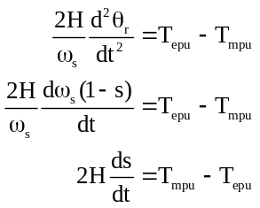

The per unit mutual reactance X_{mpu} is

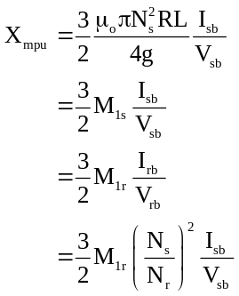

Both the rotor and stator reactances are the sum of the mutual and leakage reactances. The per unit resistances and reactances are identical to the normally defined per unit resistances and reactances per phase, i.e.,
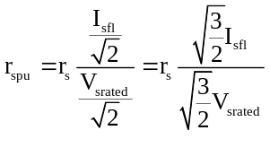

Apart from the use of reactance instead of inductance, the per unit equations have exactly the same form as the unscaled equations. It is normal to leave out the subscript pu in the scaled equations. That is
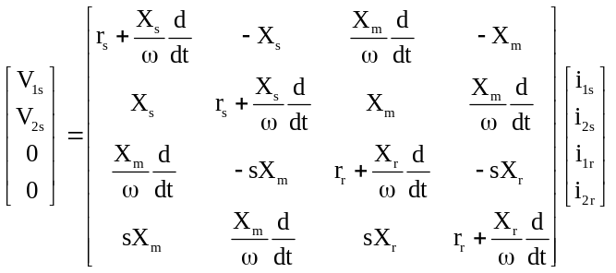

Motor Performance Steady State

To obtain the steady state equations from Kron's model, all rates of change are set to zero (with this model, the currents are direct in the steady state).

The steady state equations can be reduced to the positive sequence steady state equations by defining
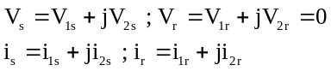
Then
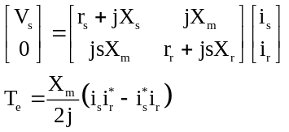

From the rotor equation
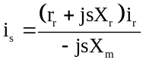
Thus
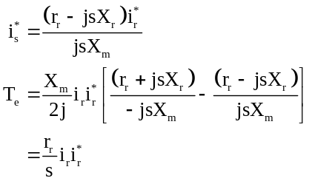

Substituting for i_{s} in the stator equation, solving for i_{r} and substituting in the electrical torque equation gives

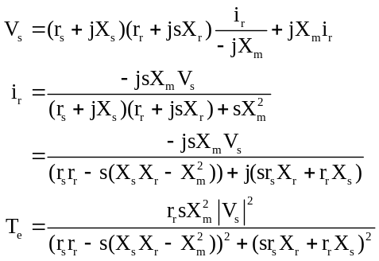

To get a rough idea of a motors characteristics, we may neglect r_{s} and assume that X_{s} = X_{r} to give the approximate expression for motor torque
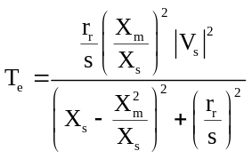

This expression has a maximum when
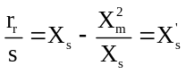

Where X_{s}’ is the transient reactance.

The maximum torque (the motor's pull out torque) is

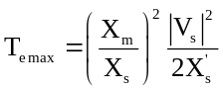

The slope of the torque slip characteristic at s = 0 , i.e., the motor is at synchronous speed, is given by
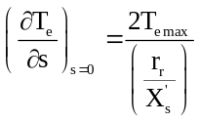

When s =1, i.e., the motor is at standstill, the torque is
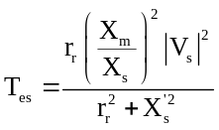

The starting current magnitude is approximately

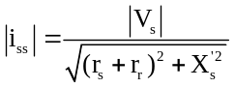

The slip at pull out is sometimes called the critical slip s_{cr}. The torque expression becomes quite simple as the ratio of torque to maximum torque, i.e.,
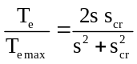

The torque and current characteristics with and without stator resistance are shown in Figure 2 and Figure 3. The model with stator resistance has the following parameters

rs = 0.0418 xs = 0.11253 rr = 0.011769 xr = 0.11253 Xm = 3.1719

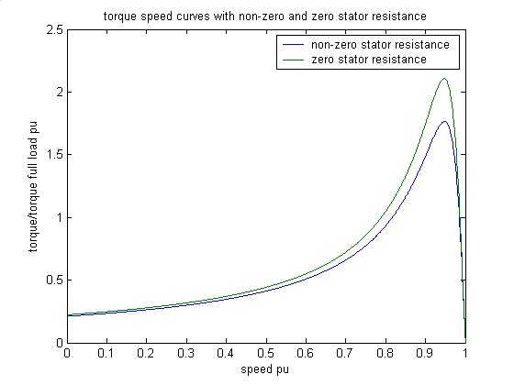
Figure 2 Torque speed characteristic with zero and non-zero stator resistance
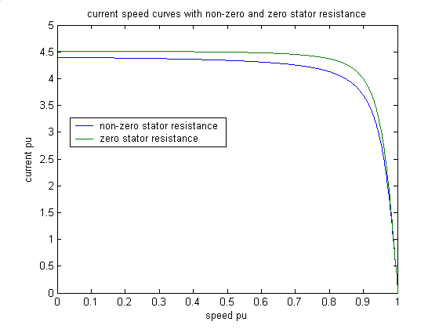
Figure 3 Stator current magnitude speed characteristic, with zero and non-zero stator resistance

The maximum error is in the region of pull out. The approximate model over estimates both the torque and the current at pull out slip.

As a rule of thumb, it is useful to remember that the starting current is approximately 1/X_{s}'. The transient reactance is approximately equal to the sum of the stator and rotor leakage reactances, that is about two times the stator leakage reactance. The pull out torque is also inversely proportional to the transient reactance. So high pull out torque implies high starting current.

Special Rotor Designs

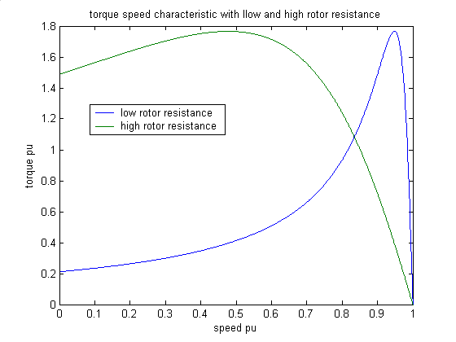
Figure 4 Torque speed characteristics with low and high rotor resistance

It is important for large induction motors to be efficient. To achieve high running efficiency, the stator and rotor resistances must be small. But, a motor's starting torque is proportional to the rotor resistance. With a wound rotor motor, it is possible, by adding rotor slip rings, to add resistance to the rotor windings for starting. When the rotor is up to speed, the added resistance may be removed to give better efficiency. This is shown in the Figure 4, which compares the torque characteristic of the motor with the parameters given in section 5, with that when the rotor resistance is increased 10 times. The full load efficiency with low rotor resistance is higher than that with high rotor resistance.

To improve the efficiency and starting performance of induction motors with cage rotors, motor designers arrange to have the rotor resistance of the cage automatically reduce as the speed of the motor increases. This is done in two ways

the use of two cage windings, one close to the rotor surface, and one more deeply embedded
the use of a single rotor cage which consists of a set of deep rectangular rotor bars

Double Cage Rotors
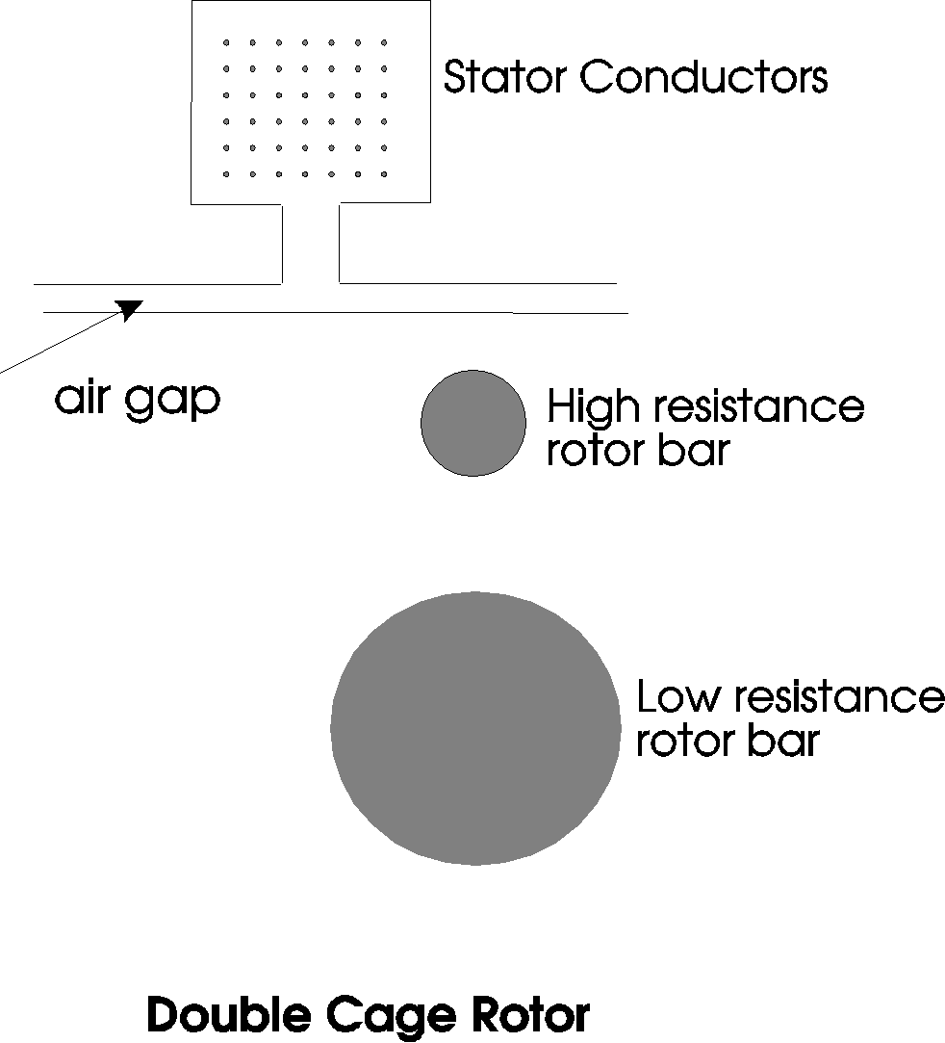

Figure 5 Double Cage Rotor Bars

Double cage rotors have two sets of cages. One has a high resistance and low reactance and is situated close to the rotor surface. The other has a low resistance and high reactance and is placed deeper in to the rotor. The equivalent circuit is shown in Figure 6.
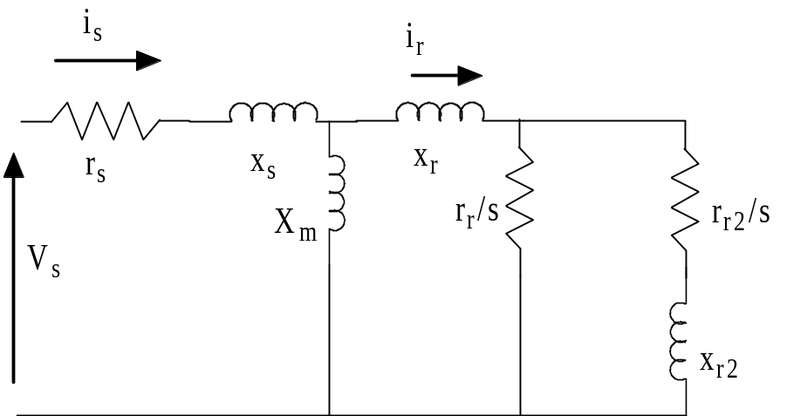
Figure 6 Double cage rotor equivalent circuit

At starting, the rotor frequency is equal to the supply frequency. The rotor current flows mainly in the high resistance, low reactance cage. At normal running speed, the rotor frequency is very low, and the reactances of the rotor cages are correspondingly low. The rotor current is now shared between the two rotor cages and the effective rotor resistance is the parallel combination of the resistances of the two cages.

Rather than use two separate rotor cages, shaped rotor bars are often used. These are narrower close to the rotor surface than they are away from the rotor surface. In power system simulation programs it is best to model this type of cage as a double bar.

Double cage rotors are used in the medium power range. Control over the motor characteristics is achieved by the designer by altering the values of the rotor resistances and reactances . The design ratio,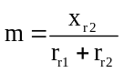 , is varied to modify the torque speed characteristics between standstill and full load. At zero speed and full load speed, the motor torque is fixed by the motor's specifications. To match the characteristics of a particular motor, it may be necessary to experiment with the value of m.
Figures 7 and 8 show the variation of the effective rotor resistance and reactance with slip for a double cage rotor with different values of design ratio. 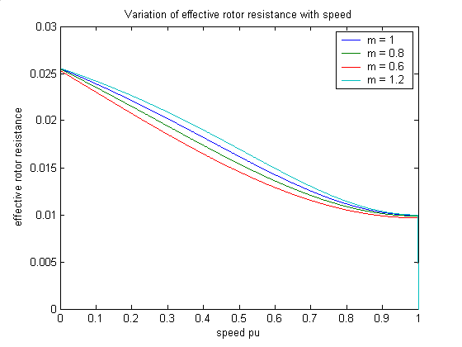
Figure 7 Variation of Effective Rotor Resistance with Speed
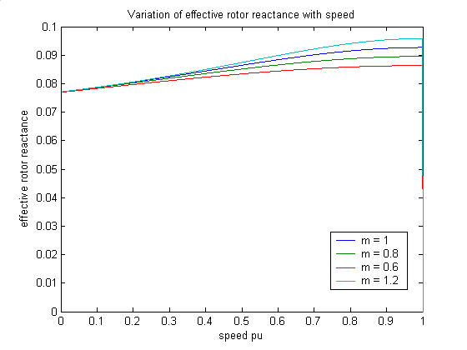
Figure 8 Variation of Effective Rotor Reactance with Speed

Deep Bar Rotors

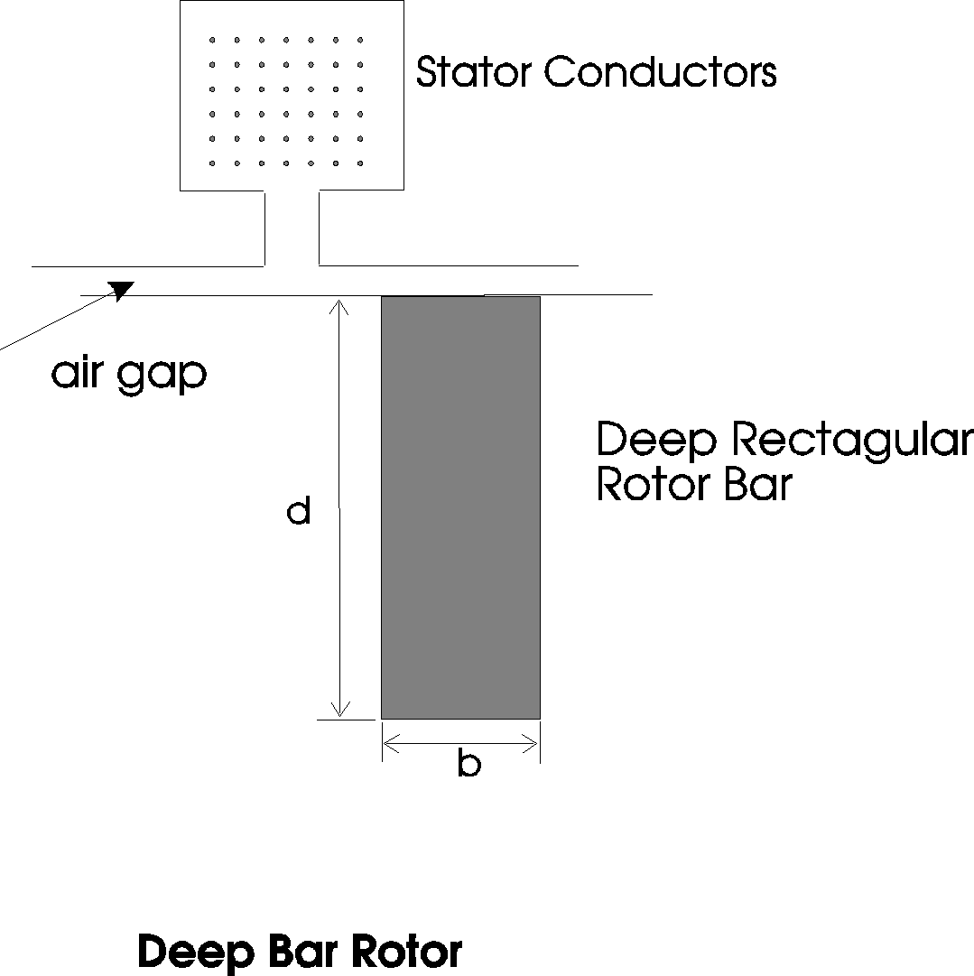
Figure 9 Deep Bar Rotor

Deep rectangular rotor bars are frequently used in the cage windings of large induction motors. In this type of rotor cage, the eddy current distribution in the bar alters with the frequency of the bar current. At high frequencies, the eddy currents cause the rotor bar current to flow mainly in the top portion of the bar. At low frequencies the bar current flows evenly throughout the whole bar. Thus, at starting, when the frequency is high, the effective resistance of the rotor bar is high. At the running speed, the rotor frequency is very low and hence the effective rotor bar resistance is low.

The effective resistance and reactance of a deep rotor bar changes with frequency. Assume that the total current flowing in the rotor bar is I and that there is a magnetic field H with a component in the x direction across the rotor bar. The iron surrounding the bar has infinite permeability, thus H within the iron is zero. The current density at a distance y from the bottom of the slot is J and at y+Δy it is J+ΔJ. The corresponding magnetic field is H and H+ΔH respectively.

The integral of the magnetic field around a closed contour is equal to the current enclosed. Thus,
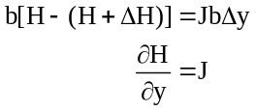

The electric field E is in the same direction as the current density and is related to it by
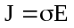, where σ is the conductivity of the rotor bar. The electric and magnetic fields are related by
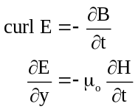
Combining these equations
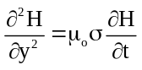

Assuming that the angular frequency of the rotor current is ωr , then in the steady state
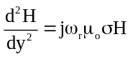

Equation 6.4 has the solution
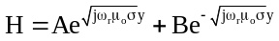

At the bottom of the rotor bar H is zero, and at the top of the rotor bar H = I/b. Thus at any distance y from the bottom of the bar
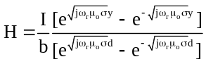

The electric field at y = d is
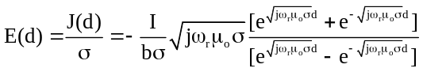

The rotor bar voltage is the electric field (E) multiplied by the length of the bar (L). The impedance of the bar is the voltage divided by the current
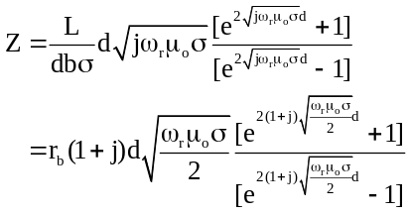

The deep bar factor DBF is defined as
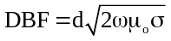

Introducing the variable 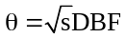
gives
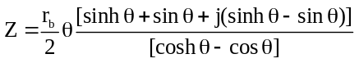

As the slip tends to zero, the effective rotor impedance tends to
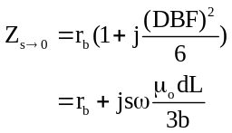

Figures 10 and 11 show the bar resistance and reactance variation with slip for DBF equal to 1, 2, 4 and 8. The deep rotor bar causes the resistance to increase as the slip increases and the reactance to decrease. These are just the characteristics required to give a high starting torque and high running efficiency.

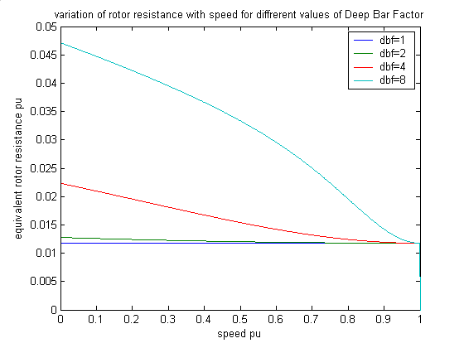
Figure 10 Variation of effective rotor resistance with motor speed

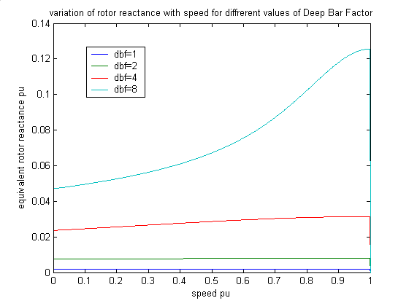
Figure 11 Variation of effective rotor reactance with motor speed

Examples of Special Rotors

The following examples show the differences in the steady state characteristics of motors having wound (or single cage), double cage and deep bar rotors. Starting with the same basic specifications, the equivalent circuit is constructed for the three different rotor types.

The specifications are
Full Load Efficiency 0.95
Full Load Slip 0.01
Full Load Power Factor 0.90
Rated Voltage 4.0 kV
Full Load Current 800 A
Starting Current 4.8 kA

For deep bar and double cage rotors, the starting torque is specified to be equal to the full load torque. The design ratio for the double cage rotor is specified as unity, and the leakage inductances do not saturate.

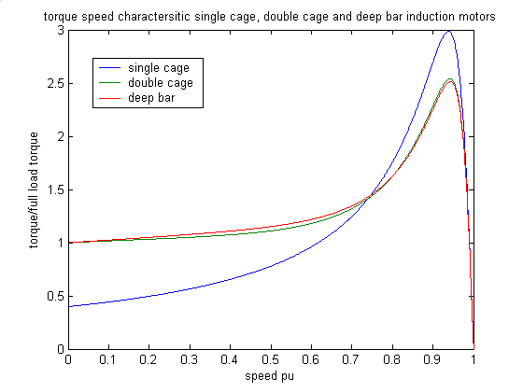
Figure 12 Torque speed characteristics for induction motors
In this case the torque characteristics of the double cage and deep bar rotors are almost identical. The single cage rotor has a higher maximum torque, but a much smaller starting torque.

The Effect of the Design Ratio

Next we will show how the design ratio alters the characteristics of the double cage rotor. The starting point will be the same as for the last example, in which the default design ratio of 1 was used.
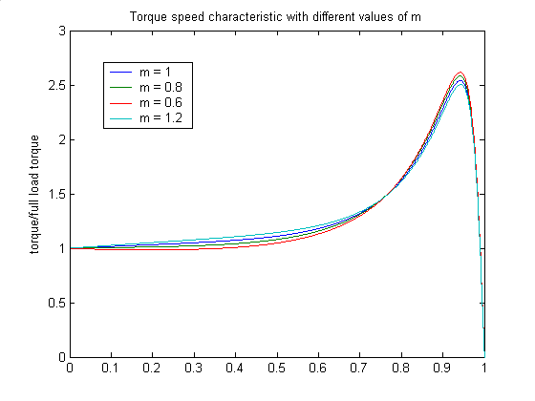
Figure 13 The effect of the design ratio on a double cage motors torque speed characteristic

In this example, the design ratio has only a small effect. Lowering the ratio has caused the low speed torque characteristic to flatten out and the pull out torque to increase slightly.

The Effect of the Deep Bar Factor

To satisfy the motor specifications, and the starting torque specification, a deep bar factor of 5.1684 is required. In Figure 14, the torque characteristic is shown for deep bar factors of 6 and 8 as well as the calculated value.
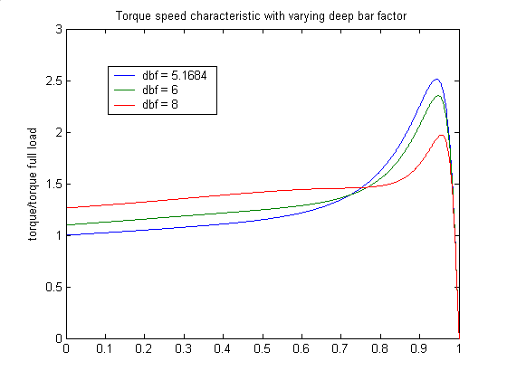
Figure 14 Torque speed characteristic variation with deep bar factor

Leakage Inductance Saturation

When induction motors start, they draw a current of between 5 and 10 times the full load current. With such high currents, the leakage flux associated with the stator and rotor conductors becomes high enough to magnetically saturate the surrounding iron. This reduces the stator and rotor leakage reactances, and causes the current and the torque to increase. This phenomenon is used to obtain the highest possible starting torque. Half of the stator leakage reactance is assumed to saturate as a function of the stator current. In deep bar and double cage rotor models, half of the leakage reactance not associated with the bar is assumed to saturate as a function of the rotor current. Saturation is assumed to start when the current is greater than a specified saturation current. The saturable portion of the leakage reactance reduces as the current increases in the manner of the describing function for a saturation nonlinearity. This function was shown to be suitable in Rogers and Beneragama (1978).

The saturation describing function is the ratio of the amplitude of the fundamental component of a sinusoid clipped at the saturation level to the full amplitude of the sinusoid. The describing function reduces as the full amplitude of the sinusoid exceeds more and more the saturation level. That is
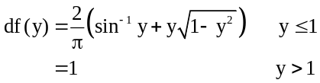
For a saturable reactance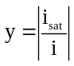.
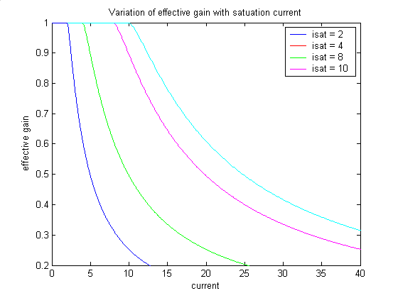
Figure 15 Effect of leakage inductance saturation

When the current is less than the saturation current, the reactance remains at its unsaturated value. When the current is 6 times the saturation current, the leakage reactance reduces to about 70% of its unsaturated value. The effect of leakage inductance saturation on the torque and current characteristics of the induction motors considered above is shown below. The equivalent circuit parameters are kept constant and the saturation level is modified from 2 to 10.

Wound or Single Cage Rotor

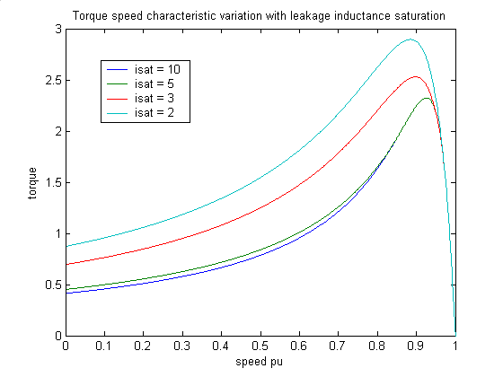
Figure 16 Effect of leakage inductance saturation on the torque speed characteristics of induction motors
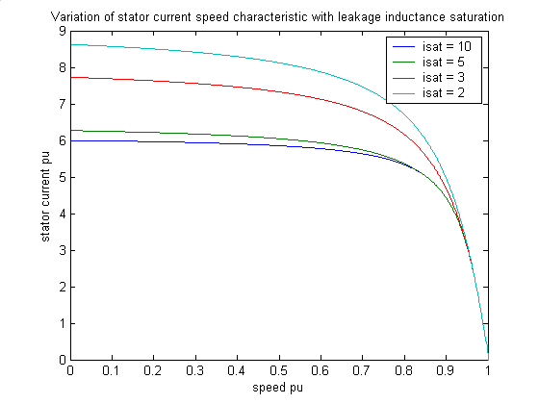
Figure 17 Effect of leakage inductance saturation on the stator current/speed characteristic

Double Cage

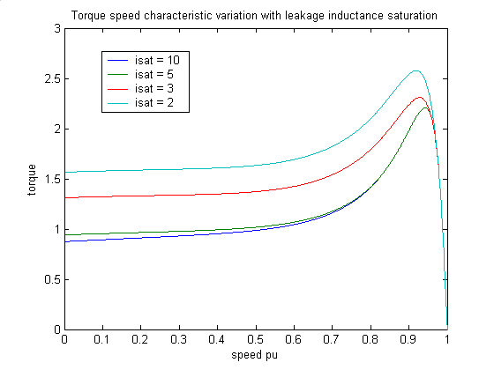
Figure 18 Variation in torque/speed characteristic with leakage inductance saturation
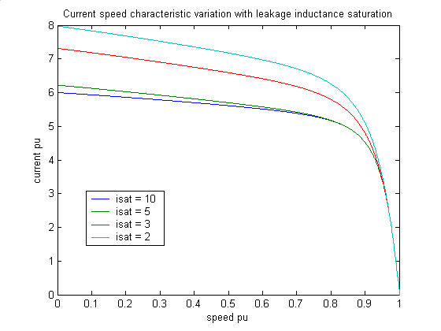
Figure 19 Variation in current/speed characteristic with leakage inductance saturation

Deep Bar

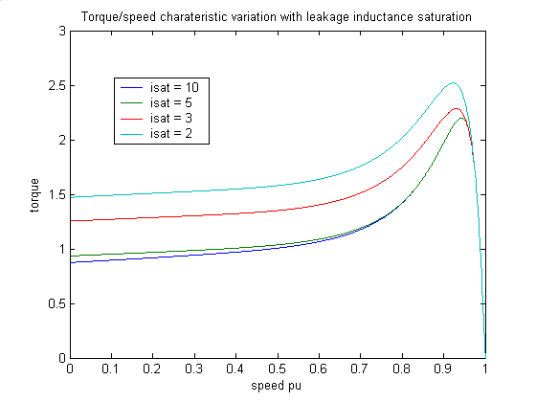
Figure 20 Effect of leakage inductance saturation on a deep bar motor torque speed characteristic
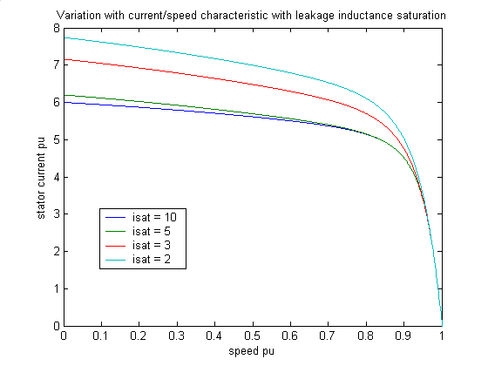
Figure 21 Variation of current/speed characteristic with leakage inductance saturation

Motor Transient Performance

The transient performance of the induction motor is far less well understood than its steady state performance. This is surprising for such a simple device. In part, it is because of the versatility of induction motors: they are able to perform a wide variety of duties without exhibiting obvious problems.

In power systems, induction motors can have a considerable impact on system stability. Induction motors form a large proportion of the load at many power system load points. Swings in voltage may cause motors to stall, and in some cases may even cause the power system voltage to collapse. On a more local scale, the starting of a large induction motor may depress the local power system voltage sufficiently to cause other loads to disconnect. Therefore, it is important to study at least motor starting.

In many industrial plants, there is the facility (bus transfer) to connect essential motors to an alternative supply when the normal supply is lost. If the change over is not timed correctly, the motor may experience large current and torque pulsations.
The motor model used in most power system transient programs is the per-unit version of Kron's model, but with the stator transients ignored; the Brereton, Lewis and Young model.

Kron’s model in per unit is

Neglecting the stator transients is effectively a singlular perturbation approximation as ω becomes very large compared to the frequencies of interest in the motors dynamics. With this approximation the stator equations become
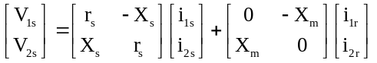
New variables, the voltages behind transient reactance, are introduced, which are defined in terms of the rotor flux linkages,
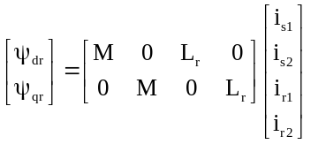
as
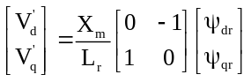
Equation 7.2 can be written

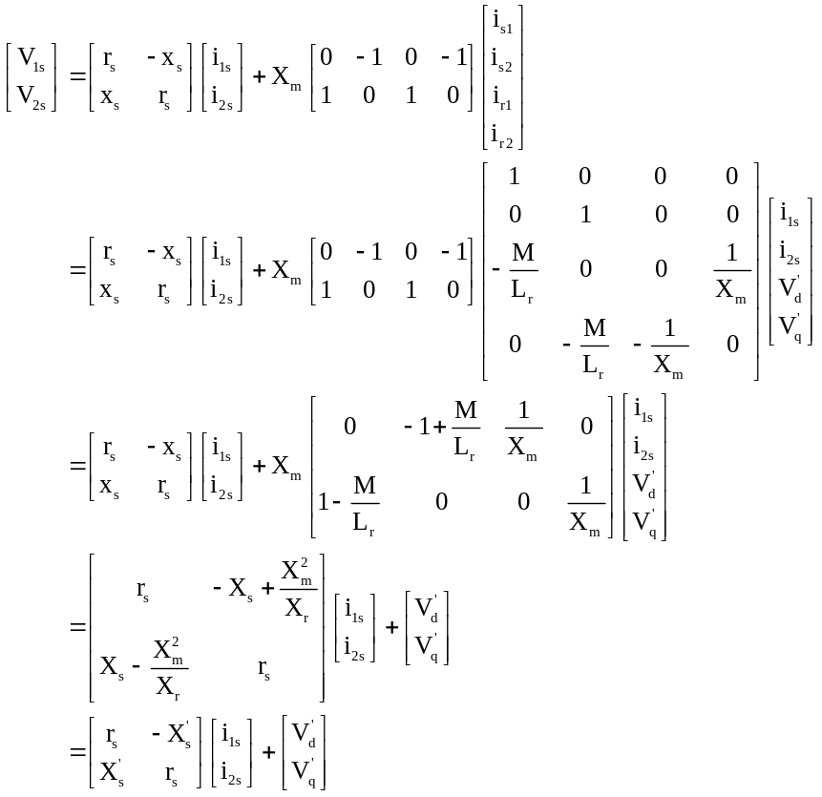

The rotor equations are changed to

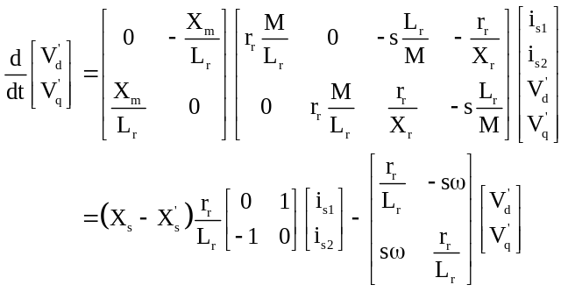

The torque equation is
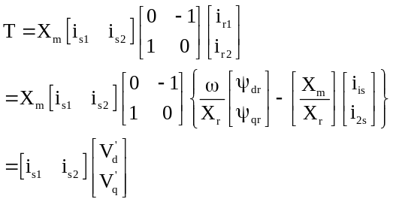

The rotor impedances are a function of slip (for double cage and deep bar rotors). In power system transient analysis, only two rotor states are required no matter which rotor type is specified. Leakage reactance is modelled to saturate if the current is greater than the specified saturation current. The motor dynamic model takes the following form:
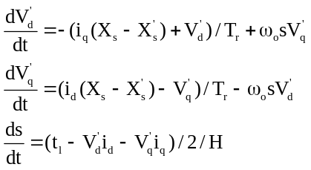
where
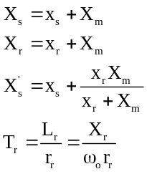
The interface with the network determines the motor currents at each time step given the voltage behind transient impedance (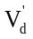and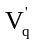). The network admittance matrix is augmented by the motor transient admittance, 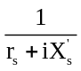, which is added to the motor bus admittance.

For double cage and deep bar induction motors the values of x_{r} and r_{r} are functions of the motor slip (s). The leakage reactances are functions of their respective current magnitudes.

In some cases, it is not permissible to neglect the rate of change of the stator transients, for example if the motor is supplied at a low frequency, or if the initial high frequency oscillations in motor torque and current are important. Kron’s model, as it stands, has the stotor and rotor currents as states. In simulations where the currents may be discontinuous it is better to use the stotor and rotor flux linkages as states. The flux linkages are defined as

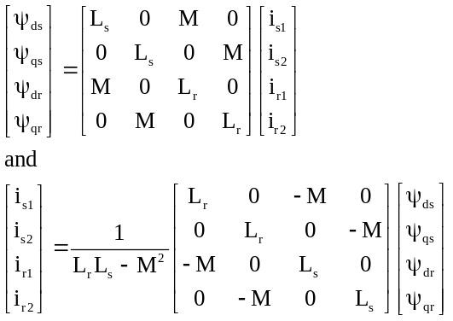

With this change of variables equation 7.6 becomes

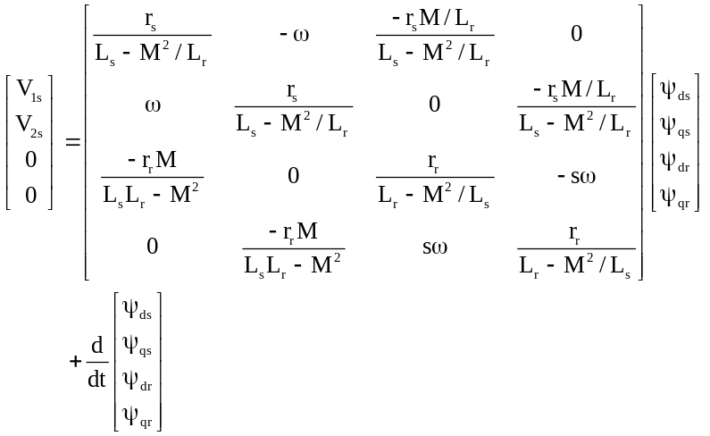

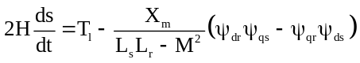

Singular Perturbations

As mentioned, the stator transients are much faster than the mechanical transients. At starting, the rotor transients are also much faster. However, as the motor accelerates, the rotor transients become slower
( 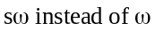). In power system simulations, it is normal to neglect the stator transients, but this is only completely satisfactory if the frequency of the system is constant. The fast and slow nature of the transients is best seen by a simple change of variables in equation 7.10.
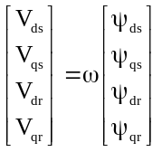
The equation 7.10 becomes
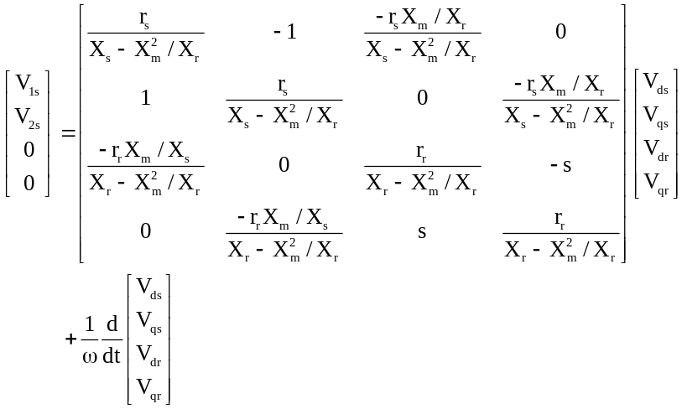

The singular perturbation parameter is 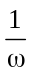. The torque equation is transformed to
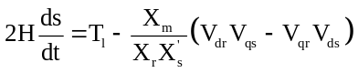
To be consistent with the power system motor model of 7.8, the rotor quantities may be changed to
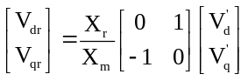

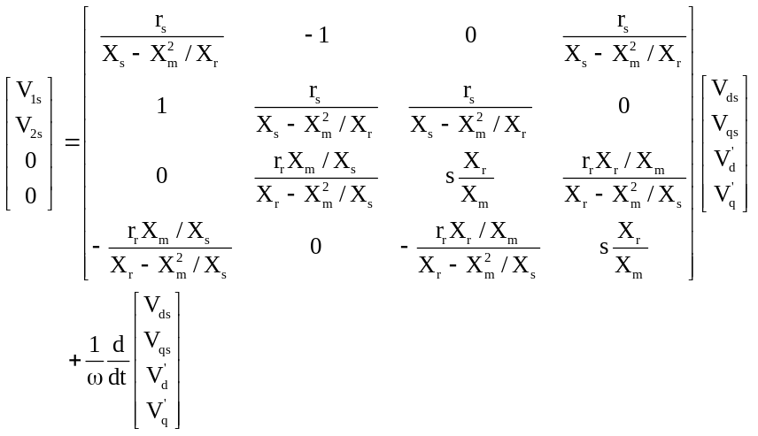

The torque equation becomes

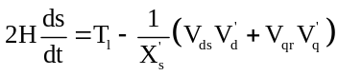

The electrical and mechanical equations may be solved separately when the angular frequency of the supply is large. If this is the case, a change of time variable, 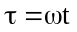, may be applied to equation 7.16 to give

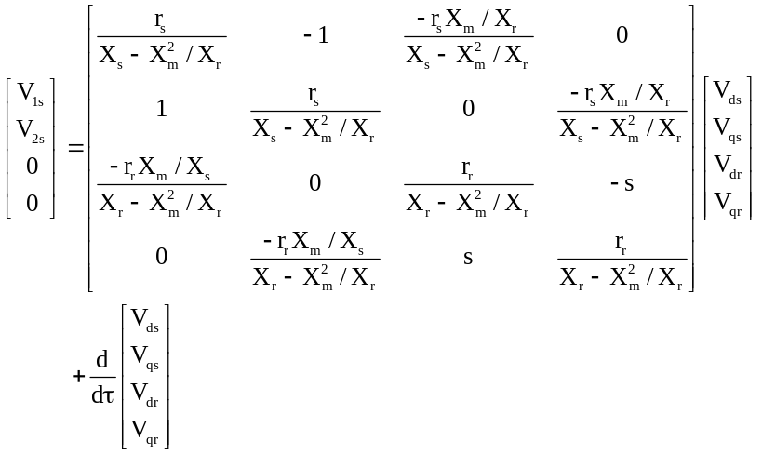

In these equations, the slow varying slip (s) may be assumed to be constant, and the stator and rotor states may be solved for a short time period.

The slip may then be calculated from the torque equation, taking the average of the torque obtained from the solution to the electrical equations.

Motor Starting

Direct on-line starting draws a very high initial current from the supply. Normally, the supply impedance is such that the motor terminal voltage is depressed. This, in turn, depresses the starting torque, and in extreme conditions the torque may be insufficient to overcome the load torque. In some applications, a lower voltage is applied to the motor during starting to limit the current. This may be achieved by altering the stator windings from a normal delta connection to a star connection, so reducing the phase voltage to 1/√3 of its normal value. Alternatively, a reactance may be inserted in the motor supply line to reduce the starting current. Both of these methods are suitable only when the motor is able to start on light load.

When an induction motor starts, there is always an initial period, in which high amplitude torque pulsations at the supply frequency occur. These last for a shorter time in small motors with a low inertia constant, than in large motors with a large inertia constant. In low frequency motors this initial transient may be difficult to distinguish. This effect is not modelled by equations 1.81, since the stator transients are neglected. This is compatible with the neglect of the generator stator transients and the network transients in power system transient simulation. After these oscillations decay, a steady torque is produced which accelerates the rotor and the motor load to normal running speed. Generally, the transient motor torque is less than the steady state torque. This is because of the rate of change of the rotor currents alters the torque characteristic. In many motors the torque at low speeds is quite small, and increases as the speed increases to the maximum torque, which in large motors often occurs at more than 90% of synchronous speed. As the motor speed increases, the motor accelerates rapidly, and generally overshoots the final steady state speed. This overshoot implies that, at full speed, the motor has a similar response to that of a resonant second order system. In motors driving pulsating loads, e.g., reciprocal compressors, this characteristic may cause problems if the motors natural frequency coincides with the torque pulsations caused by the load. Normally, a motor’s resonant frequency is between 1.0 Hz and 10.0 Hz, and may be estimated from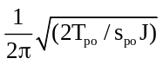, where T_{po} and s_{po} are the steady state pull out torque and slip respectively, and J is the inertia of motor and load.

The current drawn by an accelerating induction motor is highest at zero speed, it falls slightly until the motor reaches the speed for maximum torque and then rapidly decreases to a value required to drive the load. If the supply voltage drops, the motor will slow down so as to maintain the required load torque. However, the maximum motor torque is reduced as the square of the voltage magnitude, and at low voltages the motor may stall. When the voltage is restored, the stalled motor will draw close to starting current, and this may be sufficient to hold the motor voltage low and prevent acceleration to normal speed. On a weak supply, a starting motor may reduce the voltage sufficiently to prevent the motor reaching normal operating speed.

Starting on an infinite bus
The high and low frequency transients of a motor starting may be required in application design. For example, high current peaks on starting may cause fast acting over-current relays to trip. It is also interesting to compare the responses of different models based on similar specifications, e.g., the difference between deep and double cage rotor models and the effects of leakage inductance saturation.

Steady State Torque speed variations
Induction motor models, which satisfy the parameters of Table 1, are given in Tables 2 and 3.

Table 1 Performance Specifications
full load η | full load power factor | full load slip | starting torque ratio | starting current ratio
0.9 | 0.9 | 0.01 | 1 | 5

Each model has a rated line-to-line voltage of 600V and a rated current of 1 KA.

Table 2 Double Cage Motor Parameters
Sat Curr | rs | xs | Xm | xr | rr | rr2 | xr2
10 | 0.061789 | 0.077247 | 3.2314 | 0.77247 | 0.059942 | 0.012035 | 0.071976
3 | 0.061789 | 0.089438 | 3.5412 | 0.089438 | 0.05975 | 0.011839 | 0.071589

Table 3 Deep Bar Motor Parameters
Sat Curr | rs | xs | Xm | xr | rr | dbf
10 | 0.061789 | 0.072353 | 3.475 | 0.072353 | 0.0099837 | 6.9788
3 | 0.061789 | 0.083849 | 3.7989 | 0.083849 | 0.0098401 | 7.0461

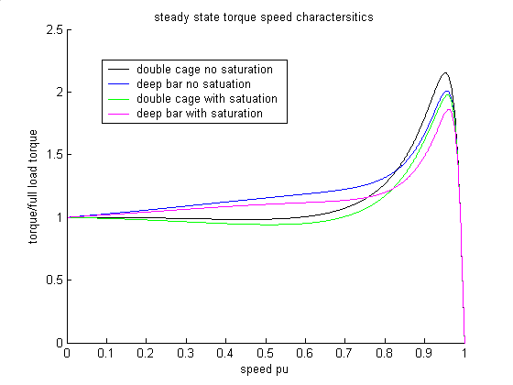
Figure 22 Torque speed characteristics for double cage and deep bar induction motors with and without saturation of leakage inductance
It can be seen from Figure 22 that the deep bar models have lower pull-out torques than the double cage motors. However, they have higher torques from zero speed to between 0.7 and 0.8 pu speed. The torques with leakage inductance saturation are lower than the torques without leakage inductance saturation.

Under dynamic conditions, the difference in the torque/speed characteristics give differences in the starting time, as shown in Figure 23. Both the double cage and deep bar rotor models reach full speed later when the effect of leakage inductance saturation is modelled. The deep bar rotor models reach full speed earlier than the double cage models.
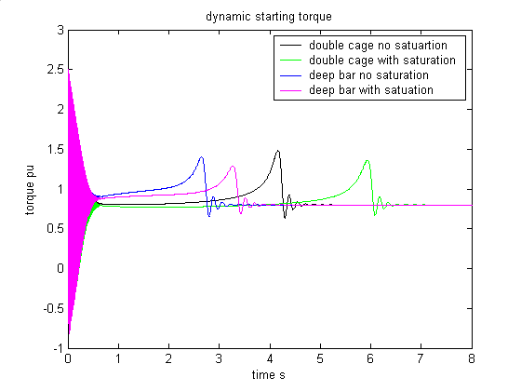
Figure 23 Dynamic starting torque time characteristic
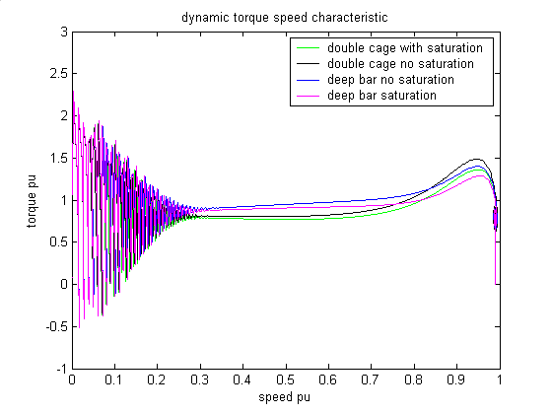
Figure 24 Dynamic torque speed characteristic

A power system example
The Power System Toolbox uses the Breriton, Lewis and Young model for induction motors. In the following, the Power System Toolbox is used to simulate the effects of two motors starting on an small interconnected system. A single line diagram of the test system is shown in Figure 25. The system data is given in Appendix 1.
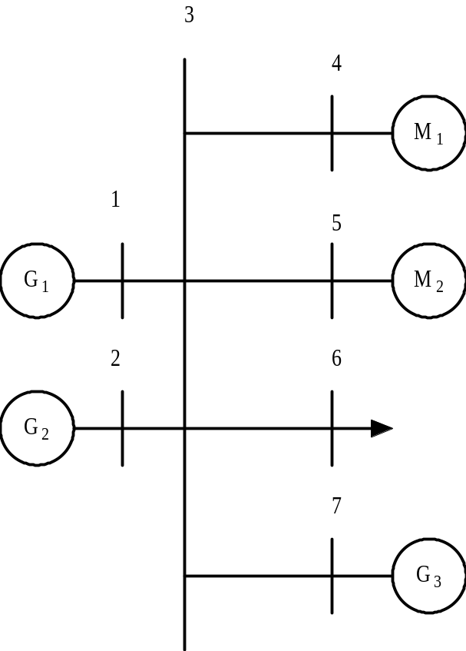
Figure 25 Single line diagram of test system
The system has three generators; two (G₁ and G₂) have ratings of 3.125 MVA, and the other (G₃) is rated at 105 MVA. There are two induction motors (M₁ and M₂) each rated at 2.8 MVA. There is an active load at bus 6 of 2 MW and at bus 7 an active load of 50 MW. In the initiating power flow the load at each motor bus is set to zero. Motor 1 has a deep rotor bar and motor 2 has a double cage rotor.
The steady state torque speed characteristics of the two motors is shown in Figure 26, and the transient torque speed characteristic in Figure 27.
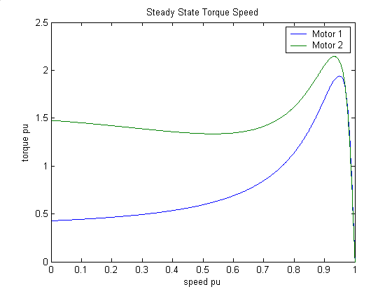
Figure 26 Steady state torque speed characteristics of induction motors M₁ and M₂
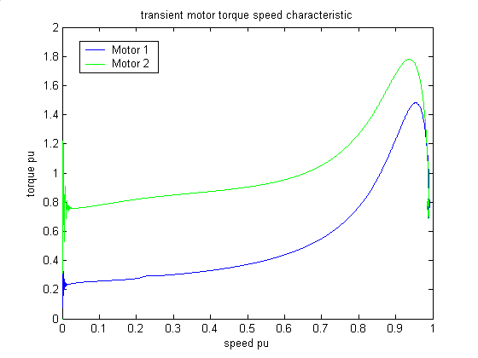
Figure 27 Transient torque speed characteristic of induction motors M₁ and M₂
It can be seen that the transient torques are lower than the steady state torques. This is mainly due to the drop in the motors’ terminal voltages during the start period. The motor voltages are shown in Figure 28. Motor 1 accelerates more slowly than Motor 2 owing to the lower starting torque. The initial high frequency oscillation is due to the natural frequency of the rotor states, it is highly damped, In addition, the natural frequency of the rotor states decreases as the motors slip decreases. The motor currents are shown in Figure 29.
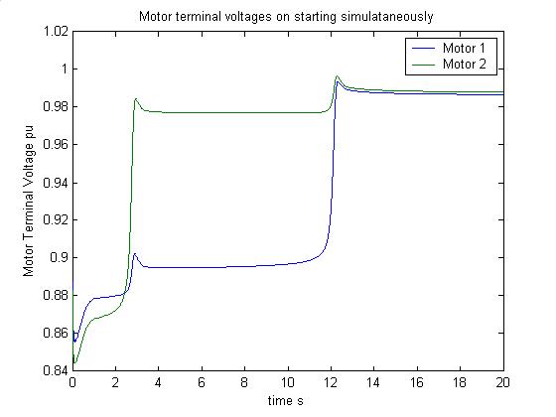
Figure 28 Motor terminal voltage magnitudes on simultaneous starting
The generators have fast acting exciters, which operate to keep the generator voltage constant. The generators’ field voltages are shown in Figure 30. It can be seen that when both motors are drawing their full starting current, the exciter of Generator 3 hits its maximum limit. As soon as motor 1 reaches its normal running speed, the demand for reactive power reduces and the exciter voltage comes off its limited value and is able to control generator voltage. The generators’ speeds vary as shown in Figure 31.

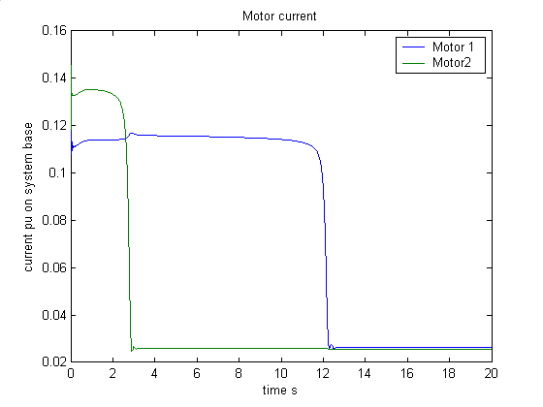
Figure 29 Motor current magnitudes on simultaneous starting
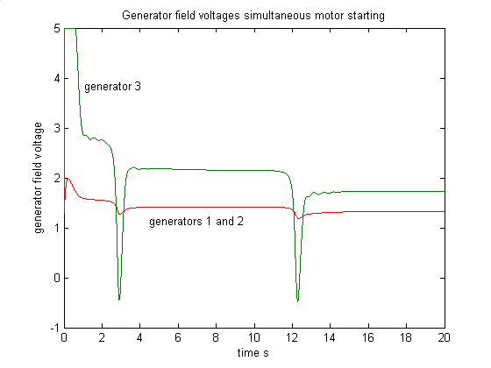
Figure 30 Generator field voltages simultaneous motor starting
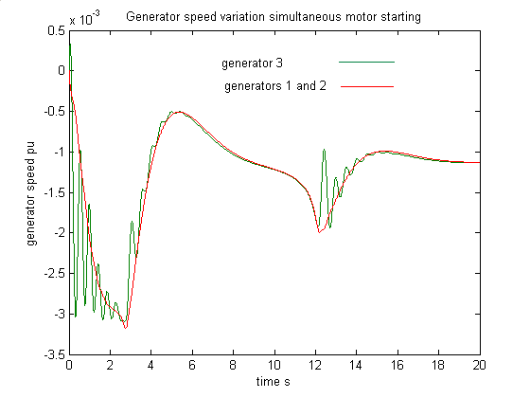
Figure 31 Generator speeds simultaneous motor starting

Small Signal Stability

Induction motor loads in an interconnected power system may influence the capability of generator controls to damp inter-area power system electromechanical oscillations. The effect will vary from system to system. In the following, it is shown that the effect of power system stabilizers is modified by induction motor loads in a two-area system. A single line diagram is shown in Figure 32.
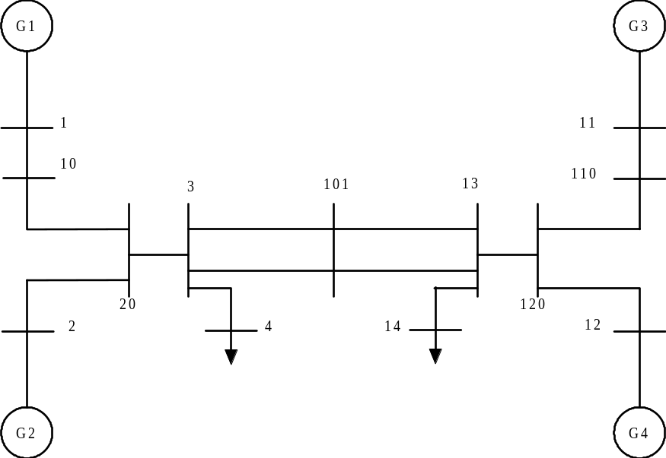
Figure 32 Single line diagram of two area system
The system loads are at buses 4 and 14. They have been adjusted so that 200 MW flows between bus 3 and bus 13. In the small signal simulation, the percentage of motor load is varied, and the motors’ base MVA is adjusted in the same proportion. For each level of motor content, the root locii of the dominant system eigenvalues is obtained as the gain of a power system stabilizer is varied. A single power system stabilizer is applied to each generator in turn and the gain of the stabilizer is varied from 0 to 200.

The power system stabilizer is shown in Figure 33.

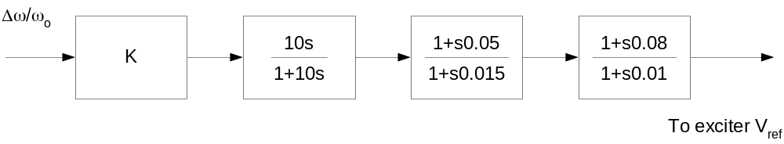
Figure 33 Power system stabilizer block diagram
The eigenvalues associated with the electromechanical modes for the system without power system stabilizers are shown in Table 4.
Table 4 Eigenvalues of electromechanical modes for different induction motor content percentages
Motor Content | 0 | 10 % | 25 %
Inter-area | 0.067012±4.1528i | 0.0532± 4.1579i | 0.0588±4.1552i
Local mode 1 | -0.52636±7.3531i | -0.5338±7.33504i | -0.5633±7.3461i
Local mode 2 | -0.52062±7.4373i | -0.52731±7.4367i | -0.54093±7.4387i

The damping of the electromechanical modes increases as the percentage of motor load is increased. This is compensated for by a reduction in the damping of oscillatory modes introduced by the induction motors. These modes are shown in Table 5.
Table 5 Eigenvalues of induction motor modes with different induction motor content
Motor Content | 10 % | 25 %
Mode 1 | -7.666± 22.518i | -10.547±22.804i
Mode 2 | -7.9474±24.13i | -11.026 ±23.042i

The root locii with power system stabilizer gain (K) are shown in Figues 34 to 38 for varying propotions of induction motor load.

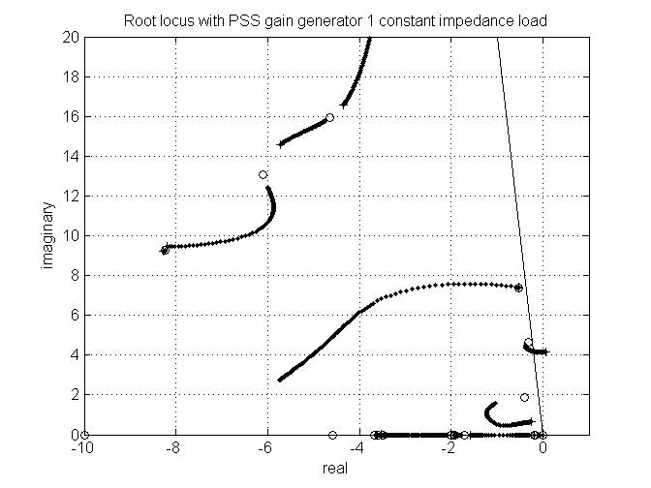
Figure 34 Root locus with power system stabilizer constant impedance load
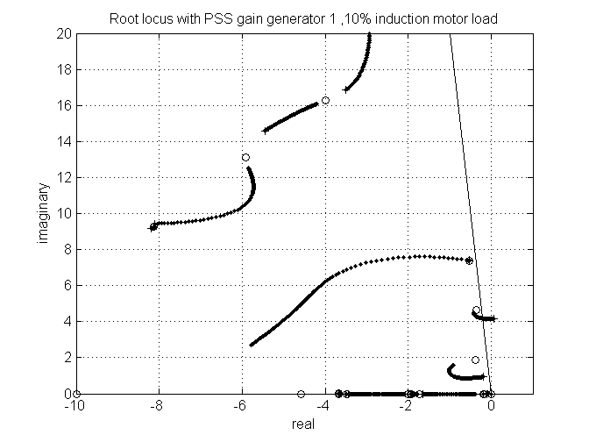
Figure 35 Root locii with power system stabilizer gain 10 % induction motor load
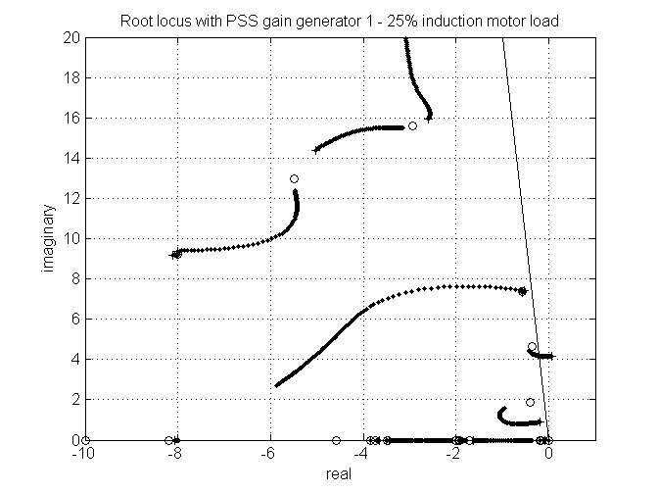
Figure 36 Root locii with power system stabilizer gain 25% induction motor load

Generally, the power system stabilizers are able to add damping to the local electromechanical modes independent of induction motor content. The inter-area mode is best damped by power system stabilizers at either generator 3 or generator 4; in the receiving area for power transfer.

The dominant modes with power system stabilizers in-service on all generators are shown in Figures 37 to 39.
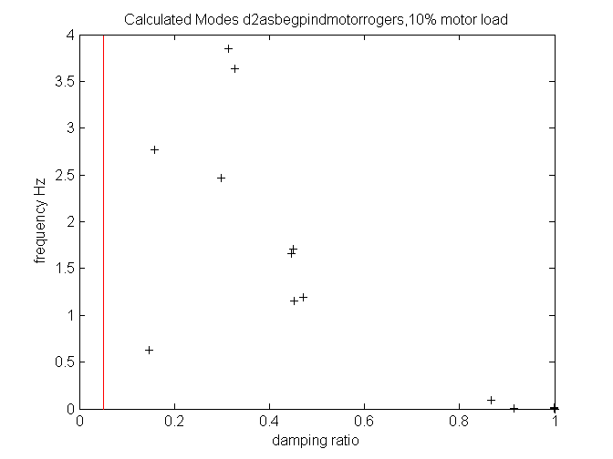
Figure 37 Dominant modes with power system stabilizers, 10 % induction motor load
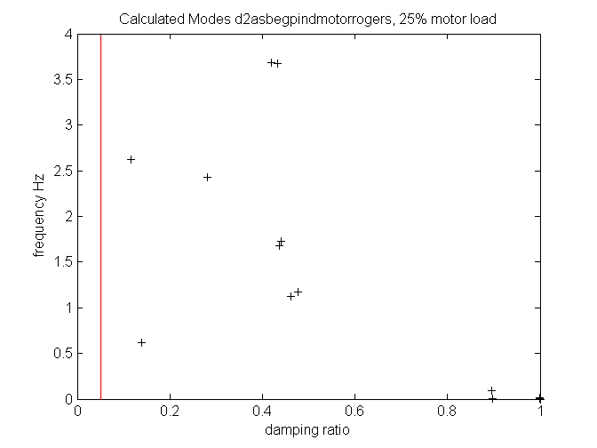
Figure 38 Dominant modes with power system stabilizers, 25% induction motor load

With power system stabilizers at each generator, it can be seen from Figures 39 to 42 that the system remains within satisfactory stability limits as the motor content is changed from 10% to 100%. It remains to be seen that the transient stability is satisfactory. With 100 % motor load, the system fails to recover from a normally cleared three-phase fault at either bus 3 or bus 13. With 50 % motor load, the system recovers from such faults.

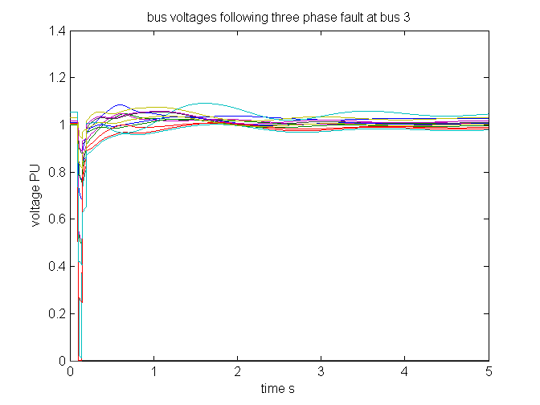
Figure 39 Bus voltage magnitudes, 3 phase fault at bus 3, 10% induction motor load
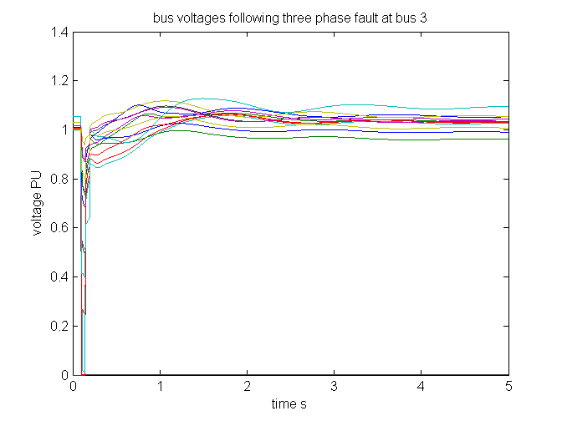
Figure 40 Response to a three phase fault at bus 3, 25% induction motor load
The dominant modes in a post fault system with lines 3 to 101 and 13 to 101 out-of-service are shown in Figure 41.
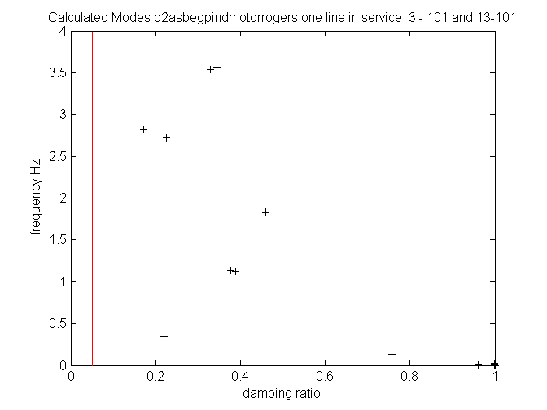
Figure 41 Calculated modes, post fault , 20% induction motor load

Appendix 1 Data Files

Transient Simulation
The following is the Power System Toolbox data file used in the transient simulation of section 7.

% The three generator system
% with two induction motors starting at t = 0
% The induction motors both have leakage inductance saturation
% one motor has a deep bar rotor and the other a double cage rotor

% bus data format
% bus:
% col1 number
% col2 voltage magnitude(pu)
% col3 voltage angle(degree)
% col4 p_gen(pu)
% col5 q_gen(pu)
% col6 p_load(pu)
% col7 q_load(pu)
% col8 G shunt(pu)
% col9 B shunt(pu)
% col10 bus_type
% bus_type - 1, swing bus
% - 2, generator bus (PV bus)
% - 3, load bus (PQ bus)
% col11 q_gen_max(pu)
% col12 q_gen_min(pu)
% the voltage on bus 2 is adjusted for zero Q at machine 1

bus = [ 1 1.0 0.0 .025 0.0 0.0 0.0 0.0 0.0 2 999 -999;
2 1.0 0.0 .025 0.0 0.0 0.0 0.0 0.0 2 999 -999;
3 1.0 0 0 0 0 0 0.0 0.0 3 0 0;
4 1.0 0 0 0 0. 0. 0 0 3 0 0;
5 1.0 0 0 0 0. 0 0 0 3 0 0;
6 1.0 0 0 0 0.02 0 0 0 3 0 0;
7 1.0 0 0.45 0 0.5 0.1 0 0 1 999 -999;
];

% line data format
% line: from bus, to bus, resistance(pu), reactance(pu),
% line charging(pu), tap ratio, phase shifter angle

line = [1 3 0.0 0.8 0. 1. 0.;
2 3 0.0 0.8 0. 1. 0.;
3 4 0.0 0.8 0. 1. 0.;
3 5 0.0 0.8 0. 1. 0.;
3 6 0.0 0.8 0. 1. 0.;
3 7 0.07591 0.08778 0.03046 1 0;
];

% Machine data format
% machine: 1. machine number
% 2. bus number
% 3. base mva
% 4. leakage reactance x_l(pu)
% 5. resistance r_a(pu)
% 6. d-axis sychronous reactance x_d(pu)
% 7. d-axis transient reactance x'_d(pu)
% 8. d-axis subtransient reactance x"_d(pu)
% 9. d-axis open-circuit time constant T'_do(sec)
% 10. d-axis open-circuit subtransient time
% constant T"_do(sec)
% 11. q-axis sychronous reactance x_q(pu)
% 12. q-axis transient reactance x'_q(pu)
% 13. q-axis subtransient reactance x"_q(pu)
% 14. q-axis open-circuit time constant T'_qo(sec)
% 15. q-axis open circuit subtransient time
% constant T"_qo(sec)
% 16. inertia constant H(sec)
% 17. damping coefficient d_o(pu)
% 18. dampling coefficient d_1(pu)
% 19. bus number
% 20. S(1.0) - saturation factor
% 21. S(1.2) - saturation factor

mac_con = [
1 1 3.125 0.13 0 1.6 0.42 0.271 4.34 0.027 ...
0.963 0.30 0.271 1.00 0.030 ...
3 6.0 0 1 0 0;
2 2 3.125 0.13 0 1.6 0.42 0.271 4.34 0.027 ...
0.963 0.30 0.271 1.00 0.030 ...
3 6.0 0 1 0 0;
3 7 105 0.12 0.002 1.48 0.18 0.013 8.0 0.028 ...
1.48 0.33 0.013 1.61 0.198 ...
5.95 10.0 0 2 0 0;
];
% Exciter data format
% exciter: 1. exciter type - 1 for Simple exciter
% 2. machine number
% 3. input filter time constant T_R
% 4. voltage regulator gain K_A
% 5. voltage regulator time constant T_A
% 6. voltage regulator time constant T_B
% 7. voltage regulator time constant T_C
% 8. maximum voltage regulator output V_Rmax
% 9. minimum voltage regulator output V_Rmin
% 10. maximum internal signal V_Imax
% 11. minimum internal signal V_Imin
% 12. first stage regulator gain K_J
% 13. potential circuit gain coefficient K_p
% 14. potential circuit phase angle theta_p
% 15. current circuit gain coefficient K_I
% 16. potential source reactance X_L
% 17. rectifier loading factor K_C
% 18. maximum field voltage E_fdmax
% 19. inner loop feedback constant K_G
% 20. maximum inner loop voltage feedback V_Gmax

exc_con = [...
0 1 0 200.0 0.05 0 0 5.0 -5.0...
0 0 0 0 0 0 0 0 0 0 0;
0 2 0 200.0 0.05 0 0 5.0 -5.0...
0 0 0 0 0 0 0 0 0 0 0;
0 3 0 200.0 0.05 0 0 5.0 -5.0...
0 0 0 0 0 0 0 0 0 0 0;
];

% governor data
% 1. governor type = 1
% 2. machine number
% 3. speed set point , normally equal to 1
% 4. gain ( inverse of droop)
% 5. max power pu on gen base
% 6. servo time constant s
% 7. governor or HP time constant s
% 8. transient gain time constant s
% 9. T4 set to make T4/T5 = frac of HP
%10. T5 reheater time constant
tg_con=[...
1 1 1.0 25.0 1.0 0.1 0.4 0.1 -5.0 2.5;
1 2 1.0 25.0 1.0 0.1 0.4 0.1 -5.0 2.5;
1 3 1.0 25.0 1.0 0.1 0.4 0.0 1.25 5.0;
];

% induction motor data
% 1. Motor Number
% 2. Bus Number
% 3. Motor MVA Base
% 4. rs pu
% 5. xs pu - stator leakage reactance
% 6. Xm pu - magnetizing reactance
% 7. rr pu
% 8. xr pu - rotor leakage reactance
% 9. H s - motor plus load inertia constant
% 10. rr1 pu - second cage resistance
% 11. xr1 pu - intercage reactance
% 12. dbf - deepbar factor
% 13. isat pu - saturation current
% 15. fraction of bus power drawn by motor
% (if zero motor starts at t=0)
% Motor 1 has a deep bar and leakage inductance saturation
% Motor 2 has a double cage and leakage inductance saturation
ind_con = [ ...
1 4 2.86 .0229 .1153 3.469 .0102 .0877 1.0 ...
0 0 3.469 3 0 0;
2 5 2.86 .03274 .0852 3.779 .0616 .0601 1.0 ...
0.0135 0.0752 0 3 0 0;
];

% Motor Load Data
% format for motor load data - mld_con
% 1 motor number
% 2 bus number
% 3 stiction load pu on motor base (f1)
% 4 stiction load coefficient (i1)
% 5 external load pu on motor base(f2)
% 6 external load coefficient (i2)
%
% load has the form
% tload = f1*slip^i1 + f2*(1-slip)^i2
mld_con = [ ...
1 5 .1 1 .8 2
2 6 .1 1 .8 2
];
%Switching file defines the simulation control
% row 1 col1 simulation start time (s) (cols 2 to 6 zeros)
% col7 initial time step (s)
% row 2 col1 fault application time (s)
% col2 bus number at which fault is applied
% col3 bus number defining far end of faulted line
% col4 zero sequence impedance in pu on system base
% col5 negative sequence impedance in pu on system base
% col6 type of fault - 0 three phase
% - 1 line to ground
% - 2 line-to-line to ground
% - 3 line-to-line
% - 4 loss of line with no fault
% - 5 loss of load at bus
% - 6 no fault
% col7 time step for fault period (s)
% row 3 col1 near end fault clearing time (s) (cols 2 to 6 zeros)
% col7 time step for second part of fault (s)
% row 4 col1 far end fault clearing time (s) (cols 2 to 6 zeros)
% col7 time step for fault cleared simulation (s)
% row 5 col1 time to change step length (s)
% col7 time step (s)
%
%
%
% row n col1 finishing time (s) (n indicates that intermediate rows may be
% inserted)
sw_con = [...
0 0 0 0 0 0 0.001;%sets intitial time step
0.1 4 3 0 0 6 0.001;%no fault
0.15 0 0 0 0 0 0.001;
0.20 0 0 0 0 0 0.001;
0.50 0 0 0 0 0 0.001;
10.0 0 0 0 0 0 0.005; % increase time step
20.0 0 0 0 0 0 0.005];% end simulation

Small Signal Stability
The following is the Power System Toolbox data file used in the small signal stability simulation. The data is for 50% motor load. In the other cases, the proportion of load taken up by the motors was adjusted as was the motor rating. Thus for 100% motor load the MVA bases for the motors were double the value for 50% motor load.

% Two Area Test Case
% sub transient generators with static exciters, turbine/governors
% 50% Motor load
disp('Two-area test case with subtransient generator models')
disp('Static exciters')
disp('turbine/governors')
% bus data format
% bus:
% col1 number
% col2 voltage magnitude(pu)
% col3 voltage angle(degree)
% col4 p_gen(pu)
% col5 q_gen(pu),
% col6 p_load(pu)
% col7 q_load(pu)
% col8 G shunt(pu)
% col9 B shunt(pu)
% col10 bus_type
% bus_type - 1, swing bus
% - 2, generator bus (PV bus)
% - 3, load bus (PQ bus)
% col11 q_gen_max(pu)
% col12 q_gen_min(pu)
% col13 v_rated (kV)
% col14 v_max pu
% col15 v_min pu

bus = [...
1 1.03 18.5 7.00 1.61 0.00 0.00 0.00 0.00 1 5.0 -1.0 22.0 1.1 .9;
2 1.01 8.8 7.00 1.76 0.00 0.00 0.00 0.00 2 5.0 -1.0 22.0 1.1 .9;
3 0.98 -6.1 0.00 0.00 0.00 0.00 0.00 3.00 3 0.0 0.0 230.0 1.5 .5;
4 0.95 -10 0.00 0.00 9.76 1.00 0.00 0.00 3 0.0 0.0 115.0 1.05 .95;
10 1.01 12.1 0.00 0.00 0.00 0.00 0.00 0.00 3 0.0 0.0 230.0 1.5 .5;
11 1.03 -6.8 7.16 1.49 0.00 0.00 0.00 0.00 2 5.0 -1.0 22.0 1.1 .9;
12 1.01 -16.9 7.00 1.39 0.00 0.00 0.00 0.00 2 5.0 -1.0 22.0 1.1 .9;
13 0.99 -31.8 0.00 0.00 0.00 0.00 0.00 5.00 3 0.0 0.0 230.0 1.5 .5;
14 0.95 -35 0.00 0.00 17.65 1.00 0.00 0.00 3 0.0 0.0 115.0 1.05 .95;
20 0.99 2.1 0.00 0.00 0.00 0.00 0.00 0.00 3 0.0 0.0 230.0 1.5 .5;
101 1.00 -19.3 0.00 1.09 0.00 0.00 0.00 0.00 2 2.0 0.0 230.0 1.5 .5;
110 1.01 -13.4 0.00 0.00 0.00 0.00 0.00 0.00 3 0.0 0.0 230.0 1.5 .5;
120 0.99 -23.6 0.00 0.00 0.00 0.00 0.00 0.00 3 0.0 0.0 230.0 1.5 .5;
];

% line data format
% line:
% col1 from bus
% col2 to bus
% col3 resistance(pu)
% col4 reactance(pu)
% col5 line charging(pu)
% col6 tap ratio
% col7 tap phase
% col8 tapmax
% col9 tapmin
% col10 tapsize
line = [...
1 10 0.0 0.0167 0.00 1.0 0. 0. 0. 0.;
2 20 0.0 0.0167 0.00 1.0 0. 0. 0. 0.;
3 4 0.0 0.005 0.00 1.0 0. 1.2 0.8 0.02;
3 20 0.001 0.0100 0.0175 1.0 0. 0. 0. 0.;
3 20 0.001 0.0100 0.0175 1.0 0. 0. 0. 0.;
3 101 0.011 0.110 0.1925 1.0 0. 0. 0. 0.;
3 101 0.011 0.110 0.1925 1.0 0. 0. 0. 0.;
10 20 0.0025 0.025 0.0437 1.0 0. 0. 0. 0.;
11 110 0.0 0.0167 0.0 1.0 0. 0. 0. 0.;
12 120 0.0 0.0167 0.0 1.0 0. 0. 0. 0.;
13 101 0.011 0.11 0.1925 1.0 0. 0. 0. 0.;
13 101 0.011 0.11 0.1925 1.0 0. 0. 0. 0.;
13 14 0.0 0.005 0.00 1.0 0. 1.2 0.8 0.02;
13 120 0.001 0.01 0.0175 1.0 0. 0. 0. 0.;
13 120 0.001 0.01 0.0175 1.0 0. 0. 0. 0.;
110 120 0.0025 0.025 0.0437 1.0 0. 0. 0. 0.;
];

% Machine data format
% Machine data format
% 1. machine number,
% 2. bus number,
% 3. base mva,
% 4. leakage reactance x_l(pu),
% 5. resistance r_a(pu),
% 6. d-axis sychronous reactance x_d(pu),
% 7. d-axis transient reactance x'_d(pu),
% 8. d-axis subtransient reactance x"_d(pu),
% 9. d-axis open-circuit time constant T'_do(sec),
% 10. d-axis open-circuit subtransient time constant
% T"_do(sec),
% 11. q-axis sychronous reactance x_q(pu),
% 12. q-axis transient reactance x'_q(pu),
% 13. q-axis subtransient reactance x"_q(pu),
% 14. q-axis open-circuit time constant T'_qo(sec),
% 15. q-axis open circuit subtransient time constant
% T"_qo(sec),
% 16. inertia constant H(sec),
% 17. damping coefficient d_o(pu),
% 18. dampling coefficient d_1(pu),
% 19. bus number
%
% note: all the following machines use sub-transient model
mac_con = [ ...

1 1 900 0.200 0.00 1.8 0.30 0.25 8.00 0.03...
1.7 0.55 0.24 0.4 0.05...
6.5 0 0 1 0.0654 0.5743;
2 2 900 0.200 0.00 1.8 0.30 0.25 8.00 0.03...
1.7 0.55 0.25 0.4 0.05...
6.5 0 0 2 0.0654 0.5743;
3 11 900 0.200 0.00 1.8 0.30 0.25 8.00 0.03...
1.7 0.55 0.24 0.4 0.05...
6.5 0 0 3 0.0654 0.5743;
4 12 900 0.200 0.00 1.8 0.30 0.25 8.00 0.03...
1.7 0.55 0.25 0.4 0.05...
6.5 0 0 4 0.0654 0.5743];
% simple exciter model, type 0; there are three exciter models
exc_con = [...
0 1 0.01 200.0 0.05 0 0 5.0 -5.0...
0 0 0 0 0 0 0 0 0 0 0;
0 2 0.01 200.0 0.05 0 0 5.0 -5.0...
0 0 0 0 0 0 0 0 0 0 0;
0 3 0.01 200.0 0.05 0 0 5.0 -5.0...
0 0 0 0 0 0 0 0 0 0 0;
0 4 0.01 200.0 0.05 0 0 5.0 -5.0...
0 0 0 0 0 0 0 0 0 0 0];
% power system stabilizer model
% col1 type 1 speed input; 2 power input
% col2 generator number
% col3 pssgain*washout time constant
% col4 washout time constant
% col5 first lead time constant
% col6 first lag time constant
% col7 second lead time constant
% col8 second lag time constant
% col9 maximum output limit
% col10 minimum output limit

pss_con = [...
%1 1 100 10 0.05 0.015 0.08 0.01 0.2 -0.05;
%1 2 100 10 0.05 0.015 0.08 0.01 0.2 -0.05;
%1 3 100 10 0.05 0.015 0.08 0.01 0.2 -0.05;
%1 4 100 10 0.05 0.015 0.08 0.01 0.2 -0.05
];

% governor model
% tg_con matrix format
%column data unit
% 1 turbine model number (=1)
% 2 machine number
% 3 speed set point wf pu
% 4 steady state gain 1/R pu
% 5 maximum power order Tmax pu on generator base
% 6 servo time constant Ts sec
% 7 governor time constant Tc sec
% 8 transient gain time constant T3 sec
% 9 HP section time constant T4 sec
% 10 reheater time constant T5 sec

tg_con = [...
1 1 1 25.0 1.0 0.1 0.5 0.0 1.25 5.0;
1 2 1 25.0 1.0 0.1 0.5 0.0 1.25 5.0;
1 3 1 25.0 1.0 0.1 0.5 0.0 1.25 5.0;
1 4 1 25.0 1.0 0.1 0.5 0.0 1.25 5.0;
];

% induction motor data
% 1. Motor Number
% 2. Bus Number
% 3. Motor MVA Base
% 4. rs pu
% 5. xs pu - stator leakage reactance
% 6. Xm pu - magnetizing reactance
% 7. rr pu
% 8. xr pu - rotor leakage reactance
% 9. H s - motor plus load inertia constant
% 10. rr1 pu - second cage resistance
% 11. xr1 pu - intercage reactance
% 12. dbf - deepbar factor
% 13. isat pu - saturation current
% 15. fraction of bus power drawn by motor
% (if zero motor starts at t=0)

ind_con = [ ...
1 4 750 .0229 .1153 3.469 .0102 .0877 1.0 0 0 3.469 3 0 .5;
2 14 1500 .0327 .0852 3.779 .0616 .0601 1.0 0.0135 0.0752 0 3 0 .5;
];
% Motor Load Data
% format for motor load data - mld_con
% 1 motor number
% 2 bus number
% 3 stiction load pu on motor base (f1)
% 4 stiction load coefficient (i1)
% 5 external load pu on motor base(f2)
% 6 external load coefficient (i2)
%
% load has the form
% tload = f1*slip^i1 + f2*(1-slip)^i2
mld_con = [ ...
1 4 .1 1 .8 2;
2 14 .1 1 .8 2;
];

% col1 bus number
% col2 proportion of constant active power load
% col3 proportion of constant reactive power load
% col4 proportion of constant active current load
% col5 proportion of constant reactive current load
load_con = [4 0 0 0 0;%constant impedance
14 0 0 0 0;
];
%disp('load modulation')
%active and reactive load modulation enabled
% col1 load number
% col2 bus number
% col3 MVA rating
% col4 maximum output limit pu
% col4 minimum output limit pu
% col6 Time constant
lmod_con = [...
1 4 100 1 -1 1 0.05;
2 14 100 1 -1 1 0.05;
];
rlmod_con = [...
1 4 100 1 -1 1 0.05;
2 14 100 1 -1 1 0.05;
];
%Switching file defines the simulation control
% row 1 col1 simulation start time (s) (cols 2 to 6 zeros)
% col7 initial time step (s)
% row 2 col1 fault application time (s)
% col2 bus number at which fault is applied
% col3 bus number defining far end of faulted line
% col4 zero sequence impedance in pu on system base
% col5 negative sequence impedance in pu on system base
% col6 type of fault - 0 three phase
% - 1 line to ground
% - 2 line-to-line to ground
% - 3 line-to-line
% - 4 loss of line with no fault
% - 5 loss of load at bus
% - 6 no action
% col7 time step for fault period (s)
% row 3 col1 near end fault clearing time (s) (cols 2 to 6 zeros)
% col7 time step for second part of fault (s)
% row 4 col1 far end fault clearing time (s) (cols 2 to 6 zeros)
% col7 time step for fault cleared simulation (s)
% row 5 col1 time to change step length (s)
% col7 time step (s)
%
%
%
% row n col1 finishing time (s) (n indicates that intermediate rows % may
% be inserted)

sw_con = [...
0 0 0 0 0 0 0.01;%sets intitial time step
0.1 3 101 0 0 0 0.01; % 3 ph fault
0.15 0 0 0 0 0 0.01; %clear near end
0.20 0 0 0 0 0 0.01; %clear remote end
20.0 0 0 0 0 0 0]; % end simulation

Appendix 2 Bibliography

G.J. Rogers, "Linearized Analysis of Induction Motor Transients", Proc. IEE, vol. 112, 1965, pp.1917,1926.
P. Hammond and G.J. Rogers, "Use of Equivalent Fields in Electrical Machine Studies", Proc. IEE, vol. 121,1974, pp. 500-507
G.J. Rogers and G.K. Cambrell, "The Piece-by-Piece Solution of Elliptic Boundary Value Problems",
J. Phys.D:Appl.Phys 8, 1975, pp. 1615-1623
G.J. Rogers, "Forced Oscillations in Induction Motors Driving Pulsating Loads", Proc. IEE, vol. 122, 1975, pp. 847-848.
G.J. Rogers, "Induction Motors Terminal Voltage Equations", Proc. IEE, vol 123, 1976, pp. 804-810.
G.J. Rogers and D.S. Beneragama, "An Induction Motor Model with Deep Bar Effect and Leakage Inductance Saturation", Archiv fur Elektrotechnik, 60, 1978, pp. 196-201.
G.J. Rogers, "A Dynamic Induction Motor Model Including Space Harmonics", Electric Machines and Electromechanics, vol 3, 1979, pp.177-190.
J.R. Smith, G.J. Rogers and G.W. Buckley, "Application of Induction Motor Simulation Models to Power Station Auxiliary Pump Drives", IEEE Trans. PAS-98, 1979, pp1824-1831
G.J. Rogers, J. DiManno and R.T.H. Alden, "An Aggregate Induction Motor Model for Industrial Plants", IEEE Trans. on Power Apparatus and Systems, vol. PAS-103, April 1984, pp. 683-690.
G.J. Rogers and D. Shirmohammadi, "Induction Motor Modelling for Electromagnetic Transients Program", IEEE Trans on Energy Conversion, vol EC-2, December 1987, pp. 622-628.
G.J. Rogers, R.E. Beaulieu and L.M. Hajagos, "Performance of Station Load Induction Motors Following Full Load Rejection of a Nuclear Generating Unit", IEEE Summer Power Meeting, July 1994, 94SM 581-9 PWRS
X. Xu, R.M. Mathur, J. Jiang, and G.J. Rogers, ‘Modelling Effects of System Frequency Variations in Induction Motor Dynamics Using Singular Perturbations’, IEEE Transactions on Power Systems, vol. 13, May, 2000, pp. 764-770.
D.S. Brereton, D.G. Lewis and C.C. Young, "Representation of Induction Motor Loads during Power System Stability Studies", AIEE Trans., vol. 76, Part III, August 1957, pp 451-460.
M. Klein, G.J. Rogers, S.Moorty and P.Kundur, ‘Analytical Investigation of Factors Influencing Power System Stabilizers Performance’, IEEE Transactions on Energy Conversion, Vol 7, no 3, September 1991, pp. 382 – 388.

* 1,α and α2 are the three cube roots of 1

