Asian Energy Services Limited - Many Contracts, One Pattern
NSE: ASIANENE | CMP: Rs.455 | Market Cap: Rs.2,211cr | Rating: Under review (v2) | Target Price: v2 | Analyst: Dheeraj Kripalani
October 2026 | Note v1: history, business and preliminary view. Estimates, valuation and rating follow in v2 once the forecast model is built. CMP and market cap are the BSE close of 16-Oct-2026 on 4.86cr shares after the May-2026 warrant conversion; the pending merger takes the count to about 8.80cr.
Company Overview
- Asian Energy Services (AESL) is a Mumbai-based energy services contractor with four lines of business: onshore seismic data acquisition for ONGC, Oil India, Vedanta and private explorers; operations and maintenance and, since July 2025, integrated field development for Vedanta's Cambay and Rajasthan fields; coal handling plant EPC for Coal India subsidiaries and SCCL, executed through unincorporated joint ventures; and, since September 2025, Kuiper Group, a Gulf and South-East Asian oilfield crew-supply business bought for Rs.123cr. It also owns a 50% participating interest in the small Indrora oil field in Gujarat, bought from its promoter. FY26 consolidated revenue was Rs.791cr, of which Rs.299cr was Kuiper's seven months.
- The company was incorporated in 1992 as Asian Oilfield Services, listed in 1995, spent 2008 to 2016 under Samara Capital with a loss-making Kurdistan venture, and has been controlled since FY17 by Oilmax Energy, the E&P company of Dr Kapil Garg, a former BG India managing director. Oilmax holds 56% after the May-2026 warrant conversion and is now being merged into AESL at 117 AESL shares for every 10 Oilmax shares, sanctioned by the NCLT on 29-Sep-2026. The merger brings in Oilmax's participating interests in five oil and gas blocks and a quartzite mine, and takes the promoter family's holding to 49.45% of an enlarged 8.80cr shares.
- FY26 revenue grew 70% but organic growth was 6%: Rs.299cr of the Rs.326cr increase came from Kuiper, which runs at a 7% EBITDA margin. Consolidated EBITDA margin fell to 12.1% from 25.5% in FY22; PAT was Rs.51.8cr; ROE 11.5%. Three-year operating cash flow is negative Rs.24cr against Rs.119cr of PAT, receivables plus unbilled work stand at 209 days of sales, and gross debt rose from Rs.24cr to Rs.158cr to fund Kuiper and Indrora wells. The standalone order book is Rs.1,754cr, of which the Vedanta integrated contract (Rs.772cr) and the MCL Lakhanpur coal handling plant (Rs.459cr) are two-thirds.
- At Rs.455 the stock trades at about 40x FY26 earnings and 21x FY26 EV/EBITDA, up from Rs.239 in March 2026 on the 1QFY27 revenue print, a Gujarat power EPC win and the merger sanction. No institution holds the stock; BSE turnover averages about Rs.1cr a day. The price discounts the order book, a 30 to 40% standalone growth guide and E&P optionality before any post-merger quarter has been reported.
Revenue and EBITDA Margin - Business Cycles
In 34 years as a listed company AESL has never had a revenue base that survived the loss of one contract or one customer. Each of the five cycles below was carried by one or two awards and ended when they did. The audited major-customer note proves it: the top customer was 51 to 87% of revenue in every year from FY17 to FY21.
Cycle 1 - FY05 to FY13: a small domestic seismic contractor
Revenue of Rs.8cr to Rs.69cr from 2D and 3D onshore seismic and shot-hole drilling for ONGC and small operators. Margins of 12 to 33% in the two good years (FY07 and FY08), then a 71% revenue fall in FY10 as work dried up and seven years of losses. Samara Capital bought control in 2008 and installed an ex-WesternGeco team in 2013. The FY14 annual report's own description of the home market still holds: "In India, the activity continued to be low and sporadic."
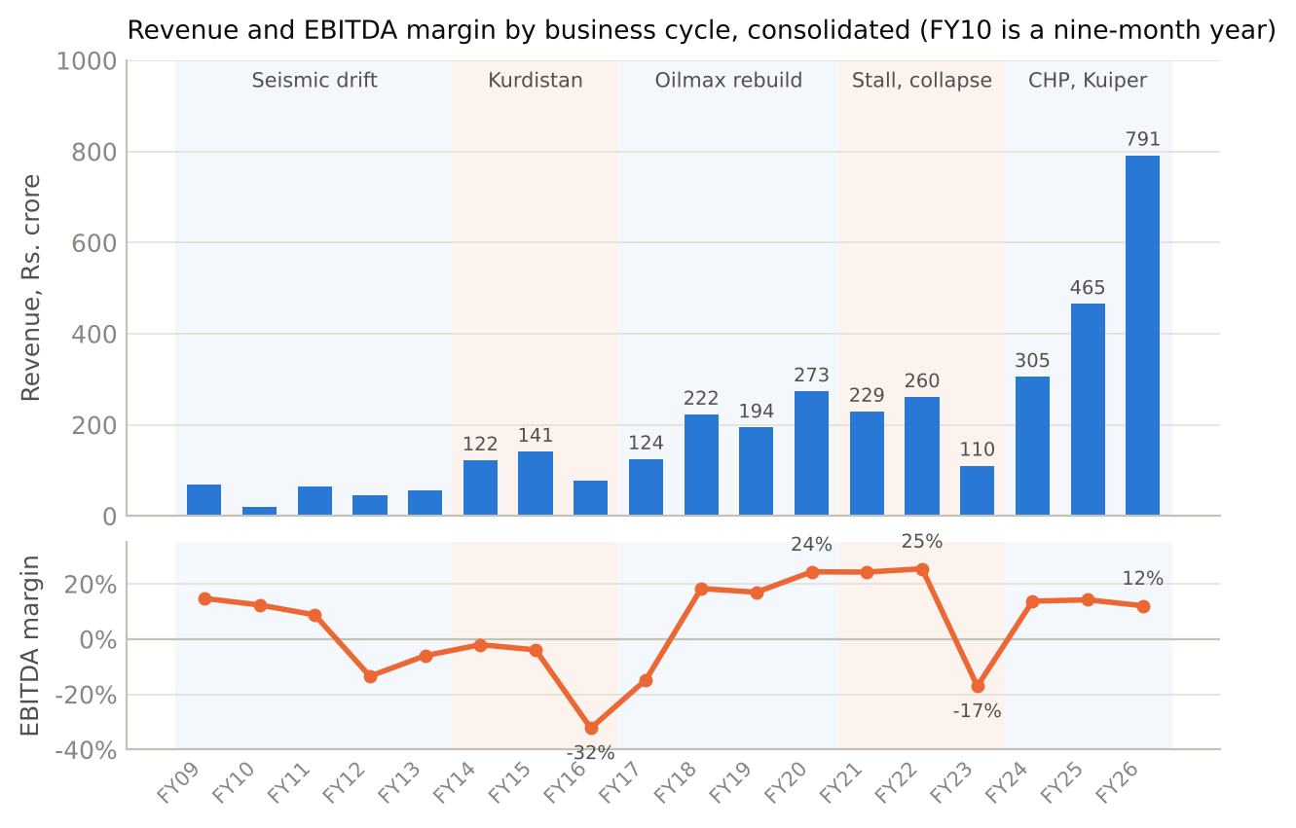
Exhibit 1. Consolidated revenue and EBITDA margin, FY09 to FY26. Source: ACE Equity consolidated financials tied to audited annual reports; FY10 is a nine-month year after the June year-end was changed to March.
Cycle 2 - FY14 to FY16: Kurdistan
One "mega contract" in Iraqi Kurdistan for Gazprom Neft, then a 3D award from Oil Search, took revenue to Rs.122cr in FY14 and Rs.141cr in FY15. The crew spread was bought for the job: Rs.108cr of capex in FY14, 7.7 times depreciation, funded partly by inter-corporate deposits at 15 to 16%. The December-2013 deck promised a "path to USD 75mm+ revenues". Oil collapsed, Kurdistan became a war zone and by FY17 the equipment was stranded in Sulaymaniyah and written off. EBITDA was negative in all three years, net worth fell from Rs.65cr to Rs.10cr and net debt reached Rs.101cr, ten times equity. Samara sold its 56% to Oilmax in 2016.
Cycle 3 - FY17 to FY20: the Oilmax rebuild, which was really a Nigerian cycle
Oilmax put in Rs.137cr of equity over FY17 and FY18 through warrants at Rs.80, repaid the debt and wrote off the past (Rs.36cr of bad-debt charges in FY17, offset by a Rs.19cr write-back of payables booked as an exceptional gain). Revenue rose from Rs.124cr to Rs.273cr and the EBITDA margin from minus 15% to 24%. The decks described a domestic seismic story with ten crews and a Rs.503cr seismic book. The audited customer note shows what actually carried the numbers: one Nigerian customer each year. Koral Energy's FPU O&M contract was 57% of FY18 revenue before Koral terminated it in May 2018; Amni International's Langley turnaround project was 87% of FY20 revenue, the best year on record (PAT Rs.29cr, operating cash flow Rs.89cr, net cash Rs.82cr). Domestic seismic in the same years was interrupted by force majeure in Manipur and NC Hills, a Rs.12.5cr bank guarantee encashed by Oil India, and a USD 37m Bashneft Iraq order that never converted.
Cycle 4 - FY21 to FY23: stall and collapse
Amni suspended Langley in November 2020 over its own technical problems and the contract was terminated in August 2021, leaving a USD 8.5m receivable that the auditor qualified for three years. Revenue held at Rs.229cr and Rs.260cr in FY21 and FY22 on the Vedanta seismic framework and the first coal handling plant and O&M awards, then fell 58% to Rs.110cr in FY23. The filings give the reasons: government seismic tendering stopped ("there has been no activity for the last 5-6 months in terms of the tendering", 1QFY23 call), the Oil India Tripura project was short-closed, the Hura coal plant waited for land, and the company kept the staff it had hired for new verticals. The oil and gas segment earned nothing on Rs.63cr of revenue; the year's loss was Rs.44cr. Investors on the August-2022 call were still working to a Rs.400 to 500cr revenue expectation.
Cycle 5 - FY24 to FY26: the coal pivot and Kuiper
The board's March-2024 strategy statement set the direction: move "from cyclical business which also frequently involves force majeure situations, to stable business with long term contracts". Coal handling plants for Eastern, Central and Mahanadi Coalfields and SCCL took the mineral segment from Rs.47cr to Rs.273cr by FY25, 59% of revenue. In FY26 the mix flipped again: the mineral segment fell 42% between projects, while Kuiper's seven months and the start of the Vedanta integrated contract lifted oil and gas to Rs.633cr. Growth was funded by Rs.85cr of warrants in 2023, Rs.157cr of warrants in 2024, and Rs.158cr of debt at FY26. The company missed its FY26 standalone guide of 40 to 50% growth by delivering 6%.
What the cycles teach
The present book depends on Vedanta (about 40%) and MCL (about 26%), which is the same two-contract structure as every prior cycle; the overseas leg is again a single acquired platform in a volatile region; and FY23 is the stress test for the cost base, because when awards stop the fixed cost of a standing organisation produces a loss within two quarters.
Business Lines and How Each Earns
AESL reports two segments under Ind AS 108: Oil and Gas, and Mineral and other energy. Segment capital employed is not disclosed because the chief operating decision maker does not review it, so returns can only be judged at the group level.
Rs. crore | FY21A | FY22A | FY23A | FY24A | FY25A | FY26A | FY27E | FY28E | FY29E
Oil and gas revenue | 221.9 | 188.9 | 63.2 | 191.9 | 192.4 | 632.7 | v2 | v2 | v2
YoY | - | -15% | -67% | +204% | 0% | +229%
Mineral and other energy revenue | 6.9 | 71.6 | 46.7 | 113.2 | 272.6 | 158.4 | v2 | v2 | v2
YoY | - | n.m. | -35% | +142% | +141% | -42%
Oil and gas result, margin | 35% | 29% | -0.5% | 21% | 17% | 16%
Mineral result, margin | n.m. | 46% | 14% | 17% | 22% | 20%
Unallocable cost, D&A, finance, other income (net) | -37.1 | -46.8 | -45.5 | -30.6 | -41.9 | -58.8

Segment result is before depreciation, finance cost, other income and unallocable corporate cost. Source: annual reports FY22 to FY26, segment note. FY27E onward in v2.
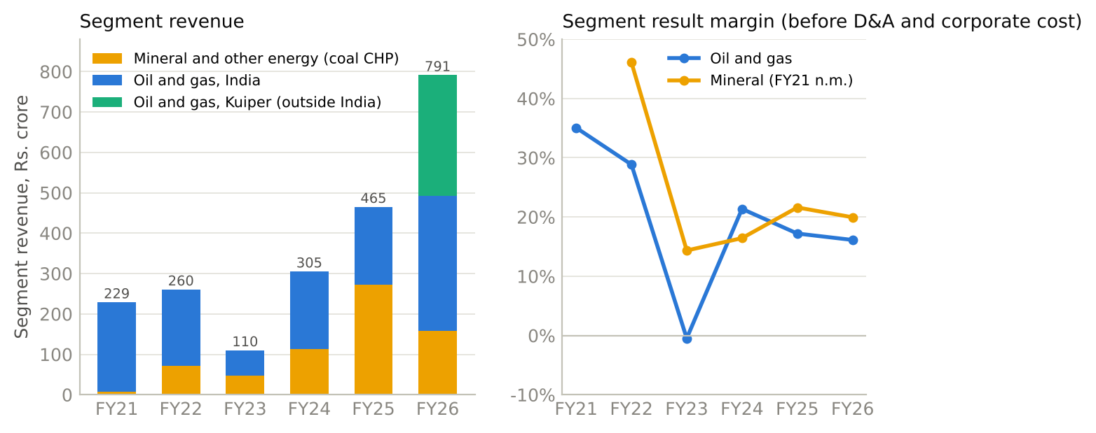
Exhibit 2. Segment revenue and segment result margin, FY21 to FY26. Kuiper's Rs.299cr sits inside the oil and gas segment in FY26. Source: annual report segment notes.
1. Seismic data acquisition - the original business, now 5% of the order book
Seismic crews record sound echoes to map the rock below a licence block before anyone drills. AESL fields a few hundred people per crew with recording channels, geophones and either shot-hole drilling or vibroseis trucks (commissioned in 2020 for Rajasthan). Contracts come from tenders by ONGC, Oil India, GAIL and private operators such as Sun Petrochemicals, are priced per line-kilometre of 2D or per square kilometre of 3D with mobilisation paid separately, and are billed monthly on certified progress. Recent awards show the scale: ONGC 3D Gujarat Rs.78cr over 11 months (2023), GAIL Rajasthan Rs.17cr over six months (2023), Oil India 2D Rajasthan Rs.82cr over 18 months (2024), Sun Petrochemicals 3D Rs.46cr over 12 months (2025) and 4D Rs.55cr over a year (2025).
The economics are those of a seasonal, labour-heavy service with its own equipment: no work in the monsoon, crews paid monthly whether or not the client has certified progress, force majeure stopping revenue but not cost, and a bank guarantee at risk on every job. Management puts seismic gross margins at 30 to 35% before depreciation on an equipment fleet that is now 74% depreciated: oilfield equipment of Rs.253cr gross carries Rs.66cr net, and FY26 additions were Rs.0.9cr. Seismic revenue was about Rs.120cr in FY24 and Rs.72cr in FY25; FY26 is not disclosed. ONGC put AESL on a tender holiday for six months to March 2025 "on certain technical grounds" relating to 2017 and 2018 contracts, never explained further; Oil India empanelled it for onshore 2D and 3D for three years in June 2026, which is eligibility rather than orders.
2. Oilfield O&M and integrated field development - the Vedanta relationship
Once a field produces, the operator needs people to run and maintain the plant around the clock. AESL's reference contract is Vedanta's Suvali onshore terminal and Cambay offshore platforms: Rs.248cr including GST over four years from April 2022, roughly Rs.50cr a year plus reimbursables, extended in March 2026 to March 2027 "on the same rates, terms and conditions". The step-up came in July 2025: a Rs.772cr (ex-GST) integrated services contract over 57 months for Vedanta's Rajasthan satellite fields, under which AESL drills new wells, builds facilities and then operates the field. The pricing, per management, reimburses capex at the bid number and pays opex per barrel on baseline and incremental production; AESL takes no output or oil-price risk. Smaller work of the same kind runs for Hardy at the PY-3 offshore field (where a weather-driven cost claim was never recognised), for Oilmax at Amguri in Assam, and under a three-year build-own-operate-transfer contract for Assam Gas Company's compressor station (about Rs.200cr, Rs.82cr in year one).
This is where the company's only durable customer relationship sits: Vedanta has been a seismic buyer since 2019, an O&M customer since 2022, and has now given AESL its largest contract. It is also where concentration risk sits, because the Rs.772cr award is about 40% of the order book and Vedanta's own operated production fell 16% in FY26.
3. Coal handling plants - the growth engine of FY24 and FY25
At an opencast mine, raw coal has to be crushed, conveyed, stored in silos and loaded into rail wagons quickly. Coal India's "first-mile connectivity" programme has tendered these plants since 2020 to move coal by rail rather than road. AESL builds them as turnkey EPC jobs, usually with a five-year O&M tail, and in one case (Eastern Coalfields' Hura plant, Rs.128cr) on a build-own-operate-transfer basis. Awards since 2022: Hura (ECL, Rs.128cr), Gevra for HEC (Rs.236cr, as sub-contractor), Karo (Central Coalfields, Rs.250cr with five-year O&M), Singareni's PKOCP conveyors (Rs.148cr plus GST, 18 months), Rajmahal plough feeders (Rs.22cr), MCL Lakhanpur (Rs.459cr including GST over seven years, won November 2025, the largest in the company's history) and, in June 2026, the first order outside Coal India: GSECL's Ukai thermal station, Rs.188cr including GST over two to three years.
Two features matter for the numbers. First, Coal India tenders require specific track records, so AESL bids through unincorporated joint ventures with partners who hold the qualification (Zuberi, FFIL, Indwell, Global); AESL books "sale of services" to the JV, the JV bills the mine, and the JV is equity-accounted. Related-party revenue through these JVs and Oilmax was 51% of consolidated revenue in FY25 and 30% in FY26, and Rs.91cr of AESL's receivables at FY26 were owed by its own JVs. Second, revenue is recognised on percentage of completion, which the new auditor made its key audit matter: unbilled contract assets stood at Rs.164cr at FY26, up from Rs.86cr, and retention money held by customers at Rs.95cr, up from Rs.54cr. Cost is bought-in steel, structures and equipment (stores and consumables were Rs.212cr in FY25) plus sub-contracted civil work, so the margin is protected when a quarter washes out but the cash is slow. Management puts coal plant margins at 20 to 23% and the win rate above 50%. No commissioning has been announced for Hura (awarded February 2022), Singareni or Gevra despite three sets of promised dates.
4. Kuiper - a Gulf crew-supply business, 38% of revenue at a 7% margin
Kuiper Group recruits, employs, visas and deploys skilled oilfield workers, mainly to offshore drilling rigs and EPC contractors in Saudi Arabia, Qatar, the UAE, Oman, Egypt and South-East Asia, under master service agreements of two to five years. AESL bought it from Gulf Capital in a deal announced in April 2025 and closed on 29-Aug-2025: USD 9.25m of consideration, Rs.87.6cr at the SPA price plus Rs.35.3cr of working-capital true-ups, a net investment of Rs.122.8cr. The business came with Rs.72cr of cash and Rs.163cr of fair-valued net assets, so the accounts show a Rs.40cr bargain-purchase gain in equity rather than goodwill. Revenue was USD 82m in 2022, USD 74m in 2023 and USD 68m in 2024, the fall reflecting Aramco's suspension of some 20 jackup rigs in 2024; management's run-rate is Rs.40 to 45cr a month, USD 60 to 65m for FY27, and a target of USD 100m by FY29 or FY30.
The economics are those of a payroll pass-through: crew salary and related cost of Rs.256cr against Rs.299cr of revenue in FY26, a gross margin of about 14%, EBITDA of about 7%, net of about 6% in low-tax jurisdictions. It is asset-light but working-capital heavy, with monthly billing at 60 to 90 days. It is the reason consolidated margin fell to 12.1% in FY26 and to 8.1% in 1QFY27, and it ties the group to Gulf rig counts and, as the March-2026 Qatar disruption showed, to the region's politics. Kuiper's standalone profit is not disclosed as such; the entity table in the annual report shows its Dubai company, OCB Oilfield Services DMCC, as the single largest profit contributor in the group at Rs.34cr before consolidation eliminations.
5. Owning a slice of an oil field - Indrora, and what the merger adds
In 2023 AESL bought a 50% participating interest in the Indrora discovered small field in Gujarat from Oilmax, the operator, for Rs.15cr upfront plus production-linked payments. The press release of the time targeted 300 barrels a day by December 2023 and a potential 700. Production was about 100 barrels a day in September 2025 and 150 to 200 in May 2026; the new target is 1,000 by FY27. The Mevad NM-01 well drilled in January 2026 tested at about 100 barrels a day. AESL has Rs.82cr invested in the interest at FY26 (Rs.36cr of oil assets and Rs.46cr of wells in progress) and has committed about Rs.50cr more for six wells. FY26 crude sales were Rs.5cr. After the merger, field ownership becomes a third segment with Oilmax's Amguri (50%, producing), Duarmara (50%) and Tiphuk (80%) in Assam, South Rewa CBM (100%) in Chhattisgarh, a Kutch shallow-offshore block won in DSF-IV in August 2026, and a quartzite mine in Uttarakhand.
Where the money comes from, and who owes it
Three customers were each more than 10% of FY26 revenue; the top customer was Rs.143cr (18%) and the top three Rs.264cr (33%), down from 24% and 53% in FY25 only because Kuiper added a spread of new clients. Names are not disclosed, but the pattern across years points to Vedanta and the coal-plant JVs. Payment terms are 30 to 60 days except retention, which is released at project completion. The group's receivables and unbilled work of Rs.512cr at FY26 break into Rs.164cr of unbilled contract assets, Rs.95cr of retention, Rs.91cr owed by AESL's own JVs, Rs.10.5cr owed by Oilmax, Rs.22cr fully provided (mostly the Amni balance, now more than three years old) and the balance in normal terms.
Industry and Competition
Onshore seismic: a shrinking, two-contractor market with the biggest buyer going in-house
India acquired about 15,700 square kilometres of 3D and 2,400 line-kilometres of 2D seismic in FY24 across all operators, most of it ONGC's and most of ONGC's acquired by its own crews. ONGC's 3D acquisition halved in FY26 to 4,631 square kilometres while its 2D rose to 957 line-kilometres; swings of 40 to 60% a year in the largest buyer's volumes are normal. The government programmes that created onshore demand are finishing: the National Seismic Programme (48,000 line-kilometres of 2D) completed acquisition in February 2022, and Mission Anveshan (20,275 line-kilometres across seven onland basins, Rs.792cr outlay) was due to complete in FY26; AESL's Rs.82cr Oil India Rajasthan contract is part of it. The Rs.84,084cr Samudra Manthan offshore exploration scheme approved in July 2026, including Rs.28,534cr for seismic, is offshore and deepwater, where AESL has no vessel, crew or track record; those contracts have gone to Shearwater and TGS.
Triangulating the outsourced onshore market from the two listed contractors' revenue and the named awards of the last 30 months gives Rs.250 to 400cr a year, against the "about Rs.1,000cr" management has cited in annual reports. The only listed peer, Alphageo, saw revenue fall 85% from its FY18 peak of Rs.429cr to Rs.66cr in FY23 and is loss-making in FY25 and FY26 on Rs.112cr of revenue. Chinese land contractors (BGP, Sinopec) are effectively excluded from PSU tenders by the 2020 procurement rule on bidders from countries sharing a land border; Western land contractors are absent. That leaves AESL, Alphageo, ONGC's in-house parties and Oil India's own crews. ONGC bought three Sercel recording systems with 24,000 channels in October 2025 for the 2026 season, which is the clearest signal that the in-house share will rise. AESL's own stated win rate in seismic tenders is one in three.
Coal handling plants: a real programme, smaller and lumpier than the headline
The Ministry of Coal's first-mile-connectivity programme has grown from 55 projects in 2023 to 139 by July 2026, with 72 commissioned (about 589 million tonnes a year of capacity) and a target of 1,319 million tonnes by FY30, at a total capex of about Rs.31,000cr including rail sidings and silos. Coal India's capex has plateaued at Rs.16,000 to 20,000cr a year (FY26 Rs.19,607cr; FY27 budget Rs.16,500cr), with evacuation infrastructure earmarked at about Rs.5,600cr in FY26; in the first quarter of FY27 it spent Rs.195cr on plants and silos and Rs.754cr on rail links. The realistic award pool for the plant EPC that AESL does is therefore Rs.1,500 to 3,000cr a year, awarded in lumps, not the Rs.4,000cr a year the headline implies, and management's "Rs.20,000cr to be awarded in five years" is the top of the range. AESL's roughly Rs.1,170cr of plant awards since 2022 is about 4% of the programme's value and makes it, on the public record, the most frequent winner of recent plant tenders; the competitor set it names is small (Samanta, Madhucon, its own partner Indwell, L&T on larger jobs), and two of the large EPC houses of the 2010s, Tecpro and McNally Bharat, are defunct. Demand beyond Coal India is opening (SCCL, GSECL's Ukai order, private power producers), and the official policy requires mechanised handling within five years at mines above 2 million tonnes a year. The programme tails off after FY29 unless the project count keeps being revised up, as it has three times.
Customers' own spending
Customer | Spending series | What it means for AESL
ONGC | Standalone capex Rs.35,878cr FY26; exploration capex about Rs.10,000cr a year, guided up to Rs.12,000cr in FY27; 2D up and 3D halved in FY26; 24,000 in-house channels added for 2026 | Exploration money is flat to up but moving offshore and in-house; outsourced onshore work from ONGC is at best flat
Oil India | E&P capex above Rs.10,000cr in FY27, 100 wells against 74; executed 2,600 of Mission Anveshan's 2,950 line-kilometres to March 2025 through contractors including AESL and Alphageo; empanelled AESL for three years in June 2026 | The most likely source of the next seismic award; awards still tendered
Coal India and SCCL | Capex Rs.19,607cr FY26, Rs.16,500cr FY27 budget; evacuation infrastructure about a third; 67 plant projects still to commission | Steady tender flow for three to four years, lumpy by quarter; collections slow (retention Rs.95cr)
Vedanta Oil and Gas | FY26 revenue Rs.9,582cr, down 13%; operated production down 16%; USD 5bn three-year E&P capex plan announced June 2026 | Outsourcing to arrest decline cheaply is the reason the integrated contract exists; its pace follows Vedanta's well programme
Gulf national oil companies (Kuiper) | ADNOC USD 150bn envelope 2026 to 2030; Aramco USD 50 to 55bn in 2026; Middle East oil and gas investment down 1% in 2026 per the IEA; Aramco suspended about 20 jackups in 2024 | Crewing demand follows rig counts set by OPEC+ policy, not by Indian factors

Sources: ONGC and Oil India directors' reports and results coverage; Ministry of Coal parliamentary replies and Coal India releases; Vedanta results coverage; IEA World Energy Investment 2026; MEED. Primary PDFs from DGH and the Ministry of Coal were unavailable at the time of writing and these figures are from published summaries; to be verified before external use.
Competition and bargaining power
PSU contracts are won by technical pre-qualification followed by lowest price; private operators negotiate and repeat-award. AESL wins where it has a reference job and a partner, and loses where it needs a vessel or a Chinese cost base. Supplier power is real in recording systems (a Sercel, INOVA and Wireless Seismic oligopoly that will sell directly to ONGC) and shared with JV partners in coal plants. Customer power shows in the balance sheet rather than in disclosed terms: retention rose from Rs.54cr to Rs.95cr in a year when standalone revenue grew 6%, and CRISIL measured receivable days at 284 in September 2025.
Peer (latest year) | Revenue, Rs. cr | EBITDA margin | ROCE | Debtor days | Gross debt / EBITDA | What it says
Asian Energy Services (FY26) | 791 | 12% | 16% | 132 (209 incl. unbilled) | 1.7x gross, 0.1x net | Lowest margin of the oilfield names; highest asset turns; worst collections
Alphageo (FY26) | 112 | -7% | -7% | 131 | nil | The only onshore seismic peer is loss-making
Deep Industries (FY26) | 891 | 40% | 16% | 197 | 0.6x | Asset-owning gas compression and O&M; margin from owned equipment
Jindal Drilling (FY26) | 997 | 35% | 14% | 82 | 0.3x | Offshore rigs; capital-heavy, high margin
Seamec (FY26) | 952 | 42% | 20% | 120 | 0.9x | Diving support vessels; same pattern
Power Mech Projects (FY26) | 6,062 | 12% | 22% | 93 | 0.9x | The closest margin analogue: EPC and manpower services

Source: Screener consolidated figures and company filings; AESL from the model. Peer net cash not available on the same basis.
Business Model, Value Chain and Moat
AESL sits as a tier-one contractor to oil companies in seismic and O&M, a JV lead billing a joint venture in coal plants, and a labour supplier to drilling contractors through Kuiper. People are 41% of FY26 cost (crew salaries Rs.256cr, project employees Rs.28cr, other employees Rs.42cr); bought-in materials and equipment for coal plants were Rs.170cr; sub-contracting Rs.121cr; fuel is immaterial. Input inflation sits with AESL on fixed-price seismic and lump-sum EPC work, with the client on the Vedanta integrated contract (capex reimbursed, opex per barrel) and on Kuiper's cost-plus day rates. There is no proprietary technology; the wireless-seismic edge of 2013 to 2020 has not been renewed.
The moat is thin and mostly contract-specific. Pre-qualification takes two to four years and one completed reference job per category, and coal-plant qualification is held through partners an entrant could also hire. The Vedanta relationship is the one asset that took years to build. Equipment ownership is decaying (74% depreciated, Rs.0.9cr of additions). Regulatory protection is nil. The weakest layer is people: the chief operating officer lasted nine months to July 2024, the head of infrastructure projects left in July 2025, and the heads of seismic, O&M and procurement resigned between 31-Aug and 13-Sep-2026, just before the merger took effect, with no disclosed successors. A well-funded entrant could replicate the stack in three to five years, and could buy a Kuiper-type platform for what AESL paid.
Preliminary View
The market is paying a growth multiple for a business whose growth is order-book driven, working-capital hungry and equity funded, and it is paying it before the merger's dilution appears in a reported quarter. The evidence says the business is better than its capital allocation record and worse than its price.
- Every cycle has rested on one or two contracts, and this one does too. The Vedanta integrated contract and MCL Lakhanpur are two-thirds of the Rs.1,754cr book. The top customer has been 18 to 87% of revenue in every year since FY17. When the Nigerian contract stopped in FY21 and tendering stopped in FY23, the cost base did not flex: revenue fell Rs.150cr and EBITDA fell Rs.85cr. The company has not shown it can absorb the loss of a large contract.
- Profit has not become cash in the growth years. PAT of Rs.119cr over FY24 to FY26 against operating cash flow of minus Rs.24cr; FY26's reported Rs.53cr includes Rs.20cr of fixed-deposit redemptions and Kuiper's opening working capital. Receivables plus unbilled work are 209 days of sales. Since FY17 shareholders have put in Rs.270cr (and Rs.92cr more in May 2026), received Rs.4.4cr in dividends, and seen the share count double before the merger doubles it again. The incremental pre-tax return on the Rs.406cr of capital added since FY20 is 8.6%.
- The merger brings in a promoter company whose earnings have already fallen. The 117-for-10 swap was set in September 2025 on a DCF value of Rs.4,349 per Oilmax share, about Rs.2,480cr, using FY25 earnings of Rs.48.6cr. Oilmax reported a Rs.12.2cr loss for the nine months to December 2025 on revenue down to Rs.72cr, after a Rs.34cr ESOP charge. Existing public holders' claim on AESL's own earnings falls from about 44% to about 24% of the enlarged company; Oilmax must earn about Rs.42cr a year for the swap to be neutral to them on FY26 numbers. Tiphuk and Duarmara, promised for FY26, have slipped to FY27.
- What is genuinely good. A coal-plant franchise with few credible competitors and a better-than-50% win rate; a Vedanta relationship that has grown for seven years and has produced the company's largest contract; Kuiper bought at 0.75x book with Rs.72cr of cash inside; a clean FY26 audit with no contingent liabilities; a promoter who has put in money three times. The bear case has to respect that there is a business here.
What would make this view wrong. Standalone revenue growth of 30% or more in H1FY27 with operating cash flow positive before treasury movements and receivable days below about 170; and Oilmax FY26 audited profit before ESOP cost of Rs.40cr or more with Tiphuk or Duarmara producing by March 2027. What would confirm it. A further equity raise within twelve months of the May-2026 conversion, or a second consecutive Oilmax loss.
The rating and target price come with the forecast model in v2. The model has to answer: what revenue the committed contracts support in FY27 to FY29 contract by contract; how much cash 30% growth absorbs at 120 to 130 working-capital days and whether debt rises; what Kuiper is worth at USD 55 to 65m and 7 to 9%; what production Oilmax needs to earn Rs.42cr and what its blocks are worth on a NAV basis; and what multiple a 12 to 14% margin contractor with 12% ROE deserves on 8.80cr shares.
Financial Performance
Rs. crore | FY20A | FY21A | FY22A | FY23A | FY24A | FY25A | FY26A | FY27E | FY28E | FY29E
Revenue | 273.2 | 228.8 | 260.5 | 110.0 | 305.1 | 465.0 | 791.0 | v2 | v2 | v2
YoY growth | +41% | -16% | +14% | -58% | +177% | +52% | +70%
EBITDA | 66.5 | 55.5 | 66.3 | -18.8 | 41.8 | 66.1 | 95.4 | v2 | v2 | v2
EBITDA margin | 24.4% | 24.3% | 25.5% | -17.1% | 13.7% | 14.2% | 12.1%
Share of JV profit | - | - | - | 0.6 | 1.6 | 6.2 | 3.5
Exceptional items | -6.9 | -12.3 | - | -6.1 | -1.9 | - | -9.4
PAT (owners) | 29.2 | 22.6 | 38.8 | -44.4 | 25.5 | 42.1 | 51.2 | v2 | v2 | v2
PAT margin | 10.7% | 9.9% | 14.9% | -40.3% | 8.3% | 9.1% | 6.5%
EPS, Rs. | 7.8 | 6.0 | 10.3 | -11.8 | 6.3 | 9.4 | 11.4 | v2 | v2 | v2
DPS, Rs. | - | - | - | - | - | 1.00 | 1.25
Operating cash flow | 89.1 | -6.8 | 48.1 | -2.6 | -44.1 | -33.1 | 53.0 | v2 | v2 | v2
Capex | 14.2 | 36.6 | 42.4 | 1.3 | 28.6 | 19.0 | 60.6
ROE | 17.5% | 11.7% | 17.4% | -20.1% | 10.7% | 12.5% | 11.5%

Source: audited consolidated financials via ACE Equity, tied to annual reports. EBITDA excludes share of JV profit (management's Rs.98.9cr for FY26 includes it). FY27E to FY29E: analyst estimates in v2, on the post-merger share count.
Cost structure. Project-related expense was 79% of FY26 revenue and tracks revenue; the quasi-fixed base of employees and administration was Rs.74cr, about 9%. Kuiper's crew salaries of Rs.256cr are a new line. The margin story in both directions is the project line: FY23's decremental margin was 57% because project costs fell only Rs.69cr on a Rs.150cr revenue fall while staff cost rose; FY26's incremental margin was 9% because the increment was Kuiper.
Quarterly. Margin is seasonal (monsoon in Q1 and Q2, peak in Q4) and structurally lower since Kuiper: 15.6% in 4QFY25, 10.5% and 8.9% in the first two quarters of FY26 (a loss in Q2 after Rs.6.5cr of Kuiper deal costs), 12.0% and 14.6% in the second half, then 8.1% in 1QFY27 on revenue of Rs.271cr. Management's consolidated guide is 12 to 13%.
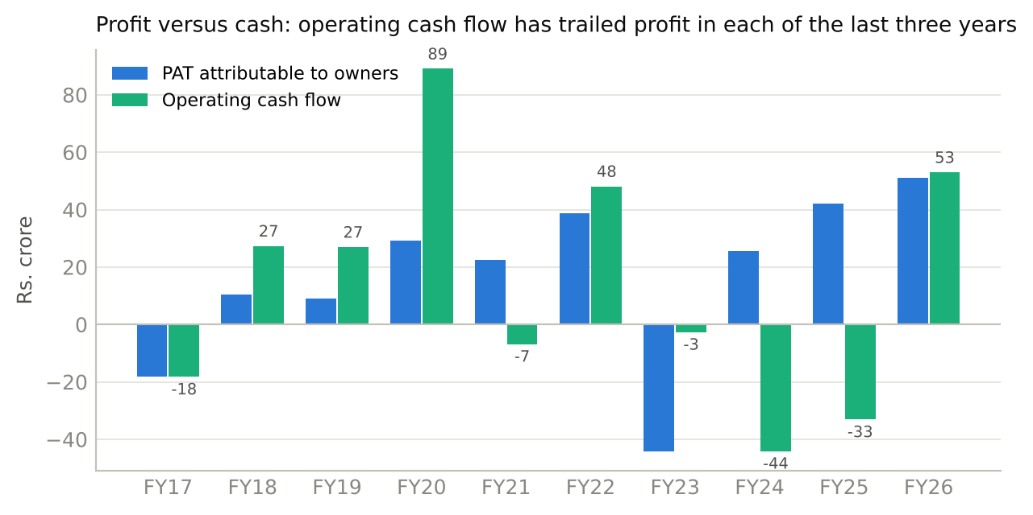
Exhibit 3. Profit attributable to owners against operating cash flow, FY17 to FY26. FY26 cash flow includes Rs.20cr of fixed-deposit redemptions. Source: model, from audited cash-flow statements.
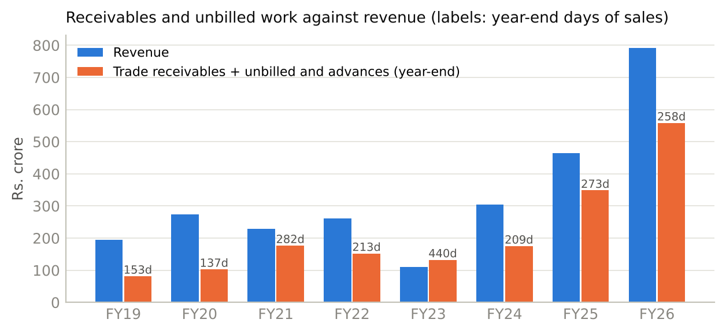
Exhibit 4. Revenue against year-end trade receivables plus unbilled work and advances, with days of sales. Source: model.
Accounting points an investor should know. Receivable and advance write-offs appear in seven of ten years, about Rs.78cr gross, with Rs.57cr of liability write-backs in five of them; in substance these recur. The consolidated audit was qualified in FY21, FY22 and FY23 over the Nigerian receivable and unverified Nigerian equipment; FY24 to FY26 are clean. FY26 exceptional items are Rs.6.7cr of Kuiper deal costs and a Rs.2.7cr write-off on a dispute whose counterparty is not named. The FY26 ESOP charge of Rs.9.2cr comes from a 2025 plan that granted 3.8 lakh options at a Rs.10 exercise price when the share was Rs.326, to employees of group entities as well as AESL and to a non-executive director. Fifteen Kuiper subsidiaries were unaudited in FY26 and the database-level audit trail was not enabled. The Kuiper purchase price allocation recognised no customer or workforce intangibles.
Treasury and Balance Sheet
Rs. crore | FY22A | FY23A | FY24A | FY25A | FY26A | FY27E
Cash and bank, incl. fixed deposits | 50.2 | 26.9 | 38.9 | 77.7 | 146.8 | v2
of which margin money against guarantees and borrowings | n.d. | n.d. | n.d. | 38.2 | 55.9
Current investments (liquid funds) | - | 13.1 | 3.4 | 18.4 | -
Gross debt | 7.3 | 19.1 | 21.3 | 23.7 | 158.1 | v2
Net debt / (net cash) | (42.9) | (20.9) | (21.1) | (72.4) | 11.3 | v2
Shareholders' funds | 241.8 | 199.5 | 277.9 | 398.7 | 494.2 | v2
Trade receivables + unbilled and advances | 152.3 | 132.3 | 175.0 | 348.5 | 558.2
Retention money within receivables | n.d. | n.d. | n.d. | 53.5 | 95.2

Source: annual reports; model. Net debt counts cash and bank including fixed deposits; Rs.55.9cr of the FY26 balance is pledged as margin money.
FY26 debt is new: a USD 6.7m Kotak term loan to the Dubai subsidiary for the Kuiper purchase (SOFR-linked, 7.0%, to FY31, guaranteed by AESL), a Rs.32cr Bank of Maharashtra term loan for plant and machinery (9.3%, to FY30, guaranteed by Oilmax) and Rs.61cr of working-capital lines secured by Oilmax corporate guarantees and the Garg family's personal guarantees and property. Covenants exist but are not disclosed; the board's gearing ceiling is 0.5x. The company describes itself as "net zero debt" on a standalone basis, which is true only if Rs.147cr of cash, a third of it pledged, is netted against Rs.158cr of group debt. CRISIL rates the facilities BBB+ with the rating on "Watch Developing" pending the merger; India Ratings' rating was withdrawn at the company's request in April 2026.
The Oilmax Merger
Oilmax Energy, the promoter company, is being absorbed into AESL. Shareholders approved the scheme in June 2026, the NCLT sanctioned it on 29-Sep-2026 and the certified order arrived on 15-Oct-2026; the record date is to be fixed. The terms and their arithmetic:
 | Amount | Note
Swap ratio | 117 AESL shares per 10 Oilmax shares | Bansi S. Mehta valuation, 6-Sep-2025; fairness opinion by Sundae Capital
Oilmax value per share | Rs.4,349 (DCF only, 100% weight) | Oilmax is unlisted; no market check possible
AESL value per share used | Rs.372 (ICDR floor; relative value Rs.357) | Share was Rs.326 on the day of the ESOP grant a month later
Oilmax equity value implied | About Rs.2,480cr | Of which about Rs.1,015cr is Oilmax's own 2.73cr AESL shares at Rs.372
Implied value of Oilmax's E&P and other business | About Rs.1,460cr | About 30x its FY25 standalone PAT of Rs.48.6cr
New AESL shares to Oilmax holders | 6.67cr; Oilmax's 2.73cr AESL shares cancelled | Share count 4.86cr to about 8.80cr
Promoter family post merger | 49.45% (deck figure of 51.7% predates the warrant conversion) | Oilmax's 68 outside shareholders (35% of Oilmax) become AESL public holders
Oilmax FY25 standalone | Revenue Rs.128cr, PAT Rs.48.6cr, net worth Rs.290cr | Includes dividend from AESL
Oilmax nine months to Dec-2025 | Revenue Rs.72cr, loss Rs.12.2cr | Rs.34cr ESOP charge; profit before ESOP and tax about Rs.22cr

What comes in: participating interests in Amguri (50%, producing about 1,850 barrels of oil equivalent a day at the group level), Duarmara (50%) and Tiphuk (80%), both "expected production in FY26" in the September-2025 deck and now FY27, South Rewa CBM (100%, under development), a Kutch shallow-offshore DSF-IV block (50%, operator, awarded August 2026), a quartzite mine, and "about 70 million barrels" of claimed reserves with no certified report in the public record. Management's target is Oilmax revenue of Rs.800 to 900cr and 10,000 barrels a day by FY30, from about 2,500 today.
What it does to the economics: at Rs.455 the market pays about Rs.3,030cr for the 6.67cr new shares, of which about Rs.1,240cr is the cancelled stake and about Rs.1,790cr the E&P business. Public holders of AESL go from a 44% claim on AESL's earnings to a 24% claim on the combined company; the swap is neutral to them only if Oilmax earns about Rs.42cr a year, which it did in FY25 and did not in the nine months since. The merger also removes a layer: the Rs.27.8cr of services AESL sold to Oilmax in FY26, the Oilmax guarantees on AESL's bank lines and the Indrora operatorship all become intra-group, which is the right structure even if the price of admission is dilution. It also takes the promoter below 50%.
Stock Price History
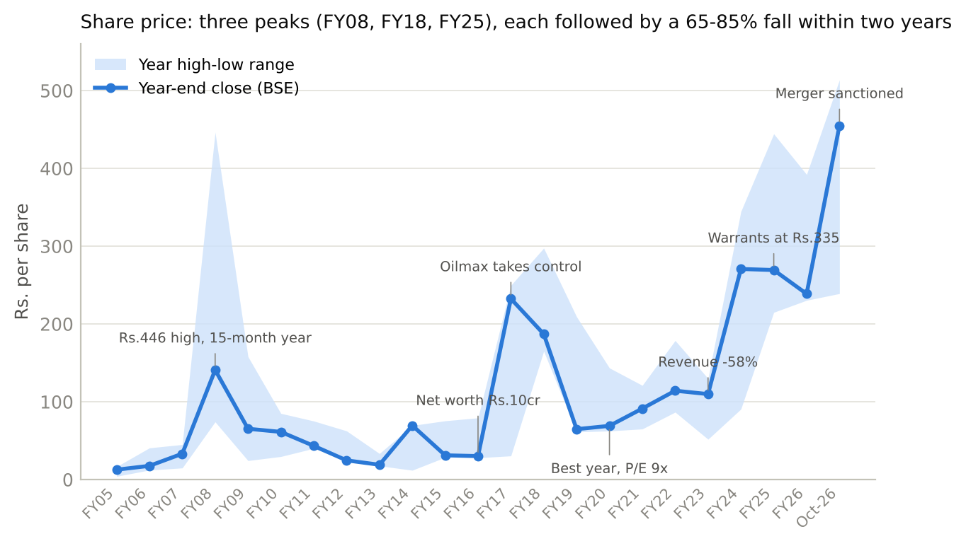
Exhibit 5. Share price, BSE year-end closes with the year's range, FY05 to October 2026. Source: ACE Equity; annotations from annual reports and filings.
- Three peaks, three drawdowns. Rs.446 in January 2008 on a 15-month year with Rs.9.6cr of profit and a Rs.40cr raise; the price took sixteen years to be seen again. Rs.297 in FY18 on the Oilmax re-rating, 69x earnings, then Rs.65 by March 2019. Rs.444 in September 2024 on the coal-plant order flow, then Rs.239 by March 2026 as margins fell and the merger dilution became known. Each peak was followed by a 65 to 85% fall within two years, which is why long-term holders have been trained to sell re-ratings.
- The best price coincided with the best numbers. At the March-2020 low of Rs.62 the company had Rs.82cr of net cash, Rs.29cr of profit and a P/E of 9x. The market was still pricing the FY18 collapse.
- The current leg. Rs.239 in March 2026 to Rs.455 in October: the 1QFY27 print (revenue up 135% on Kuiper), the GSECL order, the Mevad discovery and the merger sanction. Trailing P/E about 40x on FY26 EPS of Rs.11.4; EV/EBITDA about 21x; price to book about 4x. On the enlarged 8.80cr shares, FY26 EPS for AESL alone would be about Rs.5.9.
- Who sets the price. No mutual fund holds the stock; foreign portfolio investors hold 1.3%; the 2024 warrant round went to 28 family offices and individuals at Rs.335, of whom 22% let their warrants lapse in April 2026. BSE turnover averaged about Rs.1cr a day in the month to 16-Oct-2026. No sell-side initiation is referenced in any filing; call participants are small brokers. A Rs.2,200cr company priced by a handful of marginal buyers can move 30% either way on one quarter.
Valuation
Valuation in v2 will use P/E as the primary method for the services business with EV/EBITDA as the cross-check, and a NAV for the Oilmax blocks, on the post-merger share count and with net debt at FY26. For now, what the price implies.
At CMP Rs.455 | FY26A | Comment
Market capitalisation, 4.86cr shares | Rs.2,211cr | 8.80cr shares post merger: about Rs.4,000cr for the combined entity
P/E on FY26 EPS Rs.11.4 | 40x | Peers: Power Mech about 20x, Deep Industries about 20x on published figures, to be confirmed with Bloomberg
EV/EBITDA on FY26 Rs.95cr | 21x
Price to book | 4.1x | ROE 11.5%
Earnings the price needs at 20 to 25x | Rs.90 to 110cr | FY26 PAT Rs.52cr; 1QFY27 run-rate Rs.13cr a quarter

Source: model; ACE Equity. Peer multiples indicative; Bloomberg data with a single date will replace them in v2.
The arithmetic the stock has to satisfy: the FY27 standalone guide of 30 to 40% growth with margins up 100 to 200 basis points, Kuiper at USD 60 to 65m at 7 to 9%, and Oilmax at or above Rs.42cr of profit. Delivered together, pro forma FY27 EPS on 8.80cr shares lands near Rs.14 to 16 and the stock is on about 30x. Delivered without Oilmax, EPS is nearer Rs.9 to 10 and the stock is on 45 to 50x. The v2 scenarios will be built on those operating paths, not on multiples alone.
Corporate Governance Checks
Parameter | Status | Comment
Promoter holding | 56% after May-2026; 49.45% post merger | Oilmax has put in money three times (FY17 to FY18, 2023, 2024) and converted warrants at discounts of 60 to 70% to the market in 2024
Pledges | Nil | Oilmax and the Garg family give corporate and personal guarantees for bank lines
Independent directors | 3 of 7; independent chairman (ex-Oil India CMD) | Two of four non-independents are family; two non-executives hold ESOPs; an independent director resigned in January 2026 at 75
Earnings calls | Seven in six and a half years; none in FY21, FY22, FY24; half-yearly since FY25 | Quarterly decks; the September-2025 merger call was announced at two days' notice
Related-party transactions | Material | Oilmax is customer (Rs.27.8cr), operator of Indrora, guarantor, landlord through the promoter family, and holds an approved ceiling of Rs.1,000cr for a mine-development contract; JV receivables Rs.91cr
Auditor | SGCO & Co from FY26 after Walker Chandiok completed two terms | Clean FY26 opinion; qualified FY21 to FY23; 15 Kuiper subsidiaries unaudited; audit trail not enabled
Penalties and regulatory | None disclosed | ONGC tender holiday of six months to March 2025 on unexplained "technical grounds"
Dividend record | Rs.1.00 for FY25, Rs.1.25 for FY26; none before | Started in the same two years as Rs.170cr of equity and warrant money came in
Treasury | Rs.147cr cash and bank at FY26, Rs.56cr pledged; Rs.6.2cr EV start-up investment written off | Borrowing at 7 to 9% while earning 4% on deposits
Compensation | MD pay up 76% to Rs.2.8cr, 51x the median; Rs.10-strike options; options to a non-executive director and to holding-company staff | Approved by shareholders; worth watching post merger

The real red flags are the promoter sitting on both sides of the ledger with a DCF-priced merger, the operating-head departures just before the merger, and a small audit footprint over a newly international group. The structural quirks, which are uncomfortable but explainable, are the JV-routed revenue (a consequence of Coal India qualification rules), the dormant offshore shells with negative net worth (Samara-era residue), and the personal guarantees (skin in the game).
Management Team
Name and role | Background | Assessment
Dr Kapil Garg, Managing Director, promoter | IIT Roorkee; ONGC, Enron, GAIL; former MD of BG Group India; founded Oilmax in 2008; on the board since 2020 | The strategy is his: coal plants, Indrora, Kuiper, the merger. Deep upstream pedigree. Key-man risk is high: no COO since July 2024, the merger makes him operator, service provider and controlling shareholder at once
Nirav Talati, CFO | Statutory CFO; background not disclosed | Earnings calls are fronted by Sumit Maheshwari, "Group CFO", who is not a listed-company officer; the two-CFO structure blurs accountability
Nayan Mani Borah, Chairman, independent | Former Chairman and MD of Oil India; chairs the audit committee; full attendance | Credible industry elder and a useful face with the PSU customers
Dr Rabi Bastia, non-executive director; "CEO, E&P" in the group chart | Padma Shri; led Reliance's exploration for 16 years | Technical anchor for the E&P ambition; paid in options while sitting as a non-executive; weakest attendance
Anil Kumar Jha, independent | Former Chairman of Coal India | Directly relevant to the coal-plant franchise
Aman Garg, non-executive; son of the MD | Mechanical engineering graduate (2021); worked at Oilmax | Succession signal; sits on the committees that set options and pay with thin experience
Parikshit Datta, non-executive; Oilmax director | Former senior tax partner at EY | Appointed May 2025 ahead of the merger; a promoter-side director
Kuiper leadership | CEO Himanshu Naharas and operations director Scott McIlwraith, named on one slide | Retention of the inherited team is the thesis for that business; no terms disclosed

Three of the four senior managers listed in the FY26 annual report (procurement, seismic, O&M) resigned in August and September 2026. The company suits investors comfortable underwriting one person's capital allocation and a related-party-heavy structure; it does not yet have the management depth, disclosure cadence or free float that institutions require.
Triggers to Watch
- Record date and listing of the merger shares (October to November 2026). Confirms the share count and the promoter's sub-50% holding, and whether a doubled public float brings supply.
- H1FY27 results (November 2026). Standalone growth against the 30 to 40% guide; consolidated margin against 12 to 13%; operating cash flow before treasury movements; receivable plus unbilled days at September 2026. This is the first test of the view.
- First post-merger segment disclosure (likely 3QFY27, February 2027) and Oilmax's FY26 audited accounts. Whether Oilmax earns the Rs.42cr a year the swap needs, and whether the nine-month loss was ESOP alone.
- First oil at Tiphuk and Duarmara (guided for Q1FY27, already slipped) and the Amguri gas connection. The production ramp the merger valuation assumes.
- Commissioning of Hura, Singareni and Gevra coal plants and release of retention (Rs.95cr) by March 2027. Whether projects complete and cash follows.
- CRISIL's resolution of "Watch Developing" after the merger, and any board notice of a preferential or warrant issue. An independent view of the enlarged balance sheet; or the dilution pattern repeating.
Key Risks
- Oilmax earns less than the swap assumes. The merger was valued on FY25 profit of Rs.48.6cr; the nine months to December 2025 show a Rs.12.2cr loss and both new fields have slipped a year. Below about Rs.42cr of Oilmax profit the swap dilutes existing holders' earnings, and the enlarged share count is permanent. We would know from the first post-merger segment numbers and the FY26 Oilmax accounts.
- Cash does not follow profit and equity is raised again. Rs.512cr of receivables and unbilled work, Rs.95cr of it retention and Rs.91cr owed by the company's own JVs, against Rs.158cr of new debt; a ten-year record of funding growth with equity. A further raise below today's price would confirm the pattern. We would know from H1FY27 cash flow and any board notice.
- Kuiper's rig-count exposure and the Gulf. A 7%-margin crew-supply business that lost 17% of its revenue in 2024 when Aramco parked rigs, and was disrupted in Qatar in March 2026, now 38% of consolidated revenue with a SOFR-linked loan behind it. We would know from the gap between consolidated and standalone revenue each quarter.
Other risks | How we would lose | What would tell us
Concentration in Vedanta (about 40% of the book) and MCL | A slower Vedanta well programme or a contract variation removes the growth driver; the FY23 template shows costs do not flex | Wells drilled and facilities milestones in the decks; Vedanta capex disclosures
Execution and guidance | Twelve of 27 scored promises missed; FY26 standalone guide missed by 24 to 30%; three operating heads gone | Quarterly standalone revenue against the guide; replacement appointments; commissioning filings
Governance and related parties | Promoter as counterparty on both sides; approved RPT ceilings up to Rs.1,000cr; Rs.10-strike options; small auditor over 25 foreign entities | Annual report RPT schedules; audit committee disclosures; any emphasis of matter
Seismic decline | Market of Rs.250 to 400cr a year, both contractors shrinking, ONGC going in-house, fleet not renewed | Seismic order intake; ONGC tender outcomes
Things that cannot be verified | Kuiper's standalone profit, Oilmax's reserves, which contracts ended in FY23, whether the coal plants are commissioned, the loan covenants | Management clarification at the first meeting
Long-dated | Coal India's plant programme tails off after FY29; ONGC's incremental rupee is offshore; Gulf crewing follows OPEC+ | 2029 onward

Final Outlook
Rating: Under review | Target Price: v2 | Preliminary view: cautious (CMP Rs.455, market cap Rs.2,211cr; about Rs.4,000cr post merger)
Asian Energy Services enters FY27 as a different company from the one that reported FY25: Kuiper makes it 38% international at a third of the margin, the Vedanta integrated contract makes it a field developer rather than a maintenance contractor, and the Oilmax merger makes it an oil producer with a promoter who no longer holds a majority. The order book of Rs.1,754cr is real and the coal-plant franchise has few competitors. Those are the reasons the stock has doubled since March.
The reasons for caution are in the record rather than the story. Each of the company's five cycles was carried by one or two contracts and ended when they did; the current book has the same shape. Profit has not turned into cash in any of the last three years, growth has been paid for with equity in every cycle, and the share count is about to double again at a swap ratio set before the merging company turned loss-making. At 40x trailing earnings the price assumes that the FY27 guide is met, that Kuiper's margin improves and that Oilmax's fields produce on schedule, and none of the three has yet appeared in a reported quarter.
The next two results will settle most of this. H1FY27 in November shows whether standalone growth and cash conversion are on track; the first post-merger quarter shows what Oilmax contributes. Until then the honest position is that the services business is worth owning at a price that reflects a 12 to 14% margin contractor with slow collections, and that the merger is an unpriced variable with a wide range. The forecast model in v2 will put numbers and a rating on both.

Appendix
A. Order book history
Date | Order book, Rs. cr | Mix | Trailing revenue | Note
Dec-2019 | 997 (1,343 incl. Iraq) | Seismic 58% | 250 | Included a USD 37m Iraq award never executed
Aug-2022 | above 500 | Mostly coal plants; seismic 60 | 260 | Tendering had stopped
Nov-2023 | about 900 | 3 coal, 3 O&M, 4 seismic contracts | 110
Jun-2024 | 1,033 | Coal 63%, O&M 33%, seismic 4% | 305
Mar-2025 | 973 | Coal 36%, O&M 56%, seismic 8% | 465
Aug-2025 | 1,688 | Oil and gas 75% after the Vedanta award | about 520 | Definition changed to standalone, ex-GST, ex-Kuiper
Nov-2025 | 2,005 | Coal 33%, O&M 62%, seismic 4% | about 525 | MCL Lakhanpur added
Mar-2026 | 1,750 | Oil and gas 68%, mineral 32% | 492
Aug-2026 | 1,754 | Oil and gas 60%, mineral 40% | about 526 | GSECL added; management says 60 to 70% executes in FY27 and FY28

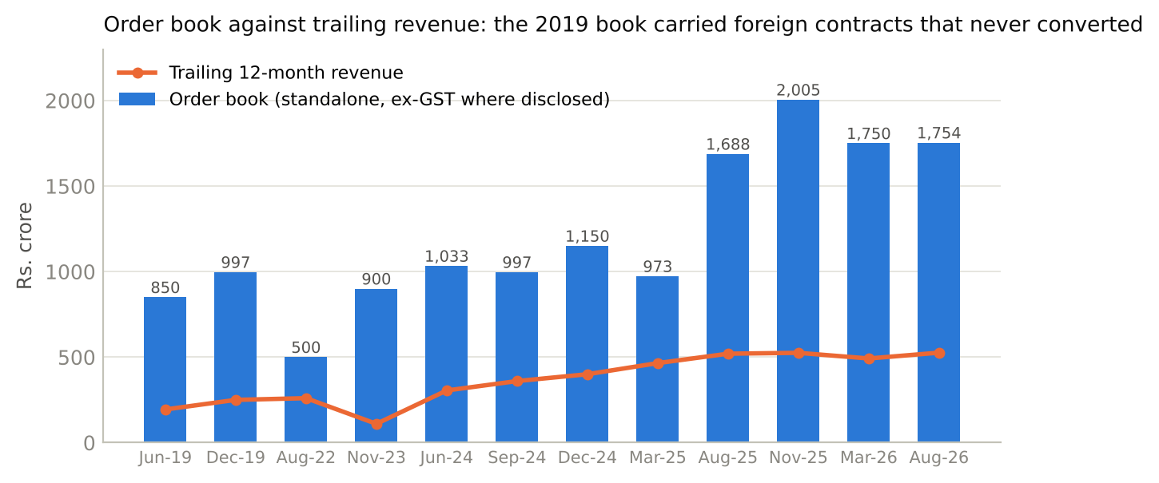
Exhibit 6. Order book against trailing twelve-month revenue, 2019 to 2026. Source: investor decks, calls and press releases; revenue from the model.
B. Order wins since 2022
Date | Customer | Value, Rs. cr | Scope | Tenure
Jan-2022 | Vedanta | 248 incl. GST | Suvali and Cambay O&M | 4 + 1 years; extended to Mar-2027
Feb-2022 | Eastern Coalfields (Zuberi-Asian JV) | 128 incl. GST | Hura coal handling plant, BOOT | Build + 5-year O&M
FY22 | HEC (Gevra) | 236 | Coal plant expansion, sub-contract | n.d.
Jun-2023 | ONGC | 78 | 3D seismic, Gujarat | 11 months
Aug-2023 | GAIL | 17 | Seismic, Rajasthan | 6 months
Jan-2024 | Eastern Coalfields | 22 | Rajmahal plough feeders | 8 to 9 months
Feb-2024 | Central Coalfields | 250 incl. taxes | Karo coal plant with silo | EPC + 5-year O&M
Mar-2024 | Hardy Exploration | about 48 (LoI) | PY-3 flowlines and risers | FY25
Jun-2024 | Sun Petrochemicals | 38 | 3D seismic, Gujarat | 6 months
Jun-2024 | SCCL (Asian-Indwell JV) | 148 + GST | PKOCP coal evacuation conveyors | 18 months
Sep-2024 | Oil India | about 82 | 2D seismic, Rajasthan, 4,300 line-km | 18 months
Dec-2024 | Assam Gas Company | about 200 | Compressor station, BOOT | 3 years
Apr-2025 (closed Aug) | Kuiper Group (acquisition) | USD 9.25m | 100% of Kuiper | -
Jul-2025 | Vedanta | 772 ex-GST | Integrated field development, Rajasthan satellite fields | 57 months
Jul-2025 | Sun Petrochemicals | about 46 | 3D seismic, Gulf of Khambhat | 12 months
Nov-2025 | Mahanadi Coalfields (Asian-Global JV) | about 459 incl. GST | Lakhanpur coal plant, turnkey + O&M | 7 years
Dec-2025 | Sun Petrochemicals | 55 | 4D seismic, Bhaskar field | 1 year
Jun-2026 | Oil India | empanelment | Onshore 2D and 3D | 3 years
Jun-2026 | GSECL | 188 incl. GST | Ukai thermal station coal plant, lump-sum EPC | 2 to 3 years

C. Promised versus delivered, the ten that matter
Promise and source | Outcome | Verdict
No single client above 30 to 40% of revenue by FY23 (calls, FY20) | Top customer 43% in FY23, 24% in FY25 | Missed
Complete the Nigerian Langley project by September 2020 | Suspended November 2020, terminated 2021, receivable qualified | Missed
USD 37m Bashneft Iraq seismic contract "in December" 2019 | Never executed | Missed
Rs.570cr Vedanta seismic framework over two years (FY20) | Phase completed; amount called out never disclosed | Partly
Hura coal plant commissioned in FY24, then FY25, then FY26 | No commissioning announced to October 2026 | Missed
FY25 revenue Rs.450 to 500cr (November 2024) | Rs.465cr | Delivered
FY26 standalone revenue Rs.650 to 700cr, EBITDA Rs.110 to 120cr (May 2025) | Rs.492cr, Rs.78cr | Missed by 24 to 30%
Indrora above 300 barrels a day by December 2023 (April 2023) | About 100 in September 2025; 150 to 200 in May 2026 | Missed
Kuiper closing "within two months" (April 2025) | Closed 29-Aug-2025 | Delivered, late
Oilmax merger in about 12 months (September 2025) | NCLT order 29-Sep-2026 | Delivered

Of 27 commitments scored in the evidence file: 5 delivered, 6 partly, 12 missed, 4 too early.
D. Sources
Annual reports FY16 to FY26; quarterly results, investor presentations and earnings-call transcripts FY20 to 1QFY27; Regulation 30 filings on contracts, capital raises and management changes; the Oilmax merger scheme documents (valuation report, fairness opinion, shareholder notice, NCLT orders, Oilmax three-year financials and nine-month accounts to December 2025); CRISIL and India Ratings rationales; ACE Equity consolidated and standalone financials; ONGC, Oil India, Coal India and Vedanta disclosures as published; Ministry of Coal and DGH figures as reported in parliamentary replies and press summaries. The supporting evidence file carries the document and page for every figure in this note.

