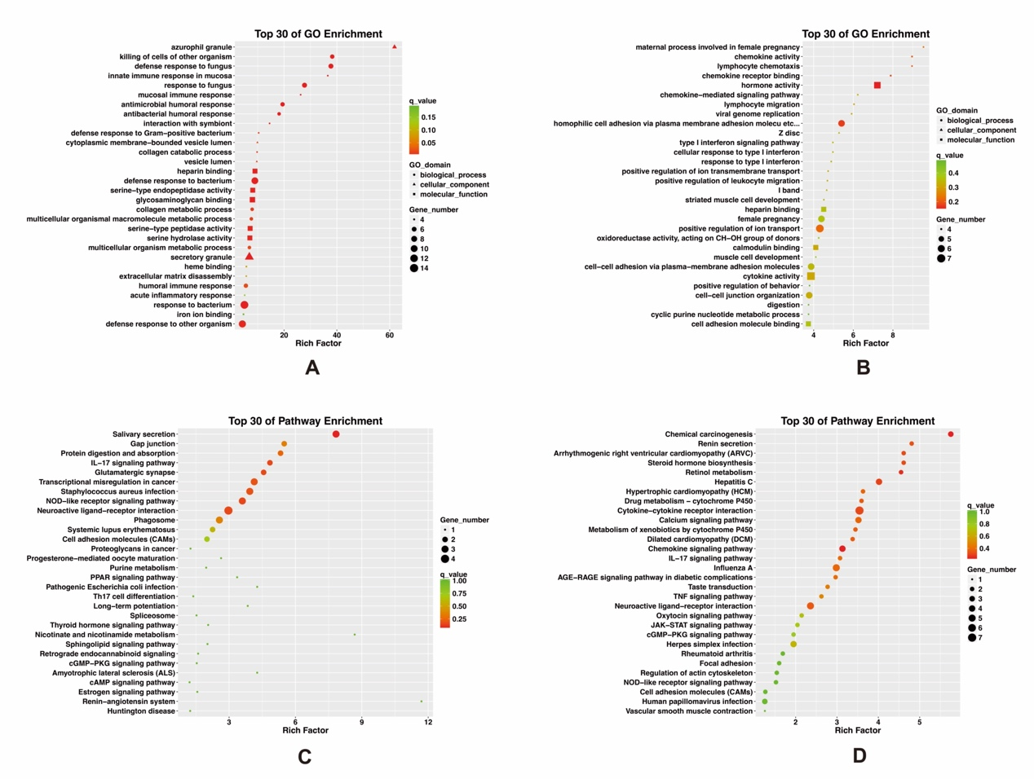
Fig. S1. Gene enrichment analysis of upregulated and downregulated DEGs. (A) and (B) are bubble plots of GO enrichment analysis for upregulated and downregulated DEGs, respectively, showing the top 30 enriched GO terms. (C) and (D) are bubble plots of KEGG enrichment for upregulated and downregulated DEGs, respectively, showing the top 30 enriched KEGG pathways. A larger Rich Factor and smaller q-value indicate a higher enrichment level. Larger bubbles indicate more enriched genes.

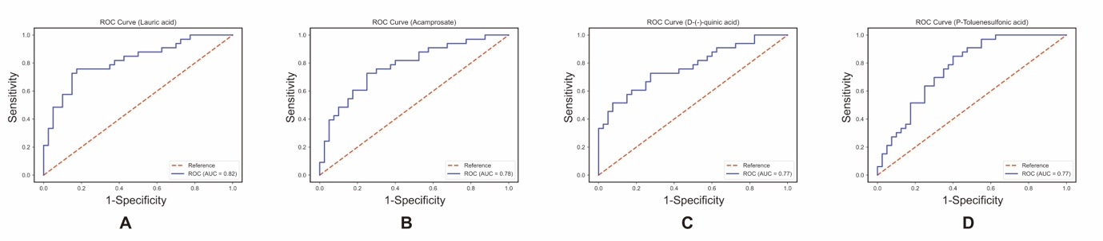
Fig. S2. AUC for differential metabolites Lauric acid, Acamprosate, P-Toluensulfonic, and D-(-)-quinic acid, respectively.

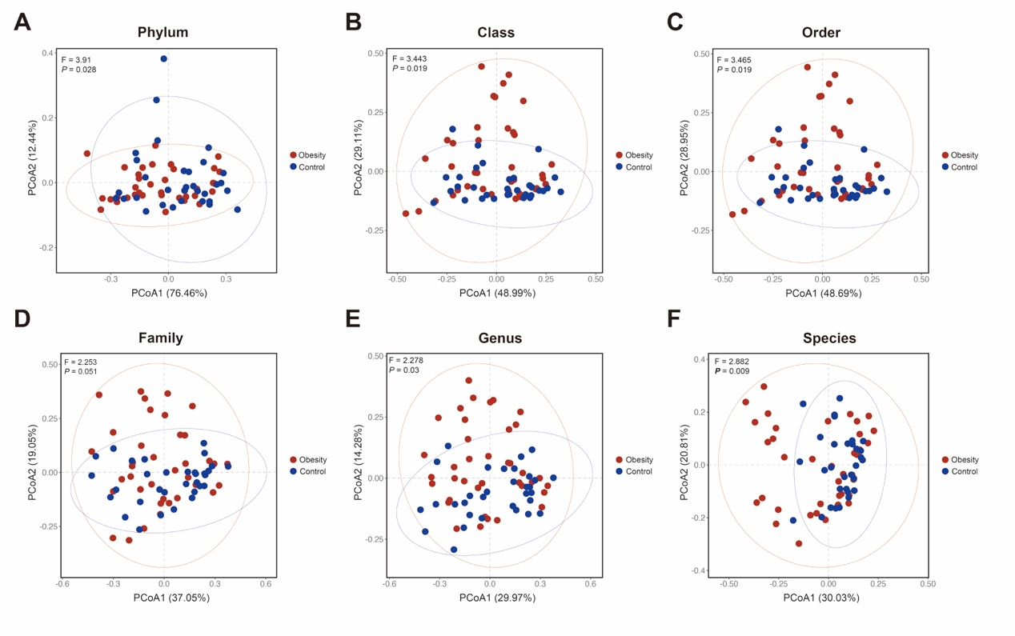
Fig. S3. Beta diversity comparison of gut microbiota between two groups at different taxonomic levels (Phylum, Class, Order, Family, Genus, and Species) based on PERMANOVA analysis.

