**Setting Up My Developer Environment**

This document outlines the steps I took to set up my developer environment for software engineering projects. It includes details on the chosen tools, configurations, and any troubleshooting encountered during the process.

1. **Operating System:**

I chose to install **Windows 10** (hardware requirements for Windows 11 could not be met). Downloaded the installer from the official Microsoft website:  
(<https://www.microsoft.com/en-gb/software-download/windows10>). Installing Windows 10 involves creating a bootable USB drive and using it to boot your computer and run the installation process.

**Downloading the Installation Media:**

1. Visited the Microsoft software download website: <https://www.microsoft.com/en-us/software-download/windows10%20>
2. I Clicked the blue button "Download tool now" to download the Media Creation Tool.
3. Then I ran the downloaded Media Creation Tool.

**Creating Bootable USB Drive:**

1. Downloaded the automation tool, accepted the license terms and clicked "Next."
2. Chose "Create installation media for another PC" and clicked "Next."
3. Selected the language, edition (Windows 10 Pro), and architecture (64-bit).
4. Chose "USB flash drive" and selected my USB drive from the list. Clicked "Next."
5. The tool downloaded Windows 10 and created the bootable USB drive.

**Booting from the USB Drive:**

1. Once the bootable USB drive was created, I restarted my laptop.
2. During startup, I pressed the key used to enter the boot menu for my laptop which is F10.
3. In the boot menu, I select my USB drive as the boot device.
4. My computer booted from the USB drive and launched the Windows 10 setup process.

**Installing Windows 10:**

1. I followed the on-screen instructions during the setup process.
2. I chose my language, time zone, and keyboard layout.
3. Agreed to the license terms.
4. Since I was upgrading from a previous version of Windows, I was prompted to keep your personal files and settings.
5. I selected the drive where I want to install Windows 10.
6. The installation process began and took some time to complete.
7. Once the installation was completed, my laptop restarted automatically.
8. **Text Editor/IDE:**

I opted for **Visual Studio Code (VS Code)** as a versatile and popular IDE, and it was also recommended. Downloaded and installed it from the official website: <https://code.visualstudio.com/download>

**Downloaded the VS Code Installer:**

* Opened my Google Chrom web browser and visited the official VS Code download page: <https://code.visualstudio.com/download>
* Clicked on blue Windows button to download the installer.

**Ran the Installer:**

* Once the download finished, I located the downloaded file in my downloads folder.
* I double-clicked the downloaded file to launch the installer.

**Accepted License Terms:**

* The VS Code setup window popped up and I read the license terms carefully.
* I agreed to the terms by clicking the "I Agree" button.

**Chose Installation Options:**

* Chose installation folder and reviewed other options. And clicked the install button.
* Clicked the "Finish" button to complete the installation.

1. **Version Control System:**

**Installed Git:**

* Visited the official Git website: <https://www.git-scm.com/downloads>
* Downloaded the installer for my operating system Windows.
* Ran the downloaded installer and followed the on-screen instructions.

**Configured Git:**

* Opened my terminal.
* Typed the following command and pressed enter to verify Git installation:

git --version

**Created a GitHub Account:**

* Visited the GitHub website: <https://github.com/>
* Clicked on "Sign Up" and created a free account using my email address and a chosen username.

**Initialized a Git Repository:**

* I opened a terminal window and navigated to my project directory using the cd” command. For example: cd Desktop/my-project
* In my project directory, I initialized a Git repository by typing the following command and pressing Enter: git init

**Created a Sample File:**

* Created a simple "README.md" file (a common file for project descriptions). Wrote some basic information about my project in this file. Saved the file.

**Add Files to Staging Area:**

* Used the git add command to tell Git which files I want to track for version control.

**Commit Your Changes:**

* Finally, committed the staged changes with a descriptive message using the git commit command.
* Pressed Enter to create my first commit.

1. **Install Necessary Programming Languages and Runtimes:**

**Download the Python Installer:**

* Visited the official Python downloads website: <https://www.python.org/downloads/>
* Under the "Latest Python Releases" section, I located the download link for Windows. Chose the 64-bit version (amd64).

**Run the Installer:**

* Double-clicked the downloaded installer file.
* Installation took a few minutes.

**Verify Installation (Optional):**

* Opened a terminal window
* Typed the following command and pressed Enter to verify installation: python –version

1. **Package Managers:**

Since I chose Python, **pip** (Python's package manager) was automatically installed to manage dependencies.

1. 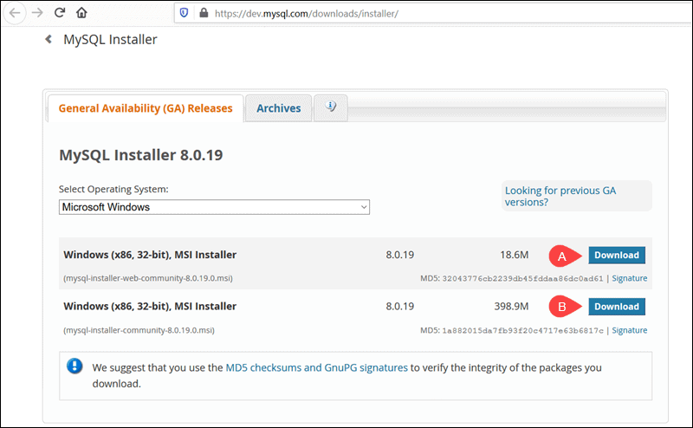**Configure a Database (MySQL):  
     
   Download MySQL Installer for Windows**Selected and downloaded my preferred version. I selected the Full MySQL Package (B).  
     
     
     
     
     
     
     
     
     
     
     
     
     
     
   Didn’t sign up for free account  
     
   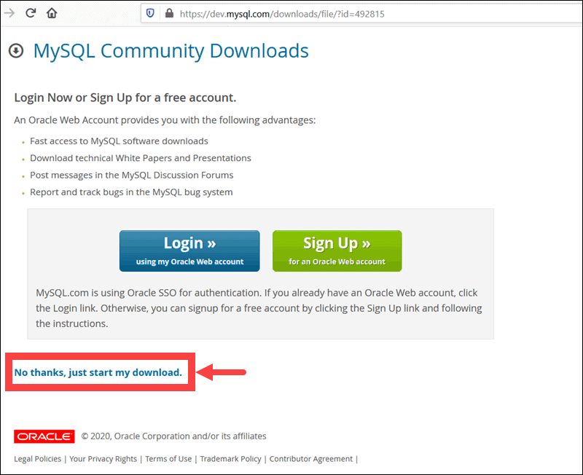

**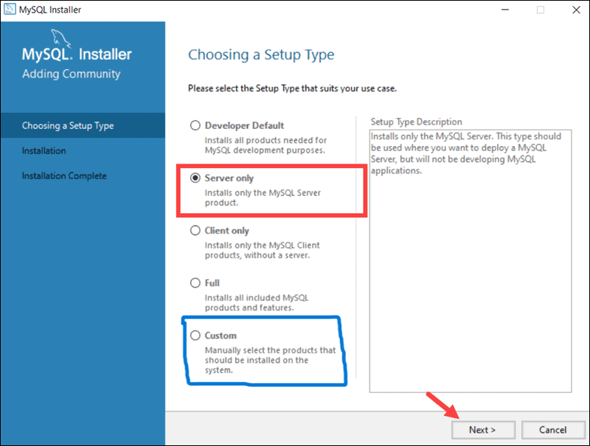  
  
  
  
  
  
  
  
  
  
  
  
  
  
  
  
  
  
  
  
  
  
  
  
  
  
  
Setup MySQL Installer for Windows:**After accepting the Oracle license agreement terms, the first screen you encounter allows you to define which MySQL products are going to be installed. I chose the custom setup type in blue.