**#Assignment: Setting Up Your Developer Environment**

1. Select Your Operating System (OS):

**Choose an operating system that best suits your preferences and project requirements. Download and Install Windows 11. https://www.microsoft.com/software-download/windows11I have downloaded and installed the windows**

I have already installed the windows 10 pro. I do not have a license so it was difficult to download windows 11. The steps followed include:

1. Obtain a Windows installation media (DVD or USB) from Microsoft's website.
2. Insert the installation media into your computer and restart.
3. Enter BIOS/UEFI settings (typically by pressing Del, F2, or Esc) to prioritize booting from the installation media.
4. Follow on-screen prompts to begin installation.
5. Choose installation type (e.g., upgrade or custom).
6. Select the drive for installation and format if necessary.
7. Complete installation by following prompts for language, region settings, and user account creation.

**2. Install a Text Editor or Integrated Development Environment (IDE):**

**Select and install a text editor or IDE suitable for your programming languages and workflow. Download and Install Visual Studio Code. https://code.visualstudio.com/Download**

I downloaded and installed the VS code as it is excellent for most languages and has extensive plugin support. The steps include:

1. Go to the official Visual Studio Code (VS Code) website.
2. Click on the "Download" button for your operating system (Windows, macOS, Linux).
3. Once downloaded, open the installer.
4. Follow the on-screen instructions to install VS Code.
5. After installation, launch VS Code.

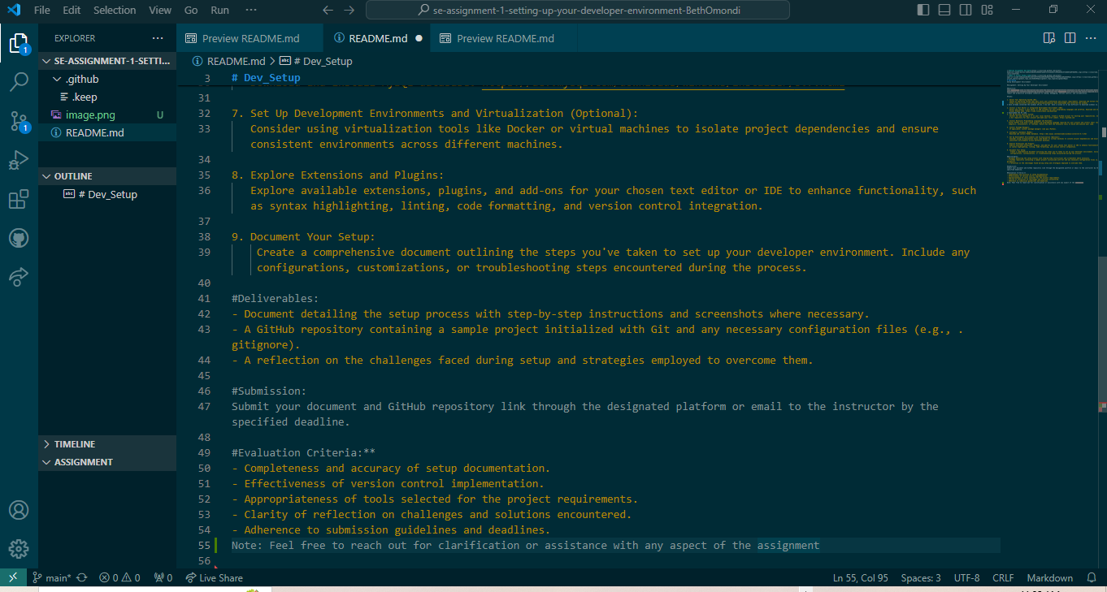

3. **Set Up Version Control System:**

**Install Git and configure it on your local machine. Create a GitHub account for hosting your repositories. Initialize a Git repository for your project and make your first commit.** [**https://github.com**](https://github.com)

I created a github account. The steps include:

1. Go to github.com and click on "Sign up."

2. Enter your desired username, email address, and password.

3. Click "Create account."

4. Verify your email address by clicking the link sent to your email.

5. Optionally, complete your profile with a profile picture and bio.

6. Your GitHub account is now created and ready to use.

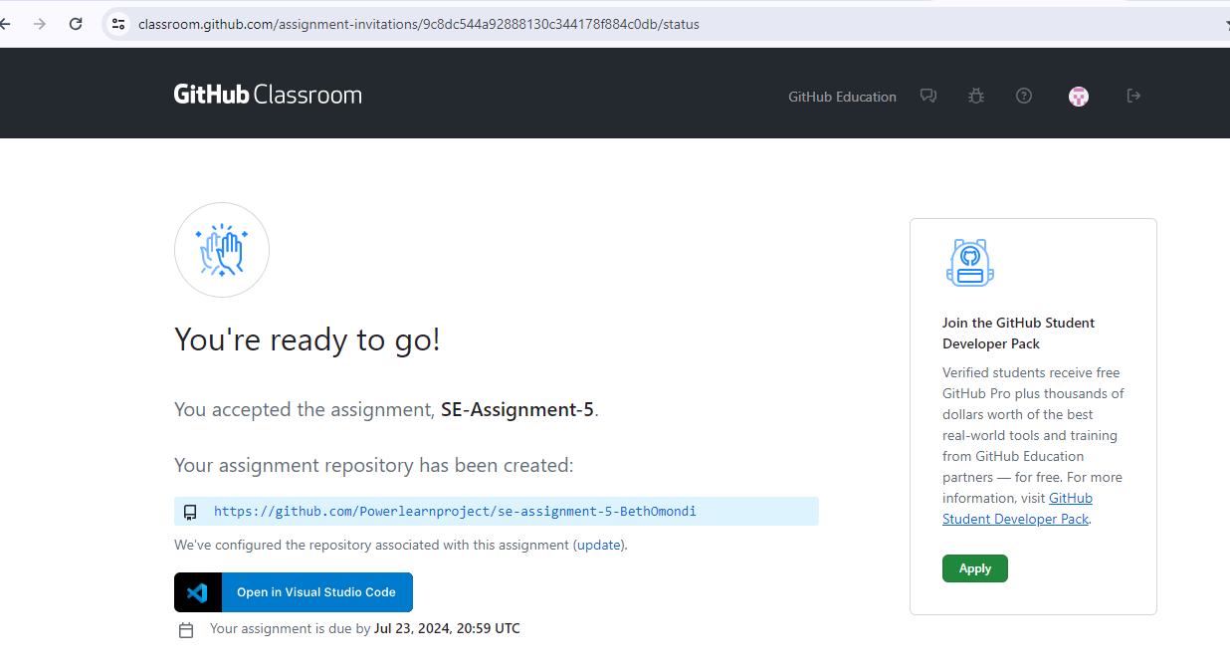

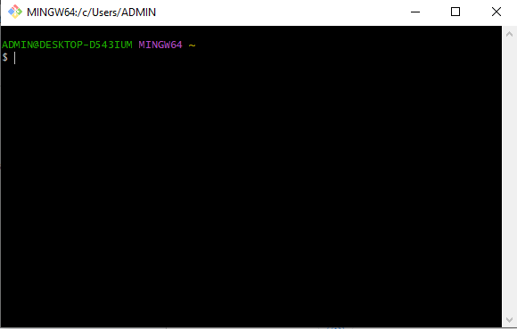

**4. Install Necessary Programming Languages and Runtimes:**

**Instal Python from http://wwww.python.org programming language required for your project and install their respective compilers, interpreters, or runtimes. Ensure you have the necessary tools to build and execute your code.**

I installed Python.

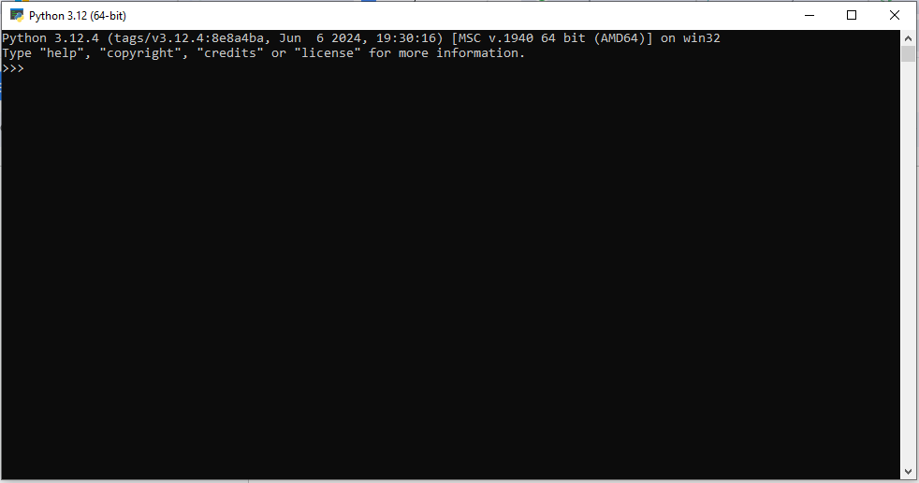

5. Install Package Managers:

If applicable, install package managers like pip (Python).

**6. Configure a Database (MySQL):**

**Download and install MySQL database. https://dev.mysql.com/downloads/windows/installer/5.7.html**

**I installed My SQL**

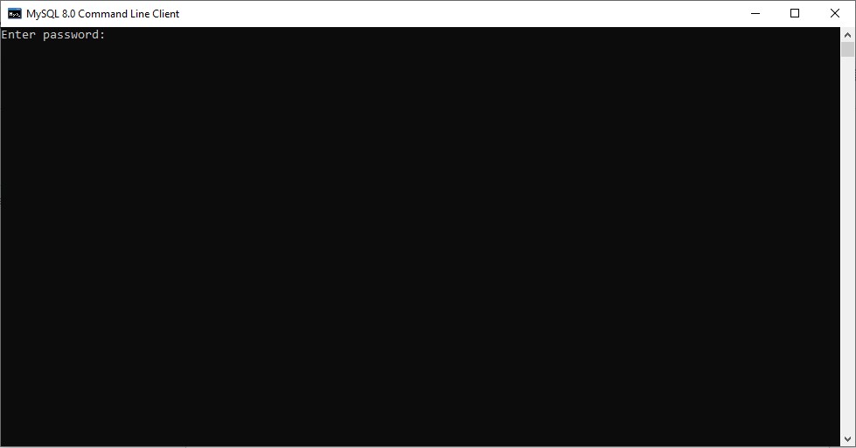

7. Set Up Development Environments and Virtualization (Optional):

Consider using virtualization tools like Docker or virtual machines to isolate project dependencies and ensure consistent environments across different machines.

8. Explore Extensions and Plugins:

Explore available extensions, plugins, and add-ons for your chosen text editor or IDE to enhance functionality, such as syntax highlighting, linting, code formatting, and version control integration.

9. Document Your Setup:

Create a comprehensive document outlining the steps you've taken to set up your developer environment. Include any configurations, customizations, or troubleshooting steps encountered during the process.

#Deliverables:

- Document detailing the setup process with step-by-step instructions and screenshots where necessary.

- A GitHub repository containing a sample project initialized with Git and any necessary configuration files (e.g., .gitignore).

- A reflection on the challenges faced during setup and strategies employed to overcome them.