SETUP DEVELOPMENT ENVIRONMENT

1. Select your Operating system  
   *My laptop is MacbookAir am using MacOs*
2. Installation of microsoft visual studio code
3. *Downloading from the visual studio code website*

*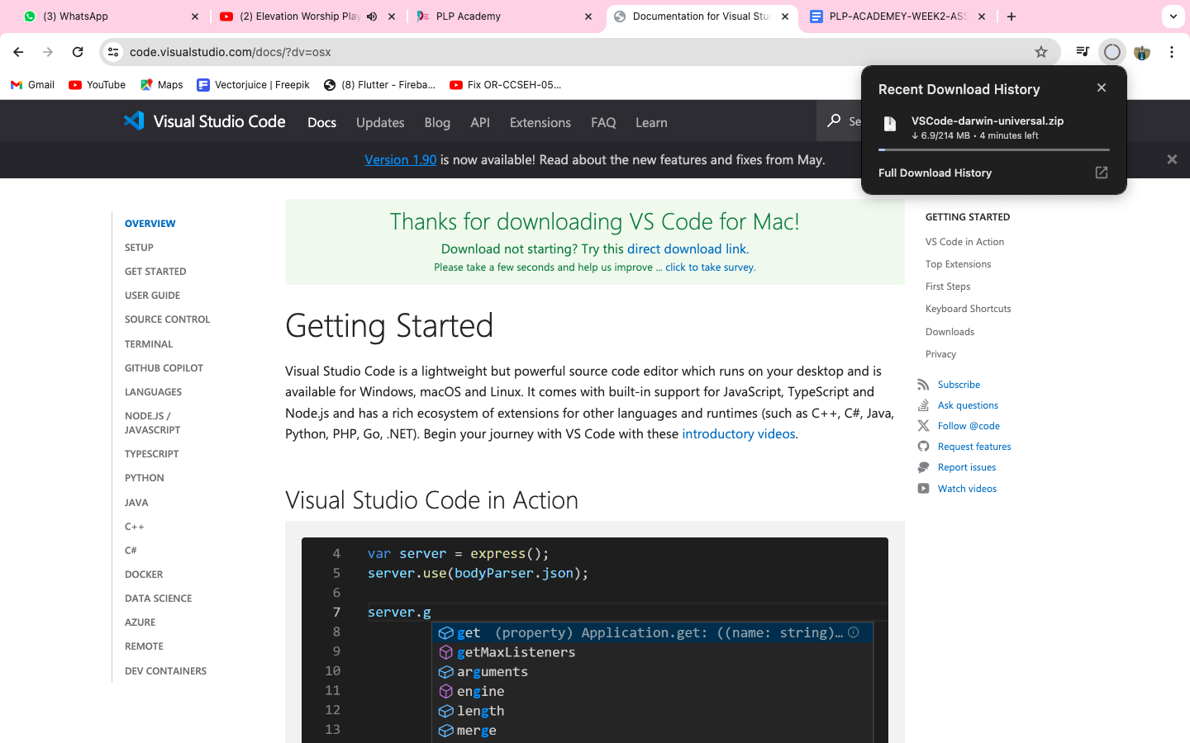*

1. *Setting up visual studio code in my mac-os laptop*

*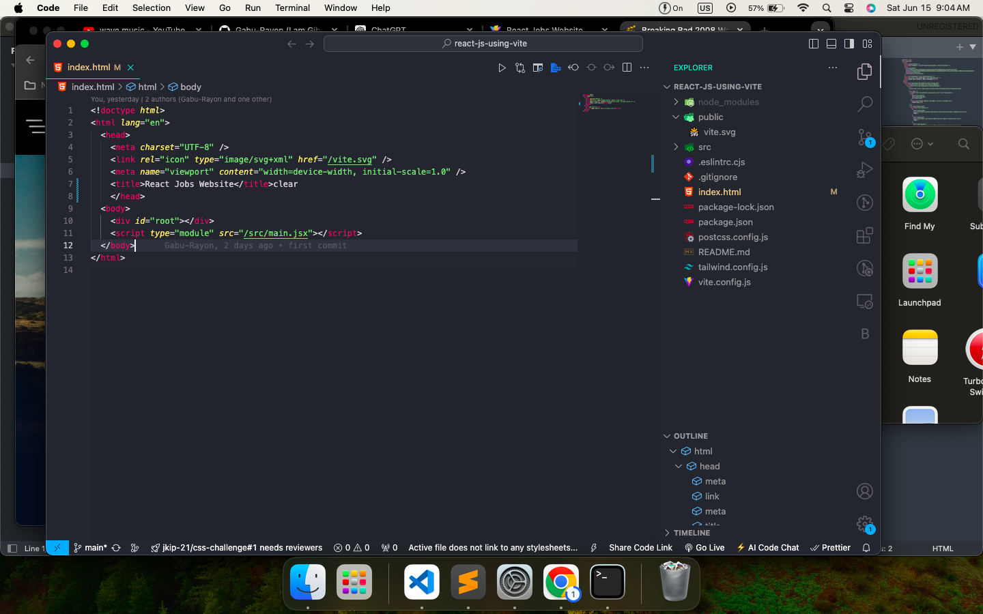*

*3.* Installing git and configuring it to my machine

1. *Installing git using Homebrew.*

*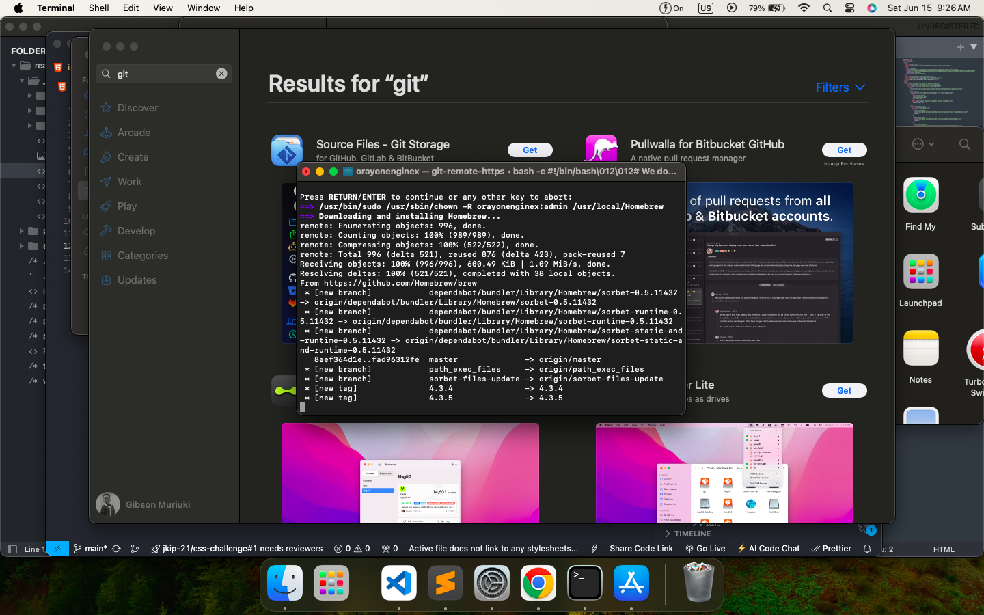*

*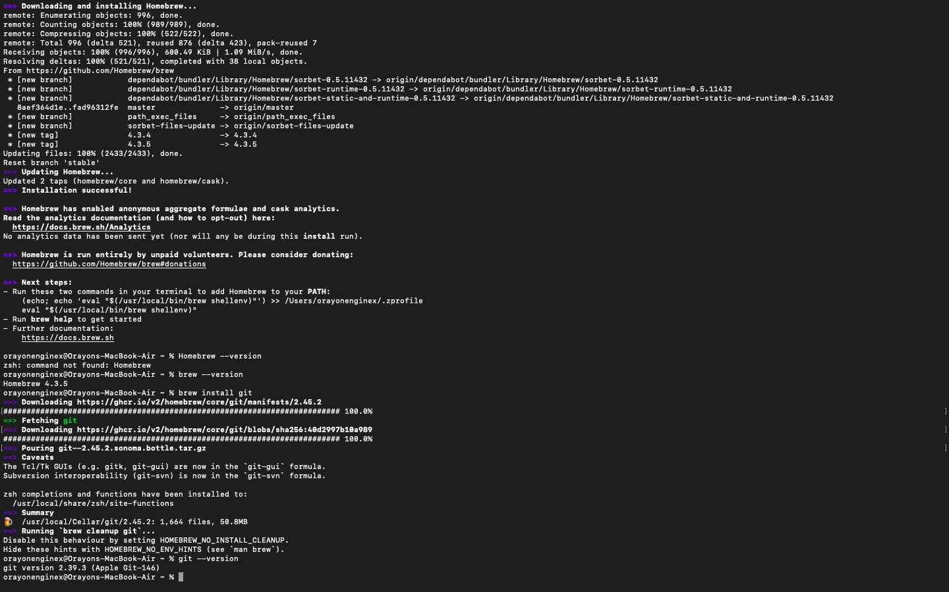*

*Setting up git in my machine*

*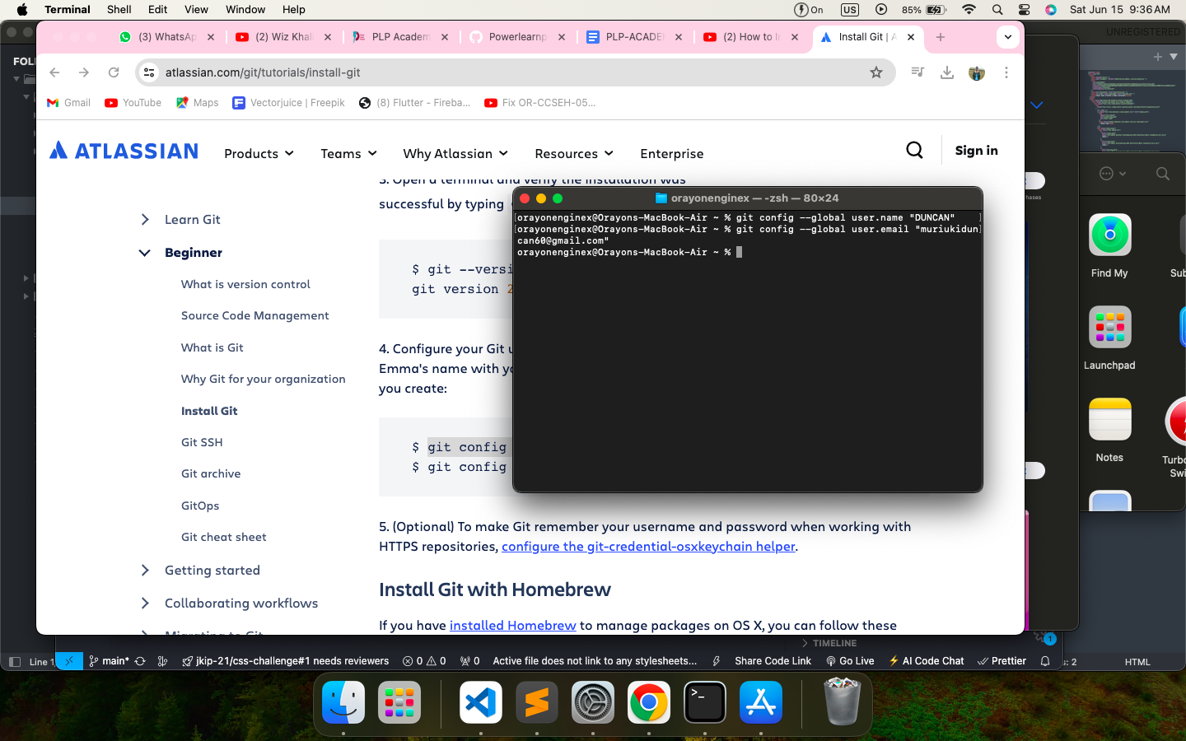*

*Initializing git and making commit*

*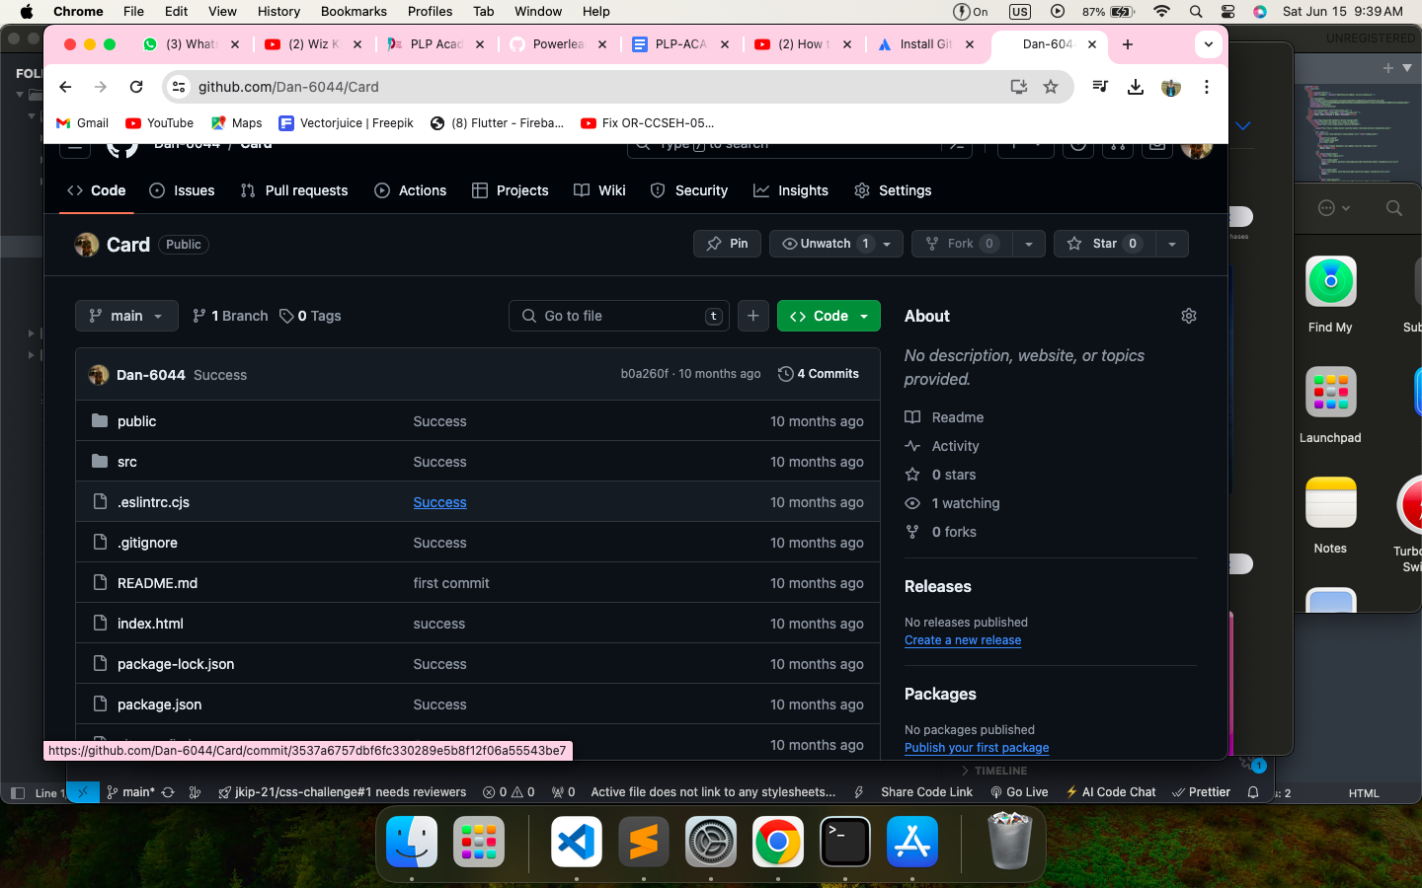*

4. Installing python and setting up the IDEs for it.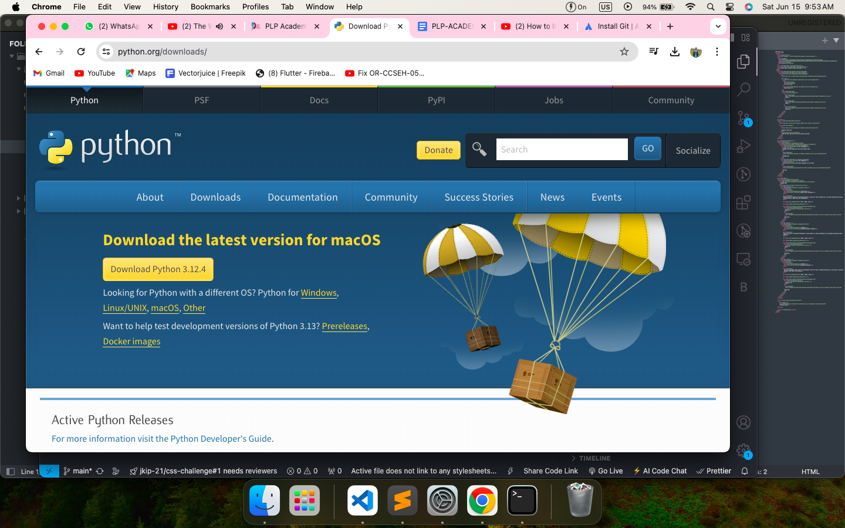

*Downloaded python for mac-os installed and launched. Set up the runtime for running the code after compiling with the visual studio Ide*

Configured MYSQL database using xampp as the server   
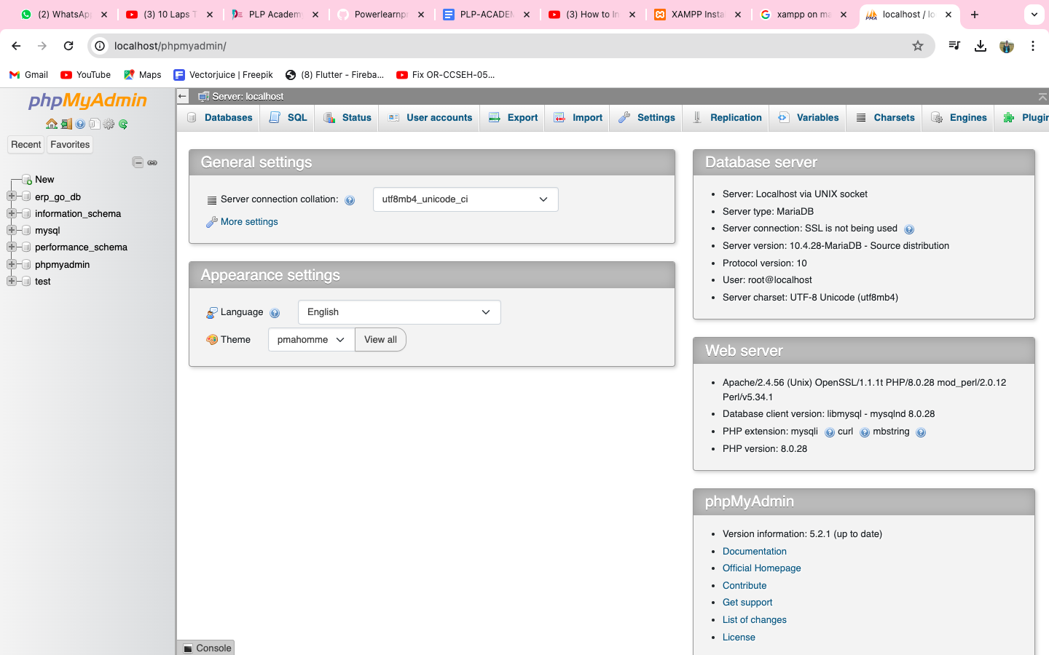

Challenges *Installation of apps on mac-os is a bit tedious with some extra checks of terms and conditions, giving the administrator privileges. Again some applications that are not made for specific mac like xampp it gives you errors like it comes from unknown developer and we have to customize some security measures for the applications to install. Doing a bit more of research into recent developers experience we then get the knowledge to go about with the applications*