* I have VS Code installed already. Here’s a screenshot;

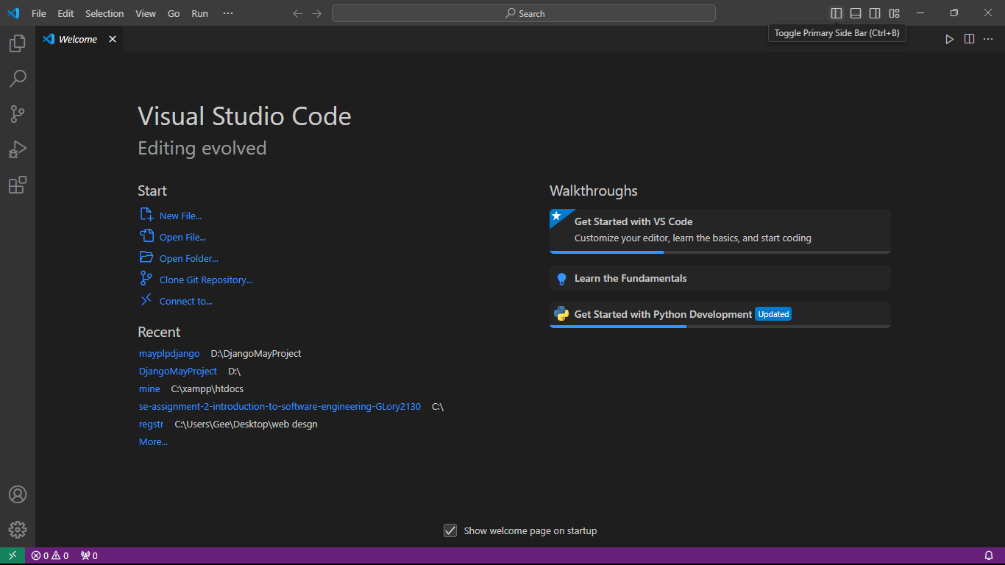

* I also have git installed. Here’s the screenshot;

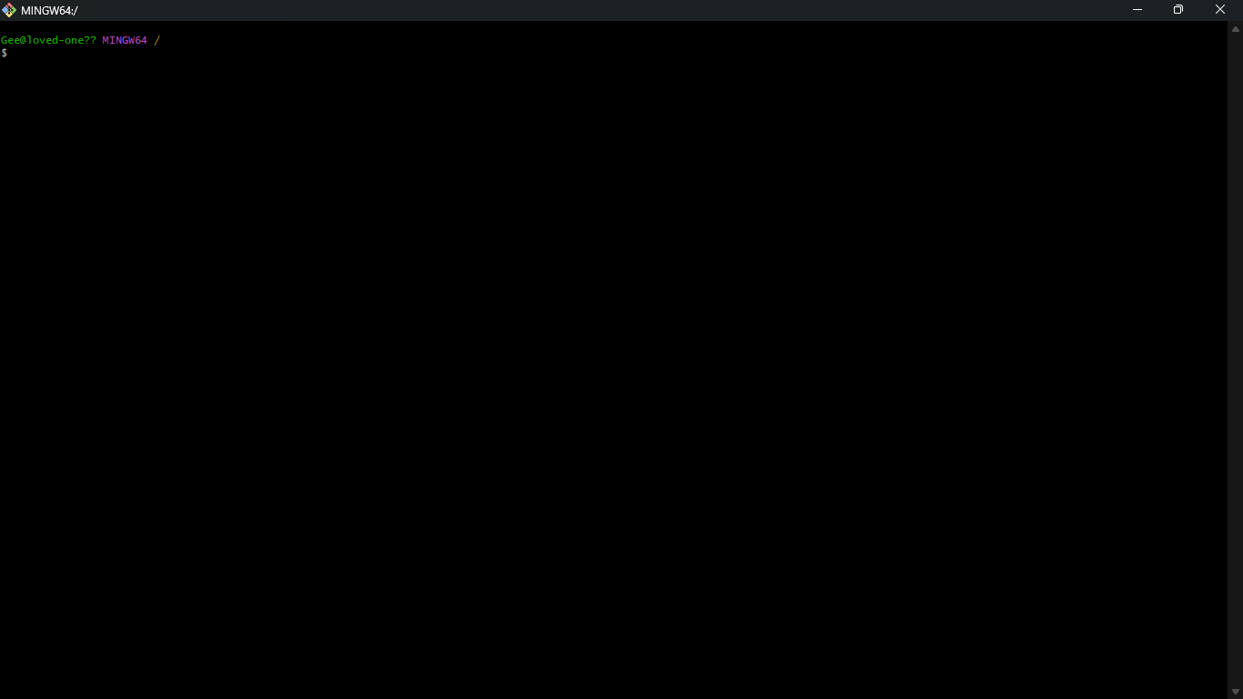

* The languages installed are Python and Flutter. Here are the versions in screenshot;

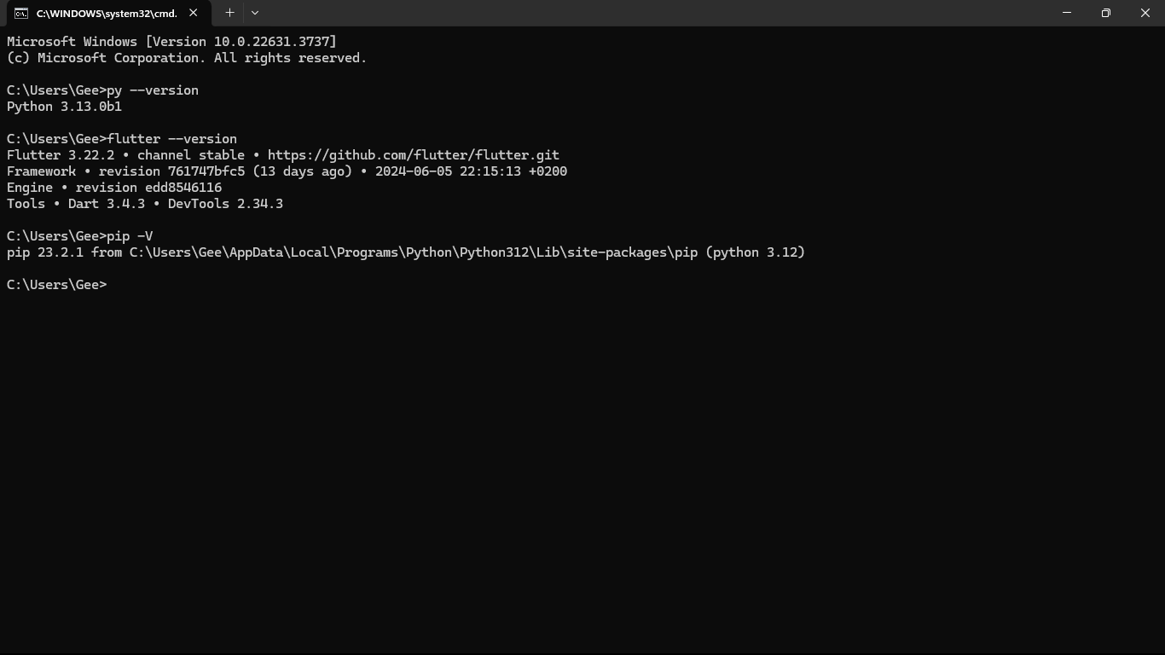

* The database available is the MySQL database. Here’s the screenshot.

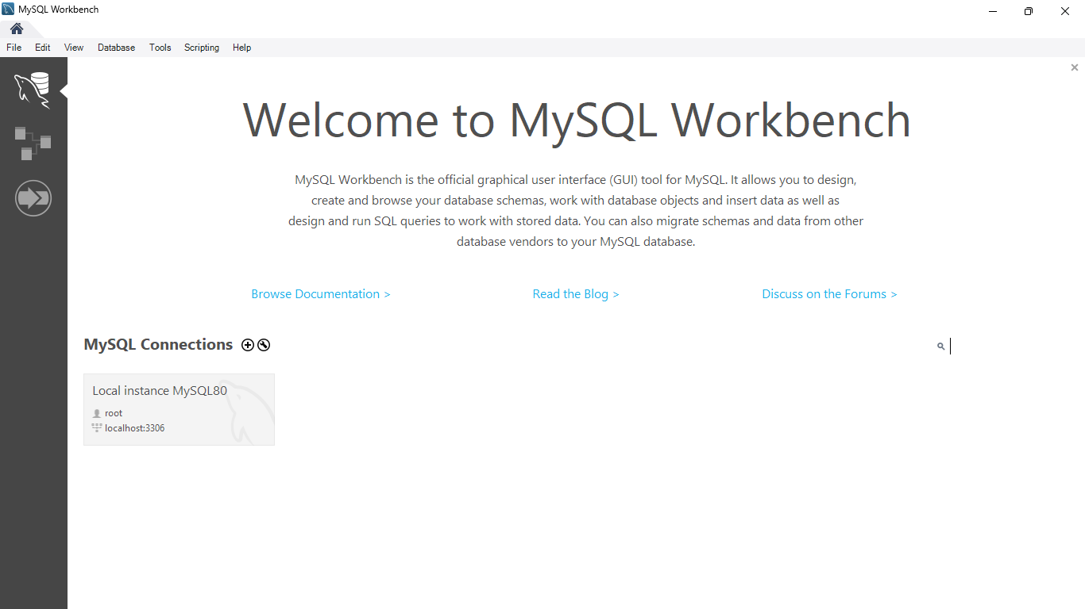

* **Steps to Install Visual Studio Code on Windows:**

1.Download the VS Code file from the Official Website.

2.Execute the download file.

3.Accept the Terms & Conditions.

4.Click on the Install button.

5.Wait for the installation to complete.

6.Click on the Launch button to start it.

* Steps to Install Git

1: Install Git and Create a GitHub Account.

2: Create a Local Git Repository.

3: Create a New Repository on GitHub.

4: Add a File to the Repos

5: Unstage Files on Git.

6: Create a Commit.

7: Undo Last Commit.

8: Create a New Branch.

* Steps to Install MySQL database

1: Visit the Official MySQL Website

2: Go to the Downloads Section and download the MySQL

3: Run the Installer

4: Choose Setup Type

5: Check Requirements

6: MySQL Downloading

7: MySqL Installation

8: Navigate to Configuration Pages

Proceed to “Product Configuration” > “Type and Networking” > “Authentication Method” Pages by clicking the “Next” button.

9: Create MySQL Accounts

10: Connect To Server

11: Complete Installation

12: Verify Installation

* Steps to Install Flutter

1: Navigate to flutter.dev on your webpage. On the top menu bar, select Docs > Get Started > Install > Windows.

2: Check for the System Requirements. Henceforth, you can begin the installation.

3: Restart the system after installing Git on your windows. Once done, let’s get to the installation of Flutter Software development Kit (Flutter SDK). Click on the download link for the latest version

4: Once the zip file is downloaded, extract the ‘flutter’ folder (drag and drop) to any path/directory of the system where you get the read and write access.

5: Now double-click on the ‘flutter’ folder. Go to ‘flutter_console.bat’ file and double-click to open a command prompt window.

6: Check and edit environment variables for global system access. For this, scroll down to ‘Update your path’ on the official Docs page of the flutter installation page. For this, go to Control Panel > System and Security > System > Advanced System Settings > Environment Variables… .