This is the process in which my computer was set up to effectively pursue the software engineering programme.

My computer run a windows 10 OS which is my preferred OS therefore there is no need for any re-installation.

The next step is the installation of an IDE, the recommended one is the visual studio code.The download is made from the official website https://code.visualstudio.com/Download . The installation process is very straightforward.

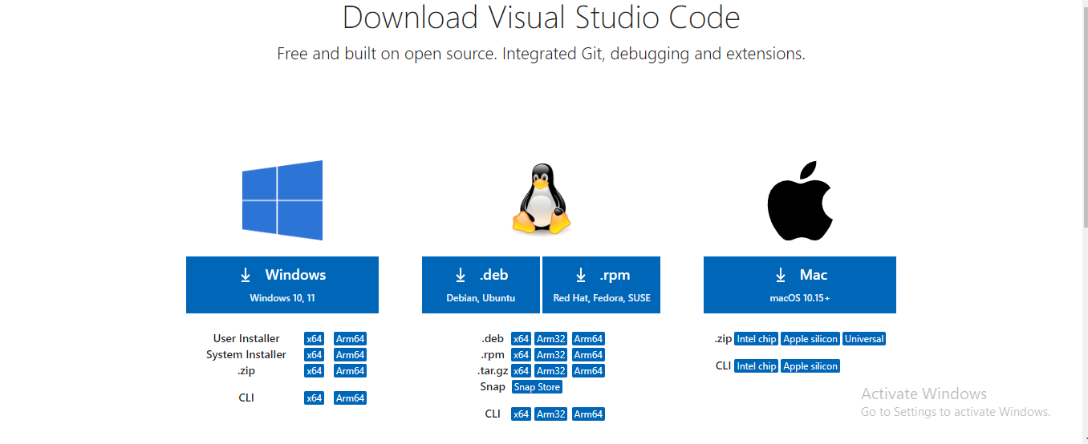

The next step is the installation of git and setting up of a github account, both of which I’ve done previously done.

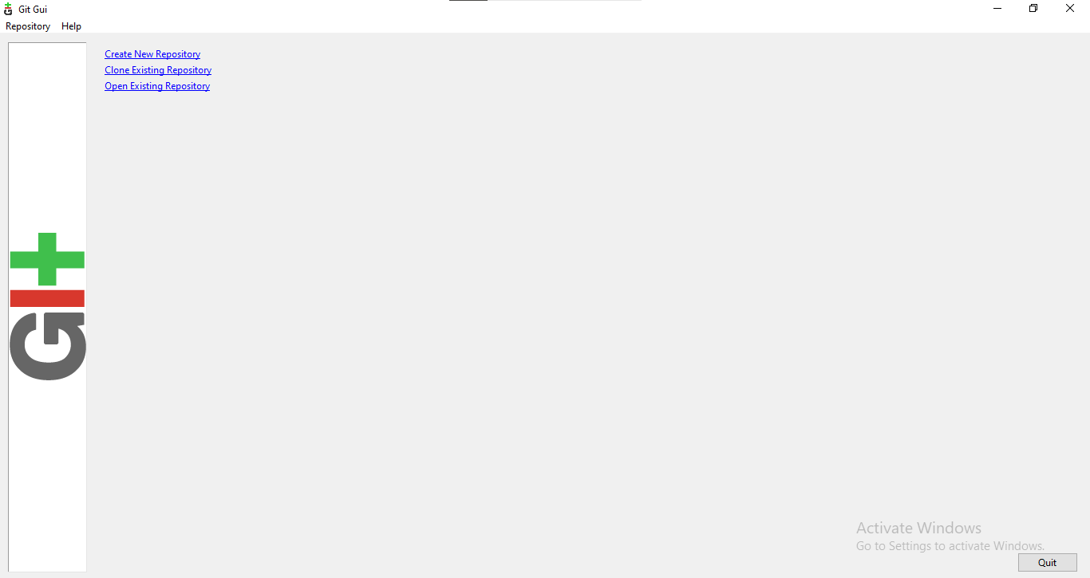

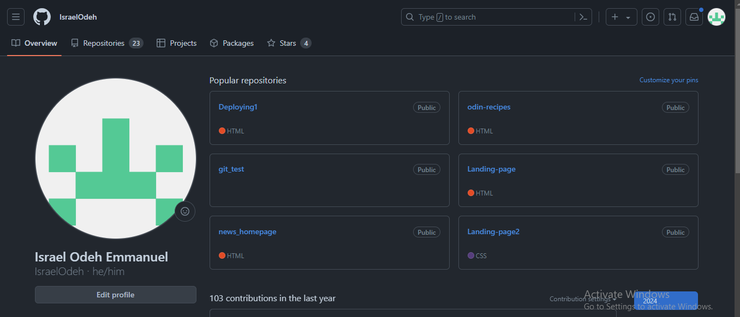

The next step is the installation of python and its dependencies. The python installer was downloaded from the official website: <https://www.python.org/downloads/windows/>. The installer was run and the installation is straightforward.

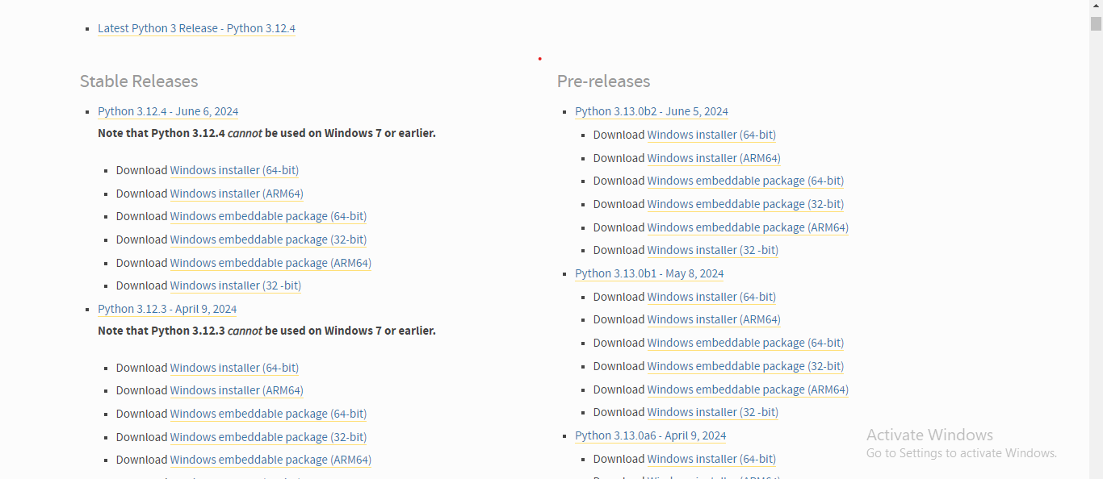

Package managers such as pip has been previously installed.

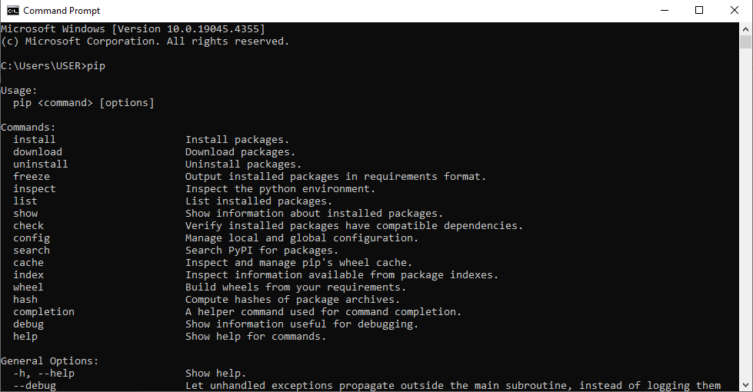

The next step is the installation of MYSQL database, the installer was downloaded from the official website: <https://dev.mysql.com/downloads/file/?id=52848.>

The installation is also straightforward, the default settings are used during the process.

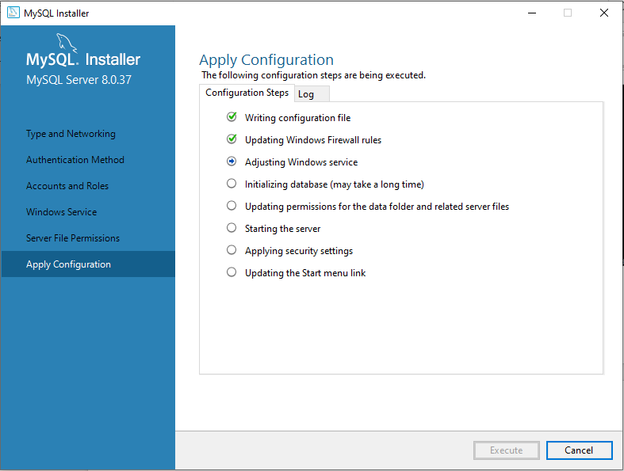

This is the process in which I set up my computer for the software engineering training.