Installing windows:

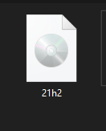downloaded windows software from the internet.

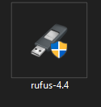installed rufus to help in copying the windows software on a portable device {flash disk}.

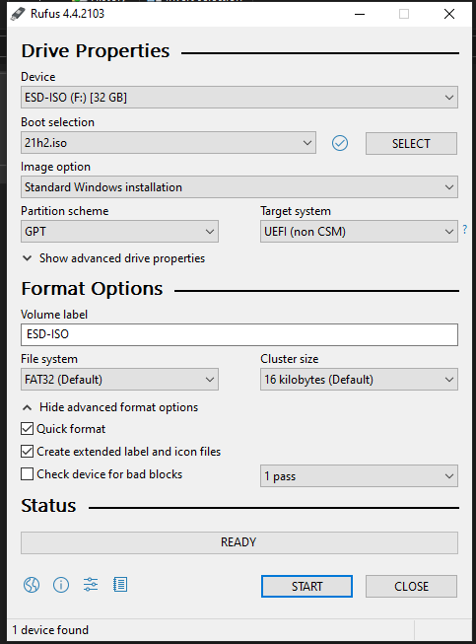



Using Rufus to copy windows software to the device. This allows for the installation on a PC using the function keys and directing it to install via the bootable device.



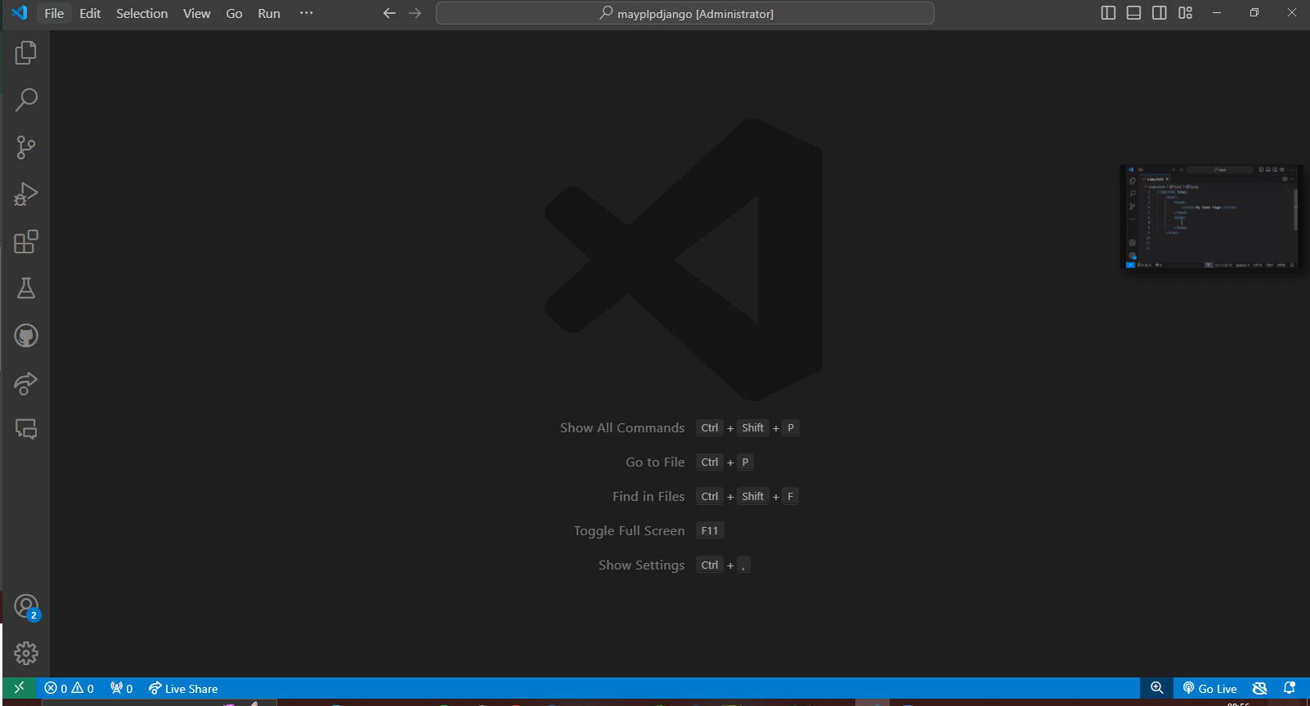Installing visual studio Code:

Downloaded and installed VS code

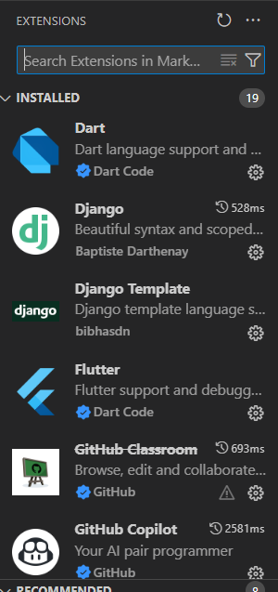

Installed some extensions that will allow the smooth flow of my coding.

Creating a Github Account

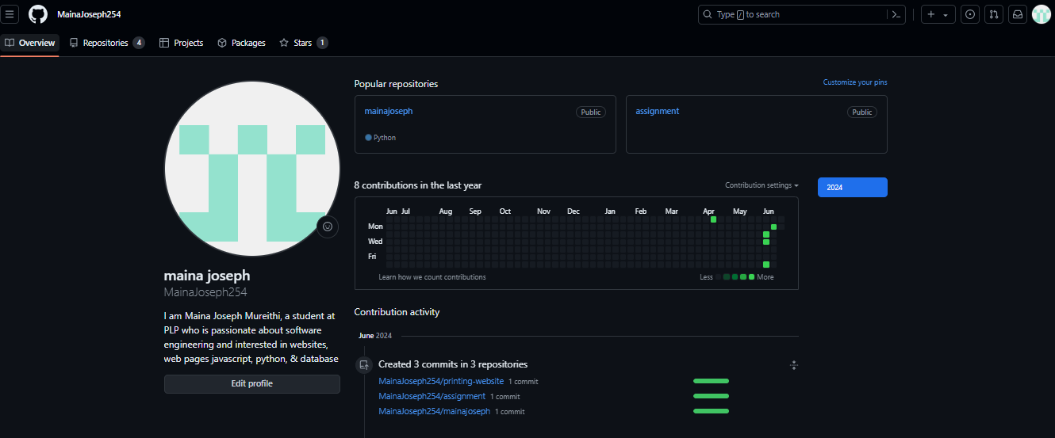GitHub Name: Mainajoseph254

Printing Website Repository

https://github.com/MainaJoseph254/printing-website.git

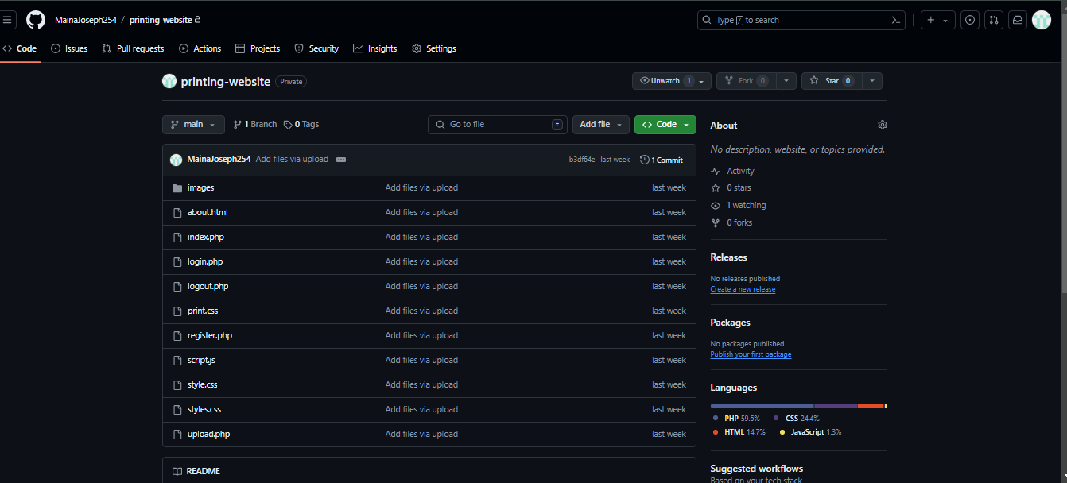

Created some repositories

Downloading and Installing Python

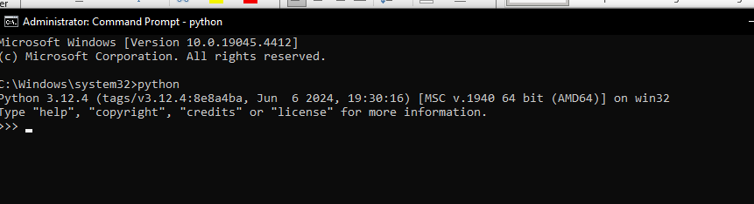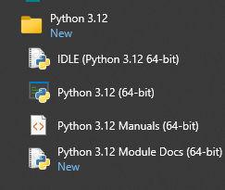

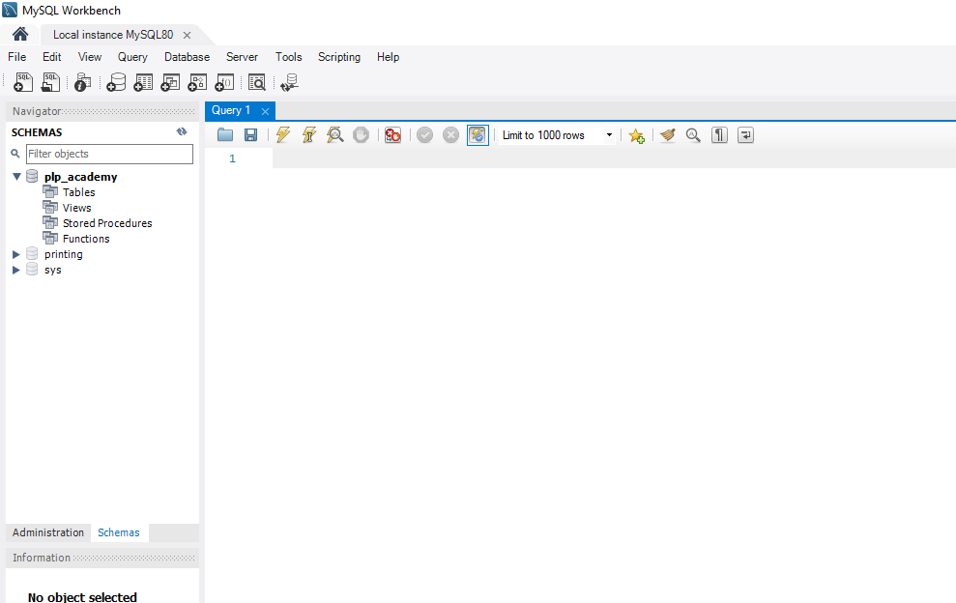Downloading and Installing MySQL