**Assignment: Setting Up Your Developer Environment**

**1. Select Your Operating System (OS):**

I chose Windows 11 as my operating system because it suits my preferences and project requirements. To download and install Windows 11, I followed these steps:

1. Went to the official Windows 11 download page: [Windows 11 Download](https://www.microsoft.com/software-download/windows11).

2. Downloaded the installer and followed the on-screen instructions to install Windows 11 on my machine.

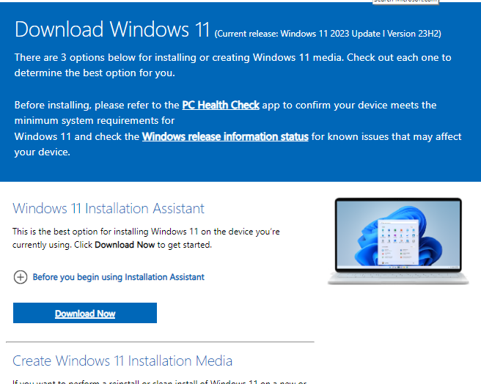

**2. Install a Text Editor or Integrated Development Environment (IDE):**

I selected Visual Studio Code (VS Code) as my text editor because it supports a wide range of programming languages and workflows. To download and install VS Code:

1. Went to the official VS Code download page: [Visual Studio Code Download](https://code.visualstudio.com/Download).

2. Downloaded the installer for Windows and followed the installation steps.

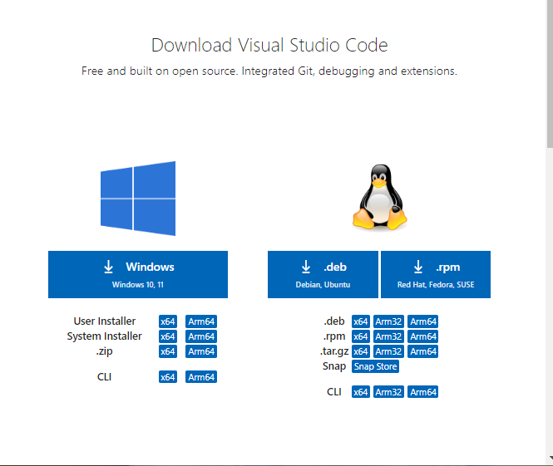

**3. Set Up Version Control System:**

To install Git and configure it on my local machine, I did the following:

1. Downloaded and installed Git from the official site: [Git Download](https://git-scm.com/download/win).

2. Created a GitHub account at [GitHub](https://github.com).

3. Initialized a Git repository for my project and made my first commit:

    ```bash

    git init

    git add .

    git commit -m "Initial commit"

    ```

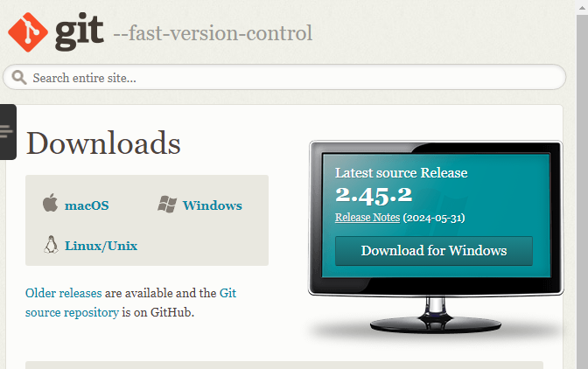

**4. Install Necessary Programming Languages and Runtimes:**

For my project, I needed Python. To install it, I:

1. Downloaded Python from the official website: [Python Download](https://www.python.org/downloads/).

2. Followed the installation instructions, ensuring that I added Python to the system PATH.

**5. Install Package Managers:**

Since I'm using Python, I made sure `pip` was installed:

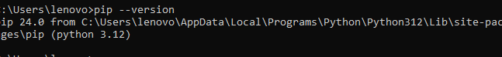

**6. Configure a Database (MySQL):**

To install and set up MySQL, I:

1. Downloaded the MySQL installer from: [MySQL Download](<https://dev.mysql.com/downloads/windows/installer/5.7.html>).

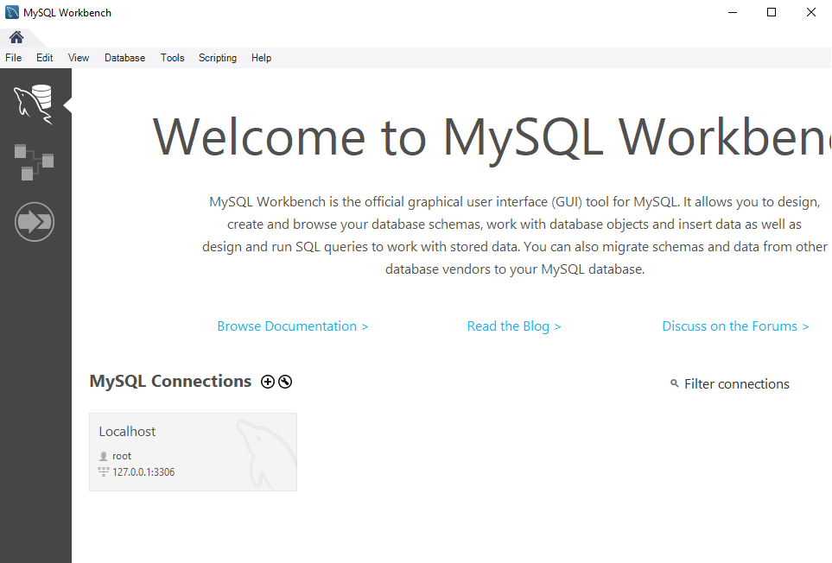

2. Followed the installation instructions to set up MySQL on my machine.

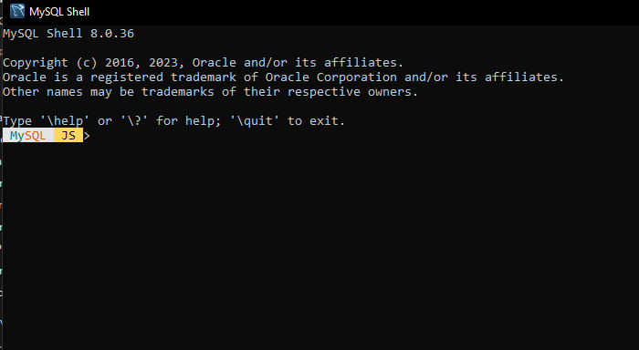

**7. Explore Extensions and Plugins:**

I explored various extensions for VS Code to enhance its functionality:

1. Opened VS Code and clicked on the Extensions view icon in the Activity Bar or pressed `Ctrl+Shift+X`.

2. Installed extensions like:

    - **\*\*Python\*\***: For Python support.

    - **\*\*Prettier\*\***: For code formatting.

    - **\*\*ESLint\*\***: For JavaScript linting.

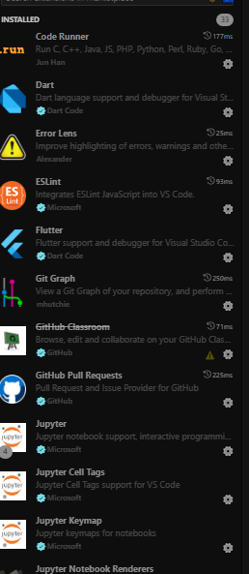

I created a comprehensive document outlining the steps I took to set up my developer environment.