**Document Detailing the Setup Process with Step-by-Step Instructions and Screenshots**

**Developer Environment Setup Guide**

**1. Select and Installing Operating System (Windows 11)**

**Step 1: Download Windows 11**

1. Visit the [Windows 11 Download](https://www.microsoft.com/software-download/windows11) page.
2. Click on **"Download now"** under the **"Windows 11 Installation Assistant"**.

**Step 2: Install Windows 11**

1. Run the downloaded installer.
2. Follow the on-screen prompts to complete the installation.
3. Restart your computer once the installation is complete.

**2. Install Visual Studio Code (VS Code)**

**Step 1: Download VS Code**

1. Visit the [Visual Studio Code Download](https://code.visualstudio.com/Download) page.
2. Download the installer for your operating system.

**Step 2: Install VS Code**

1. Run the installer and follow the prompts.
2. Launch VS Code after installation.

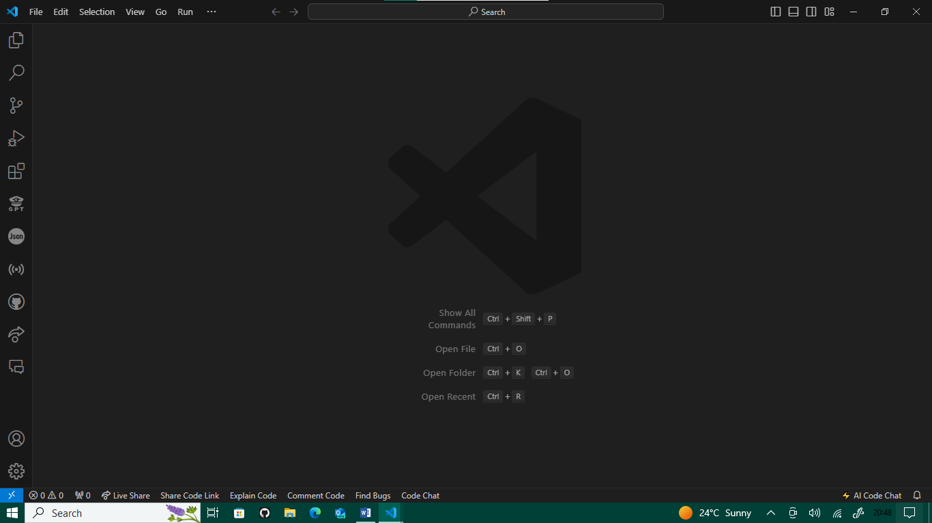

**3. Set Up Version Control System (Git)**

**Step 1: Download Git**

1. Visit the [Git Download](https://git-scm.com/) page.
2. Download the installer for your operating system.

**Step 2: Install Git**

1. Run the installer and follow the setup instructions.

**Step 3: Configure Git**

1. Open **Git Bash** and configure the Git identity:

git config --global user.name "Your Name"

git config --global user.email [kdavidmacharia8485@gmail.com.com](mailto:kdavidmacharia8485@gmail.com.com)

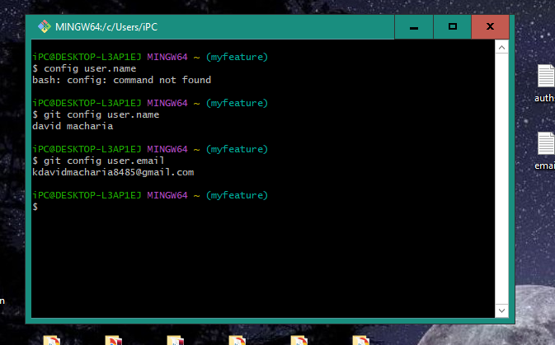

**4. Installing Necessary Programming Languages and Runtimes**

**Python**

**Step 1: Download Python**

1. Visit the [Python Download](https://www.python.org) page.
2. Download the installer for your operating system.

**Step 2: Install Python**

1. Run the installer and follow the setup instructions.
2. Ensure Python and pip (Python's package installer) are added to your system PATH.

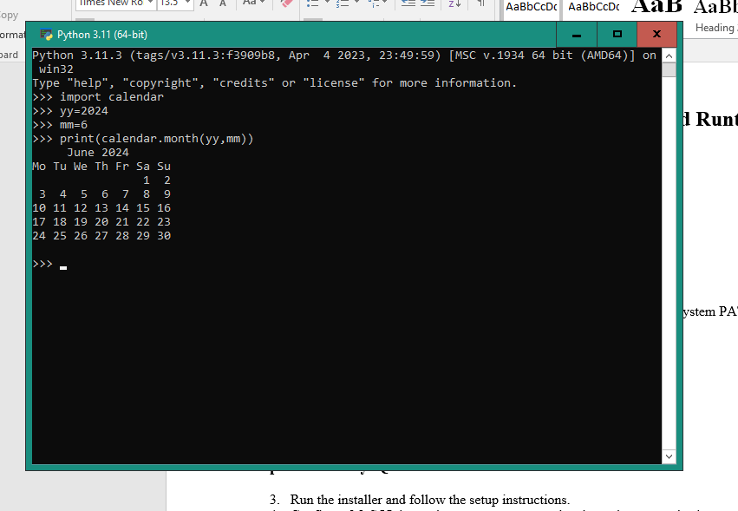

**5. Configuring a Database (MySQL)**

**Step 1: Download MySQL**

1. Visit the [MySQL Download](https://dev.mysql.com/downloads/windows/installer/5.7.html) page.
2. Download the MySQL installer for your operating system.

**Step 2: Install MySQL**

1. Run the installer and follow the setup instructions.
2. Configure MySQL by setting up a root password and creating a new database.

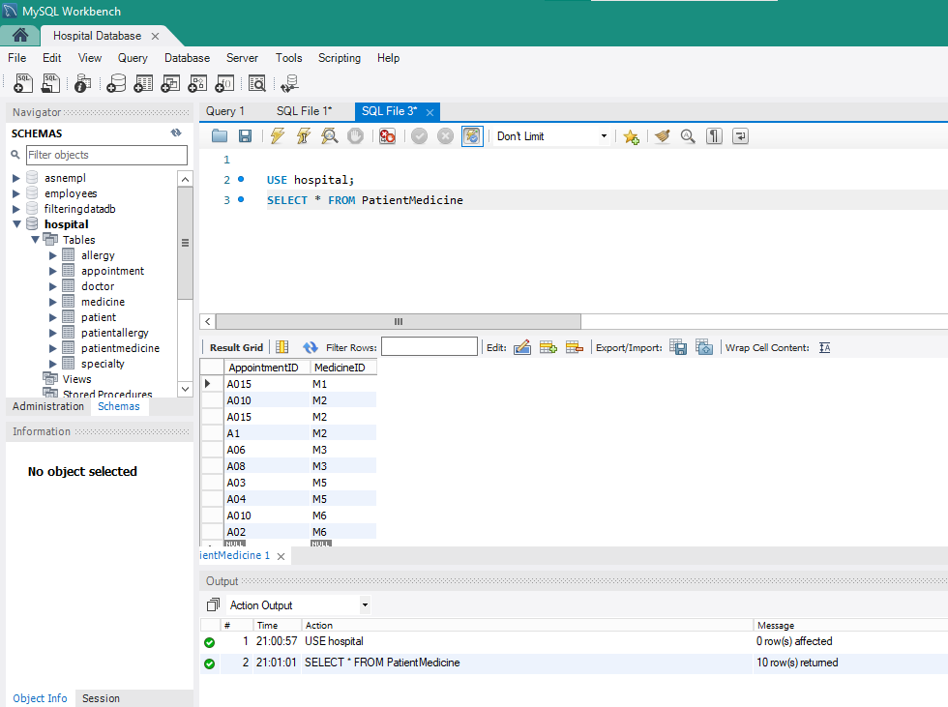

**6. Exploring Extensions and Plugins**

**Step 1: Install VS Code Extensions**

1. Open VS Code and go to the Extensions view by clicking on the Extensions icon in the Activity Bar on the side of the window.
2. Search for and install recommended extensions such as:
   * Python
   * Live server

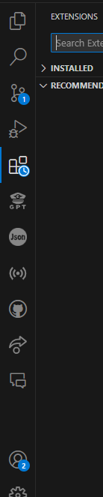

**Reflection on the Challenges Faced During Setup and Strategies Employed to Overcome Them**

**Challenges Faced:**

1. **Compatibility Issues:**
   * **Challenge:** Some software may not be compatible with the latest version of the operating system.
   * **Strategy:** Checked for updates or patches for the software. Used compatibility mode or alternative software offering similar functionality.
2. **Configuration Errors:**
   * **Challenge:** Errors during the setup of Git or MySQL due to incorrect configurations.
   * **Strategy:** Referred to official documentation and forums for solutions. Double-checked configuration settings and ensured all prerequisites were met.
3. **Network Issues:**
   * **Challenge:** Slow or unstable internet connections hindered downloads and installations.
   * **Strategy:** Used a stable internet connection, downloaded files during off-peak hours, or used download managers to resume interrupted downloads.
4. **Learning Curve:**
   * **Challenge:** Familiarizing with new tools and environments was time-consuming.
   * **Strategy:** Followed tutorials and guides. Practiced using the tools regularly to build proficiency.

**Strategies Employed:**

1. **Step-by-Step Approach:**
   * **Strategy:** Breaking down the setup process into manageable steps helped in systematically addressing each task.
2. **Utilizing Documentation and Community Support:**
   * **Strategy:** Leveraged official documentation and sought help from community forums and discussion groups for valuable insights and solutions.
3. **Testing and Validation:**
   * **Strategy:** Regularly tested the setup at various stages to ensure configurations were correct and functional.
4. **Backup and Version Control:**
   * **Strategy:** Used version control (Git) and maintained backups of important files and configurations to quickly revert to a previous state in case of issues.

***BY DAVID MACHARIA***