**WHAT NEEDED**

1.Windows installation media. This could be an installation ISO or DVD

2.USB drive with at least 5GB free space, ensure the flash disk has nothing important in it.

3.Windows PC that you will use to format the USB flash drive

4.A PC that you will install windows on

**STEP1**

1.Connect the USB flash drive to your PC

2.Formart the the USB drive partition in the Disk Management.

**STEP2**

1.Copy windows setup to the USB flash drive

**STEP3**

* Connect the USB flash drive to a new PC.
* Turn on the PC and press the key that opens the boot-device selection menu for the computer, such as the Esc, F10 or F12 keys.
* Select the option that boots the PC from the USB flash drive.
* Windows setup starts, remove the USB flash drive after it finished coping files.

Final Operating System Installed

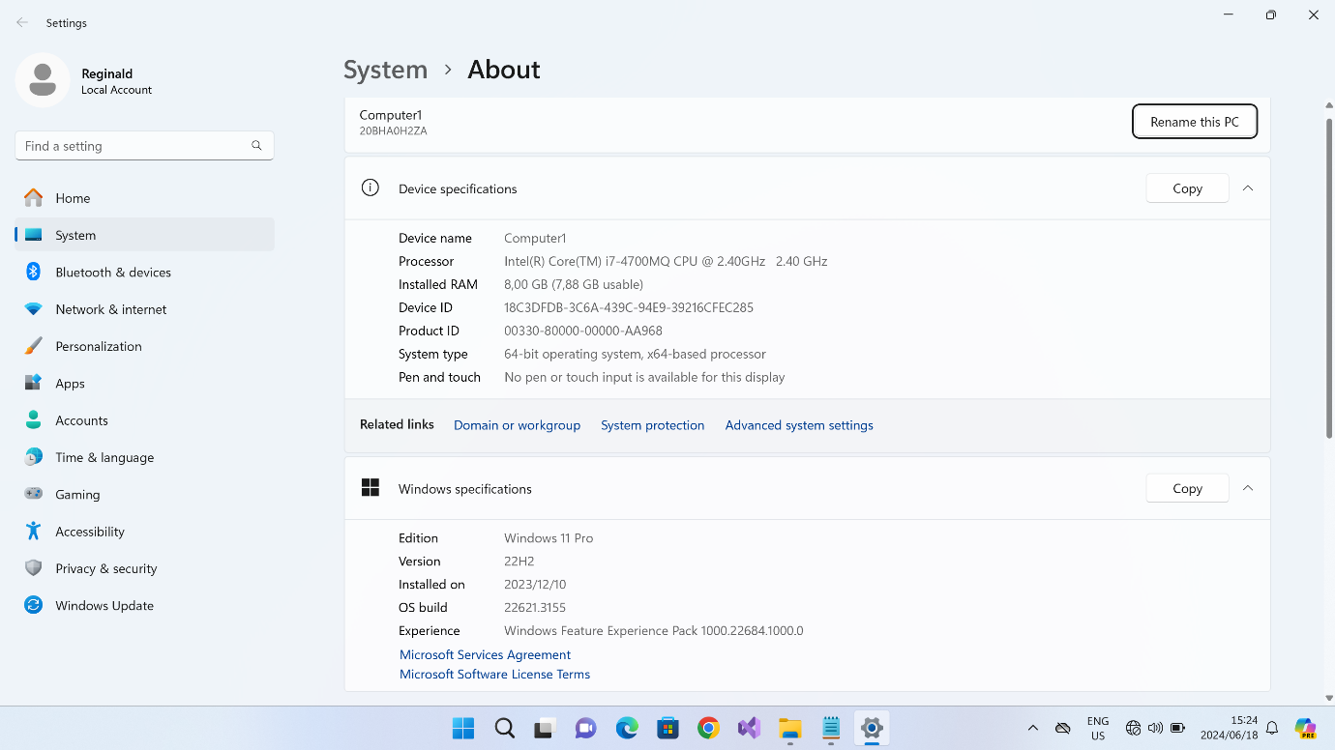

IDE(Integrated Development Environment)

1.Download Visual Studio on a website https://code.visualstudio.com/download

2.Run the installer

3.Select workloads and components

4.Install

5.Launch visual studio

Final Visual Studio code installation

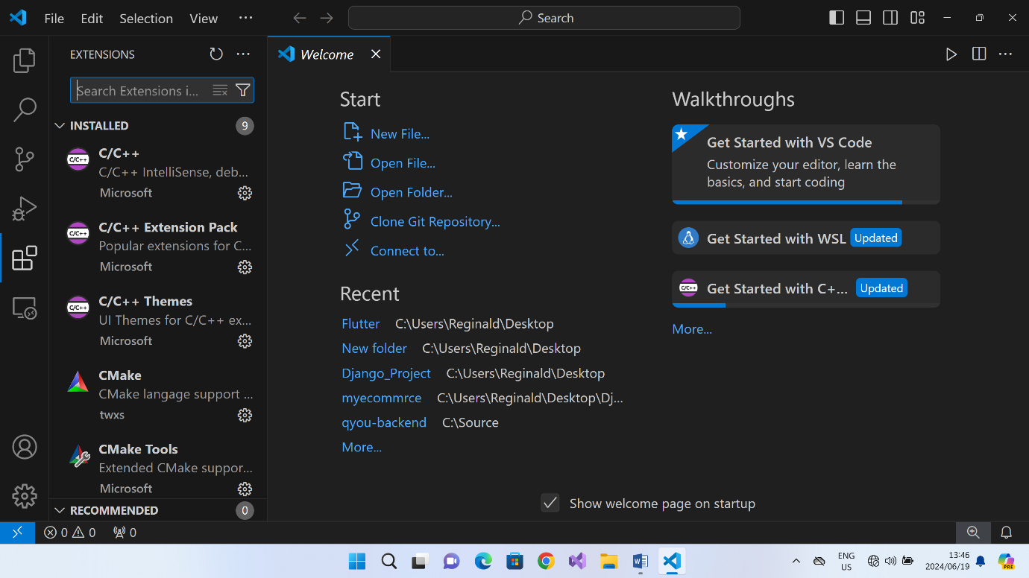

**PYTHON SET UP**

Installation on windows, visit the link <https://www.python.org/downloads/>

**STEP1**

Select the python’s version to download

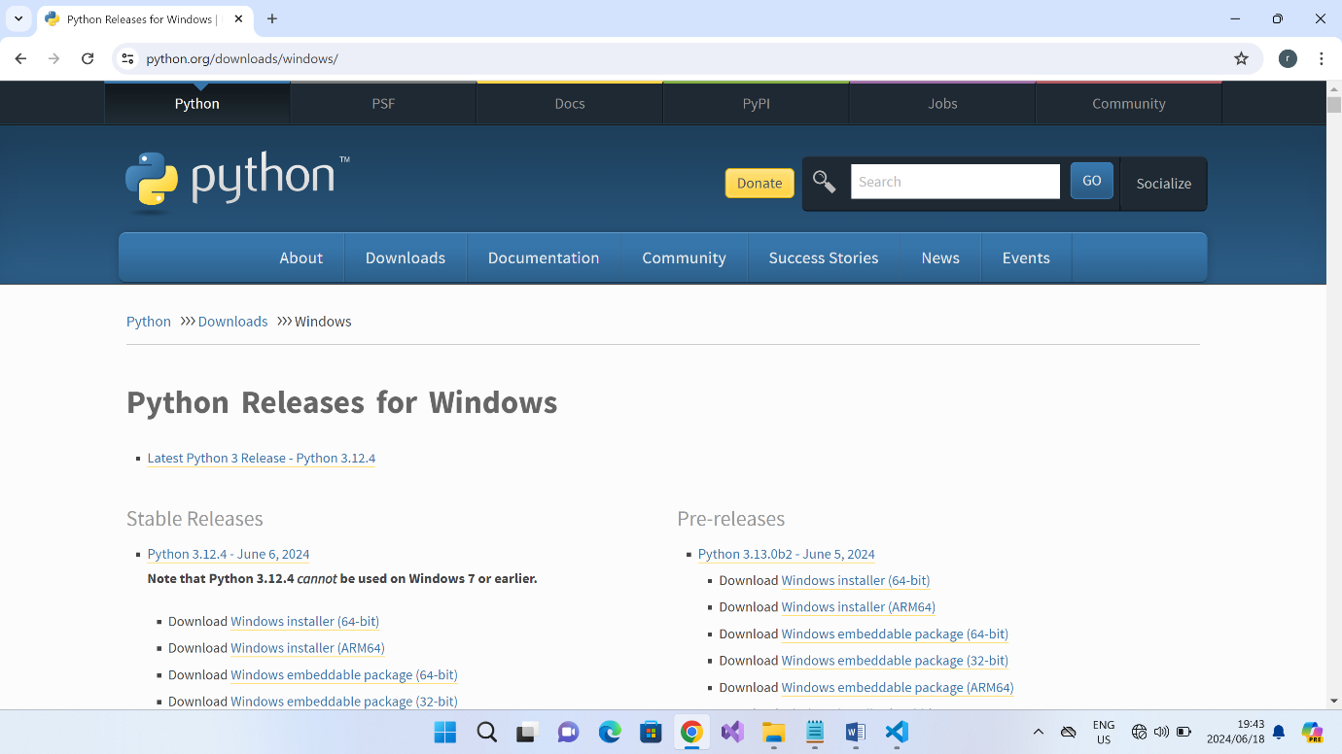

**STEP2**

Double-click the executable file, which is downloaded

Follow the installation process

**STEP3**

Add the path to the Environment Variables

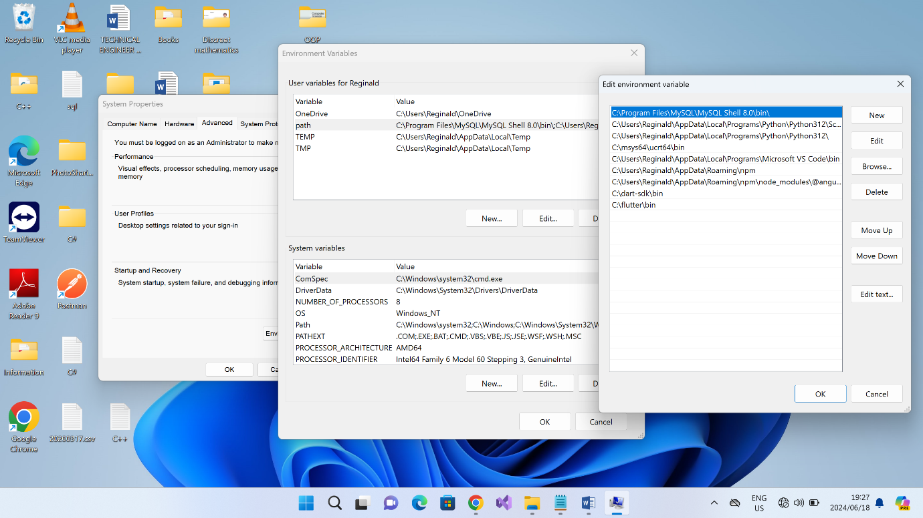

**STEP4**

Try to run python on the command, python version

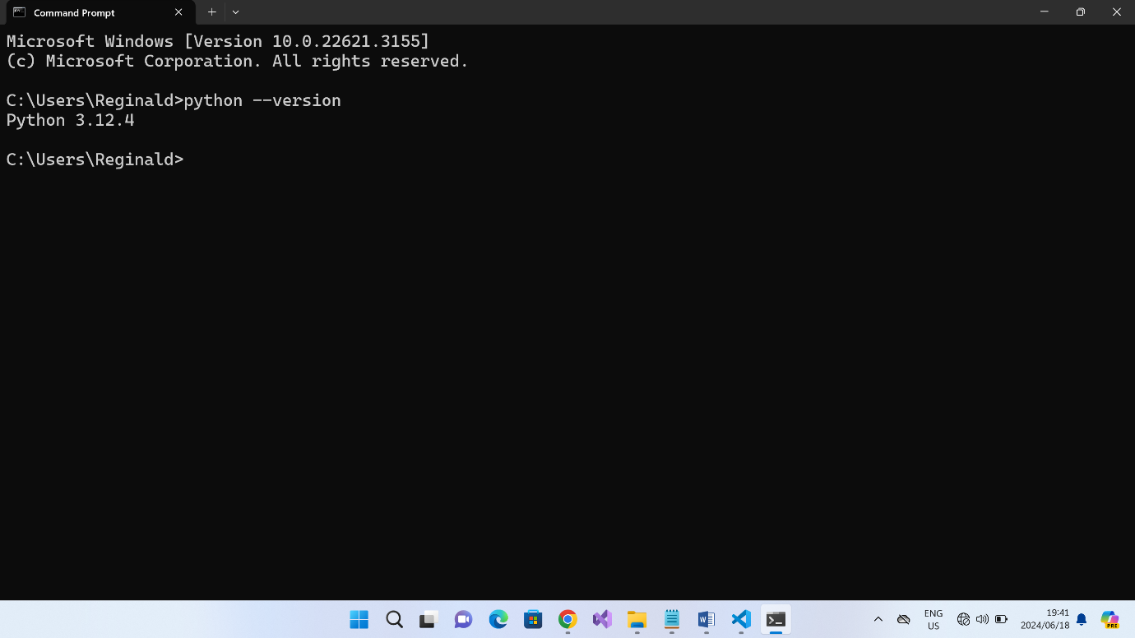

**STEP5**

How to run python code in Visual Studio Code

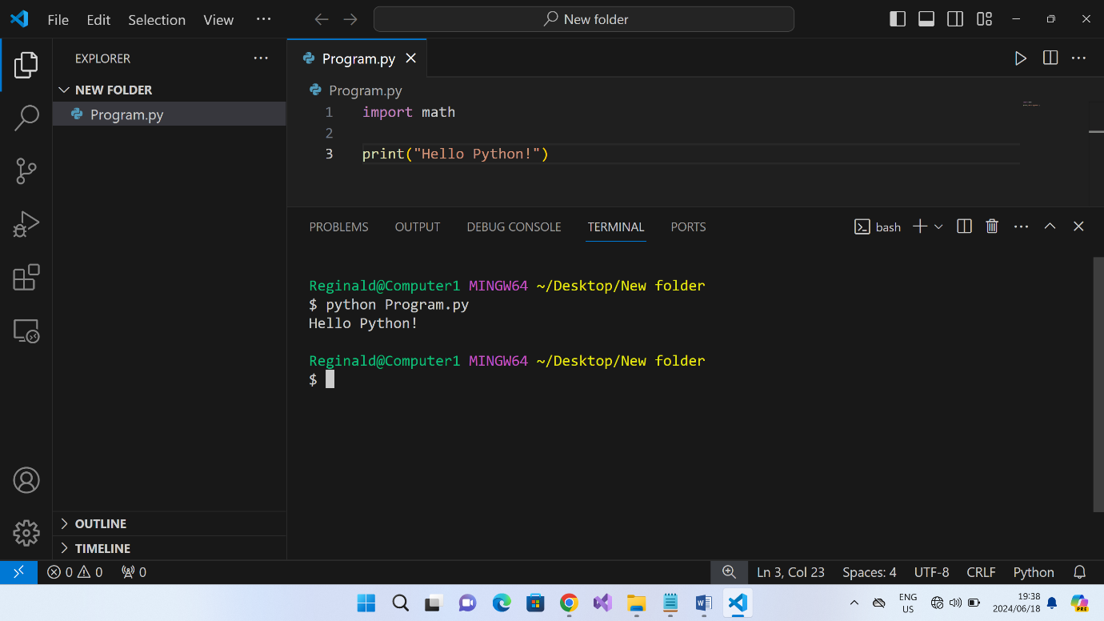

**SET UP DARTAND FLUTTER ENVIRONMENT**

**STEP1**

Download the installer from <https://www.dart.dev/get-dart>

Download the installer from https://www.flutter.dev/

**STEP2**

Extract the zip file and copy the dart to local drive or where you want place it

**STEP3**

Add the path to the Environment Variables

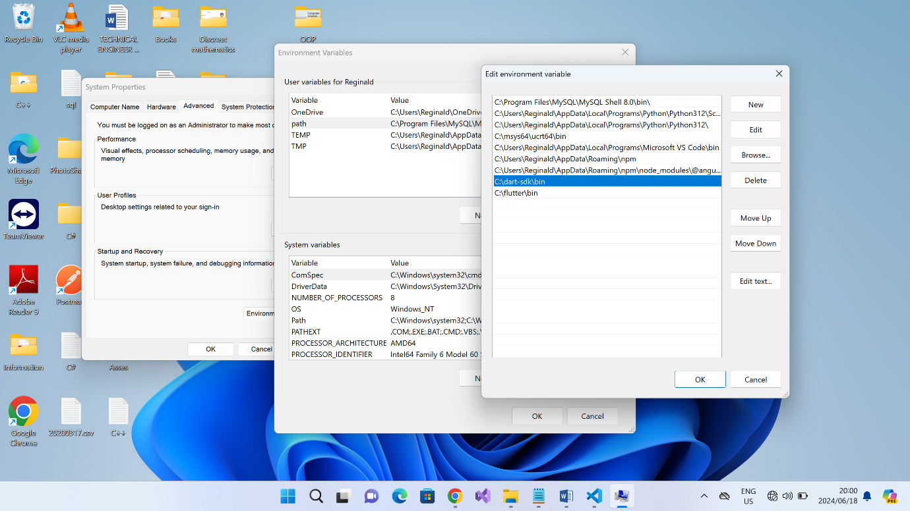

**STEP4**

Try run dart on the command prompt, dart version to verify it was installed successfully

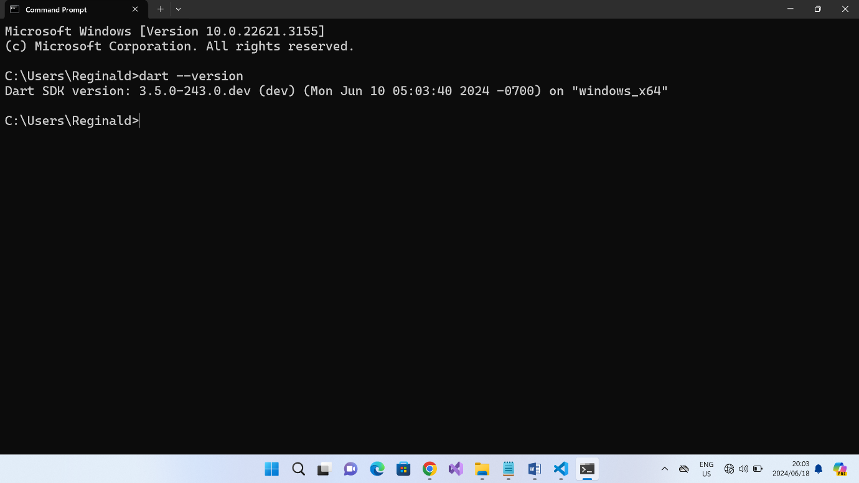

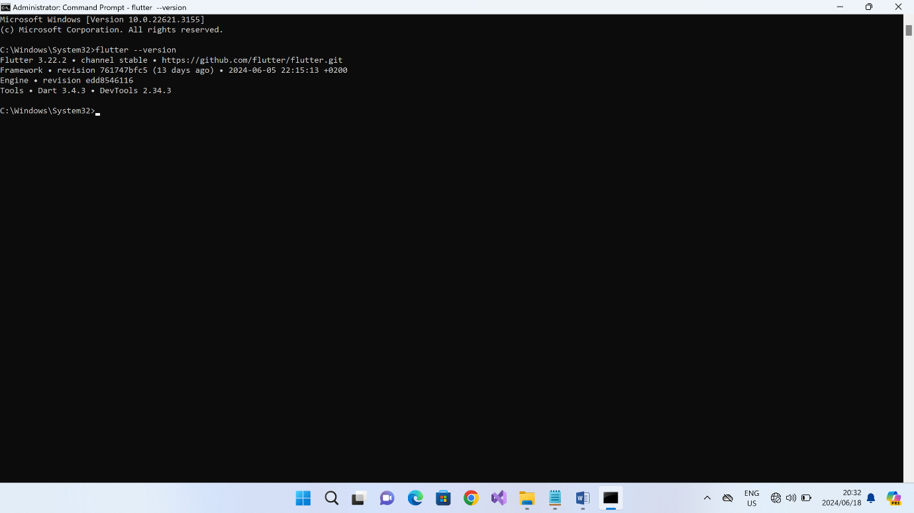

**STEP5**

How to run dart on Visual Studio Code

