**Developer Environment Setup Documentation**

**Introduction**

This document provides a step-by-step guide to setting up a developer environment for software engineering projects. The setup includes the installation and configuration of the operating system, IDE, version control system, programming languages, package managers, database, and optional virtualization tools.

**1. Operating System Installation**

**Download and Install Windows 11**

**Visit the Windows 11 Download Page:**

Go . <https://www.microsoft.com/software-download/windows11>.

**Download Installation Assistant**:

Click on "Download Now" under the "Windows 11 Installation Assistant".

**Run Installation Assistan**t:

Open the downloaded file and follow the on-screen instructions.

**Complete Installation**:

Follow prompts to complete the installation and restart your computer as needed.

**2. Install a Text Editor or Integrated Development Environment (IDE)**

**Download and Install Visual Studio Code**

**Visit Visual Studio Code Download Page:**

Go to <https://code.visualstudio.com/Download>.

**Download the Installer:**

Select the appropriate installer for your operating system (Windows, macOS, or Linux).

**Run the Installer:**

Open the downloaded file and follow the installation prompts.

**Launch Visual Studio Code:**

After installation, launch Visual Studio Code.

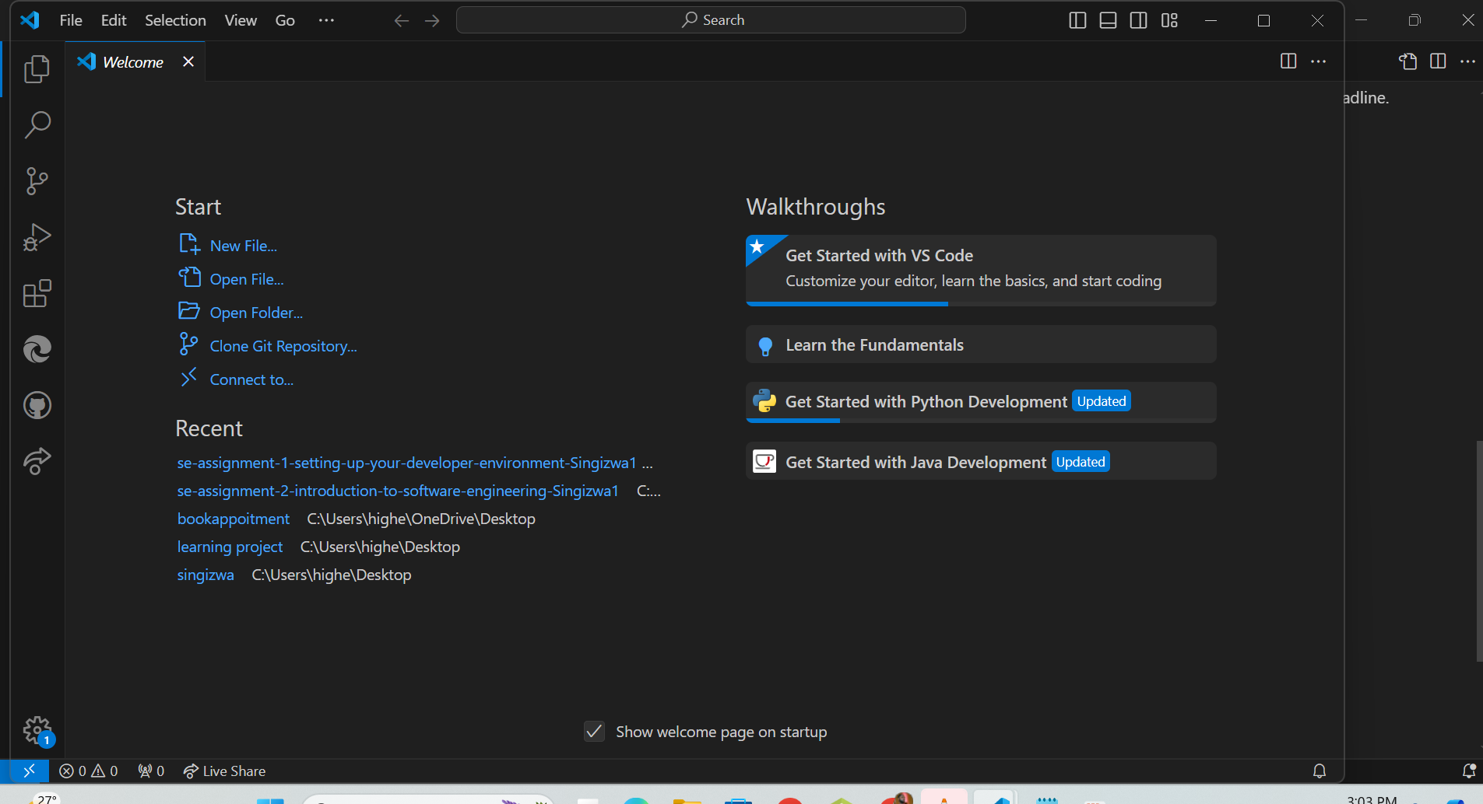

this vscode after downloaded, I already have it

**3. Set Up Version Control System**

**Install Git**

**Visit Git Download Page:**

Go to Git download page.

**Download the Installer:**

Select the appropriate installer for your operating system.

**Run the Installer:**

Open the downloaded file and follow the installation prompts.

Verify Installation

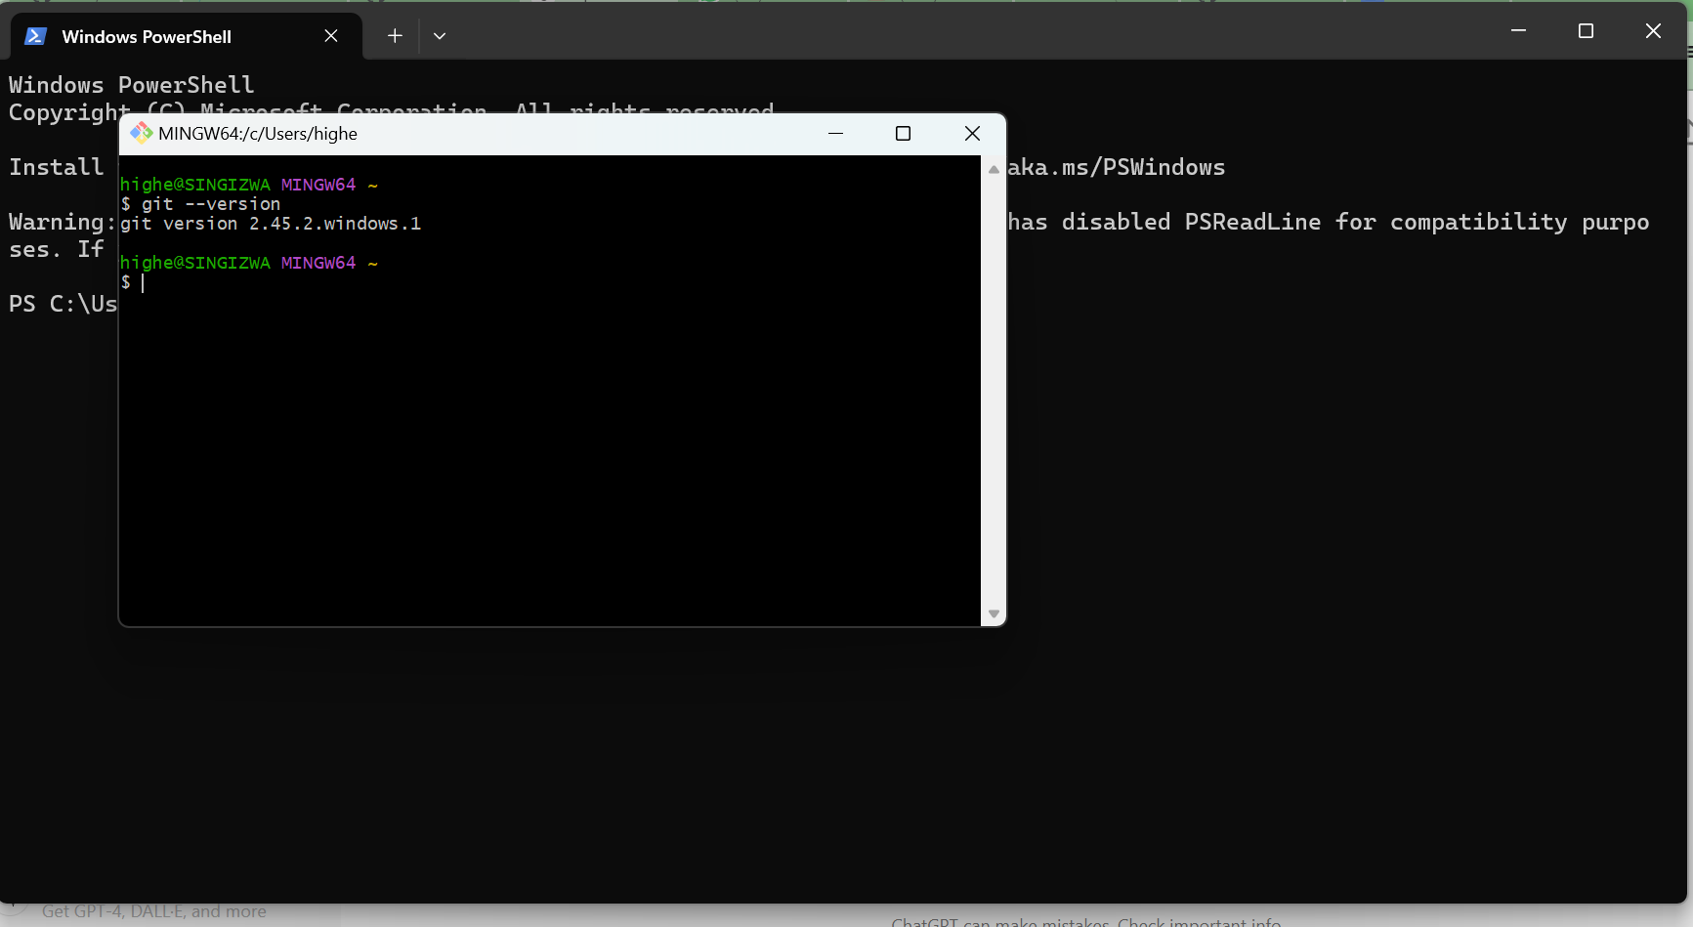

this git app

**Create a GitHub Account**

**Visit GitHub:**

[https://github.com](https://github.com/)

**Sign Up:**

Click on "Sign up" and follow the instructions to create a new account.

this my official github account

<https://github.com/Singizwa1>

4. **Install Necessary Programming Languages and Runtimes**

**Install Python**

**Visit Python Download Page:**

Go [http://wwww.python.org](http://wwww.python.org/)

**Download the Installer:**

Click "Download Python" and select the appropriate installer for your operating system.

**Run the Installer:**

Open the downloaded file and follow the installation prompts. Ensure you check the "Add Python to PATH" option.

**Verify Installation:**

Open a terminal and run

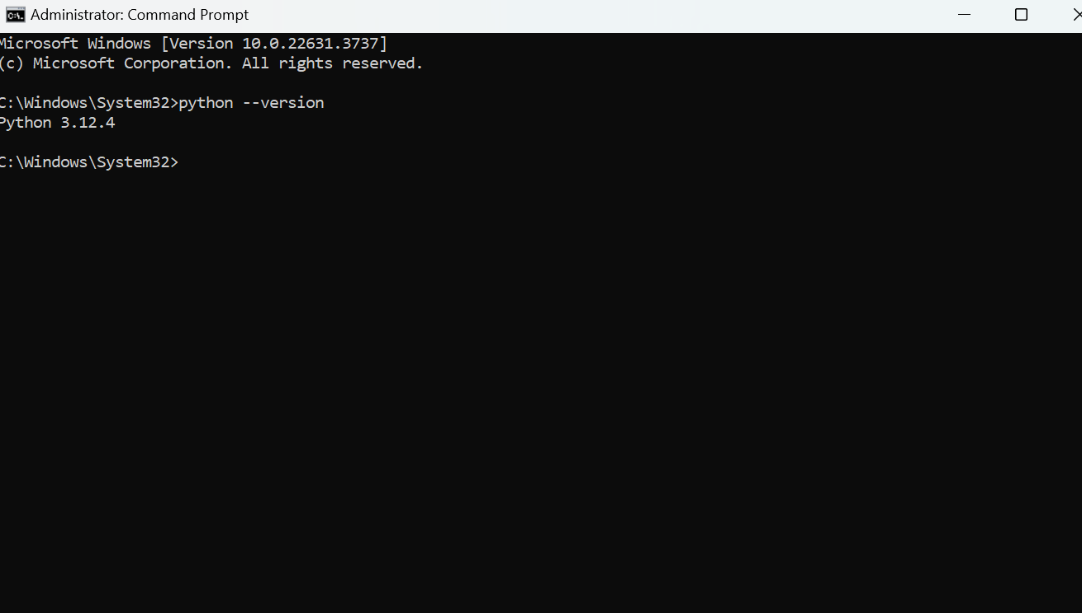

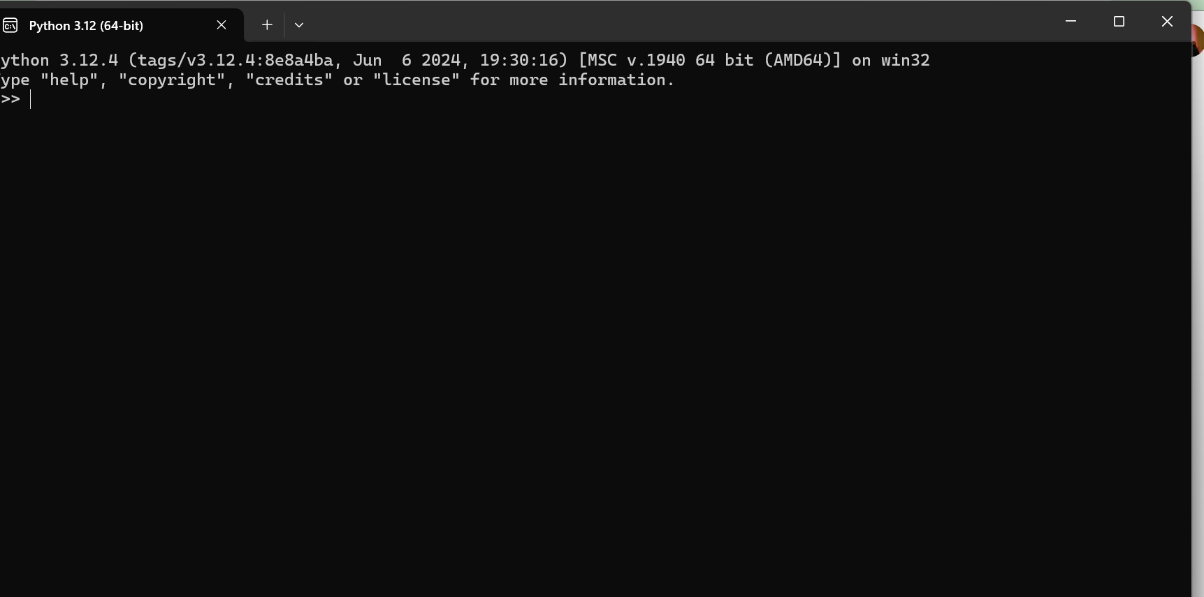

this python setup

**5. Configure a Database (MySQL)**

**Download and Install MySQL**

**Visit MySQL Download Page:**

Go <https://dev.mysql.com/downloads/windows/installer/5.7.html>

**Download MySQL Installer:**

Download the MySQL Installer for Windows.

**Run the Installer:**

Open the downloaded file and follow the installation prompts.

**Configure MySQL:**

During installation, set the root password and configure MySQL to run as a service.

**Verify Installation:**

Open MySQL Workbench or a terminal and connect to the MySQL server.

**6. Set Up Development Environments and Virtualization (Optional)**

**Install Docker**

**Visit Docker Download Page:**

Go to Docker download page.

**Download Docker Desktop:**

Download Docker Desktop for Windows.

**Run the Installer:**

Open the downloaded file and follow the installation prompts.

**7. Explore Extensions and Plugins**

**Install Visual Studio Code Extensions**

Open Visual Studio Code:

Launch Visual Studio Code.

Open Extensions View:

Click on the Extensions view icon on the Sidebar or press Ctrl+Shift+X

