OPERATING SYSTEM
I installed Ubuntu on my laptop from a USB. My laptop’s RAM is not quite large so I decided to use no virtual machines.

IDE
downloaded vs code and installed it
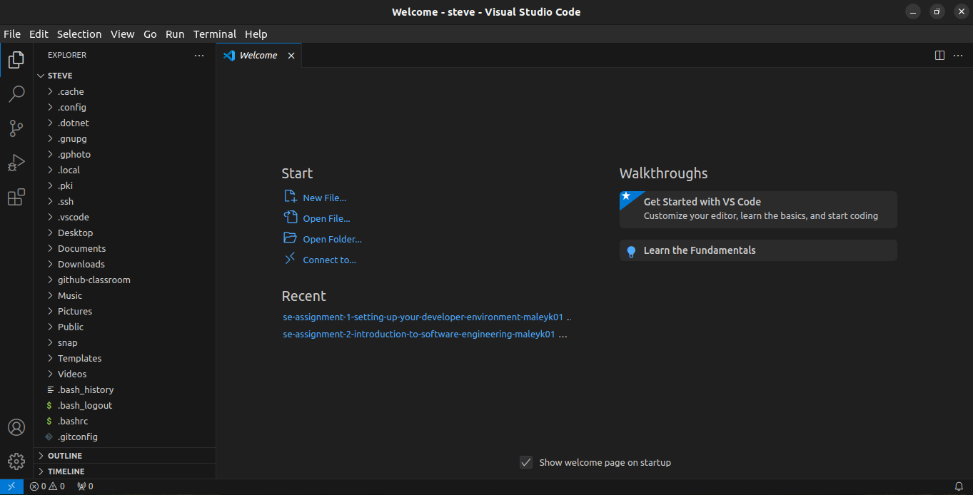
VERSION CONTROL SYSTEM
downloaded and installed git using terminal : “sudo apt-get install git”

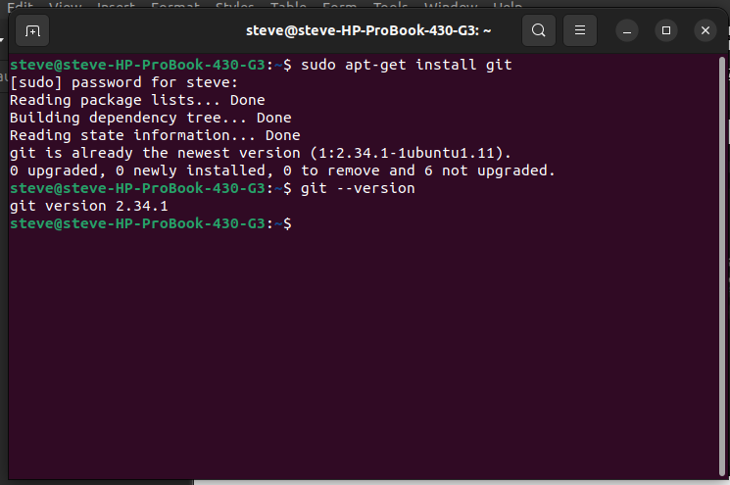
INSTALLING PYTHON AND PIP
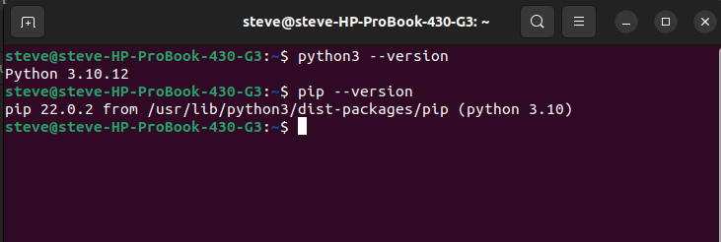
installed python and pip

INSTALLING MYSQL
