Here is my Development Environment so far that I have set up.

My pc supports the Windows 11, and this is the process I used to install VS studio

I visited the Visual studio Download page [Click Here](https://visualstudio.microsoft.com/downloads/)

Selected a standalone VS studio code installer that runs on windows followed the prompts until I downloaded

Once downloaded, I ran the installer selecting my preferred settings, the installer will install your vs code and once you run it it welcome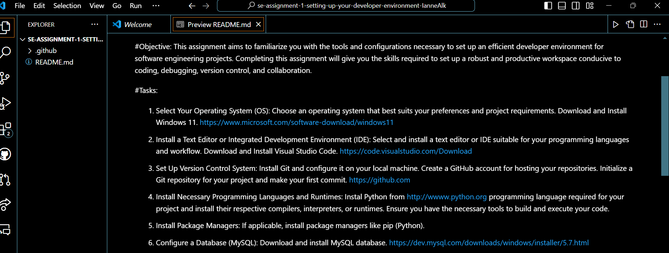ome you to a home screen.

Here you are able to customize the appearance for example have a darkmode ctrl k + ctrl t

Within VS code you are able to run various codes extensions by keying in ctrl + shift + x

Selected your preferred language extension for example python

Install the extension

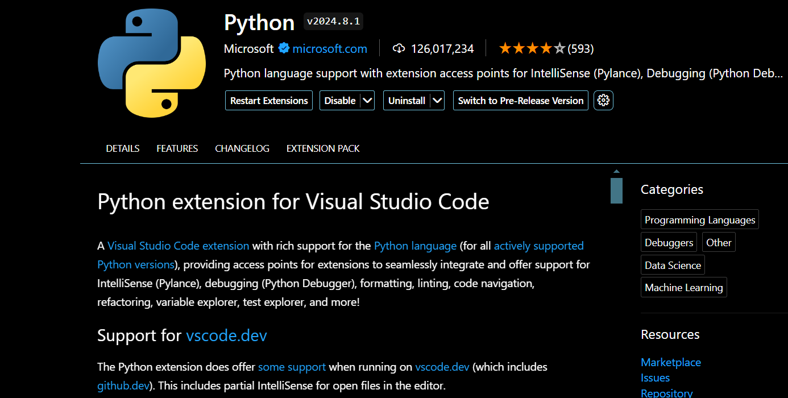

Also within the vs code one can run several terminals include bash ,cmd and powershell

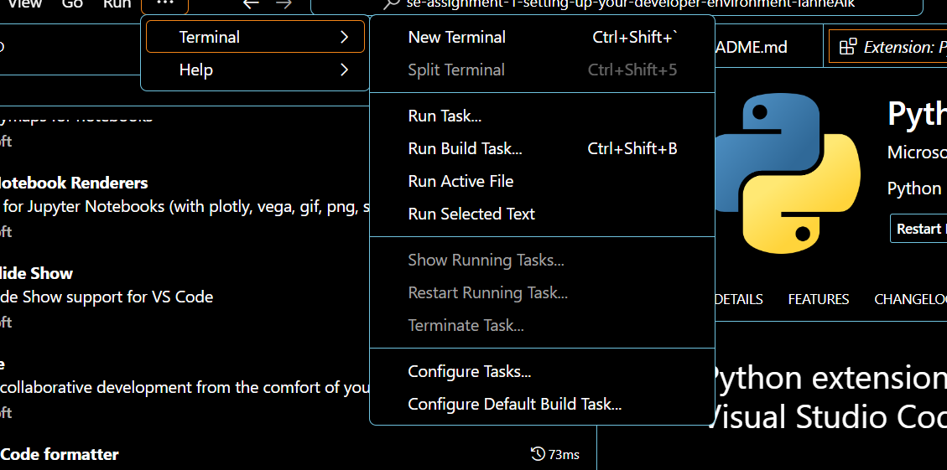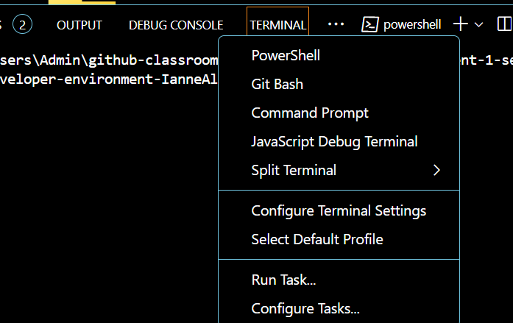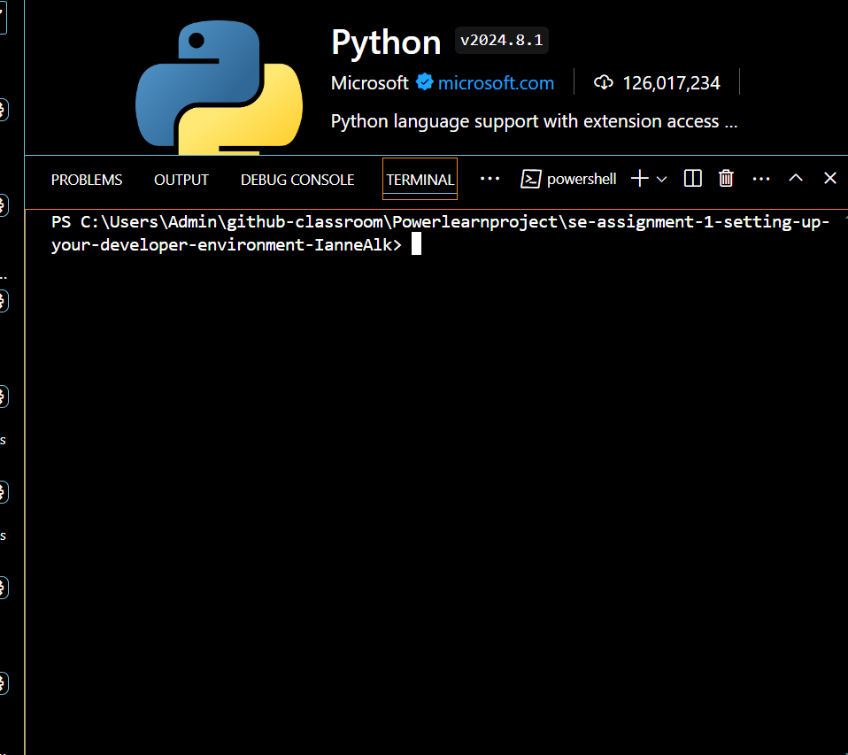

I was able to install the git extension on my vs code studio and once done this is how I linked it to my repository on git hub

Ran git version command to know my git version

mkdir assignment2 to create a directory called assignment2

cd assignment2 to change into the assignment2 directory

Ran git init to initialize my assignment2 repository

Once done I linked my repository by using

git config --global user.name "Your Name"

git config --global user.email [your.email@example.com](mailto:your.email@example.com)

once done I git commit -m “typed in the message I wanted to type describing my commit”

used git add to add to my repository

and finally git push to upload my commits to the remote version in github <https://github.com/IanneAlk/demo>

As for the MySQL database

Step 1 download MySQL installer tool from [here](https://dev.mysql.com/downloads/installer/)

Step 2 select your preferred version for me it was Download

Step 3 Once downloaded custom your installation setup for instance Server only lets you install MySQL

Step 4 Follow the prompts by clicking on execute and next

Step 5. Once the Account and Roles screen pops up, type in your preferred log in password

Step 6. Keep executing and following the prompts until the last screen comes on, where it is indicated finish

Step 7. Run the start my MySQL Server on windows

Voila you got your MySQL database set up