﻿

1.Prompt engineering is the training of Ai Models where the programmer commands an Ai Model to respond to the questions being asked in an accurate and ethical information,

2.Basic components of a prompt are Temperature and Tone,

3. The Al Model accepts the prompts as it is requested and the response will be based on how the question or prompt was structured and also on the availability of information on the Ai models Database, as well as the questions that it Has previously been asked.

4.Adding information on the Ai Model makes it more reliable and powerful, and omitting information from it makes it result in inaccurate information when prompted.

5.The effectiveness of a prompt can be evaluated based on the tone, a certain tone and then by the prompt question itself.

6.Challenges that are faced in Prompt engineering are Biased, information/Responses, inaccurate information.

And these problems can be addressed by the regular maintaining of the Ai Models, so that they always deliver the right information, if not they must be trained to refer the information they don't know to the right sources.

The article above is an example of how prompt engineering can be manipulated for unethical reasons.

This Article can be found on <https://www.wired.com/story/automated-ai-attack-gpt-4/>

7. A Successful example of Prompt Engineering being Implemented, I can say is when ChatGPT was Invented by OpenAI Company and the other Small and big Companies also decided to come up and build their own Ai Models,Companies like Google who can up with GOOGLE Bard Ai Which has now been rebranded to GEMINI, Microsoft also adobted it,Facebook and many more other Companies.

There are even website where one can find Ai Tools that have Prompt Engineered to do certain tasks.

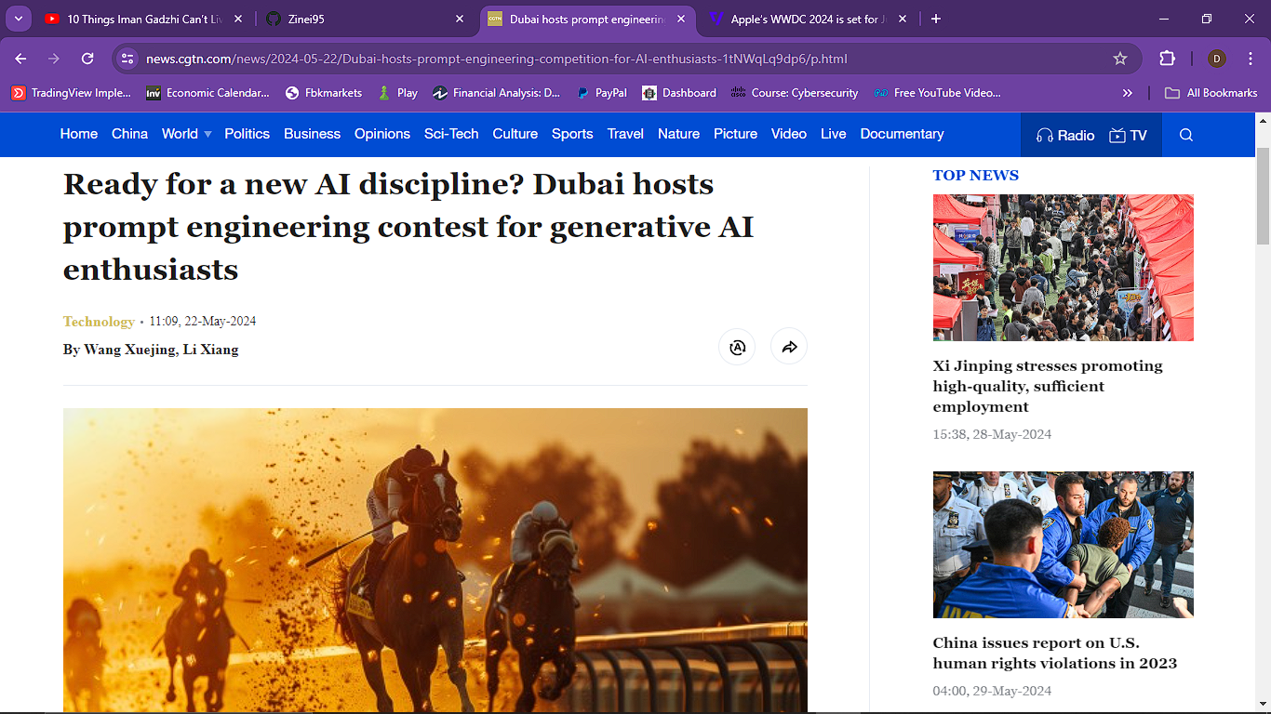

Dubai Recently Hosted a Prompt Engineering Competition, where developers were Competing for a R4.5 Million Price.

8.The emerging trends associated with Prompt engineering are Integration of API’s with AI Models and development of More AI models