Installation of VS Code on Windows 11

1. Download VS Code:

- Visit the [Visual Studio Code website] (https://code.visualstudio.com/).

- Click on the "Download for Windows" button.

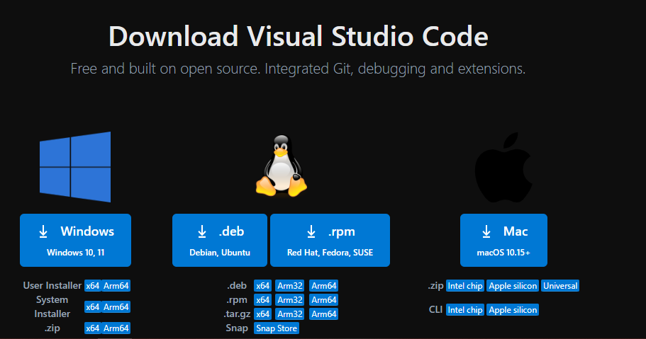

2. Run the Installer:

- Open the downloaded `VSCodeSetup.exe` file.

- Follow the installation wizard:

- Accept the license agreement.

- Choose the destination folder.

- Select additional tasks (e.g., creating a desktop icon).

3. Finish Installation:

- Click "Install" and wait for the installation to complete.

- Launch VS Code after installation by checking the appropriate box and clicking "Finish."

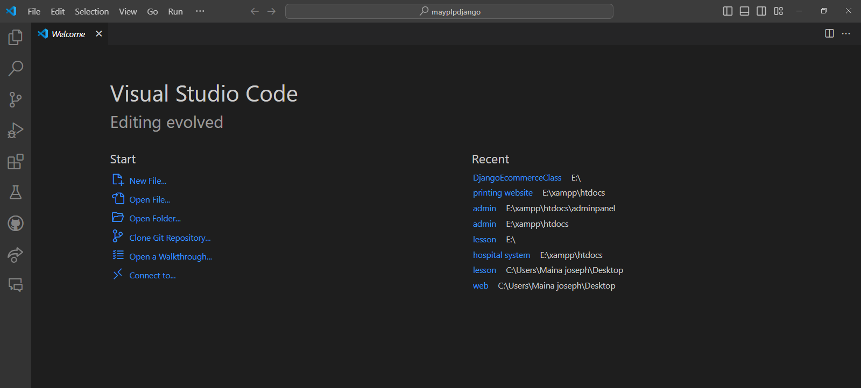

Prerequisites:

- No special prerequisites are required. Ensure that you have Windows 11 and administrative rights to install software.

First-time Setup

1. Initial Configuration:

- Theme: Go to `File > Preferences > Color Theme` and choose a theme.

- Settings Sync: Enable settings sync to synchronize your settings across devices via `File > Preferences > Settings Sync`.

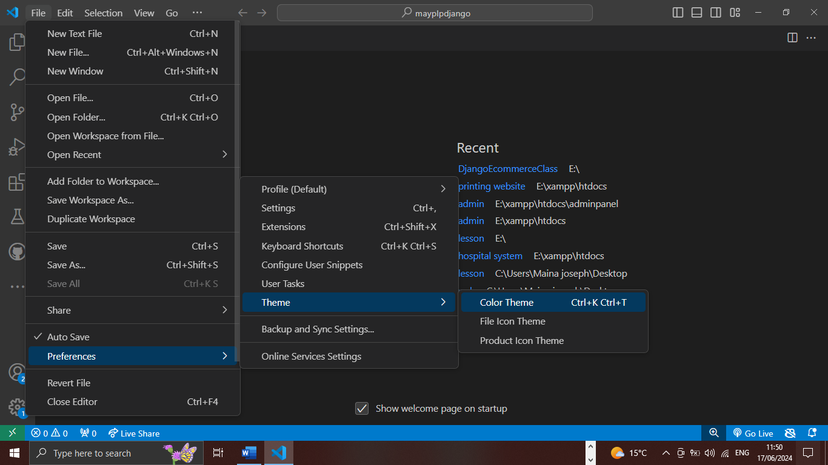

2. Important Settings:

- Auto Save: Enable auto-save via `File > Auto Save`.

- Font Size: Adjust font size in `File > Preferences > Settings > Text Editor > Font`.

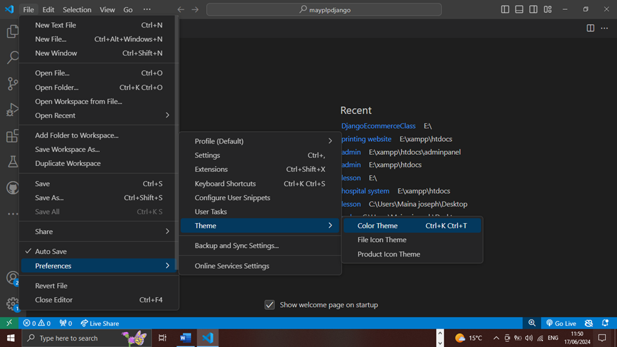

3. Essential Extensions:

- Prettier - Code formatter: For code formatting.

- Live Server: For a quick web development server.

- GitLens: Enhances Git capabilities within VS Code.

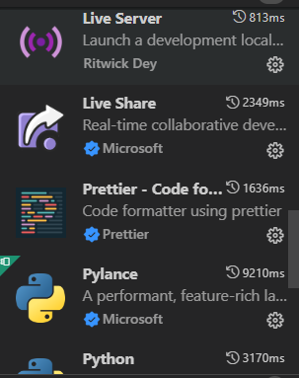

User Interface Overview

1. Activity Bar: Located on the left side, it provides access to different views like Explorer, Search, Source Control, Run and Debug, and Extensions.

2. Side Bar: Displays the contents of the selected view from the Activity Bar. For example, the Explorer view shows the file and folder structure.

3. Editor Group: The central area where files are opened and edited. You can split the editor into multiple groups for side-by-side editing.

4. Status Bar: Located at the bottom, it shows information about the current workspace, such as the branch name in source control, encoding, line endings, and language mode.

Command Palette

- Accessing Command Palette: Press `Ctrl+Shift+P` or `F1`.

- Common Tasks:

- Change the color theme: Type `Color Theme`.

- Install extensions: Type `Extensions: Install Extensions`.

- Open settings: Type `Preferences: Open Settings (UI)`.

Extensions in VS Code

1. Finding and Installing Extensions:

- Open the Extensions view by clicking the Extensions icon in the Activity Bar or pressing `Ctrl+Shift+X`.

- Search for the desired extension.

- Click `Install`.

2. Managing Extensions:

- Disable or uninstall extensions from the Extensions view.

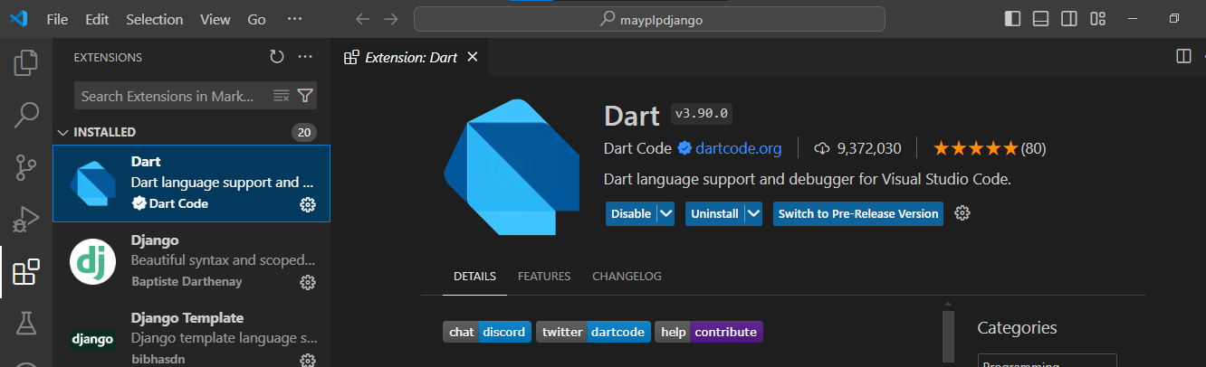 - Update extensions by clicking the update button if available.

3. Essential Extensions for Web Development:

- HTML Snippets

- CSS IntelliSense

- JavaScript (ES6) code snippets

Integrated Terminal

1. Opening the Integrated Terminal:

- Go to `View > Terminal` or press `Ctrl+`` (backtick).

- A terminal will open at the bottom of the window.

2. Advantages:

- Access terminal commands without leaving the editor.

- Run scripts, Git commands, and other tools directly within VS Code.

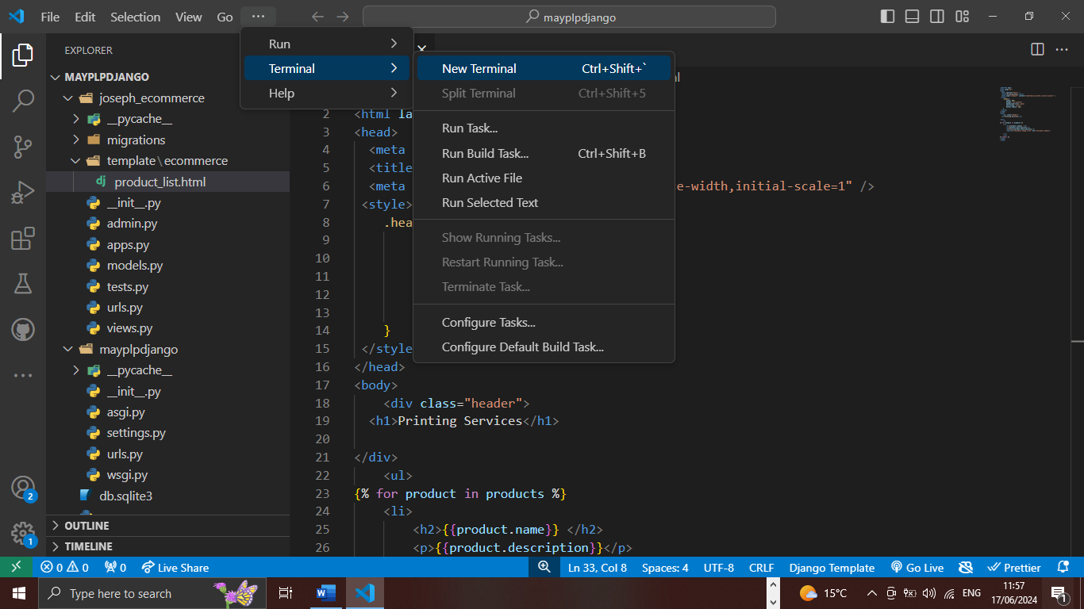

File and Folder Management

1. Creating Files and Folders:

- Right-click in the Explorer view and select `New File` or `New Folder`.

- Alternatively, use the `File > New File` or `File > New Folder` menu options.

2. Opening Files and Folders:

- Use `File > Open File` or `File > Open Folder`.

- Drag and drop files/folders into the editor.

3. Navigating Files:

- Use the Explorer view to click on files.

- Press `Ctrl+P` to quickly open files by name.

- Use breadcrumbs (enabled via `View > Show Breadcrumbs`) for easy navigation.

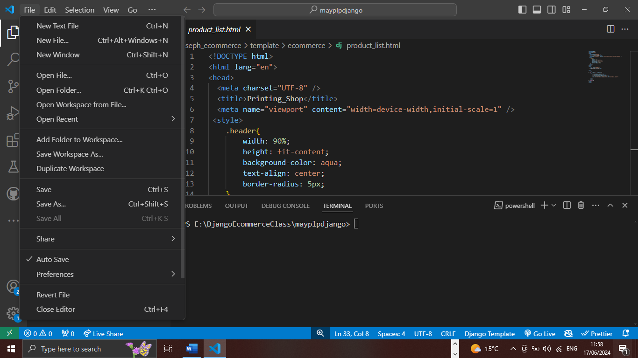

Settings and Preferences

1. Accessing Settings:

- Go to `File > Preferences > Settings` or press `Ctrl+,`.

2. Customizing Settings:

- Theme: Search for `Color Theme` and select one.

- Font Size: Search for `Font Size` and adjust.

- Keybindings: Go to `File > Preferences > Keyboard Shortcuts` to customize.

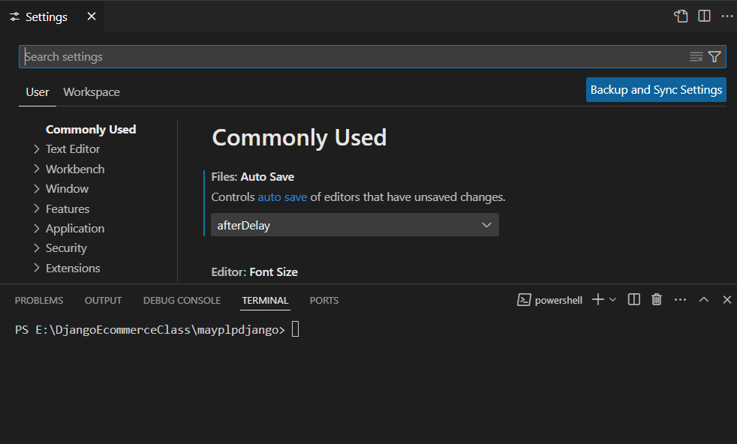

Debugging in VS Code

1. Setup and Start Debugging:

- Open the file to debug.

- Set breakpoints by clicking in the gutter next to the line numbers.

- Open the Run and Debug view from the Activity Bar.

- Click `Run and Debug` and select the appropriate configuration.

2. Key Debugging Features:

- Breakpoints: Pause execution at specific lines.

- Watch: Monitor variables and expressions.

- Call Stack: View the call stack to trace the execution path.

- Debug Console: Execute expressions and view their results.

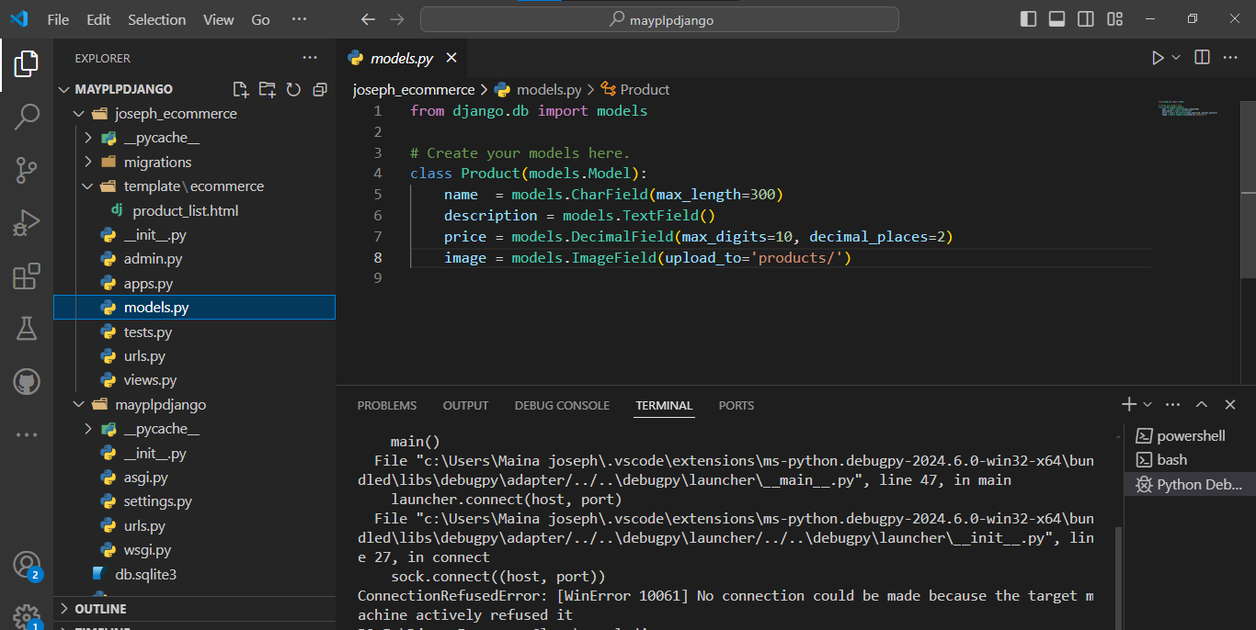

Using Source Control

1. Integrating Git:

- Initialize a repository: Go to Source Control view, click `Initialize Repository`.

- Make commits: Stage changes and write a commit message, then click `Commit`.

- Push changes: Use `Push` to upload your commits to a remote repository like GitHub.

2. Pushing Changes to GitHub:

- Set up a remote: `git remote add origin <repository URL>`.

- Push to the remote: `git push -u origin main` (or your branch name).

