 Questions:

1. **Installation of VS Code**:

   - Describe the steps to download and install Visual Studio Code on Windows 11 operating system. Include any prerequisites that might be needed.

**Prerequisites**:

Ensure Windows 11 system meets the minimum requirements for running Visual Studio Code:

**Operating System**: Windows 7 or later (Windows 11 in this case)

**Processor**: 1.6 GHz or faster processor

**RAM**: 1 GB (recommended minimum)

**Hard Disk Space**: At least 200 MB free space

**Internet**: Required for downloading VS Code and extensions

Steps to Install Visual Studio Code:

**Download Visual Studio Code**:

Open your web browser and go to the official VS Code website: https://code.visualstudio.com/.

Click on the "Download for Windows" button. This will download the installer file (VSCodeSetup.exe).

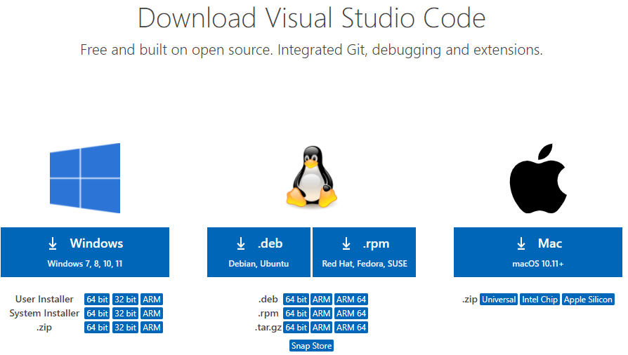

**Run the Installer**:

Once the download completes, locate the VSCodeSetup.exe file in your Downloads folder or wherever you saved it.

Double-click on VSCodeSetup.exe to start the installation process.

**Accept License Agreement**:

The installer will open a setup wizard. Click on "Next" to proceed.

Accept the license agreement terms and click on "Next".

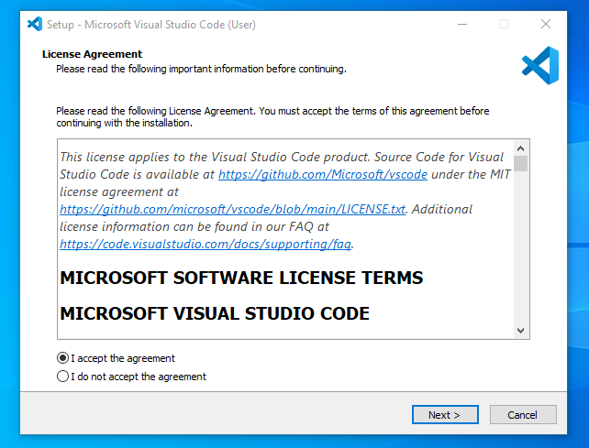

**Select Destination Location**:

Choose the destination folder where you want to install Visual Studio Code. The default location (C:\Program Files\Microsoft VS Code) is usually fine. Click on "Next".

**Select Start Menu Folder**:

Choose the Start Menu folder where shortcuts for Visual Studio Code will be created. Click on "Next".

**Select Additional Tasks**:

Optionally, you can choose to create a desktop icon and add VS Code to the PATH environment variable. Make your selections and click on "Next".

**Install**:

Click on the "Install" button to begin the installation process. This may take a few moments to complete.

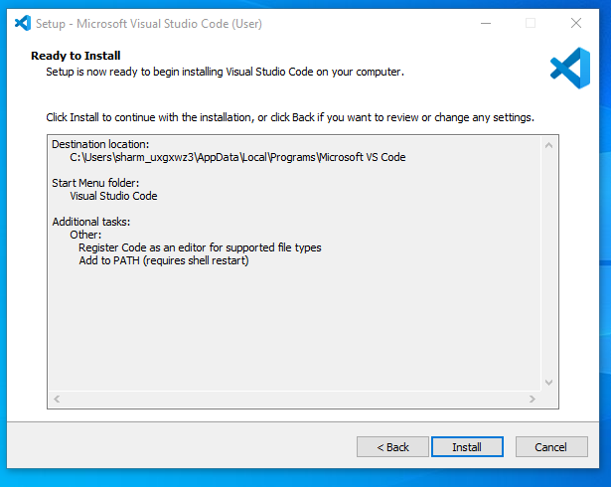

**Launch Visual Studio Code**:

Once the installation finishes, you will see a "Completing the Visual Studio Code Setup Wizard" screen. Ensure the checkbox for "Launch Visual Studio Code" is checked and click on "Finish".

**Initial Configuration**:

Visual Studio Code will launch for the first time. It may prompt you to install additional components or extensions depending on your preferences.

**Start Using Visual Studio Code**:

After the initial setup, you can start using Visual Studio Code to write code, customize settings, and install extensions as needed.

2. First-time Setup:

   - After installing VS Code, what initial configurations and settings should be adjusted for an optimal coding environment? Mention any important settings or extensions.

   After installing VS Code for the first time, there are several initial configurations and settings adjusted to optimize your coding environment.

   1. **User Interface and Theme**:

Theme: Choose a theme that suits your preferences and improves readability. You can change the theme under File > Preferences > Color Theme.

2. **Font and Font Size**:

Adjust the font and font size to make code easier to read. You can change these settings under File > Preferences > Settings and search for "font" and "fontSize".

3. **Extensions**:

Install essential extensions based on your programming languages and workflow. Some popular ones include:

**GitLens**: Enhances Git integration with features like annotations and repository history.

**ESLint/Prettier**: For JavaScript/TypeScript formatting and linting.

**Python (for Python development):** Provides syntax highlighting, debugging, and linting for Python.

**Live Server (for web development):** Launches a local development server with live reload functionality.

Developer can explore and install extensions from the Extensions view (Ctrl+Shift+X).

4**. Settings:**

Review and customize VS Code settings to match your workflow:

Access settings via File > Preferences > Settings or by pressing Ctrl+, (comma).

Adjust editor behavior, formatting options, and keyboard shortcuts.

5. **Integrated Terminal**:

Configure the integrated terminal (Ctrl+ `) to use your preferred shell (e.g., PowerShell, Command Prompt, or Git Bash).

6. Workspace Settings (if applicable):

If you work on multiple projects, consider setting up workspace-specific settings (File > Preferences > Settings > Workspace Settings). This allows you to customize settings per project.

7. **Keybindings:**

Customize or learn existing keyboard shortcuts (File > Preferences > Keyboard Shortcuts or Ctrl+K Ctrl+S) to improve productivity.

8. **Version Control Integration:**

If you use Git or another version control system, configure VS Code to integrate with it. Ensure Git is installed on your system, and VS Code will automatically detect it.

9. **Auto Save Settings:**

Configure auto-save settings (File > Preferences > Settings and search for "auto save") to suit your workflow.

10. Editor Layout and Split Views:

Familiarize yourself with editor layout options (View > Editor Layout) and how to use split views (View > Editor Layout > Split Right or Split Down) for multitasking.

11. Useful Commands and Features:

Explore and learn useful VS Code features like Command Palette (Ctrl+Shift+P), Integrated Terminal (Ctrl+``), and Quick Open (Ctrl+P`).

3. User Interface Overview:

   - Explain the main components of the VS Code user interface. Identify and describe the purpose of the Activity Bar, Side Bar, Editor Group, and Status Bar.

   1. Activity Bar:

Purpose: The Activity Bar is located vertically on the far left side of the VS Code window. It provides quick access to different views and functionalities.

Components:

Explorer: Allows navigation through your project files and folders.

Search: Provides tools for searching across files in your workspace.

Source Control: Integrates with version control systems like Git for managing source code changes.

Run and Debug: Enables running and debugging applications directly from VS Code.

Extensions: Manages installed extensions and provides access to the VS Code Marketplace.

2. Side Bar:

Purpose: The Side Bar is located to the left of the Editor Group(s) and provides additional context and actions related to your project and files.

Components:

File Explorer: Displays the file structure of your project directory.

Search Results: Shows search results from global search operations.

Source Control: Lists changes and allows interaction with version control (e.g., Git).

Extensions: Lists installed extensions and provides access to extension settings.

Debug Console: Displays output from debug sessions.

3. Editor Group:

Purpose: The Editor Group consists of one or more text editors where you write and edit code or text files.

Components:

Tabs: Each open file or editor has a tab at the top of the Editor Group.

Split Views: Allows splitting the editor horizontally or vertically to work on different files simultaneously.

Editor Settings: Provides options for customizing the behavior and appearance of the text editor.

4. Status Bar:

Purpose: The Status Bar is located at the bottom of the VS Code window and provides information about the current state of your workspace and editor.

Components:

Language Mode: Displays the current programming language mode of the active file.

Git Branch: Shows the current Git branch and status.

Line and Column Numbers: Indicates the cursor position within the active file.

Encoding: Displays the file encoding format.

Spaces/Tabs Settings: Indicates whether spaces or tabs are used for indentation.

Errors/Warnings: Shows notifications for errors, warnings, and other information.

Customization and Extensions:

VS Code allows extensive customization of its interface through themes, settings adjustments (File > Preferences > Settings), and extensions (Ctrl+Shift+X). You can tailor the interface to match your workflow and preferences, making it a versatile tool for various development tasks.

4. Command Palette:

   - What is the Command Palette in VS Code, and how can it be accessed? Provide examples of common tasks that can be performed using the Command Palette.

   It is a powerful tool that allows you to execute various commands and operations quickly without needing to navigate through menus.It serves as a central hub for accessing and executing commands, configuring settings, and installing extensions.

   Accessing the Command Palette:

To access the Command Palette in VS Code, you can use the following methods:

Keyboard Shortcut:

Press Ctrl+Shift+P (Windows/Linux) or Cmd+Shift+P (Mac).

Menu Option:

Click on View in the top menu, then select Command Palette....

Examples of Common Tasks Using the Command Palette:

Switching Themes:

Type "Color Theme" and select Preferences: Color Theme. This allows you to switch between different themes installed in VS Code.

Opening Files:

Type the name of the file you want to open or use File: Open File to navigate to a specific file in your workspace.

Running Tasks:

Use commands like Tasks: Run Task to execute predefined tasks configured in your workspace (e.g., build tasks or custom scripts).

Searching and Replacing:

Use Replace or Find commands (Edit: Find or Edit: Replace) to search for text within the current file or across the entire project.

Git Operations:

Perform Git operations such as Git: Pull, Git: Commit, Git: Push, etc., directly from the Command Palette.

Managing Extensions:

Install, enable, disable, update, or manage extensions using commands like Extensions: Install Extensions, Extensions: Disable Extensions, Extensions: Update All Extensions.

Settings and Preferences:

Access and modify VS Code settings and preferences using commands like Preferences: Open Settings, Preferences: Open Keyboard Shortcuts.

Debugging:

Start, stop, and manage debugging sessions using commands like Debug: Start Debugging, Debug: Stop Debugging, Debug: Restart.

Task Management:

Manage tasks defined in the tasks.json file using commands like Tasks: Run Task, Tasks: Configure Task.

Terminal Operations:

Access and manage integrated terminal sessions using commands like Terminal: Create New Integrated Terminal, Terminal: Focus on Terminal, Terminal: Kill Terminal.

5. Extensions in VS Code:

   - Discuss the role of extensions in VS Code. How can users find, install, and manage extensions? Provide examples of essential extensions for web development.

   Extensions allow users to customize their development environment, enhance productivity, and support various programming languages and frameworks.

   Role of Extensions in VS Code:

Enhanced Functionality: Extensions add new features, tools, and integrations to VS Code, making it suitable for different types of development tasks.

Language Support: Extensions provide language-specific support, including syntax highlighting, IntelliSense (code completion and suggestion), debugging capabilities, and more.

Task Automation: Extensions can automate repetitive tasks, such as formatting code, running tests, and deploying applications.

Integration with Tools and Services: They integrate with external tools and services like Git, Docker, Azure, and various APIs to streamline development workflows.

Customization: Users can customize VS Code’s appearance, behavior, and functionality according to their preferences and project requirements.

Finding, Installing, and Managing Extensions:

Finding Extensions:

Access the Extensions view in VS Code by clicking on the Extensions icon in the Activity Bar (Ctrl+Shift+X).

Search for extensions by name, category (e.g., Programming Languages, Debuggers, Themes), or functionality (e.g., Git integration, code formatting).

Installing Extensions:

Once you find an extension, click on the "Install" button next to it.

VS Code will download and install the extension. You may need to reload VS Code to activate some extensions.

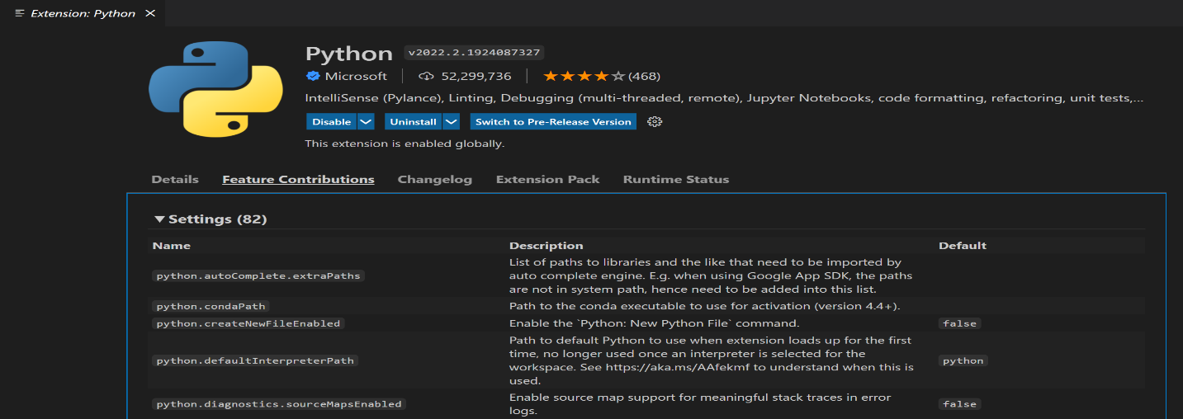

Managing Extensions:

Disable or uninstall extensions that are no longer needed or causing conflicts.

Update extensions to their latest versions to benefit from new features and bug fixes.

Configure extension settings via the Extensions view or the Command Palette (Ctrl+Shift+P) using commands like Preferences: Open Settings (JSON).

Examples of Essential Extensions for Web Development:

ESLint/Prettier:

ESLint: Provides real-time linting for JavaScript and TypeScript to maintain code quality.

Prettier: Automatically formats code for consistency across your project.

Live Server:

Launches a local development server with live reloading capability, ideal for front-end web development.

Debugger for Chrome:

Enables debugging of JavaScript code running in the Google Chrome browser directly from VS Code.

HTML CSS Support:

Provides autocompletion, syntax highlighting, and formatting for HTML and CSS files.

Auto Rename Tag:

Automatically renames paired HTML/XML tags when one is modified, ensuring consistency.

Path Intellisense:

Auto-completes filenames and paths in your code, reducing errors and speeding up development.

Bootstrap 4, Font Awesome 4, 5 Snippets:

Provides snippets and autocomplete suggestions for Bootstrap 4, Font Awesome icons, and other popular libraries.

GitLens:

Enhances Git integration with features like line-by-line blame annotations, commit history exploration, and more.

Bracket Pair Colorizer:

Colorizes matching brackets in your code, making it easier to distinguish nested code blocks.

REST Client:

Allows sending HTTP requests and viewing responses directly within VS Code, useful for testing APIs.

6. Integrated Terminal:

   - Describe how to open and use the integrated terminal in VS Code. What are the advantages of using the integrated terminal compared to an external terminal?

Opening the Integrated Terminal:

Opening the Terminal:

To open the integrated terminal in VS Code using several methods:

Press Ctrl+`` (backtick) on Windows/Linux or Cmd+`` (backtick) on macOS.

Navigate to View > Terminal from the top menu.

Use the Command Palette (Ctrl+Shift+P or Cmd+Shift+P) and type "Toggle Integrated Terminal".

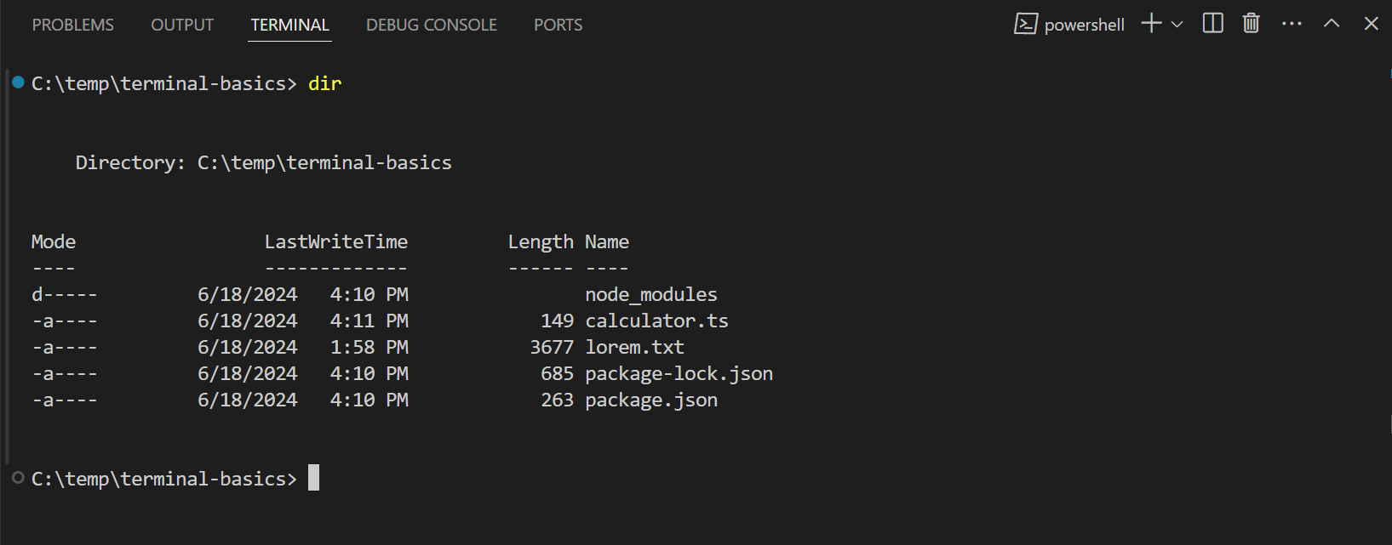

Choosing the Terminal Shell:

By default, VS Code uses your system’s default shell (e.g., PowerShell on Windows, Bash on macOS/Linux) for the integrated terminal.

You can change the terminal shell by clicking on the dropdown arrow next to the terminal tab and selecting a different shell (e.g., Command Prompt, Git Bash).

Using the Integrated Terminal:

Navigation and Commands:

Use standard shell commands (cd, ls/dir, etc.) to navigate directories and execute commands.

Run scripts, compile code, manage Git operations, and perform other command-line tasks directly within the integrated terminal.

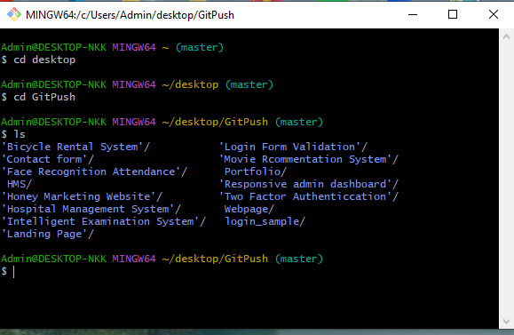

Integration with VS Code:

Open files and folders from the terminal using commands like code . to open the current directory in VS Code.

Debug applications with integrated debug consoles (e.g., Node.js, Python) and view output directly in the terminal.

Customization:

Customize the terminal appearance and behavior through settings (File > Preferences > Settings and search for "terminal").

Configure specific terminal profiles or shell environments if needed.

Advantages of Using the Integrated Terminal:

Contextual Integration:

Seamlessly switch between coding and command-line tasks within the same VS Code window, reducing context switching and improving workflow efficiency.

Direct Access and Convenience:

Access the terminal directly within VS Code’s user interface, eliminating the need to switch to an external terminal application.

Perform tasks like running scripts, managing Git, and executing commands without leaving the coding environment.

Integrated Debugging:

Debug applications and view debug output directly in the integrated terminal, enhancing the debugging experience.

Workspace Independence:

Each VS Code workspace can have its own integrated terminal session, maintaining workspace-specific configurations and environments.

Enhanced Productivity:

Utilize VS Code features like syntax highlighting within the terminal, clickable links (e.g., file paths), and integrated Git support seamlessly.

Extension Compatibility:

Extensions can extend the functionality of the integrated terminal, adding support for additional shells, integrating with specific tools, or providing custom commands tailored to your workflow.

Comparison with External Terminal:

Convenience: Integrated terminal offers a more seamless experience, eliminating the need to switch between VS Code and an external terminal window.

Efficiency: Faster execution of tasks within the integrated environment saves time and reduces interruptions.

Customization: VS Code allows you to customize the terminal appearance and behavior to suit your preferences and workflow.

Integration: Direct integration with VS Code features and extensions enhances productivity and workflow management.

7. **File and Folder Management**:

   - Explain how to create, open, and manage files and folders in VS Code. How can users navigate between different files and directories efficiently?

   Managing files and folders efficiently is essential for maintaining organized and productive development workflows in Visual Studio Code (VS Code).

**Creating and Opening Files**:

Creating a New File:

To create a new file, you can use several methods:

Click on the Explorer icon in the Activity Bar (Ctrl+Shift+E or Cmd+Shift+E), right-click in the file list, and select New File.

Use the Command Palette (Ctrl+Shift+P or Cmd+Shift+P) and type "New File" to create a new file in the current workspace directory.

Opening Existing Files:

Open files by navigating through the Explorer view or using the Command Palette (Ctrl+P or Cmd+P) and typing the file name.

Use Ctrl+Click (Windows/Linux) or Cmd+Click (macOS) on a file name in the Explorer or editor tabs to open it in a new editor tab.

**Managing Files and Folders**:

Renaming and Deleting:

Renaming: Right-click on a file or folder in the Explorer and select Rename, or press F2 when the file/folder is selected.

Deleting: Right-click and select Delete to move files/folders to the Recycle Bin (Windows) or Trash (macOS), or use Shift+Delete to permanently delete.

Moving and Copying:

Drag and drop files/folders within the Explorer view to move them to a new location.

Use Ctrl+C (Windows/Linux) or Cmd+C (macOS) to copy, and Ctrl+V (Windows/Linux) or Cmd+V (macOS) to paste files/folders.

Searching within Files:

Use the search functionality (Ctrl+Shift+F or Cmd+Shift+F) to search for specific text patterns within files across your project.

Navigating Efficiently:

Explorer View:

Use the Explorer view (Ctrl+Shift+E or Cmd+Shift+E) to navigate through files and folders in your project directory.

Collapse or expand folders to focus on specific parts of your project.

Go to File:

Use Ctrl+P or Cmd+P to quickly open files by typing part of their name. VS Code uses fuzzy matching to suggest and open files matching your input.

Switching Between Open Files:

Use Ctrl+Tab (Windows/Linux) or Cmd+Tab (macOS) to cycle through open files in the editor.

Use Ctrl+1, Ctrl+2, etc. (Windows/Linux) or Cmd+1, Cmd+2, etc. (macOS) to directly switch to a specific editor tab.

Navigating Directories in Integrated Terminal:

Use standard shell commands (cd, ls/dir, etc.) in the integrated terminal to navigate directories and perform file management tasks.

8. **Settings and Preferences**:

   - Where can users find and customize settings in VS Code? Provide examples of how to change the theme, font size, and keybindings.

   To access and customize settings for themes, font size, and keybindings:

Finding and Customizing Settings:

Accessing Settings:

Open VS Code.

Navigate to File > Preferences > Settings or use the keyboard shortcut Ctrl+, (comma) on Windows/Linux or Cmd+, on macOS.

This opens the Settings UI where you can search for specific settings or edit the settings.json file directly.

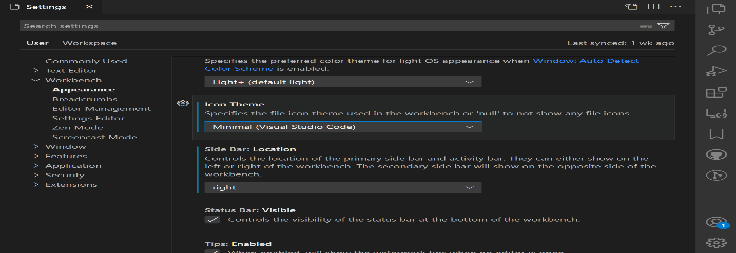

Customizing Settings:

Changing the Theme:

In the Settings UI, type "color theme" in the search bar.

Click on Color Theme under Workbench to see a list of available themes.

Click on a theme to apply it immediately.

Adjusting Font Size:

In the Settings UI, type "font size" in the search bar.

You will find settings like Editor: Font Size and Editor: Font Family.

Modify the values to change the font size and font family.

Alternatively, you can directly edit the settings.json file

Customizing Keybindings:

In the Settings UI, type "keybindings" in the search bar.

Click on Keyboard Shortcuts to view and edit keybindings.

Editing settings.json:

Advanced customization can be done directly in the settings.json file.

To open settings.json, click on the {} icon in the top right corner of the Settings UI.

9. **Debugging in VS Code**:

   - Outline the steps to set up and start debugging a simple program in VS Code. What are some key debugging features available in VS Code?

   Setting Up and Starting Debugging:

Install Necessary Extensions:

Make sure you have the necessary extensions installed for the programming language you are using. For example, for JavaScript/Node.js, you might need the "Debugger for Chrome" extension.

Open Your Project:

Open your project folder in VS Code (File > Open Folder) or navigate to an existing project.

Create or Open a Program File:

Open the file containing the code you want to debug.

Set Breakpoints:

Click in the gutter (the area to the left of the line numbers) next to the line where you want to set a breakpoint. Alternatively, you can use F9 to toggle breakpoints.

Configure Debugging Launch Configuration:

Click on the Debug icon in the Activity Bar on the side (Ctrl+Shift+D).

Click on the gear icon (create a launch.json file) and select the environment for your code (e.g., Node.js, Chrome, etc.).

VS Code will generate a launch.json file with default configurations. You can modify this file to customize how your program is launched and debugged.

Start Debugging:

Press F5 or click on the green play button (Start Debugging) in the Debug view to start debugging. If you have multiple configurations, choose the one you want to use.

**Key Debugging Features in VS Code**:

Breakpoints:

Set breakpoints in your code to pause execution at specific lines and inspect variables and state.

Step-by-Step Execution:

Use controls like F10 (Step Over), F11 (Step Into), and Shift+F11 (Step Out) to execute code line by line and navigate through function calls.

Watch and Variables Panel:

Monitor and modify variables in real-time using the Watch panel.

Explore and inspect variables in the Variables panel to understand their values during runtime.

Call Stack:

View the call stack to see the path that led to the current breakpoint, allowing you to trace back through function calls.

Debug Console:

Use the Debug Console to execute arbitrary expressions and commands, interact with the debugger, and view console output.

Conditional Breakpoints:

Set breakpoints with conditions that trigger only when specific criteria are met (e.g., variable values, expressions).

Exception Handling:

Configure VS Code to break execution when exceptions are thrown, allowing you to inspect and handle errors effectively.

Integrated Terminal for Debugging:

Use the integrated terminal to run commands, debug scripts, and interact with your debugged application's environment directly.

Advanced Features and Extensions:

Remote Debugging: Debug applications running on remote machines or containers.

IntelliSense and Hover: Get contextual information about variables and functions while debugging.

Task Automation: Debugging configurations can be automated and included in task runners like tasks.json.

10. **Using Source Control**:

    - How can users integrate Git with VS Code for version control? Describe the process of initializing a repository, making commits, and pushing changes to GitHub.

**Integrating Git with VS Code**:

Install Git:

Ensure Git is installed on your system. You can download it from git-scm.com and follow the installation instructions.

Open Your Project in VS Code:

Open VS Code and navigate to your project folder (File > Open Folder...).

Initialize a Git Repository:

Open the Source Control view by clicking on the Source Control icon in the Activity Bar on the side (or use Ctrl+Shift+G).

Click on Initialize Repository or use the command palette (Ctrl+Shift+P or Cmd+Shift+P), type "Git: Initialize Repository," and select the root folder of your project.

Stage and Commit Changes:

In the Source Control view, you'll see a list of files with changes (unstaged changes).

Click the + icon next to each file or use Stage All Changes to stage all changes.

Enter a commit message in the text box at the top of the Source Control view.

Click the checkmark icon (Commit) to commit your changes.

Push Changes to GitHub:

Linking to GitHub:

Ensure you have a GitHub account and create a new repository on GitHub if you haven’t already.

Add Remote Repository:

After committing your changes, click on the ellipsis (...) next to the branch name in the Source Control view.

Choose Publish Branch... to push your changes to GitHub.

If you haven't added a remote repository, you'll be prompted to add one. Paste the URL of your GitHub repository.

Push Changes:

After adding the remote repository, VS Code will push your changes to GitHub.

You might be prompted to log in to your GitHub account if authentication is required.

Key Operations in Source Control View:

Committing Changes:

Stage changes by clicking on the + icon next to files.

Enter a commit message and click the checkmark (Commit) to commit changes.

Branching and Merging:

Use the branch dropdown in the Source Control view to create new branches, switch between branches, and merge branches.

Viewing History:

Click on the clock icon in the Source Control view to view commit history for your repository.

**References**

* Official Visual Studio Code website: [Download Visual Studio Code](https://code.visualstudio.com/Download)
* Visual Studio Code documentation: [Setup Visual Studio Code](https://code.visualstudio.com/docs/setup/setup-overview)
* Visual Studio Code documentation: [User Interface](https://code.visualstudio.com/docs/getstarted/userinterface)
* Visual Studio Code documentation: [Settings and Preferences](https://code.visualstudio.com/docs/getstarted/settings)
* Visual Studio Code documentation: [Command Palette](https://code.visualstudio.com/docs/getstarted/userinterface#_command-palette)
* Visual Studio Code documentation: [Managing Extensions](https://code.visualstudio.com/docs/editor/extension-marketplace)
* Visual Studio Code documentation: [File and Folder Management](https://code.visualstudio.com/docs/editor/codebasics#_file-and-folder-management)
* Visual Studio Code documentation: [Debugging](https://code.visualstudio.com/docs/editor/debugging)
* GitHub documentation: [Connecting to GitHub](https://docs.github.com/en/get-started/quickstart/set-up-git)