[![Review Assignment Due Date](https://classroom.github.com/assets/deadline-readme-button-22041afd0340ce965d47ae6ef1cefeee28c7c493a6346c4f15d667ab976d596c.svg)](https://classroom.github.com/a/XoLGRbHq)

[![Open in Visual Studio Code](https://classroom.github.com/assets/open-in-vscode-2e0aaae1b6195c2367325f4f02e2d04e9abb55f0b24a779b69b11b9e10269abc.svg)](https://classroom.github.com/online_ide?assignment_repo_id=15277903&assignment_repo_type=AssignmentRepo)

# SE-Assignment-5

Installation and Navigation of Visual Studio Code (VS Code)

Instructions:

Answer the following questions based on your understanding of the installation and navigation of Visual Studio Code (VS Code). Provide detailed explanations and examples where appropriate.

Questions:

1. Installation of VS Code:

- Describe the steps to download and install Visual Studio Code on Windows 11 operating system. Include any prerequisites that might be needed.

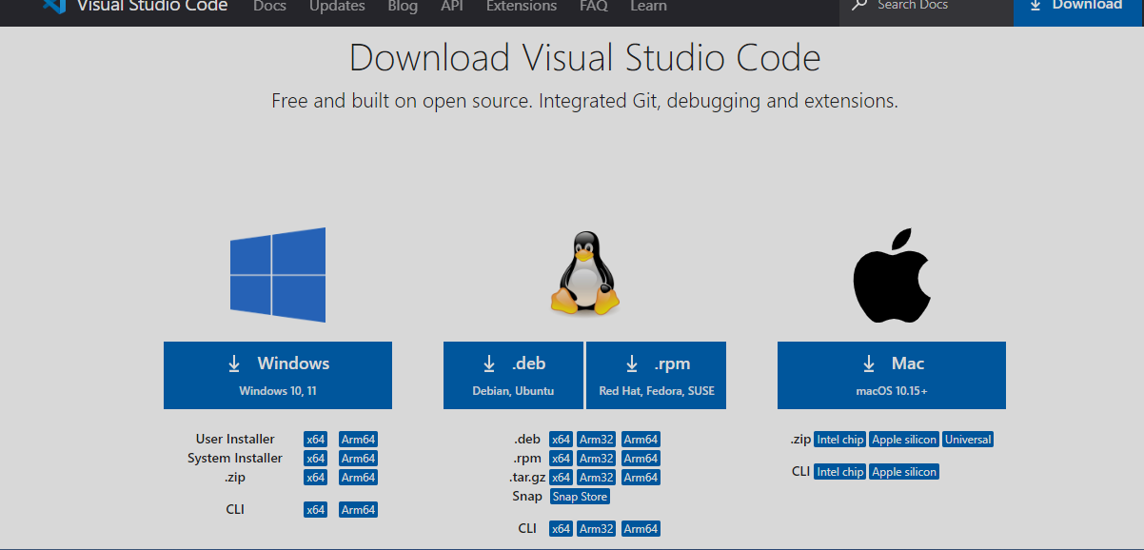

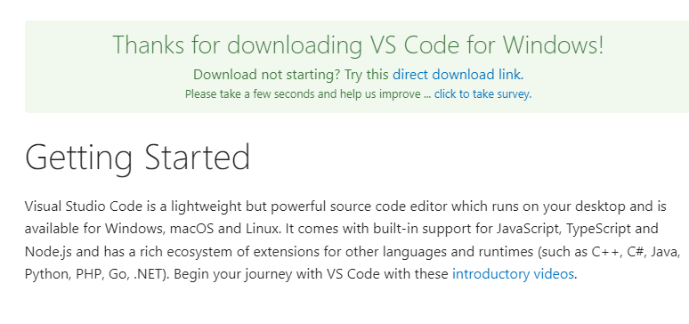

2. First-time Setup:

- After installing VS Code, what initial configurations and settings should be adjusted for an optimal coding environment? Mention any important settings or extensions.

* The file will be downloaded onto your system. Open the file and then click on Install. After downloading the VS Code file, the official site will display a Thanks message for downloading the file. Open the file, it prompts for the file location, where you want to save the VS Code file. Browse the location and then click on Next. 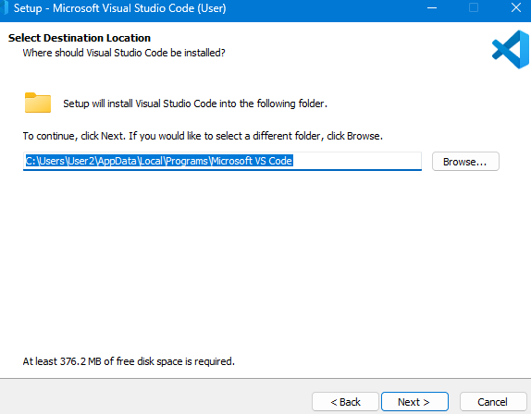
* Please read the license agreement, select you accept the agreement, and click next.

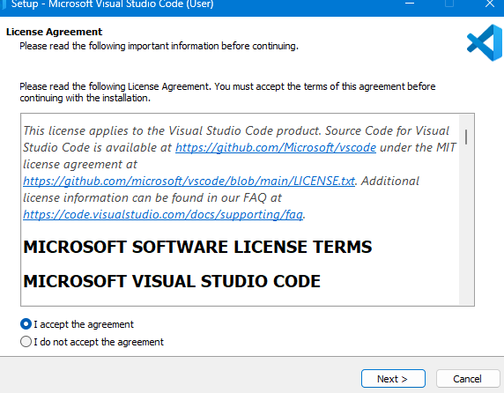

* Then it prompts for the file location, where you want to save the VS Code file. Browse the location and then click on Next.

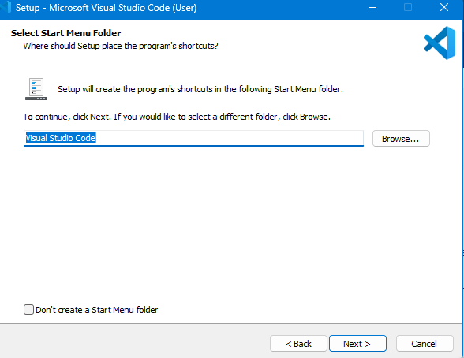

* Next, you see the prompt for the additional task which we want the VS Code to perform. At this step, choose the default settings and then click on next.

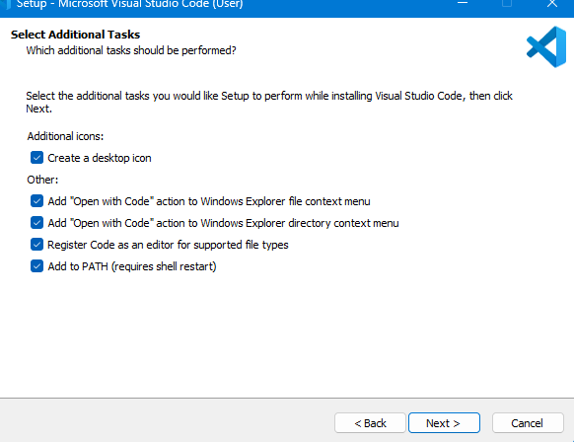

* The next prompt is how you want the VS Code on your startup. Change according to your convenience and click on Next.

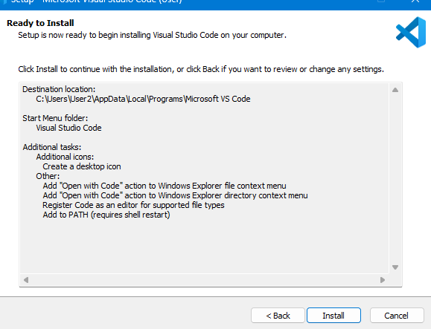

* The installation of VS Code will now begin.Wait while the setup installs Visual Studio Code on your computer.

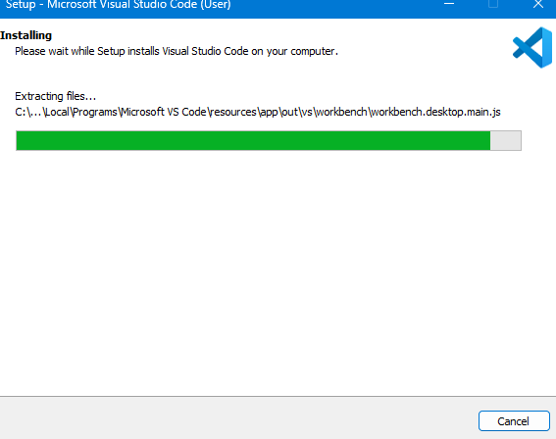

* At this step, we have completed installing VS Code, Click Finish to launch the Visual Studio Code

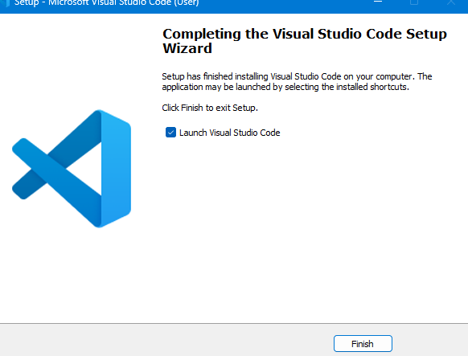

* Now that VS Code installation is successful, the page appears as below: Choosing a theme that best suits you.

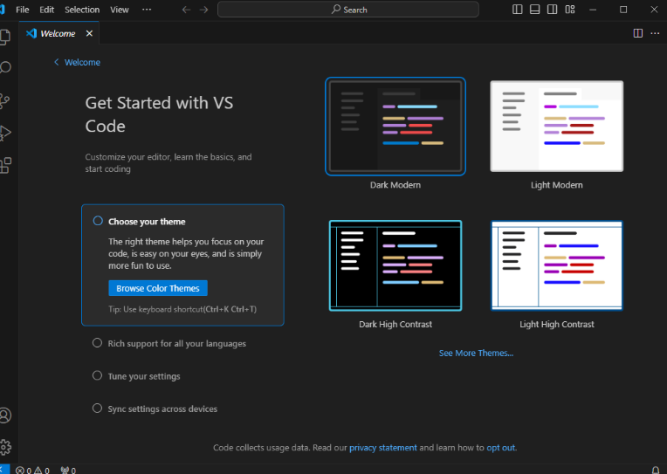

3. User Interface Overview:

- Explain the main components of the VS Code user interface. Identify and describe the purpose of the Activity Bar, Side Bar, Editor Group, and Status Bar.

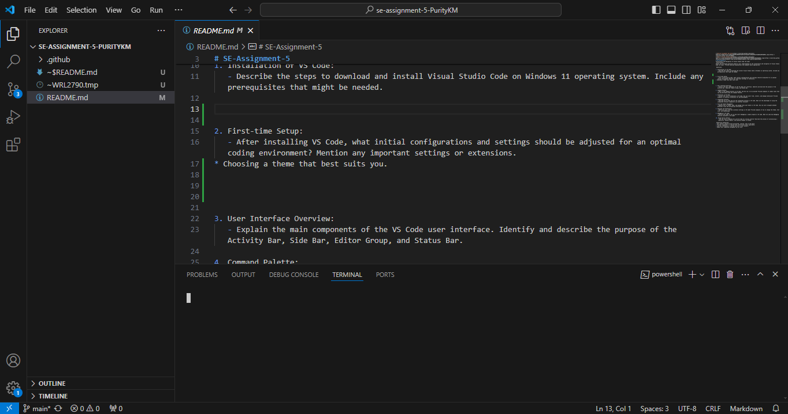

Editor Groups

Activity

Bar

Primary Side Bar

Panel

The user interface is divided into five main areas:

**Editor** - The main area to edit your files. You can open as many editors as you like side by side vertically and horizontally.

**Primary Side Bar** - Contains different views like the Explorer to assist you while working on your project.

**Status Bar** - Information about the opened project and the files you edit.

**Activity Bar** - Located on the far left-hand side. Let’s you switch between views and gives you additional context-specific indicators, like the number of outgoing changes when Git is enabled. You can change the position of the Activity Bar.

**Panel** - An additional space for views below the editor region. By default, it contains output, debug information, errors and warnings, and an integrated terminal. The Panel can also be moved to the left or right for more vertical space.

**Side by Side Editing**

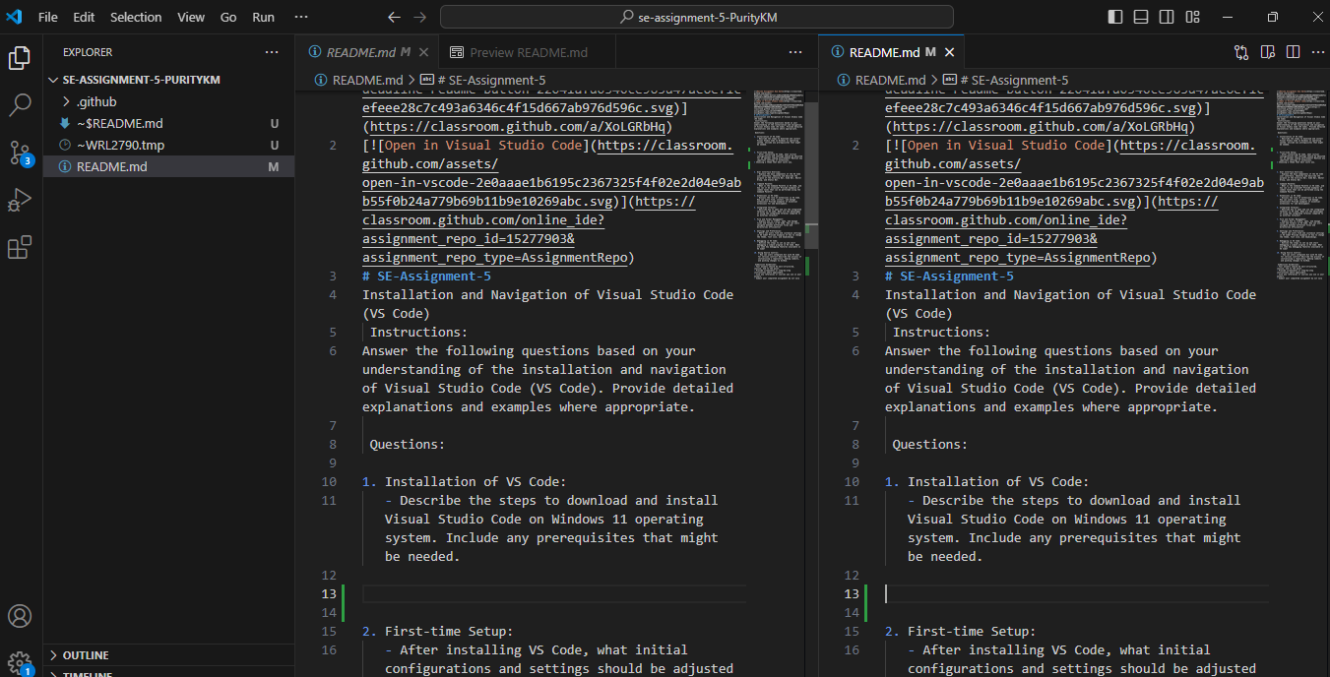

Split Right

Alt and select a file in the Explorer view.

Ctrl+\ to split the active editor into two.

Open to the Side (Ctrl+Enter) from the Explorer context menu on a file.

Select the Split Editor button in the upper right of an editor.

Drag and drop a file to any side of the editor region.

* Press Ctrl+Enter in the Quick Open (Ctrl+P) file list. Alt and select a file in the Explorer view.
* Ctrl+\ to split the active editor into two.
* **Open to the Side** (Ctrl+Enter) from the Explorer context menu on a file.
* Select the **Split Editor** button in the upper right of an editor.
* Drag and drop a file to any side of the editor region.
* Press Ctrl+Enter in the **Quick Open** (Ctrl+P) file list.

**Settings Area:**

Font Size and Font Family and Auto Save Control

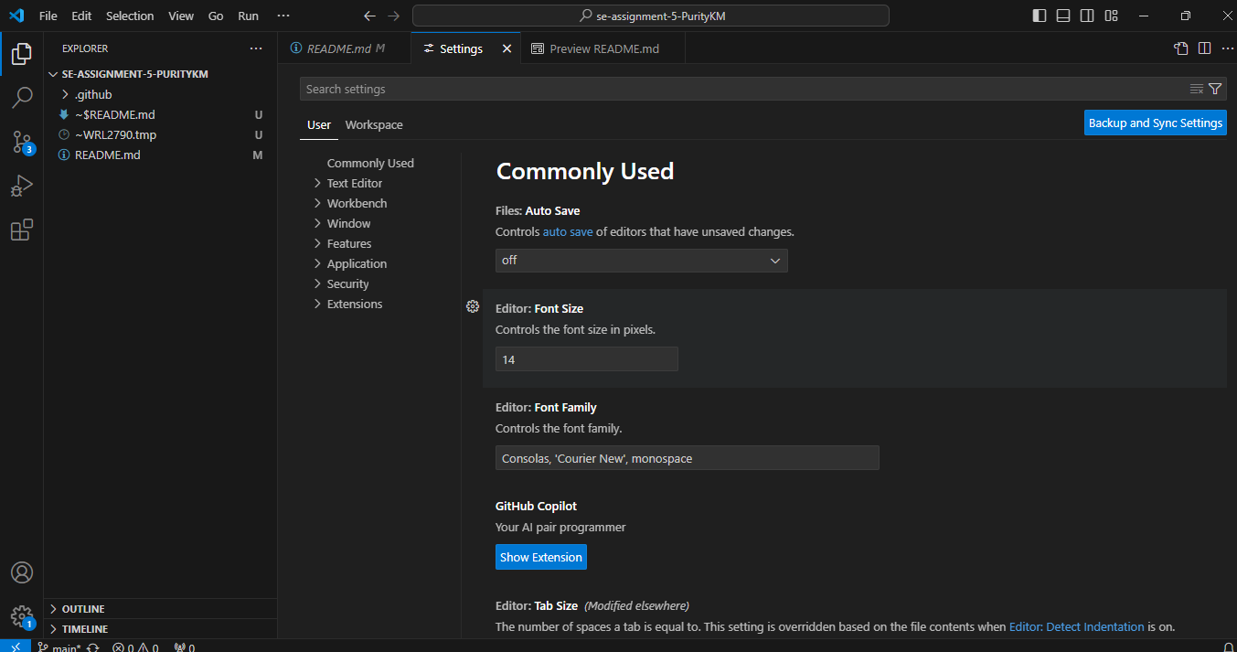

4. Command Palette:

- What is the Command Palette in VS Code, and how can it be accessed? Provide examples of common tasks that can be performed using the Command Palette.

**The Command Palette** in Visual Studio Code (VS Code) is a powerful feature that allows users to access various commands and functionalities through a searchable interface. It provides a quick and efficient way to execute commands, navigate through the editor, and perform actions without using the mouse or remembering specific keyboard shortcuts.

**How to Access the Command Palette?**

* Keyboard Shortcut: The primary way to open the Command Palette is by pressing Ctrl + Shift + P (Windows/Linux) or Cmd + Shift + P (Mac).
* Menu Option: You can also access it via the menu bar by selecting View -> Command Palette.

For instance, users can open files (File: Open File), perform search and replace operations (Replace in Files), switch between open editors (View: Switch Editor), run predefined tasks (Tasks: Run Task), manage extensions (Extensions: Install Extensions), and execute Git operations (Git: Commit, Git: Pull, Git: Push) directly from the Command Palette.

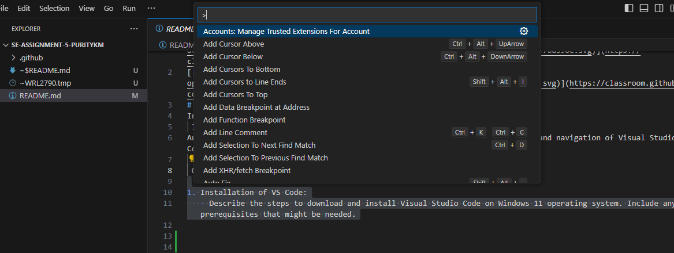

* Adding a predefined dev container configuration.
* Suspending or stopping a codespace.

5. Extensions in VS Code:

- Discuss the role of extensions in VS Code. How can users find, install, and manage extensions? Provide examples of essential extensions for web development.

**Extensions in VS Code** allow users to customize and enhance their coding experience by adding support for different programming languages, integrating with external tools and services, automating tasks, and much more. Extensions essentially cater to diverse needs, making VS Code adaptable for various development workflows.

**Finding, Installing, and Managing Extensions**

* Finding Extensions:

**Extensions View**: Open the Extensions view in VS Code (Ctrl + Shift + X), where you can browse featured extensions, search by name or category, and see recommended extensions based on your coding preferences.

* Installing Extensions:

Once you find an extension Click on the extension in the Extensions view or in the Marketplace.

Click "Install" to install the extension.

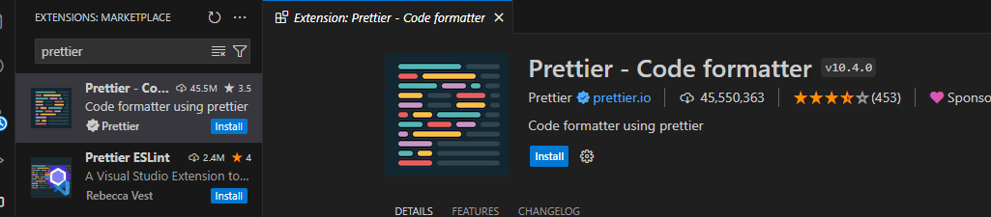

* Managing Extensions:

**Enable/Disable**: You can enable or disable extensions as per your current project needs.

**Update**: VS Code notifies you when updates are available for installed extensions. You can update them directly from the Extensions view.

**Uninstall**: If you no longer need an extension, you can uninstall it from the Extensions view.

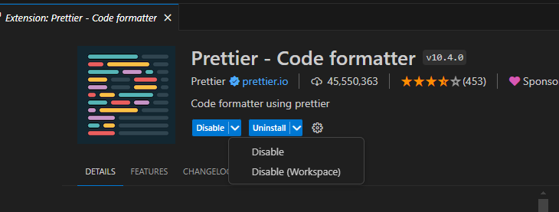

6. Integrated Terminal:

- Describe how to open and use the integrated terminal in VS Code. What are the advantages of using the integrated terminal compared to an external terminal?

To open the integrated terminal in Visual Studio Code (VS Code):

* Using Keyboard Shortcut:

Press Ctrl + (backtick) on Windows.

* Using Menu Option:

Click on View in the menu bar, then Select Terminal -> New Terminal.

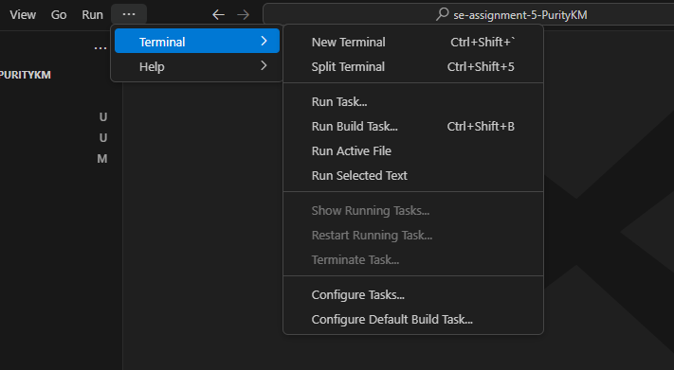

* Using Command Palette:

Open the Command Palette (Ctrl + Shift + P, then Type View: Toggle Terminal and press Enter.

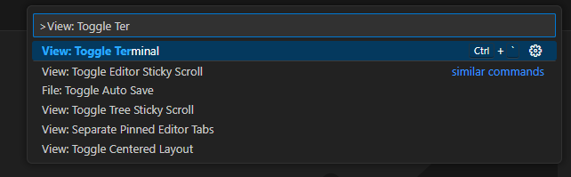

* Once the integrated terminal is open:

You can type commands directly into the terminal just like you would in any external terminal.

Navigate through directories using standard shell commands (cd, ls, dir, etc.).

Run scripts, compile code, or execute any command-line operations relevant to your project.

**Advantages of Using the Integrated Terminal Compared to an External Terminal**

* Seamless Integration: The integrated terminal is built directly into VS Code, meaning you don't have to switch between different applications or windows. This integration enhances workflow efficiency by keeping your development environment within a single interface
* Customization: You can customize the integrated terminal's appearance, font, color scheme, and other settings to match your preferences, similar to how you customize the editor itself.
* Productivity Features: VS Code offers features like terminal split view (Ctrl + \) and multiple terminal instances, allowing you to work with multiple terminals simultaneously within the same window. This feature is especially useful for tasks that require running multiple commands or scripts concurrently.
* Direct Interaction with VS Code: The integrated terminal allows for direct interaction with VS Code itself. For example, you can run VS Code commands (Ctrl + Shift + P), execute tasks defined in tasks.json, or launch debugging sessions directly from the terminal.
* Extension Integration: Extensions like Git integration (e.g., GitLens) or language-specific tools often provide additional functionality within the integrated terminal, enhancing its capabilities beyond basic command-line interactions.

7. File and Folder Management:

- Explain how to create, open, and manage files and folders in VS Code. How can users navigate between different files and directories efficiently?

**Creating Files and Folders:**

* **Creating a File**:

Click on the Explorer icon in the Activity Bar (usually the top icon resembling a folder structure) or use Ctrl + Shift + E to open the Explorer view.

Right-click on the folder where you want to create the file.

Select New File from the context menu. Enter a name for the file and press Enter to create it.

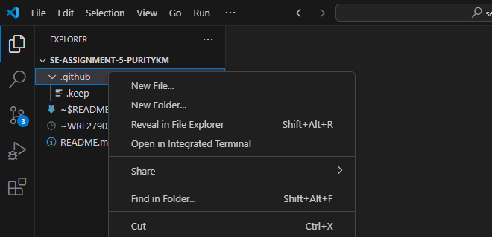

* **Creating a Folder:**

Similarly, right-click on the folder where you want to create the new folder.

Select New Folder from the context menu.

Enter a name for the folder and press Enter to create it.



**Opening Files and Folders:**

* **Opening Files:**

In the Explorer view, double-click on the file you want to open.

Alternatively, you can use the Ctrl + P shortcut to open the Quick Open dialog. Type the name of the file and press Enter to open it.

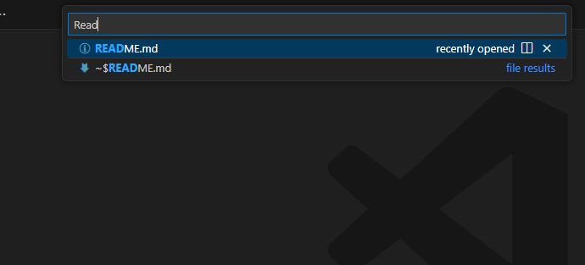

* **Opening Folders:**

To open a folder in VS Code, you can drag and drop the folder into the VS Code window, or use File -> Open Folder... from the menu bar.

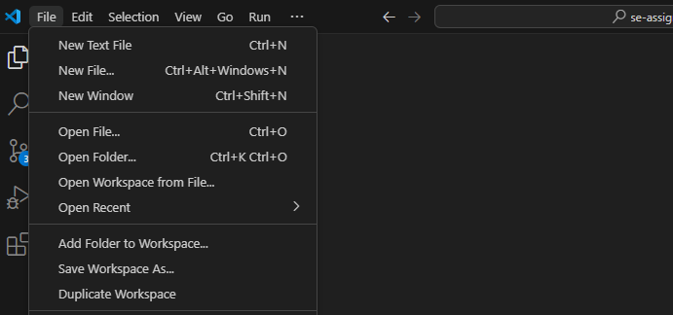

**Managing Files and Folders:**

* **Renaming and Deleting:**

Right-click on a file or folder in the Explorer view to rename (Rename) or delete (Delete) it.

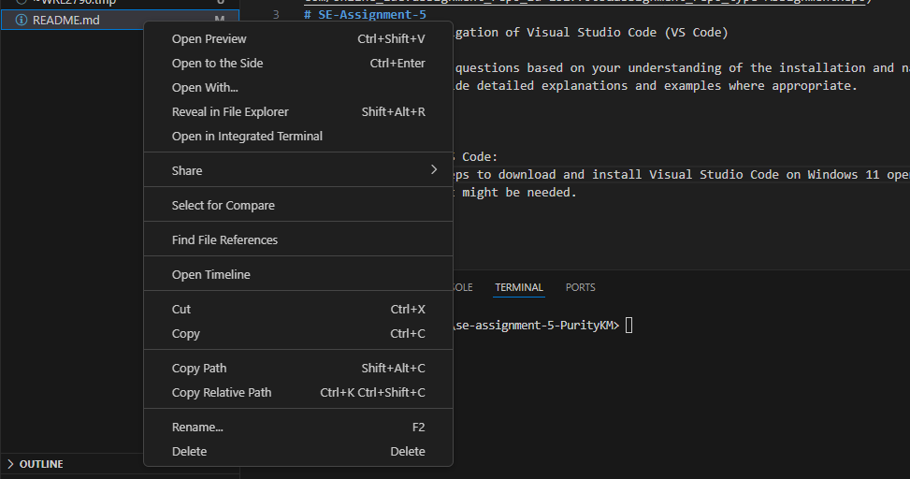

Alternatively, you can use the keyboard shortcuts F2 to rename and Delete to delete.

* **Moving and Copying:**

To move files or folders within the Explorer view, drag and drop them to the desired location.

For copying, you can duplicate a file (Duplicate) and then move it to another location.

**Navigating Between Files and Directories Efficiently:**

* **Switching Between Open Files**:

Use Ctrl + Tab (Windows/Linux) or Cmd + Tab (Mac) to cycle through open files in VS Code.

8. Settings and Preferences:

- Where can users find and customize settings in VS Code? Provide examples of how to change the theme, font size, and keybindings.

**Finding and Customizing Settings:**

* **Settings UI:**

Click on the gear icon (⚙️) in the Activity Bar on the far left or use the shortcut Ctrl + , (Cmd + , on Mac) to open the Settings UI.

Here, you can search for specific settings and adjust them using checkboxes, dropdowns, and text input fields.



* **Changing the Theme:**

Open the Settings UI (Ctrl + , or Cmd + ,). Search for "Color Theme" or navigate to Workbench -> Color Theme. Click on the dropdown menu under "Color Theme" and select the desired theme, such as "Dark+ (default dark)" or "Light+ (default light)".

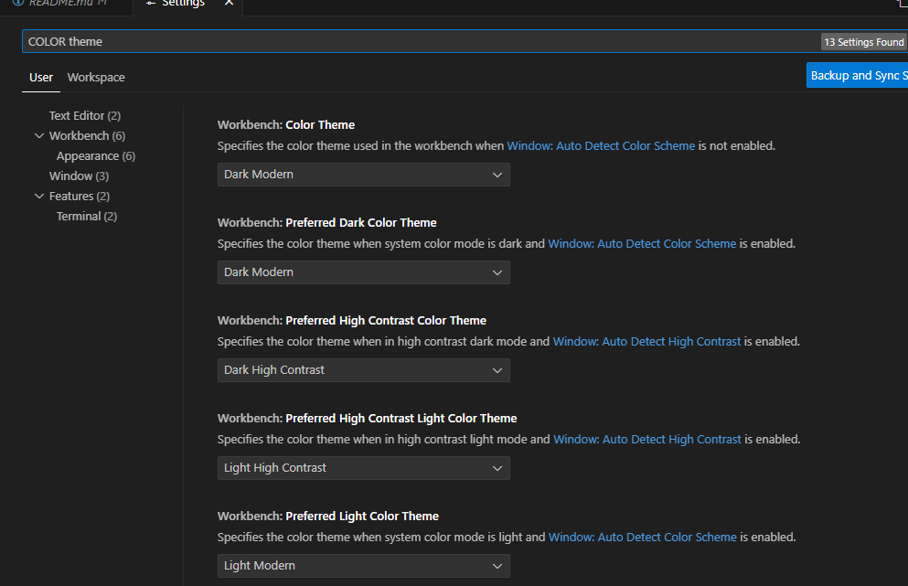

* Adjusting Font Size:
* Open the Settings UI (Ctrl + , or Cmd + ,). Search for "Font Size" or navigate to Editor -> Font Size. Use the dropdown menu or input field to set the desired font size, such as 14 for a larger font size.

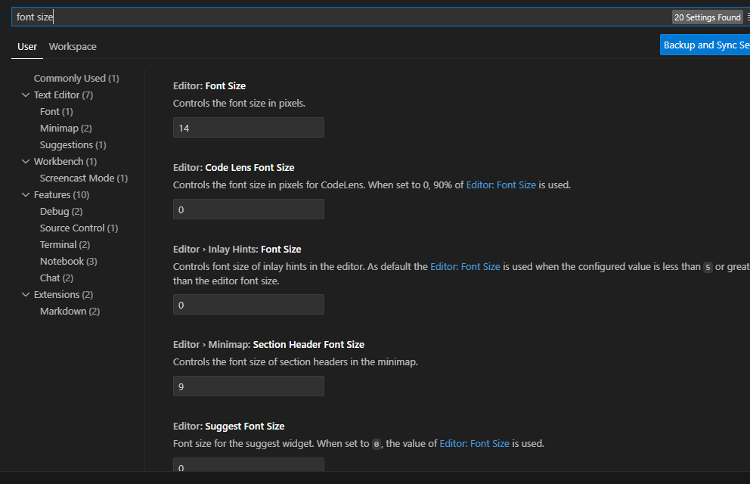

* **Customizing Keybindings:**

Open the Command Palette (Ctrl + Shift + P or Cmd + Shift + P).

Type Preferences: Open Keyboard Shortcuts (JSON) to open the keybindings.json file for editing. Here, you can define custom keybindings or modify existing ones by specifying the command and associated key combinations.

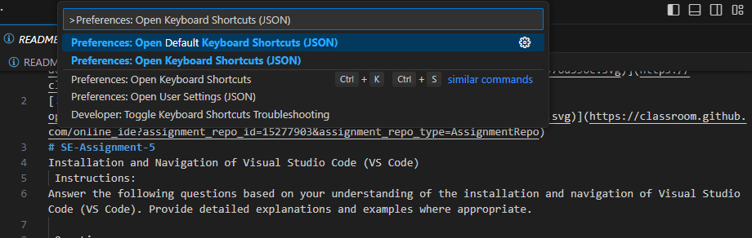

9. Debugging in VS Code:

- Outline the steps to set up and start debugging a simple program in VS Code. What are some key debugging features available in VS Code?

* **Setting Up and Starting Debugging:**

**Install Required Extensions:**

Ensure you have any necessary extensions installed for your programming language or framework that provide debugging support. For example, Debugger for Chrome for debugging JavaScript applications running in the Chrome browser.

**Open Your Project:**

Open your project folder in VS Code (File -> Open Folder...).

**Create or Open the Program File:**

Ensure the file you want to debug is open in the editor.

**Configure Launch Configuration:**

Click on the Debugging icon in the Activity Bar on the left-hand side (it looks like a bug with a play button), or use the shortcut Ctrl + Shift + D (Cmd + Shift + D on Mac).

Click on the gear icon (⚙️) to create a launch.json file if it doesn't already exist.

Select the environment and configuration appropriate for your program (e.g., Node.js for JavaScript/TypeScript, Python for Python scripts).

**Set Breakpoints:**

In the editor, click on the gutter next to the line number where you want to set a breakpoint. A red dot indicates a breakpoint.

Breakpoints pause the execution of your program at that point, allowing you to inspect variables and step through code.

**Start Debugging:**

Press F5 or click the green play button (Start Debugging) in the Debug view to start debugging.

Alternatively, you can use the Debug dropdown menu in the Debug view to select the specific configuration you want to debug.

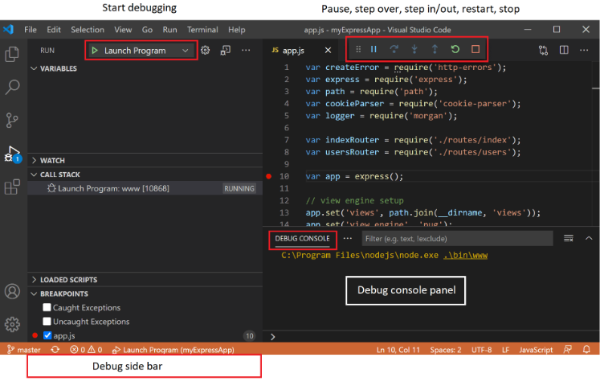

**Key Debugging Features in VS Code:**

* **Variable Inspection**:

Hover over variables in the editor or use the Variables view in the Debug pane to inspect their current values.

* **Step Through Code**:

Use F10 (Step Over), F11 (Step Into), and Shift + F11 (Step Out) to navigate through code execution line by line.

* **Console Output**:

See output from console.log() statements and interact with the program's runtime via the Debug Console.

* **Conditional Breakpoints**:

Set breakpoints that only trigger when specific conditions are met, enhancing flexibility in debugging complex logic.

* **Debugging Tasks and Launch Configurations**:

Configure different launch configurations for various scenarios (e.g., debugging tests, launching with specific environment variables).

10. Using Source Control:

- How can users integrate Git with VS Code for version control? Describe the process of initializing a repository, making commits, and pushing changes to GitHub.

**Using Source Control (Git) in VS Code**

Visual Studio Code (VS Code) provides seamless integration with Git, allowing developers to manage version control directly within the editor. Here's a step-by-step guide on how to integrate Git with VS Code, including initializing a repository, making commits, and pushing changes to GitHub:

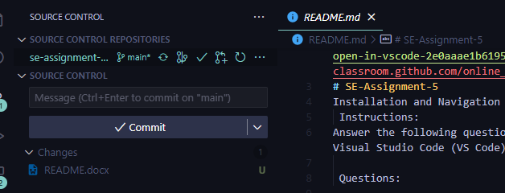

* **Integrating Git with VS Code:**

Ensure Git is installed on your machine. You can download it from git-scm.com and follow the installation instructions.

* **Open Your Project in VS Code:** Open VS Code and navigate to your project folder (File -> Open Folder...).
* **Initialize a Git Repository:**

Open the Source Control view in VS Code by clicking on the Source Control icon in the Activity Bar on the left (it looks like a branch symbol).

Click on Initialize Repository or use the command palette (Ctrl + Shift + P or Cmd + Shift + P and search for Git: Initialize Repository) to initialize a Git repository in your project folder.

* **Stage and Commit Changes:**

Make changes to your files (e.g., edit code, add new files).

In the Source Control view, you’ll see three sections:

CHANGES: Unstaged changes (files with modifications).

STAGED CHANGES: Files ready for commit.

MERGE CHANGES: Incoming or outgoing commits.

Stage changes by clicking the “+” icon next to a file (or use drag-and-drop).

Add a commit message above the changes and press Ctrl+Enter to commit.

* **Push Changes to GitHub:**

If you haven’t already, create a GitHub repository.

In VS Code, click the ellipsis (…) menu in the Source Control view.

Choose “Push” to push your committed changes to GitHub.

Submission Guidelines:

- Your answers should be well-structured, concise, and to the point.

- Provide screenshots or step-by-step instructions where applicable.

- Cite any references or sources you use in your answers.

- Submit your completed assignment by 1st July