**Installation of VS Code**

**Steps to download and install Visual Studio Code on Windows OS:**

1. **Download:** Go to the official Visual studio website <https://code.visualstudio.com/download> and download the installer for Corresponding OS, for my case windows 10.

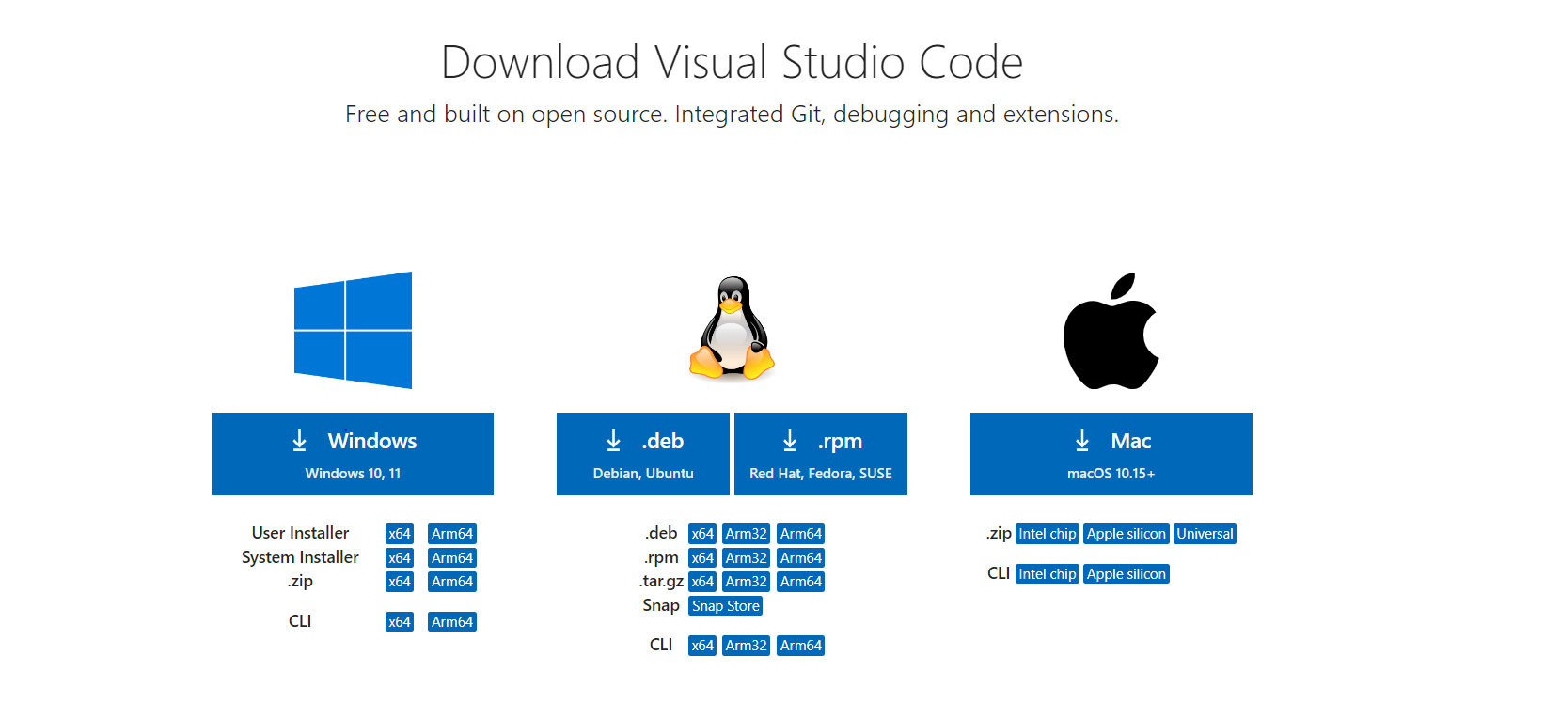

2. **Run Installer:** Once downloaded, run the installer executable (.exe file).

3. **Follow Installation Wizard:** Follow the prompts in the installation wizard. Choose the installation location if prompted.

4. **Finish Installation:** Complete the installation process by following the on-screen instructions.

~Below is a fully downloaded and installed functional Visual studio code on my PC.

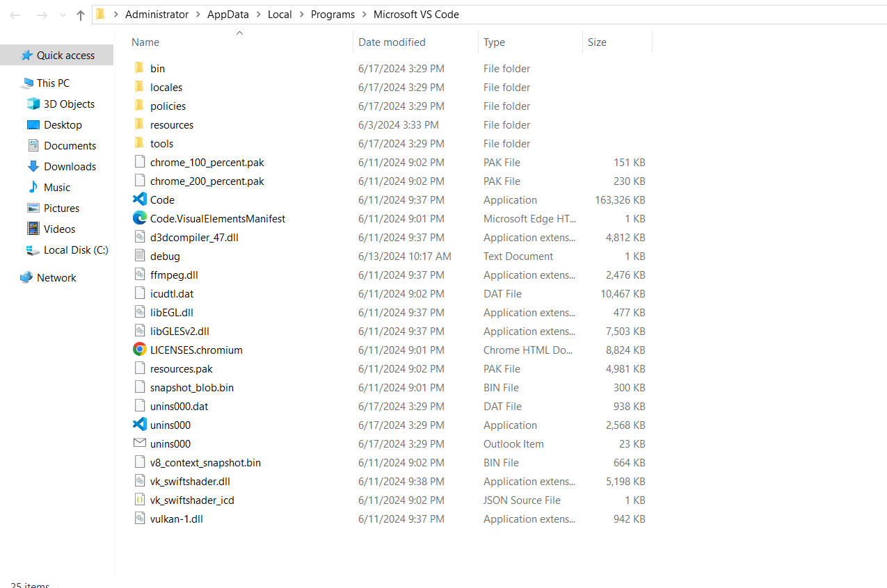

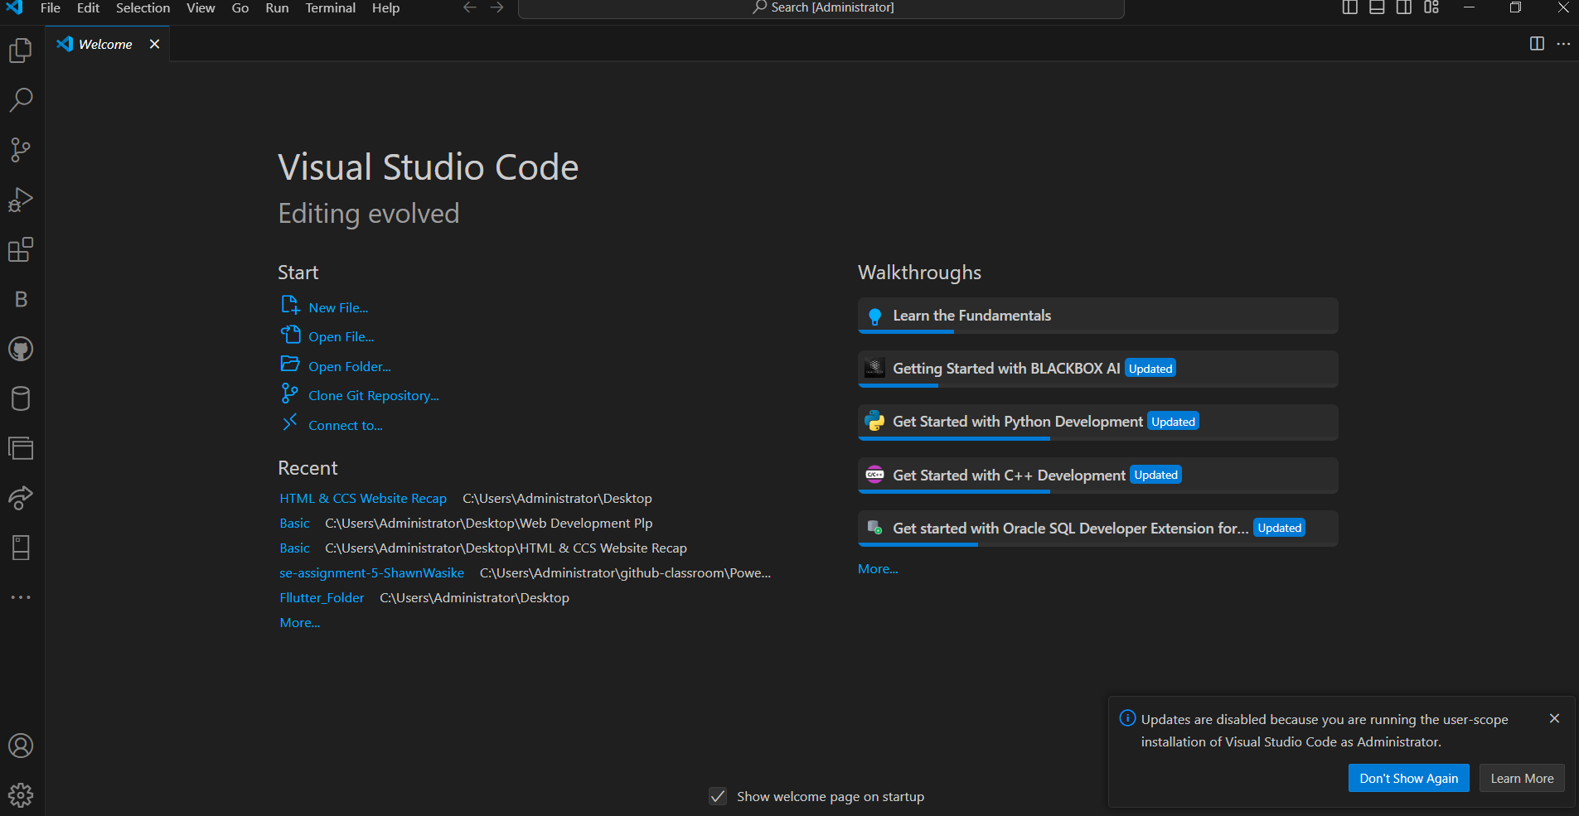

Challenges: Generally, there are no specific challenges for installing VS Code on Windows 11 beyond having sufficient system resources.

**First-time Setup**

After installing VS Code, adjust these settings for an optimal coding environment:

1. **Settings:** Configure settings such as auto-save, tab size, and editor preferences (`File > Preferences > Settings` or `Ctrl+,`).

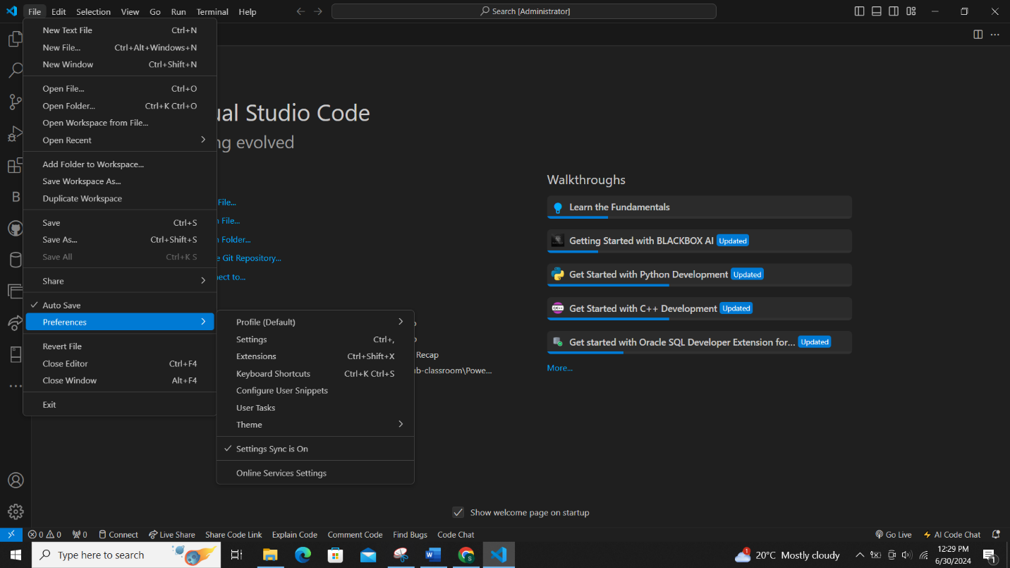

2. **Extensions:** Install useful extensions for your development needs (`Extensions` icon in the Activity Bar).

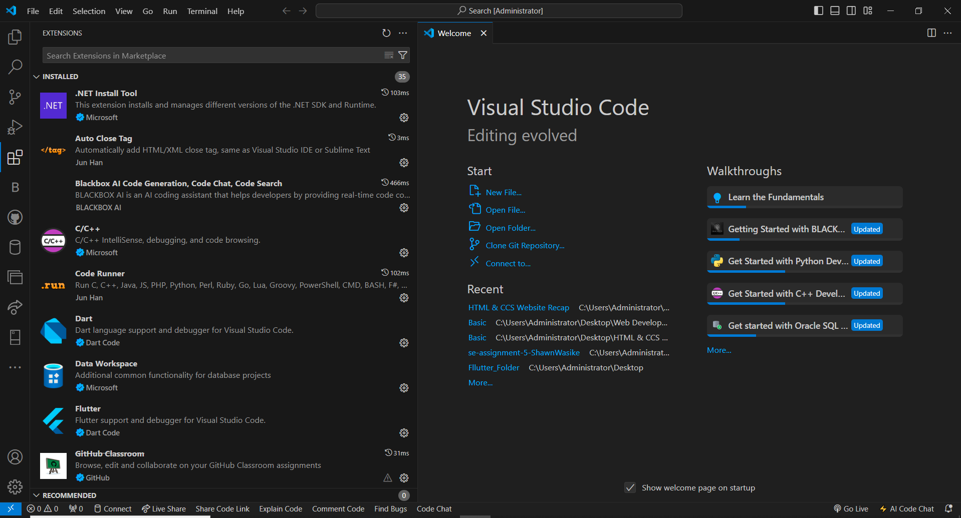

**User Interface Overview**

**~N/B: (Areas explained are highlighted in Red)**

1. **Activity Bar:** Provides quick access to different views like Explorer, Search, Source Control, and Extensions.



2. **Side Bar:** Contains different views (Explorer, Search, Source Control, etc.) and can be customized with additional extensions.



3. **Editor Group:** Area where files are opened for editing, supports splitting into multiple editor panes.

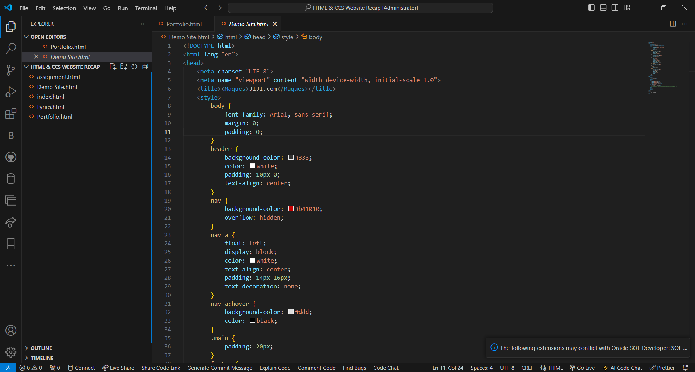

4. **Status Bar:** Displays information about the current project, Git branch, errors/warnings, and encoding.



**Command Palette**

**Command Palette:** Accessed via `View > Command Palette` or `Ctrl+Shift+P`, it allows executing commands and tasks. Examples:

- Switching between opened files (`> View: Show Opened Editors`)

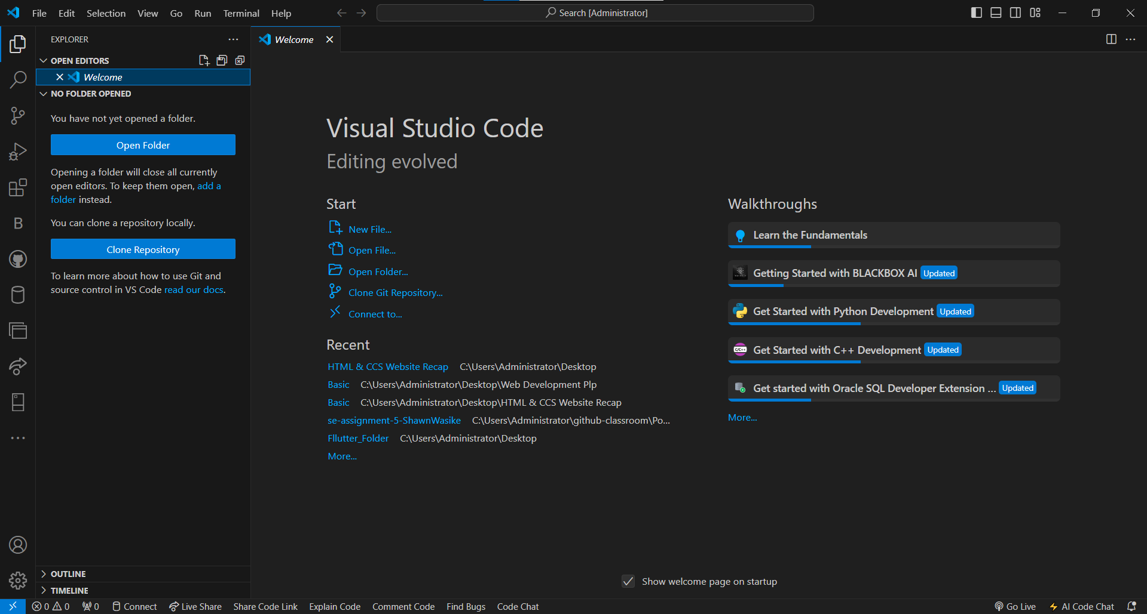

- Installing extensions (`> Extensions: Install Extensions`)

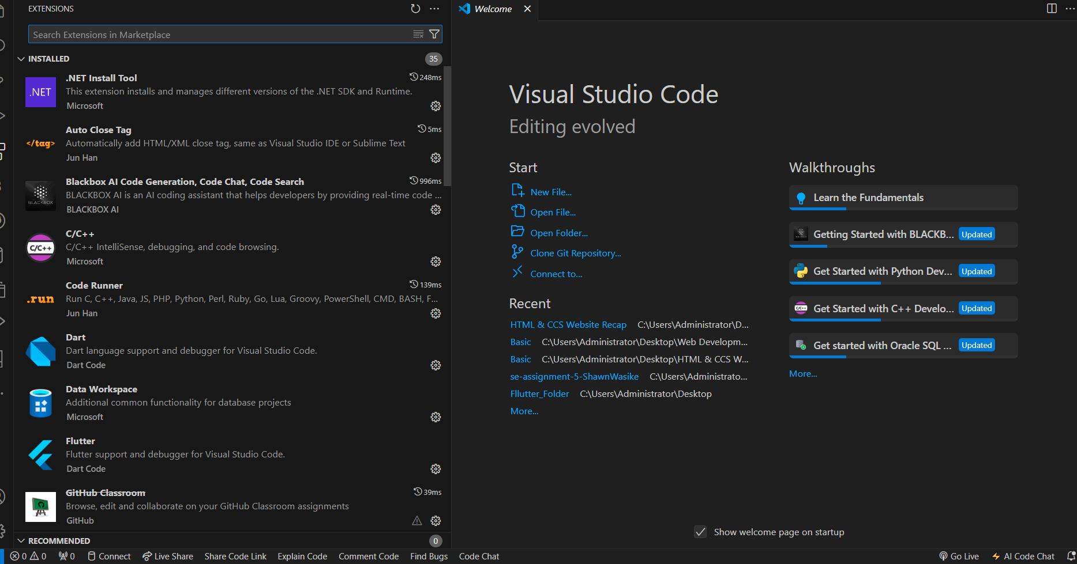

**Extensions in VS Code**

Extensions enhance VS Code functionality:

- **Finding:** Visit the Extensions view (`Ctrl+Shift+X`) to search and install extensions.

- **Managing:** Manage installed extensions (`...` next to extension).

-Download extension you require to effectively do your work, projects and assignments on your visual studio code.

- Examples: For web dev: Live Server (live preview), ESLint (code linting), GitLens (Git integration).

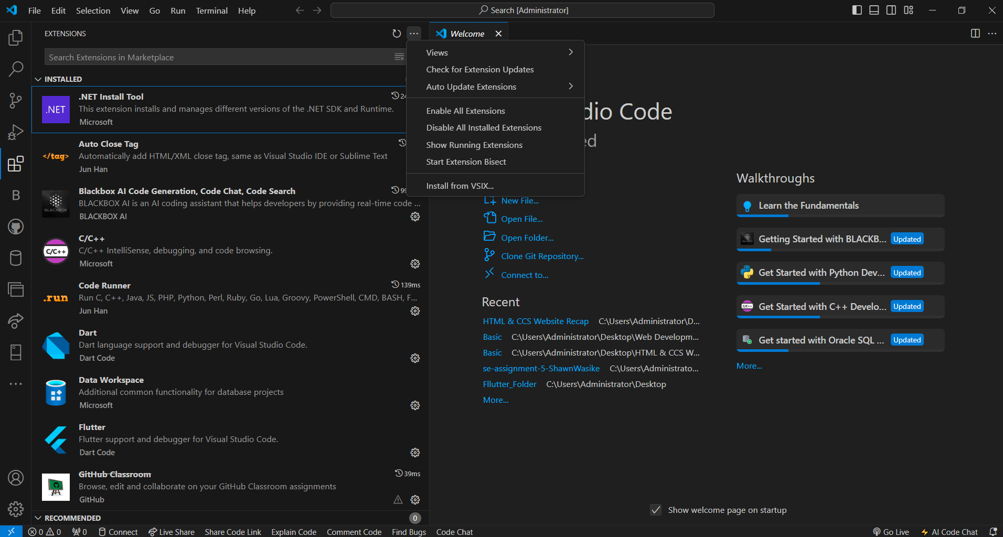

**Integrated Terminal**

Opening and using the integrated terminal:

- Open with `View > Terminal` or ``Ctrl+` ``.

- **Advantages** include seamless workflow integration, sharing workspace context, and avoiding context switching.

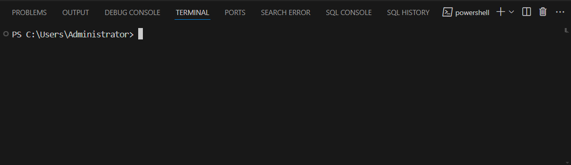

**File and Folder Management**

- **Creating:** Right-click in Explorer or use `File > New File/Folder`.

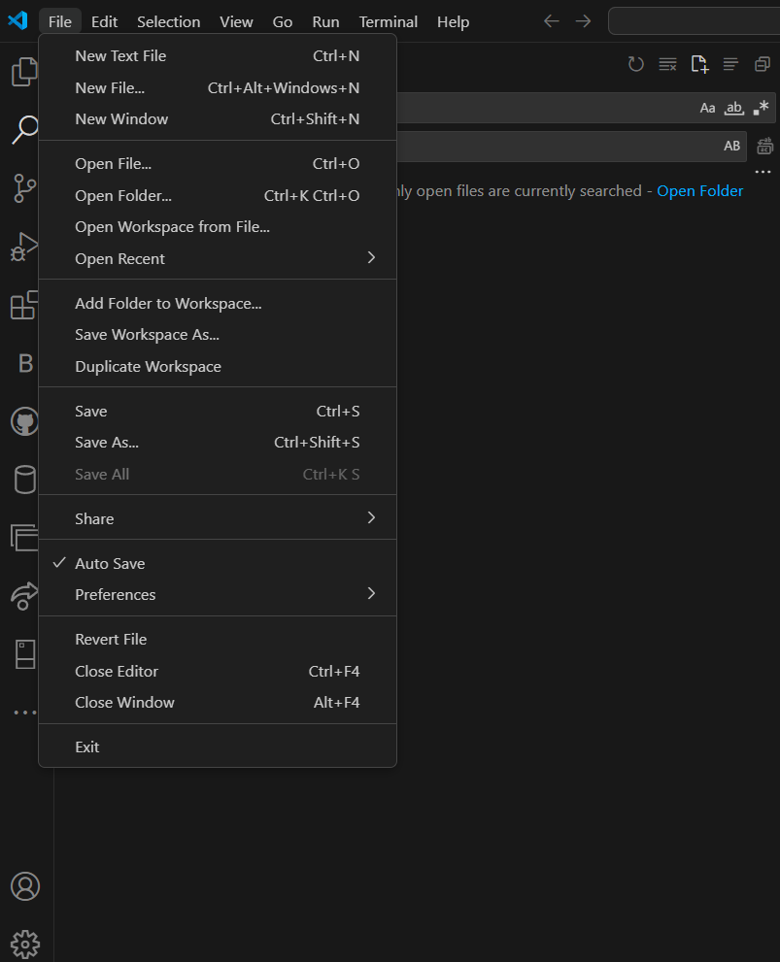

- **Opening:** Double-click a file or folder in Explorer, or use `File > Open Folder`.

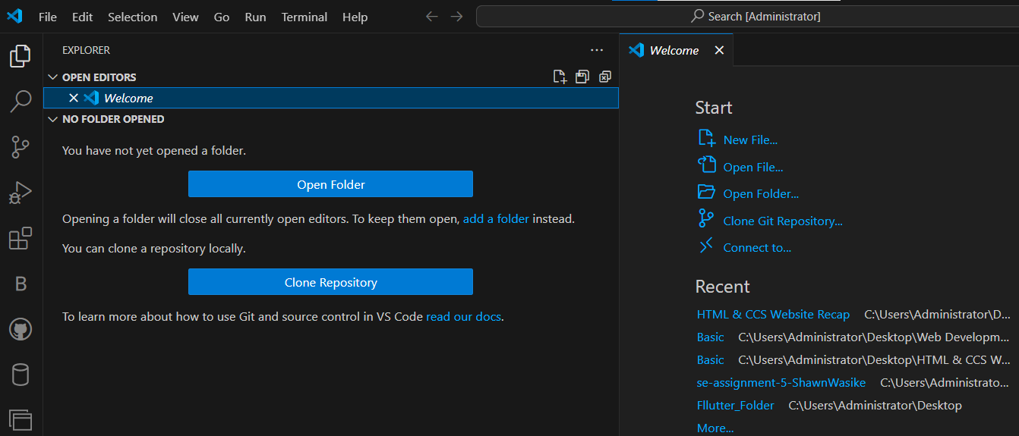

- **Navigating:** Use Explorer or `Ctrl+P` for Quick Open (`Ctrl+Shift+E` for Explorer).

**Settings and Preferences**

-In settings you can change and setup your Visual Studio Code to fit your display and functionality preferences.

- **Customizing:** Access settings via `File > Preferences > Settings` or `Ctrl+,`.

- **Examples**: Change theme (`> Color Theme`), adjust font size (`editor.fontSize`), set keybindings (`> Keyboard Shortcuts`).

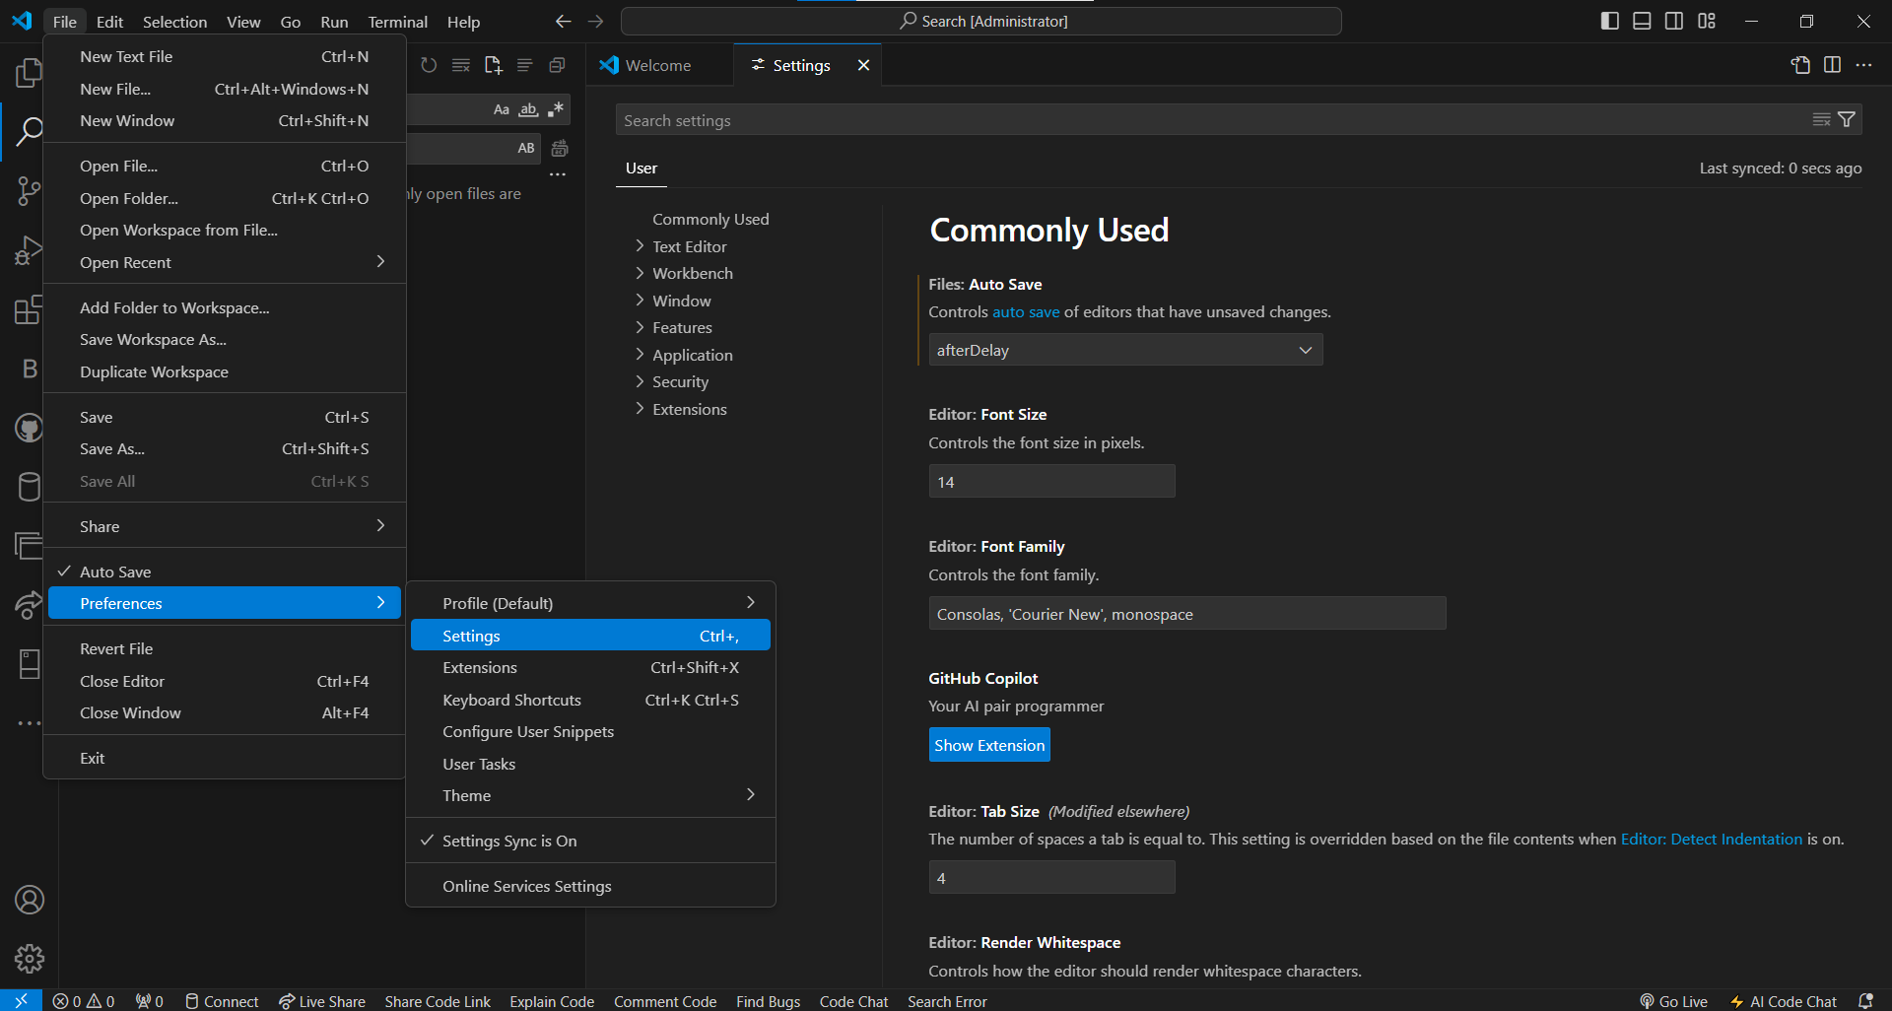

**Debugging in VS Code**

1. **Setup**:

- Install required debugger extensions.

- Create a debug configuration (`Run > Add Configuration`).

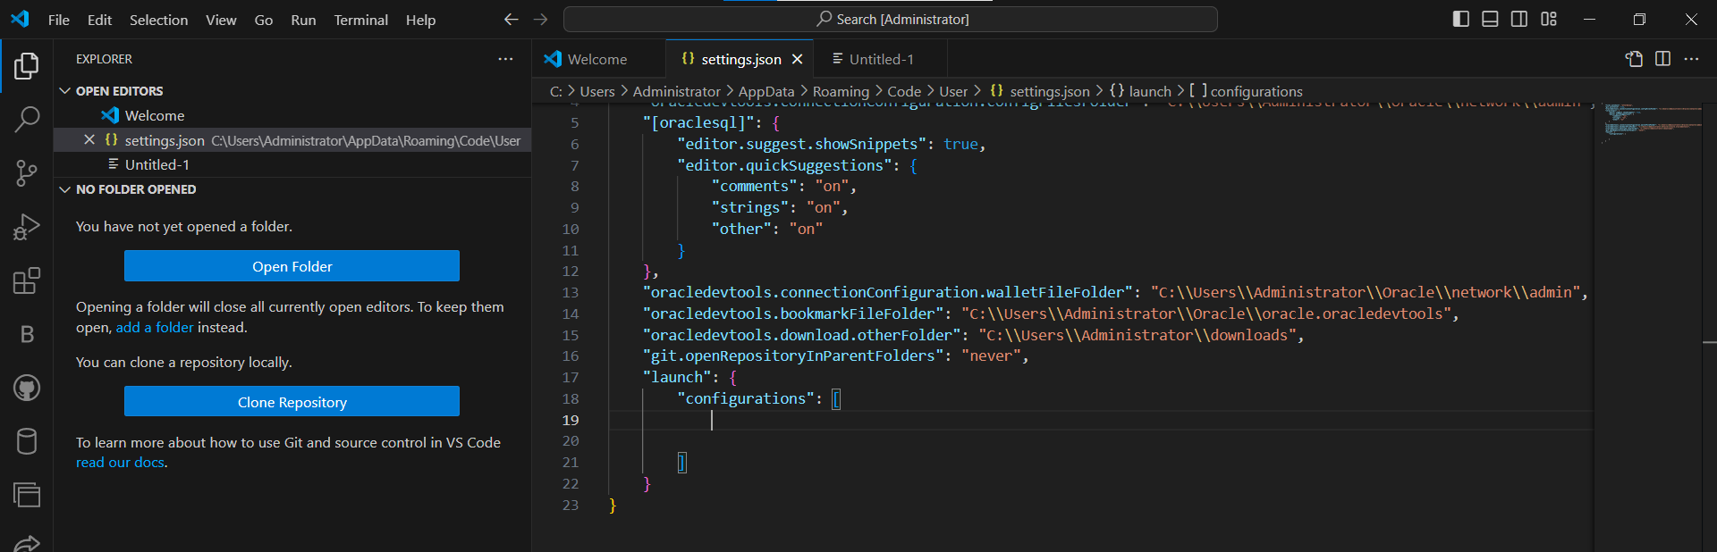

2**. Starting Debugging**:

- Set breakpoints in your code.

- Start debugging (`F5`).

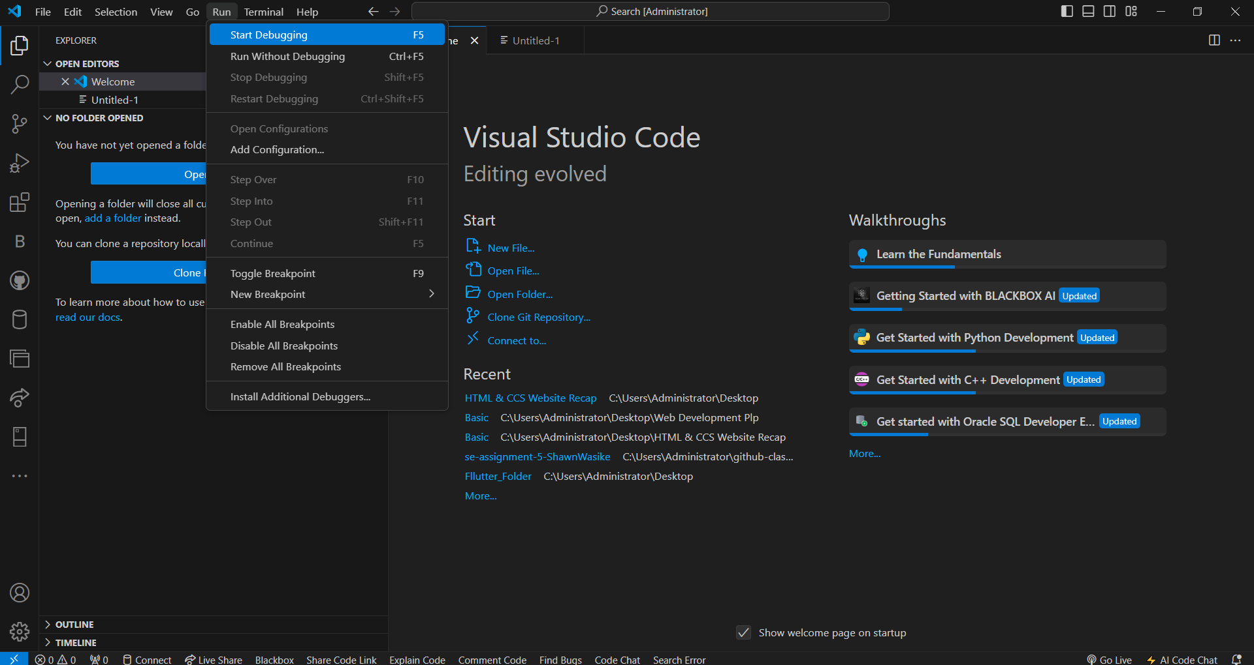

3. **Features**: Step-through debugging, variable inspection, call stack navigation.

**Using Source Control**

1. **Git Integration:**

- Initialize a repository (`Source Control view > Initialize Repository`).

- Stage changes, commit (`...` next to file in Source Control view).

- Push changes to GitHub (`... > Push`).