1. **From Microsoft Store,**
   * I downloaded VS Code
2. **Run the Installer:**
   * Once the download is complete, run the installer by double-clicking the downloaded file.
3. **Installation Process:**
   * Follow the on-screen instructions:
     + Accept the license agreement.
     + Choose the installation location.
     + Select additional tasks (e.g., adding "Open with Code" to the context menu, adding to PATH).
4. **Complete Installation:**
   * Click "Install" and then "Finish" once the installation is complete.

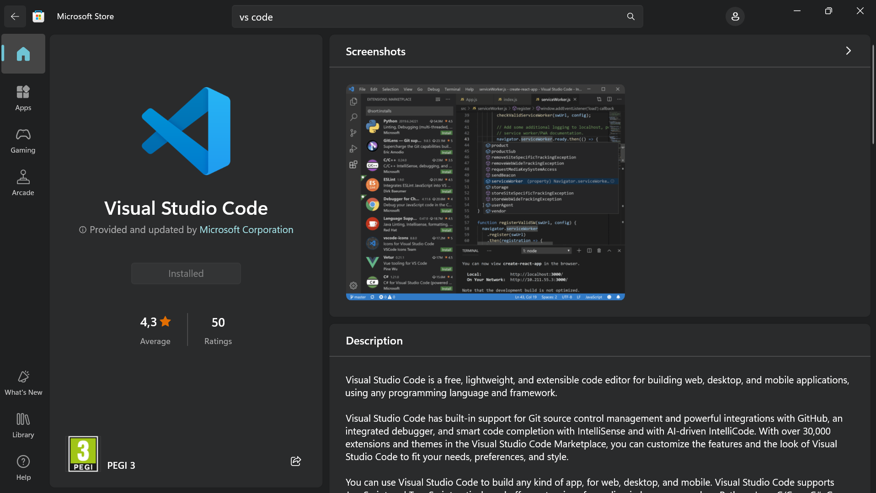

**Prerequisites**

* **Windows 11 Operating System:** Ensure your system meets the requirements for Windows 11.
* **Administrator Rights:** You may need admin privileges to install software.

**First-time Setup**

**Initial Configurations and Settings**

1. **Launch Visual Studio Code:**
   * Open VS Code from the Start menu or desktop shortcut.
2. **Settings Sync:**
   * Optionally, sign in with your Microsoft or GitHub account to sync settings across devices.
3. **Configure Settings:**
   * Go to File > Preferences > Settings or press Ctrl+,.
   * Adjust settings such as font size, theme, and autosave.
4. **Install Essential Extensions:**
   * Open the Extensions view by clicking the Extensions icon in the Activity Bar or pressing Ctrl+Shift+X.
   * Search and install recommended extensions (e.g., Python, Prettier - Code formatter, GitLens).

**User Interface Overview**

**Main Components of the VS Code User Interface**

1. **Activity Bar:**
   * Located on the left side, it provides quick access to views like Explorer, Search, Source Control, Run and Debug, and Extensions.
2. **Side Bar:**
   * Displays different views and tools depending on the selected activity (e.g., file explorer, source control).
3. **Editor Group:**
   * The central area where files are opened and edited. You can split this area into multiple groups for side-by-side editing.
4. **Status Bar:**
   * Located at the bottom, it shows information about the current workspace, such as errors, warnings, encoding, line endings, and active branch.

**Command Palette**

**What is the Command Palette?**

* The Command Palette provides quick access to many commands and functions in VS Code.

**Accessing the Command Palette**

* Open the Command Palette by pressing Ctrl+Shift+P or F1.

**Common Tasks Using the Command Palette**

* Switching themes: Preferences: Color Theme
* Running tasks: Tasks: Run Task
* Opening settings: Preferences: Open Settings (JSON)

**Extensions in VS Code**

**Role of Extensions**

* Extensions add functionality to VS Code, allowing for language support, debuggers, and tools integration.

**Finding, Installing, and Managing Extensions**

1. **Open Extensions View:**
   * Click the Extensions icon in the Activity Bar or press Ctrl+Shift+X.
2. **Search for Extensions:**
   * Use the search bar to find extensions.
3. **Install Extensions:**
   * Click the Install button on the desired extension.
4. **Manage Extensions:**
   * Click on the installed extensions to manage settings, disable, or uninstall them.

**Essential Extensions for Web Development**

* **HTML/CSS Support**
* **JavaScript/TypeScript Support**
* **ESLint**
* **Live Server**
* **Prettier - Code formatter**

**Integrated Terminal**

**How to Open and Use the Integrated Terminal**

1. **Opening the Terminal:**
   * Go to View > Terminal or press Ctrl+ ` (backtick).
2. **Using the Terminal:**
   * The terminal supports command-line operations directly within VS Code, allowing you to run scripts, install packages, and manage version control.

**Advantages of Using the Integrated Terminal**

* Seamless workflow within the editor.
* No need to switch between VS Code and an external terminal.
* Ability to split and manage multiple terminal instances.

**File and Folder Management**

**Creating, Opening, and Managing Files and Folders**

1. **Create Files/Folders:**
   * Right-click in the Explorer view and select New File or New Folder.
   * Alternatively, press Ctrl+N for a new file.
2. **Open Files/Folders:**
   * Use File > Open File or Open Folder, or drag and drop files/folders into the editor.
3. **Navigating Files:**
   * Use the Explorer view or Ctrl+P to quickly open files by name.
   * Use breadcrumbs (enabled in the View menu) to navigate directories.

**Settings and Preferences**

**Customizing Settings**

1. **Open Settings:**
   * Go to File > Preferences > Settings or press Ctrl+,.
2. **Change Theme:**
   * In Settings, search for Color Theme and select your preferred theme.
3. **Adjust Font Size:**
   * In Settings, search for Font Size and adjust as needed.
4. **Modify Keybindings:**
   * Go to File > Preferences > Keyboard Shortcuts or press Ctrl+K Ctrl+S.

**Debugging in VS Code**

**Setting Up and Starting Debugging**

1. **Open Debug View:**
   * Click the Debug icon in the Activity Bar or press Ctrl+Shift+D.
2. **Configure Debugger:**
   * Click on the gear icon to configure your launch settings (launch.json).
3. **Set Breakpoints:**
   * Click in the gutter next to the line numbers to set breakpoints.
4. **Start Debugging:**
   * Click the green play button or press F5.

**Key Debugging Features**

* **Breakpoints**
* **Watch Expressions**
* **Call Stack**
* **Variables Pane**

**Using Source Control**

**Integrating Git with VS Code**

1. **Initialize Repository:**
   * Open the Source Control view by clicking the Source Control icon or pressing Ctrl+Shift+G.
   * Click Initialize Repository.
2. **Make Commits:**
   * Stage changes by clicking the + icon next to changed files.
   * Write a commit message and click the checkmark icon to commit.
3. **Push Changes to GitHub:**
   * Click on the three dots in the Source Control view, select Push, and follow the prompts to log in to GitHub and push changes.