# **Installation of VS Code:**

To download and install Visual Studio Code on Windows 11 operating system:

1. Go to the official VS Code website ([/)) and click on the "Download" button.

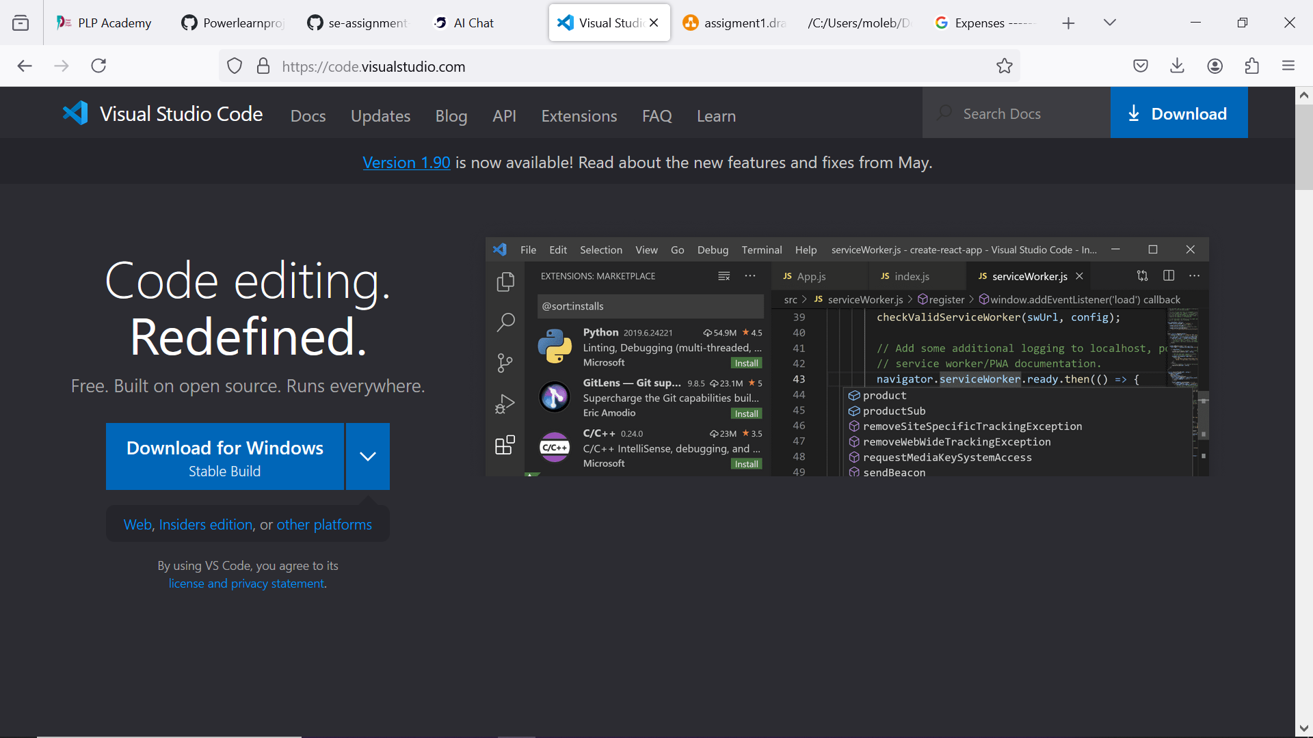

2. Select the "Windows" option and choose the 64-bit or 32-bit version depending on your system architecture.

3. Run the downloaded installer (VSCodeSetup.exe) and follow the installation prompts.

4. Choose the installation location and select the components you want to install (e.g., Node.js, Python, etc.).

5. Wait for the installation to complete, which may take a few minutes.

# **First-time Setup:**

After installing VS Code, here are some initial configurations and settings to adjust for an optimal coding environment:

* Open VS Code and navigate to File > Preferences > Settings (or press Ctrl + Shift + P on Windows/Linux or Command + Shift + P on Mac).

* Set the language mode to your preferred language (e.g., JavaScript, Python, etc.).

* Install essential extensions such as Debugger for Chrome, Debugger for Edge, or Debugger for Firefox for debugging web applications.

* Install a theme, such as Dark+ or Material Theme, to customize the appearance of the editor.

* Adjust font size and font family to your preference.

* Set keybindings for common actions like Save All (Ctrl+S) and Find All (Ctrl + Shift + F).

# **User Interface Overview:**

The main components of the VS Code user interface are:

* **Activity Bar**: Located on the left side of the screen, it provides quick access to various features like Explorer, Debugger, Extensions, and more.

* **Side Bar**: On the left side of the screen, it displays folders, files, and projects. You can use it to navigate between files and directories.

* **Editor Group**: The main area where you write your code. It's divided into multiple editors for simultaneous editing.

* **Status Bar**: Located at the bottom of the screen, it displays information about the current file, such as line numbers, syntax errors, and debug information.

# **Command Palette:**

The Command Palette is a powerful tool that allows you to perform various tasks using keyboard shortcuts. To access it:

1. Press Ctrl + Shift + P on Windows/Linux or Command + Shift + P on Mac.

2. Type a command in the search bar and press Enter to execute it.

Common tasks that can be performed using the Command Palette include:

* Running code diagnostics (Ctrl + Shift + D)

* Debugging (F5)

* Formatting code (Shift + Alt + F)

* Searching files (Ctrl + Shift + F)

# **Extensions in VS Code:**

Extensions in VS Code enhance its functionality by providing additional features and tools. To find and install extensions:

1. Open Extensions from the Extensions view (Ctrl + Shift + X) or from the Command Palette.

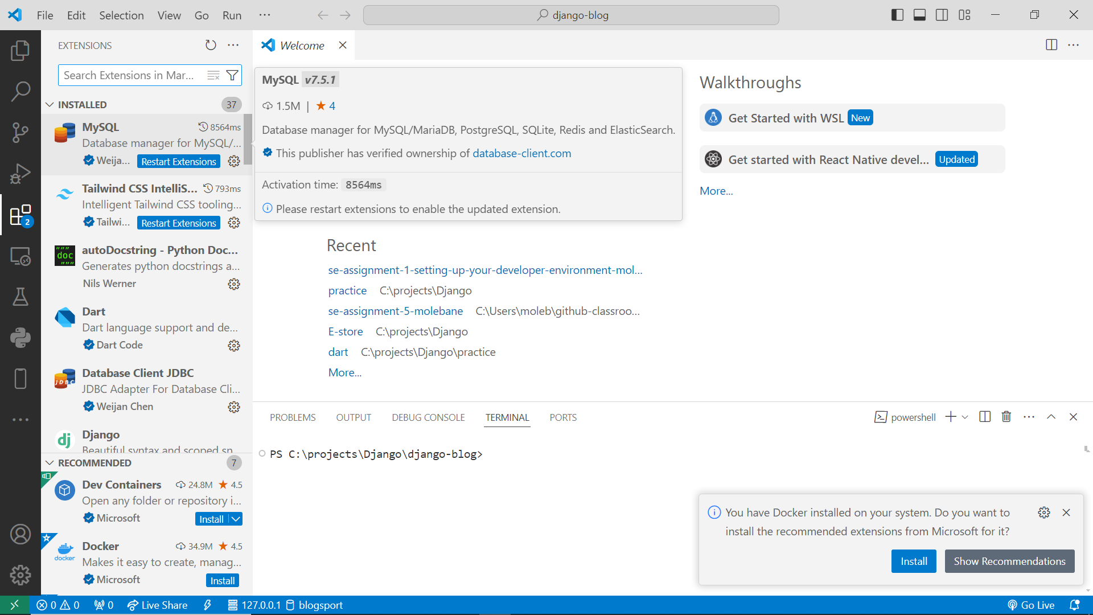

2. Search for an extension by name or keyword.

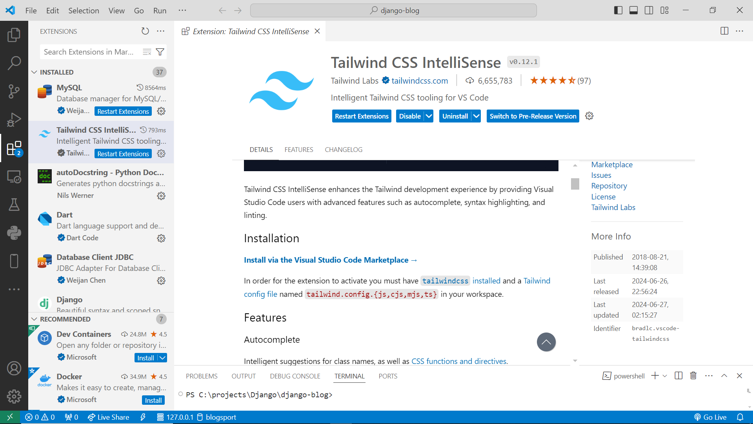

3. Read reviews and ratings before installing.

4. Click "Install" to install the extension.

Essential extensions for web development include:

* Debugger for Chrome

* Debugger for Edge

* Debugger for Firefox

* ESLint

* Prettier

# **Integrated Terminal:**

To open an integrated terminal in VS Code:

1. Go to View > Terminal or press Ctrl + ` (backtick) on Windows/Linux or Command + ` (backtick) on Mac.

2. Use the terminal as you would any other terminal application.

The integrated terminal offers several advantages over an external terminal:

* Seamless integration with VS Code

* Auto-completion of commands

* Quick access to project files

* Easy debugging

# **File and Folder Management:**

To create, open, and manage files and folders in VS Code:

1. Create a new file by going to File > New File or pressing Ctrl + N.

2. Open a file by going to File > Open Folder or pressing Ctrl + O.

3. Navigate between files and directories using the Side Bar or Explorer view.

4. Use keyboard shortcuts like Ctrl + Tab (switch between open editors) or Ctrl + Shift + Tab (switch between open folders).

# **Settings and Preferences:**

To find and customize settings in VS Code:

1. Go to File > Preferences > Settings (or press Ctrl + Shift + P).

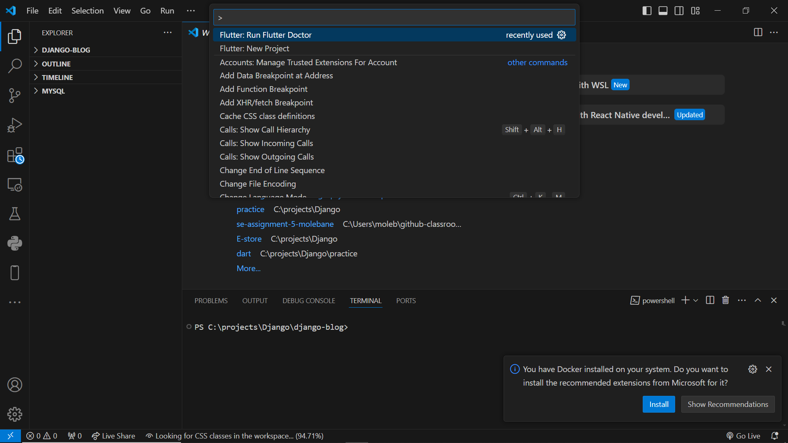

2. Search for specific settings using the search bar.

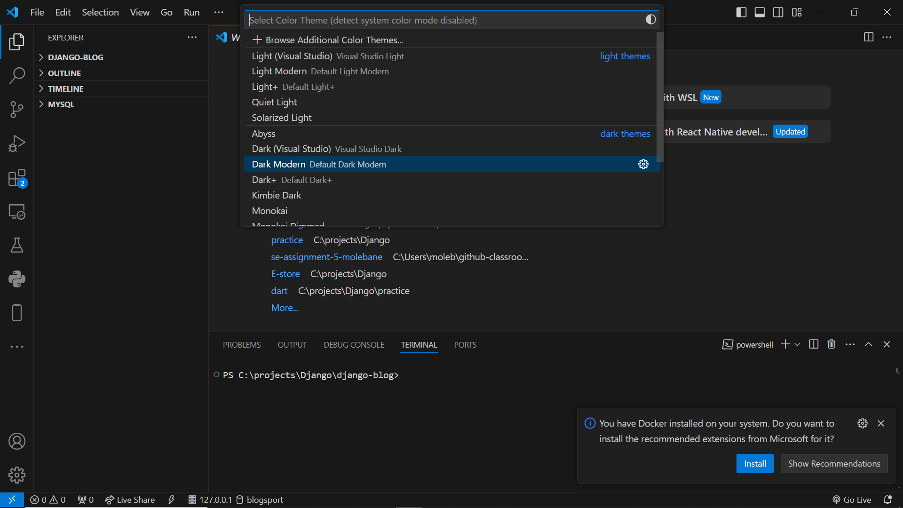

3. Click "Apply" after making changes.

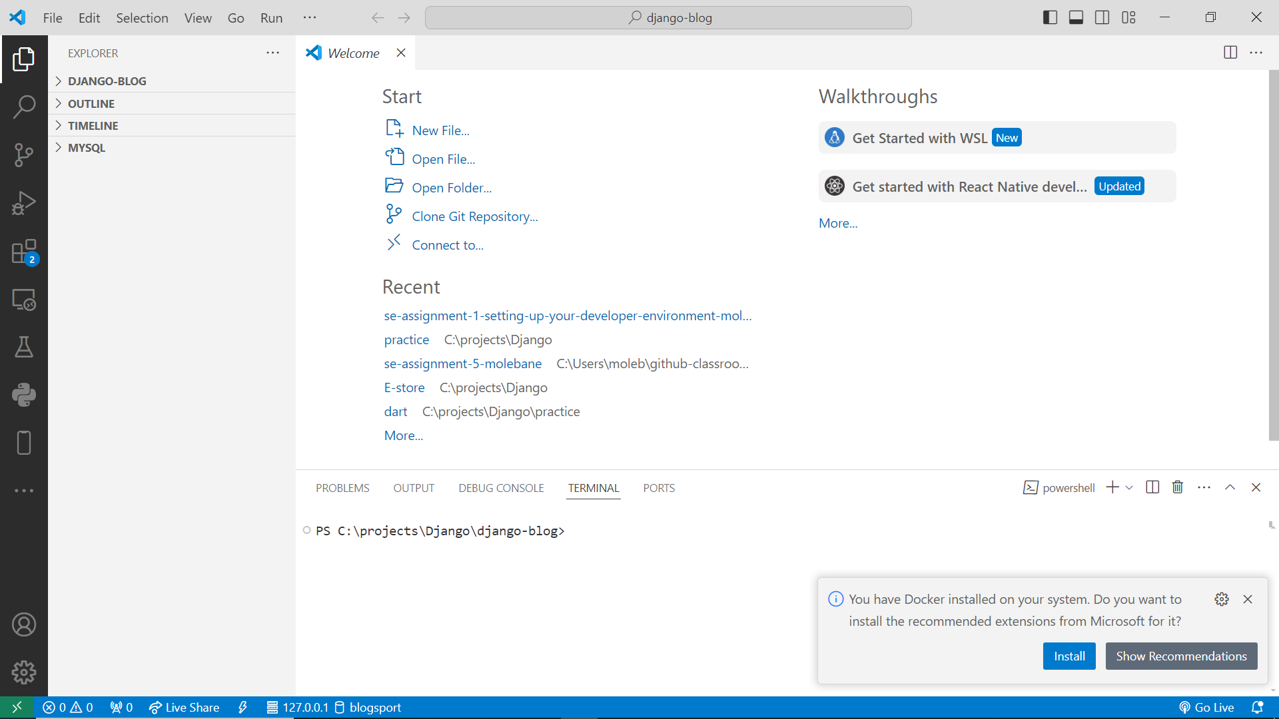

Some common settings to customize include:

* Theme: Choose from various themes like Dark+ or Material Theme.

* Font size and font family: Adjust font settings for better readability.

* Keybindings: Customize keyboard shortcuts for common actions.

# **Debugging in VS Code:**

To set up and start debugging a simple program in VS Code:

1. Create a new file with a `.js` extension or open an existing one.

2. Add breakpoints using Ctrl + B or clicking on the line number gutter.

3. Start debugging by clicking the "Run" button (F5) or pressing F5.

Key debugging features available in VS Code include:

* Breakpoints

* Step-through execution

* Variables view

* Call stack view

**Using Source Control:**

To integrate Git with VS Code for version control:

1. Install Git if not already installed.

2. Open VS Code and go to View > Git Status or press Ctrl + Shift + G.

3. Initialize a new repository by clicking "Initialize Repository" in the Git Status view.

4. Make changes to files, then commit them by clicking "Commit" in the Git Status view.

5. Push changes to GitHub by clicking "Push" in the Git Status view.