**1.) Installation of a vs code**

1.1 Open the official website of the vs code : <https://code.visualstudio.com/download>

1.2 Click on download as shown below 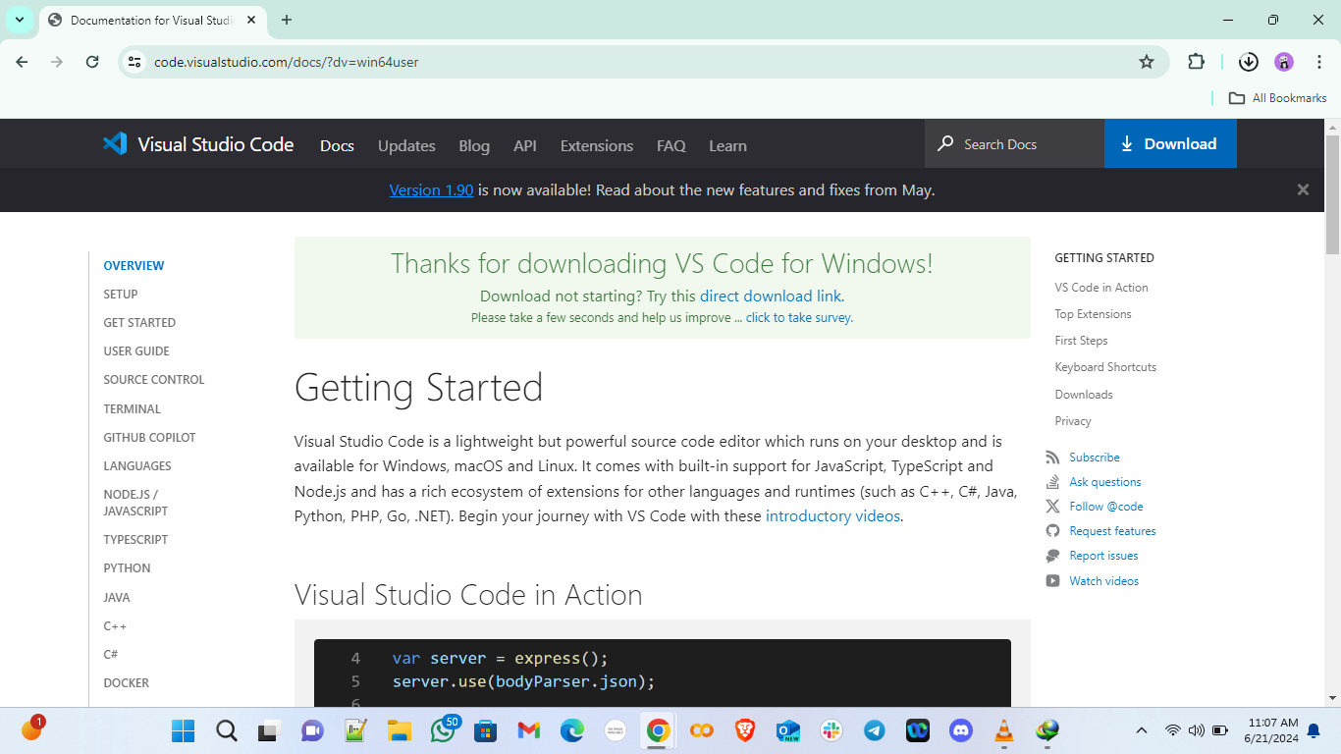

It will display a thanks message and wait for it to finish downloading

1.3 • Once the installer file is downloaded, locate it in your Downloads folder or the location you chose for downloads.

• Double-click the installer file to run it.

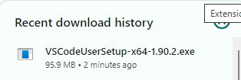

1.4 **Install Visual Studio Code**:

* The setup wizard will open. Click "Next" to continue.
* Read and accept the license agreement, then click "Next".

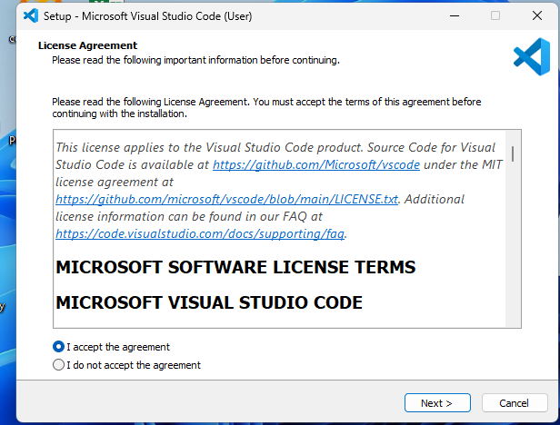

• Choose the destination folder where you want to install VS Code (the default is usually fine), then click "Next".

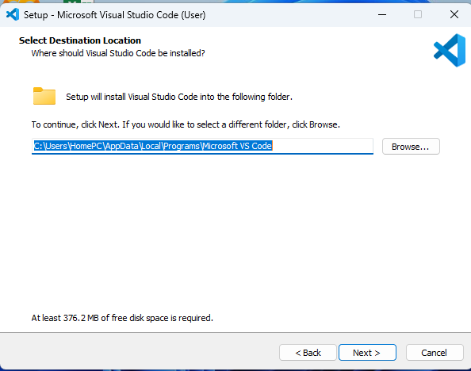

• You will be prompted to select additional tasks.

* Check "Create a desktop icon".
* Check "Add to PATH" (this allows you to use VS Code from the command line).
* Check "Register Code as an editor for supported file types".

• Click "Next" after making your selections.

• Click "Install" to begin the installation process.

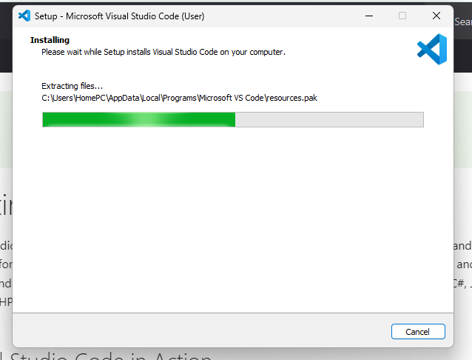

1.6 • **Complete the Installation**:

* The installer will copy the necessary files and complete the setup.
* Once the installation is complete, you can check "Launch Visual Studio Code" and click "Finish" to open VS Code immediately.

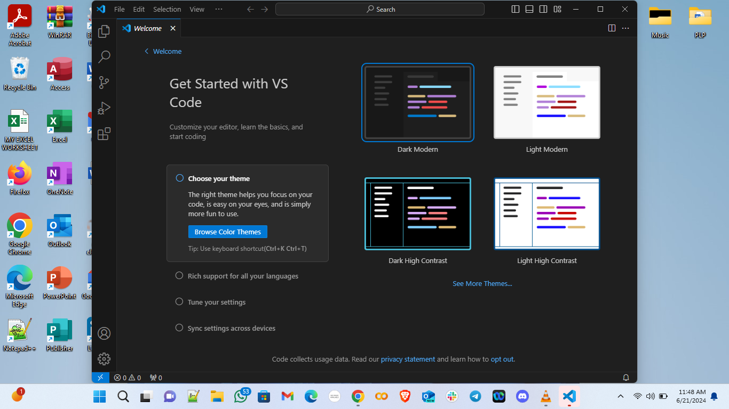

**2.) First-time Setup**:

After installing VS Code, what initial configurations and settings should be adjusted for an optimal coding environment? Mention any important settings or extensions.

a. Theme:

- Go to `File` > `Preferences` > `Color Theme` or press `Ctrl+K Ctrl+T` to choose a theme.

- Recommended: "Dark+ (default dark)" or "Light+ (default light)".

b. Font Size

- Go to `File` > `Preferences` > `Settings` or press `Ctrl+,`.

- Search for "Font Size" and adjust to your preference (e.g., 14-16 for comfortable reading).

c. Extensions:

- Prettier: Code formatter.

- ESLint: Identifies and reports on patterns in JavaScript.

- Python: Support for Python development.

- GitLens: Supercharges the Git capabilities.

d.Editor Configuration:

- Go to `File` > `Preferences` > `Settings` or press `Ctrl+,`.

- Adjust "Editor: Tab Size" to 2 or 4 spaces depending on your project needs.

- Enable "Format On Save" for auto-formatting.

**3.) User Interface Overview:**

Explain the main components of the VS Code user interface. Identify and describe the purpose of the Activity Bar, Side Bar, Editor Group, and Status Bar.

a. Activity Bar:

- Located on the far left.

- Contains icons for different views like Explorer, Search, Source Control, Run & Debug, and Extensions.

- Purpose: Switch between different tools and views.

b. Side Bar:

- Located next to the Activity Bar.

- Displays different panels depending on the selected view from the Activity Bar.

- Purpose: Shows project files, search results, source control information, etc.

c. Editor Group:

- The central area where you open and edit files.

- Supports multiple editors side by side.

- Purpose: Provides the main workspace for writing and editing code.

d. Status Bar:

- Located at the bottom.

- Displays information like line/column numbers, Git branch, errors and warnings, language mode, etc.

- Purpose: Provides contextual information and status updates.

**4.) Command Palette:**

What is the Command Palette in VS Code, and how can it be accessed? Provide examples of common tasks that can be performed using the Command Palette.

- The Command Palette provides access to many commands.

- Access it by pressing `Ctrl+Shift+P`.

- Examples of Tasks:

- Change theme: Type "Color Theme".

- Install extensions: Type "Extensions: Install Extensions".

- Open settings: Type "Preferences: Open Settings (UI)".

**5.)Extensions in VS Code:**

Discuss the role of extensions in VS Code. How can users find, install, and manage extensions? Provide examples of essential extensions for web development.

- Extensions enhance functionality.

- Finding Extensions:

- Click the Extensions icon in the Activity Bar or press `Ctrl+Shift+X`.

- Search for extensions in the Extensions view.

- Installing Extensions:

- Click the `Install` button on the extension's page.

- Examples for Web Development:

- Live Server: Launch a development local server.

- Debugger for Chrome: Debug JavaScript code in the Chrome browser.

- Auto Rename Tag: Auto rename paired HTML/XML tags.

**6.) Integrated Terminal:**

Describe how to open and use the integrated terminal in VS Code. What are the advantages of using the integrated terminal compared to an external terminal?

- Open the integrated terminal with `Ctrl+`` (backtick) or from the `View` > `Terminal` menu.

- Advantages:

- Conveniently run commands without leaving the editor.

- Easily switch between terminal and code.

- Multiple terminal instances in a single workspace.

**7.) File and Folder Management:**

Explain how to create, open, and manage files and folders in VS Code. How can users navigate between different files and directories efficiently?

- Creating:

- Right-click in the Explorer panel or use `File` > `New File`/`New Folder`.

- Opening:

- Use `File` > `Open File` or `Open Folder`.

- Navigating:

- Use the Explorer panel for quick access

- Use breadcrumbs (enabled via `View` > `Show Breadcrumbs`) for navigation within files.

**8.) Settings and Preferences**:

Where can users find and customize settings in VS Code? Provide examples of how to change the theme, font size, and keybindings.

- Find settings in `File` > `Preferences` > `Settings` or press `Ctrl+,`.

- Change Theme:

- File> Preferences> Color Theme.

- Font Size:

- In settings, search for "Font Size" and adjust.

- Keybindings:

- File > Preferences > Keyboard Shortcuts

**9.) Debugging in VS Code:**

Outline the steps to set up and start debugging a simple program in VS Code. What are some key debugging features available in VS Code?

1. Open your project and ensure you have a `launch.json` file (created by clicking the gear icon in the Run and Debug view).

2. Set breakpoints by clicking in the gutter next to the line numbers.

3. Start debugging by pressing `F5` or clicking the green play button in the Run and Debug view.

4. Key features: Step over (`F10`), step into (`F11`), step out (`Shift+F11`), watch variables, call stack, and debug console.

**10.) Using Source Control:**

How can users integrate Git with VS Code for version control? Describe the process of initializing a repository, making commits, and pushing changes to GitHub.

1. Initialize a Repository:

- Go to the Source Control view by clicking the Source Control icon in the Activity Bar.

- Click `Initialize Repository`.

2. Making Commits:

- Stage changes by clicking the `+` icon next to changed files.

- Enter a commit message and click the checkmark to commit.

3. Pushing Changes to GitHub:

- Ensure your repository is linked to a GitHub repository.

- Use `Ctrl+Shift+P` and type "Push" to push changes.