**Part 1: Retrieving Data with SELECT**

* 1. **Retrieving All Expenses:**

SELECT * FROM Expenses;

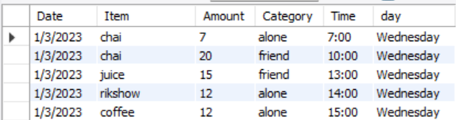

* 1. **Specific Columns:**

SELECT date, category, amount FROM Expenses;

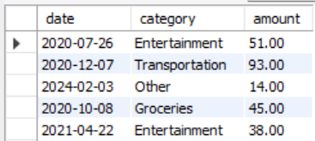

* 1. **Filtering by Date Range:**

SELECT date, category, amount FROM Expenses WHERE date >= '2021-01-01' AND date <= '2024-12-15';

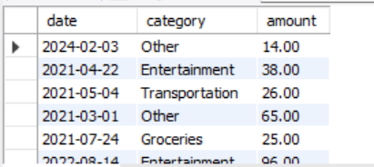

## Part 2: Filtering with WHERE Clause

**2.1 Filtering by Category**

SELECT date, category, amount FROM Expenses WHERE category = 'Entertainment';

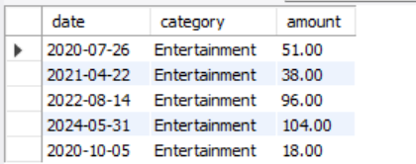

**2.2 Filtering with Comparison Operators**

SELECT date, category, amount FROM Expenses WHERE amount > 50;

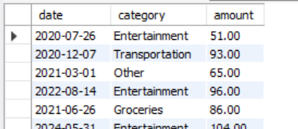

**2.3 Combining Filters**

SELECT date, category, amount FROM Expenses WHERE amount > 75 AND category = 'Food';



**2.4 Combining Filters (OR)**

SELECT date, category, amount FROM Expenses WHERE category = 'Transportation' OR category = 'Groceries';

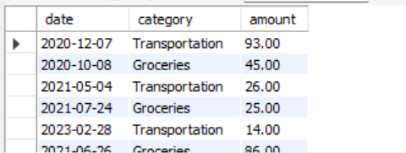

**2.5 Filtering with NOT**

SELECT date, category, amount FROM Expenses WHERE category IS NULL OR category <> 'Rent';

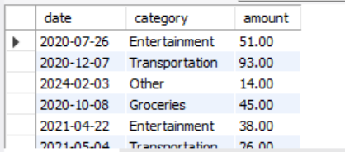

## Part 3: Sorting Retrieved Data

**3.1 Sorting by Amount**

SELECT date, category, amount FROM Expenses ORDER BY amount DESC;

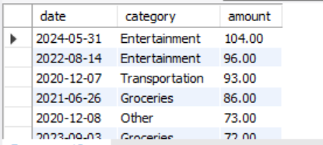

**3.2 Sorting by Date and Category**

SELECT date, category, amount FROM Expenses ORDER BY date DESC, category ASC;

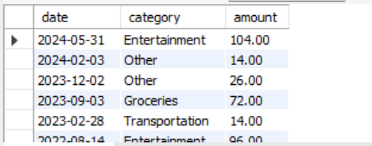

## Part 4: Database Upgrade

**4.1 Write SQL commands to achieve the following**

CREATE TABLE Income ( income_id INT PRIMARY KEY AUTO_INCREMENT, amount DECIMAL(10,2) NOT NULL, date DATE NOT NULL, source VARCHAR(50) NOT NULL );

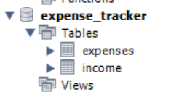

**4.2 After creating the "Income" table, you realize you also want to track the income category "source" (e.g., "Salary," "Freelance Work").**

ALTER TABLE Income ADD category VARCHAR(50);

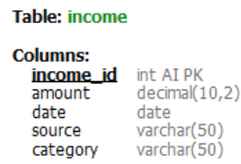

**4.3 Let's say you decide tracking the income source isn't necessary for now.**

ALTER TABLE Income DROP COLUMN source;

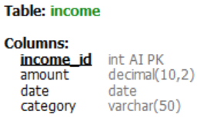

ALL MY QUERIES

