CLEAN WATER AND SANITISATION ERD
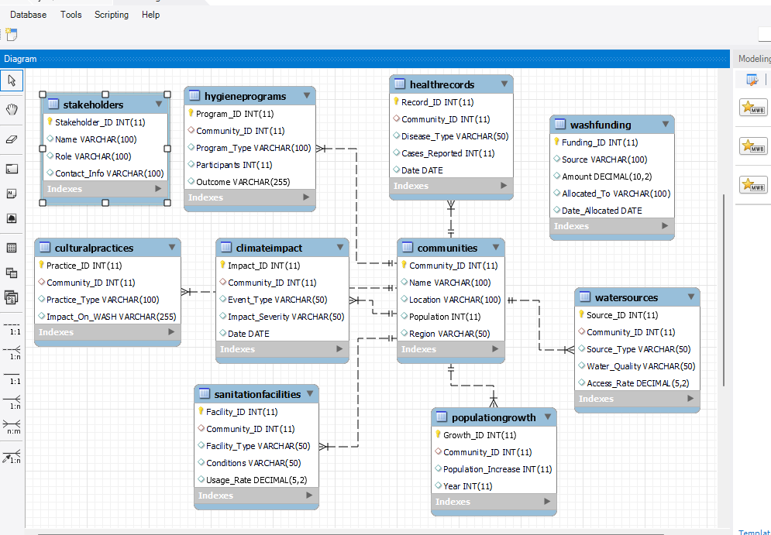
Explanation:
Communities are linked to Sanitation Facilities, Water Sources, Health Records, Hygiene Education Programs, Climate Impact, Population Growth, and Cultural Practices. It makes it one-to-many relationship.

