Neema Mwende Assignment Week 8

Part 1: SDG Selection and Problem Definition
SDG Selection:
- SDG 3: Good Health and Well-being
Problem Definition:
- Specific Problem: High maternal mortality rates in rural areas of Kenya due to inadequate healthcare facilities and poor access to medical services.

Part 2: Database Design
1. Design an ERD:
- Entities:
  - Hospitals: HospitalID, Name, LocationID
  - Maternal_Health_Cases: CaseID, HospitalID, PatientID, DoctorID, DateOfAdmission, Outcome
  - Doctors: DoctorID, Name, Specialization
  - Locations: LocationID, City, Country
  - Patient_Records: PatientID, Name, DateOfBirth
- ERD Example:
  - Hospitals are connected to Maternal_Health_Cases via HospitalID.
  - Maternal_Health_Cases are connected to Doctors and Patient_Records via DoctorID and PatientID.
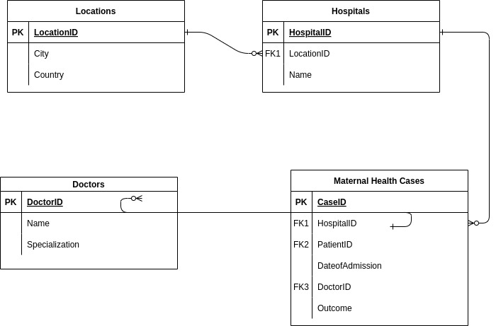
CREATE TABLE Locations (
LocationID INT PRIMARY KEY,
City VARCHAR(255),
Country VARCHAR(255)
);

CREATE TABLE Hospitals (
HospitalID INT PRIMARY KEY,
Name VARCHAR(255),
LocationID INT,
FOREIGN KEY (LocationID) REFERENCES Locations(LocationID)
);

CREATE TABLE Doctors (
DoctorID INT PRIMARY KEY,
Name VARCHAR(255),
Specialization VARCHAR(255)
);

CREATE TABLE Patient_Records (
PatientID INT PRIMARY KEY,
Name VARCHAR(255),
DateOfBirth DATE
);

CREATE TABLE Maternal_Health_Cases (
CaseID INT PRIMARY KEY,
HospitalID INT,
PatientID INT,
DoctorID INT,
DateOfAdmission DATE,
Outcome VARCHAR(255),
FOREIGN KEY (HospitalID) REFERENCES Hospitals(HospitalID),
FOREIGN KEY (PatientID) REFERENCES Patient_Records(PatientID),
FOREIGN KEY (DoctorID) REFERENCES Doctors(DoctorID)
);

3. Populate the Database
Insert sample data

INSERT INTO Locations (LocationID, City, Country) VALUES (1, 'Nairobi', 'Kenya');
INSERT INTO Hospitals (HospitalID, Name, LocationID) VALUES (1, 'Nairobi Hospital', 1);
INSERT INTO Doctors (DoctorID, Name, Specialization) VALUES (1, 'Dr. John Doe', 'Obstetrician');
INSERT INTO Patient_Records (PatientID, Name, DateOfBirth) VALUES (1, 'Jane Smith', '1985-04-12');
INSERT INTO Maternal_Health_Cases (CaseID, HospitalID, PatientID, DoctorID, DateOfAdmission, Outcome) VALUES (1, 1, 1, 1, '2024-08-01', 'Fatal');

Part 3: SQL Programming
1. Data Retrieval Queries:
- Retrieve Fatal Cases:
SELECT * FROM Maternal_Health_Cases WHERE Outcome = 'Fatal';

2. Data Analysis Queries:
- Fatal Cases by Location
SELECT l.City, COUNT(*) AS FatalCases
FROM Maternal_Health_Cases mhc
JOIN Hospitals h ON mhc.HospitalID = h.HospitalID
JOIN Locations l ON h.LocationID = l.LocationID
WHERE mhc.Outcome = 'Fatal'
GROUP BY l.City;

INTEGRATION TESTING DOCUMENT

1. Introduction

This document describes the process of integrating data from an SQL database into Microsoft Excel and subsequently using Microsoft Word for reporting purposes. This includes steps for exporting data, analyzing it in Excel, and presenting it in a Word document.

2. Data Export Process

2.1. Exporting Data from SQL to Excel

Objective: Export data from SQL tables into CSV format and import them into Excel for analysis.

Steps:

1. Run SQL Queries:
Execute the following SQL queries to export data from each table:

```sql
-- Export data from Locations table
SELECT * FROM Locations
INTO OUTFILE '/path/to/locations.csv'
FIELDS TERMINATED BY ','
ENCLOSED BY '"'
LINES TERMINATED BY '\n';

-- Export data from Hospitals table
SELECT * FROM Hospitals
INTO OUTFILE '/path/to/hospitals.csv'
FIELDS TERMINATED BY ','
ENCLOSED BY '"'
LINES TERMINATED BY '\n';

-- Export data from Doctors table
SELECT * FROM Doctors
INTO OUTFILE '/path/to/doctors.csv'
FIELDS TERMINATED BY ','
ENCLOSED BY '"'
LINES TERMINATED BY '\n';

-- Export data from Patient_Records table
SELECT * FROM Patient_Records
INTO OUTFILE '/path/to/patient_records.csv'
FIELDS TERMINATED BY ','
ENCLOSED BY '"'
LINES TERMINATED BY '\n';

-- Export data from Maternal_Health_Cases table
SELECT * FROM Maternal_Health_Cases
INTO OUTFILE '/path/to/maternal_health_cases.csv'
FIELDS TERMINATED BY ','
ENCLOSED BY '"'
LINES TERMINATED BY '\n';
```

2. Import Data into Excel:
- Open Microsoft Excel.
- Go to **Data** > **Get Data** > **From File** > **From Text/CSV**.
- Select each CSV file and import it into separate sheets within a single Excel workbook.
- Save the workbook with a meaningful name (e.g., `Maternal_Health_Data.xlsx`).

3. Data Analysis Using Excel

3.1. Analyze Data in Excel

Objective: Use Excel to perform data analysis and visualization.

Steps:

1. Create Pivot Tables:
- Insert pivot tables to analyze the maternal mortality rates, hospital performance, and regional disparities.
- Example: Pivot table showing the number of cases and mortality rates by hospital.

2. Generate Charts:
- Pie Charts:Display proportions of different outcomes (e.g., survived vs. fatal).
- Bar Charts: Compare mortality rates across hospitals or regions.
- Line Charts: Show trends over time in maternal health cases.

3. Create a Dashboard:
- Compile key metrics and visualizations into an interactive dashboard using Excel features like slicers and dynamic charts.

4. Integration into Microsoft Word

4.1. Prepare the Word Document

Objective: Create a report in Microsoft Word using data and analysis from Excel.

Steps:

1. Create a New Document:
- Open Microsoft Word and create a new document.
- Set up the document with a title page, table of contents, and relevant sections.

2. Insert Data from Excel:
- Tables:
- Copy data tables from Excel and paste them into Word using **Paste Special** > **Paste Link** to maintain the connection to Excel.
- Charts:
- Copy charts from Excel and paste them into Word. Choose to paste as a linked object to ensure they update with changes in Excel.

3. Format the Document:
- Adjust formatting for readability and presentation.
- Include sections for data analysis, key insights, and conclusions.
- Ensure all tables and charts are appropriately labeled and referenced.

4.2. Finalize and Share the Report

Objective: Prepare and distribute the final report.

Steps:

1. Review and Proofread:
- Proofread the document for accuracy and completeness.
- Verify that all data and visualizations are correctly represented.

2. Save and Export:
- Save the Word document in `.docx` format.
- Optionally, export the document to PDF for a polished final version by going to **File** > **Save As** and selecting PDF as the file format.

3. Share the Document:
- Distribute the final report via email, upload it to a shared drive, or provide access through other means.

---

This integration document outlines the steps for exporting data from SQL, analyzing it in Excel, and creating a comprehensive report in Microsoft Word. Adjust the specifics according to your data and requirements.

GOOGLE SHEETS LINK: https://docs.google.com/spreadsheets/d/1wKmFsya195kbmo-NkUBPqhNiJQTK2luX9Ouqp7eQnJA/edit?usp=sharing

