**Part 1: SDG Selection and Problem Definition**

-SDG Selection: SDG 3: Good Health i.e. health Records Management

-Problem Definition: Inconsistent and fragmented patient data as a result of uncoordinated health record systems

**Part 2: Database Design**

- **ERD:**

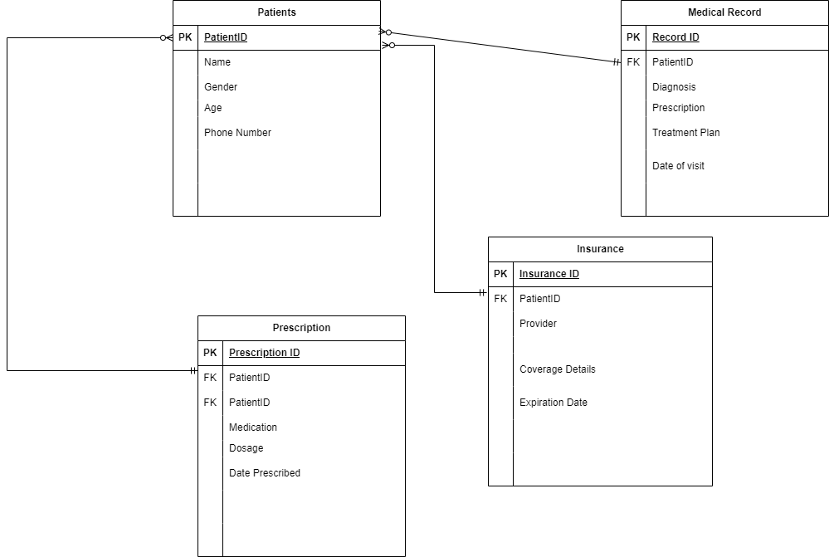

- **Schema:** **Write SQL statements to create the database schema based on your ERD.**

CREATE DATABASE health_records;

USE health_records;

CREATE TABLE Patients (

PatientID INT NOT NULL AUTO_INCREMENT PRIMARY KEY,

Name VARCHAR (255) NOT NULL,

Gender VARCHAR (100) NOT NULL,

Age INT NOT NULL,

Phone_Number INT NOT NULL

);

CREATE TABLE Medical_record (

RecordID INT NOT NULL AUTO_INCREMENT PRIMARY KEY,

PatientID INT NOT NULL,

Diagnosis VARCHAR (255) NOT NULL,

Prescription VARCHAR (255) NOT NULL,

Treatment_Plan VARCHAR (500) NOT NULL,

Date_Visit DATE NOT NULL,

FOREIGN KEY (PatientID) REFERENCES Patients (PatientID)

);

CREATE TABLE Prescription (

PrescriptionID INT NOT NULL AUTO_INCREMENT PRIMARY KEY,

PatientID INT NOT NULL,

Medication VARCHAR (255) NOT NULL,

Dosage VARCHAR (255) NOT NULL,

Date_Prescribed DATE NOT NULL,

FOREIGN KEY (PatientID) REFERENCES Patients (PatientID)

);

CREATE TABLE Insurance (

InsuranceID INT NOT NULL AUTO_INCREMENT PRIMARY KEY,

PatientID INT NOT NULL,

Provider VARCHAR (255) NOT NULL,

Coverage_Details VARCHAR (255) NOT NULL,

Expiration_date DATE NOT NULL,

FOREIGN KEY (PatientID) REFERENCES Patients (PatientID)

);

- **Sample Data:** Populate the database with relevant sample data.

INSERT INTO patients (PatientID, Name, Gender, Age, Phone_Number)

VALUES

(1, "Gayel Senescall", "Other" ,60, 763958071),

(2, "Brana Leborgne", "Female ",58, 775452352),

(3, "Tadeas Mugford", "Male" ,20, 766604800),

(4, "Ranique Derisly", "Female" ,19, 775127742),

(5, "Ginny Eykelhof", "Male”, 56, 751155537),

(6, "Urbanus Hamly", "Other" ,17, 746434352),

(7, "Sanders McComas", "Other" ,14, 782609648),

(8, "Paul Halbard", "Female" ,86, 774533415),

(9, "Corey Covely", "Male" ,66, 785184490),

(10,"Lita Jenicke", "Female" ,40, 718163383),

(11, "Shirley Pinkett", "Male" ,35, 789149078),

(12,"Eydie Archell", "Other" ,20, 783488730),

(13,"Colly MacMenamy", "Other" ,38, 747172687),

(14,"Vanya Langdridge", "Female" ,26, 745923765),

(15,"Roobbie Springer", "Male" ,30, 741361068),

(16,"Shanta Anning", "Male", 37, 776374112),

(17,"Virginie Peaurt", "Male" ,24, 746533272),

(18,"Jacklyn Weber", "Male" ,33 , 747272098)

;

INSERT INTO medical_record(RecordID, PatientID, Diagnosis, Prescription, Treatment_Plan, Date_Visit)

VALUES

(9, 1, “Drainage of Hypoglossal Nerve, Percutaneous Approach, Diagn", "Personal history of malignant neoplasm of large intestine", "Repair Left Tympanic Membrane, Via Opening","2024-04-14"),

(6, 2, “Removal of Synthetic Substitute from Left Ear, Open Approach", "Acute tracheitis", "Revision of Nonaut Sub in Larynx, Open Approach","2024-05-20"),

(2, 3, “Revision of Tissue Expander in Left Breast, Endo", "Keratopathy (bullous aphakic) following cataract surgery, right eye", "Division of Head Muscle, Percutaneous Endoscopic Approach”,"2024-06-14"),

(1, 4, “Excision of Right Hypogastric Vein, Perc Approach, Diagn", "Ankylosing spondylitis lumbar region", "Planar Nucl Med Imag of Thorax using Technetium 99m","2023-10-30"),

(8, 5, “Dilation of Hepatic Art with Drug-elut Intra, Open Approach", "Partial traumatic amputation at level between left shoulder and elbow, sequela","Fluoroscopy of Spinal Cord using Other Contrast","2024-01-02"),

(15, 6, “Insertion of Infusion Device into Cerv Jt, Perc Approach", "Nondisplaced fracture of base of neck of left femur, initial encounter for open fracture type I or II", "Replace L Hip Jt, Acetab w Synth Sub, Uncement, Open","2024-02-23"),

(13, 7, “Removal of Radioactive Element from Resp Tract, Via Opening", "Nondisplaced midcervical fracture of unspecified femur, subsequent encounter for open fracture type IIIA, IIIB, or IIIC with routine healing", "Occlusion of Right Ureter with Intralum Dev, Perc Approach","2023-09-02"),

(4, 8, “Removal of Intermittent Pressure Device on Left Lower Arm", "Displaced fracture of left radial styloid process, subsequent encounter for open fracture type IIIA, IIIB, or IIIC with nonunion", "Excision of Right Brachial Artery, Open Approach","2023-12-17"),

(5, 9, “Restrict of L Inqnl Lymph with Intralum Dev, Perc Approach", "Physeal fracture of upper end of fibula", "Fusion 2-7 T Jt w Autol Sub, Ant Appr A Col, Perc”,"2024-07-30"),

(12, 10, "Insertion of Monopln Ext Fix into L Low Femur, Open Approach", "Diffuse large B-cell lymphoma, intrathoracic lymph nodes", "Replace L Knee Jt, Femoral w Synth Sub, Cement, Open","2024-03-01"),

(18, 11, "Restriction of Upper Vein with Extralum Dev, Open Approach", "Unspecified occupant of bus injured in collision with railway train or railway vehicle in nontraffic accident", "Insertion of Infusion Device into R Wrist Jt, Perc Approach","2023-11-03"),

(16, 12, "Supplement Right Lacrimal Duct with Synth Sub, Open Approach", "Assault by other larger firearm discharge, initial encounter", "Replacement of Bladder with Nonaut Sub, Via Opening","2024-05-10"),

(10, 13, "Excision of Right Tympanic Membrane, Endo", "Single liveborn infant, unspecified as to place of birth", "CT Scan of Celiac Art using Intravasc Optic Cohere","2024-05-16"),

(7, 14, "Drainage of Left Epididymis, Percutaneous Approach", "Corrosion of unspecified degree of buttock, subsequent encounter", "HDR Brachytherapy of Pleura using Iodine 125","2024-07-02"),

(17, 15, "Reposition Left Acromioclavicular Joint, Perc Approach", "Unspecified fracture of upper end of unspecified tibia, subsequent encounter for open fracture type IIIA, IIIB, or IIIC with malunion", "Extirpation of Matter from Right Breast, External Approach" ,"2024-07-23"),

(3, 16, "Drainage of Right Scapula with Drain Dev, Open Approach", "Poisoning by local anesthetics, intentional self-harm, sequela", "Supplement L Com Iliac Art w Autol Sub, Perc Endo","2024-02-29"),

(14, 17, "Inspection of Respiratory Tract, Percutaneous Approach", "Nondisplaced fracture of shaft of third metacarpal bone, left hand, initial encounter for open fracture", "Removal of Nonaut Sub from R Knee Jt, Perc Approach","2023-11-24"),

(11, 18, "Removal of Other Device from L Up Extrem, Perc Endo Approach", "Toxic effect of copper and its compounds, undetermined, subsequent encounter", "Excision of Right Subclavian Artery, Open Approach","2024-03-30")

;

INSERT INTO prescription (PrescriptionID, PatientID, Medication, Dosage, Date_Prescribed)

VALUES

(18, 1, "Hypericum perforatum Symphytum officinale, Arnica montana", "3 times daily", "2024-01-18"),

(11, 2, "Fluphenazine Hydrochloride", "5mg daily", "2023-11-13"),

(4, 3, "ESCITALOPRAM OXALATE", "10mg daily", "2023-08-30"),

(1, 4, "Hydrochlorothiazide", "25mg daily", "2023-12-19"),

(16, 5, "Dexamethasone Sodium Phosphate", "9mg daily", "2024-07-03"),

(14, 6, "TITANIUM DIOXIDE", "35%", "2023-08-22"),

(13, 7, "Tramadol Hydrochloride and Acetaminophen", "2 tablets every 6 hours", "2023-10-21"),

(10, 8, "CEFTAZIDIME", "500mg every 8 hours", "2023-12-24"),

(8, 9, "Levetiracetam", "500mg twice daily", "2024-06-17"),

(17, 10, "Benzalkonium Chloride", "0.1-0.13%", "2023-12-27"),

(7, 11, "ISOPROPYL ALCOHOL", "70% Solution", "2024-05-18"),

(3, 12, "Alprazolam", "0.25-0.5mg 2-3 times daily", "2024-01-18"),

(9, 13, "Arsenicum 30c, Chamomilla 30c, Cina 30c, Glononium 30c, Hyoscyamus 30c, Medorrhinum 30c, Stramonium 30c, Tarentula 30c, Veratrum Album 30c", "3-4 times daily", "2024-01-25"),

(12, 14, "Valproate Sodium", "500mg twice daily", "2024-03-03"),

(15, 15, "Pantoprazole Sodium", "40mg daily", "2024-02-03"),

(2, 16, "CHLOROXYLENOL", "3%", "2024-05-12"),

(6, 17, "Lithium Carbonate", "300mg 3 times daily", "2024-02-17"),

(5, 18, "Miconazole Nitrate", "2 times daily", "2023-08-17")

;

INSERT INTO insurance (InsuranceID, PatientID, Provider, Coverage_Details, Expiration_Date)

VALUES

(7, 1, “Jubilee", "Outpatient, inpatient, dental, optical, and maternity services", "2024-07-20"),

(16, 2, “Britam", "Outpatient, inpatient, maternity, dental, optical, and chronic illness coverage", "2024-06-14"),

(6, 3, “CIC", "Inpatient, outpatient, dental, optical, and specialized treatments.", "2024-03-01"),

(2, 4, “AAR", "Outpatient, inpatient, dental, optical, and wellness services.", "2023-10-16"),

(1, 5, “Madison", "Inpatient, outpatient, dental, optical, and specialized treatment.", "2024-01-29"),

(14, 6, “CIC", "Inpatient, outpatient, dental, optical, and specialized treatments.", "2023-10-19"),

(12, 7, “Jubilee", "Outpatient, inpatient, dental, optical, and maternity services", "2023-12-20"),

(15, 8, “Britam", "Outpatient, inpatient, maternity, dental, optical, and chronic illness coverage", "2023-12-11"),

(5, 9, “Madison", "Inpatient, outpatient, dental, optical, and specialized treatment.", "2024-04-08"),

(17, 10, "CIC", "Inpatient, outpatient, dental, optical, and specialized treatments.", "2023-11-05"),

(10, 11, "AAR", "Outpatient, inpatient, dental, optical, and wellness services.", "2023-09-11"),

(8, 12, "Madison", "Inpatient, outpatient, dental, optical, and specialized treatment.", "2023-11-21"),

(9, 13, "CIC", "Inpatient, outpatient, dental, optical, and specialized treatments.", "2023-11-30"),

(18, 14, "APA", "Inpatient, outpatient, maternity, and critical illness coverage.", "2023-12-04"),

(4, 15, "CIC", "Inpatient, outpatient, dental, optical, and specialized treatments.", "2024-04-18"),

(11, 16, "Jubilee", "Outpatient, inpatient, dental, optical, and maternity services", "2024-07-06"),

(3, 17, "Britam", "Outpatient, inpatient, maternity, dental, optical, and chronic illness coverage", "2023-10-17"),

(13, 18, "APA", "Inpatient, outpatient, maternity, and critical illness coverage.", "2024-02-09")

;

**Part 3: SQL Programming**

- **\*\*Data Retrieval: \*\*** Write SQL queries to retrieve relevant data based on your problem definition.

SELECT Age

FROM patients;

SELECT Gender

FROM patients;

SELECT Provider

FROM insurance;

- **\*\*Data Analysis: \*\*** Write SQL queries to analyze data and generate insights related to your SDG problem.

SELECT Gender, AVG(Age) AS Average

FROM patients

GROUP BY Gender;

SELECT Provider, COUNT(Provider) AS Provider_tot

FROM insurance

GROUP BY Provider

ORDER BY Provider_tot DESC;

**Part 4: Data Analysis Using Excel**

- **\*\*Import Data: \*\*** Import data from your database into Excel.

- **\*\*Analysis:** Analyze the data using pivot tables, charts, and other Excel tools.

- **\*\*Dashboard: \*\*** Create an interactive Excel dashboard to visualize key insights.

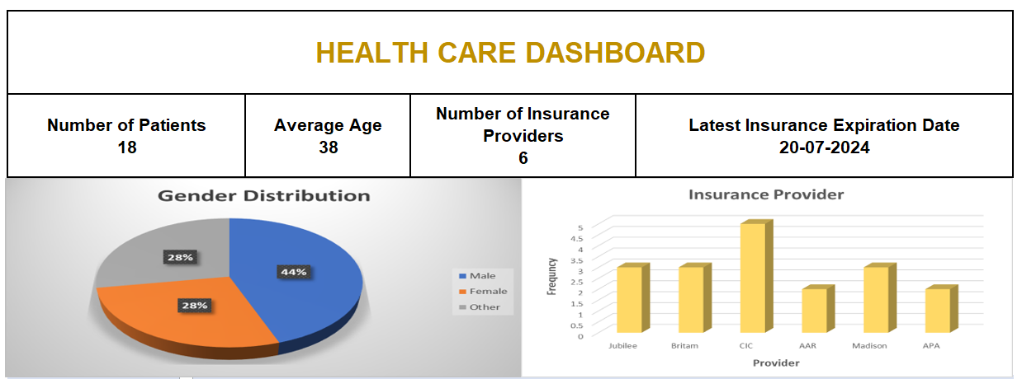

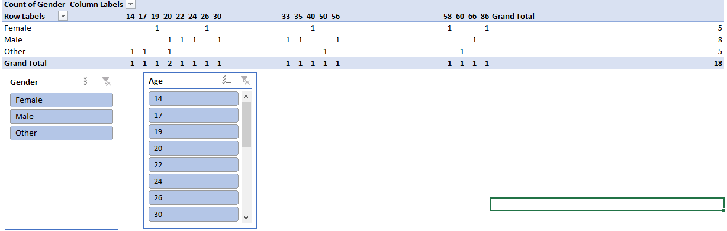

**Part 5: Integration and Testing**

- **Integration:** **Document the process of importing data into Excel and ensuring consistency.**

Open MySQL Workbench: Write and execute the SQL query to retrieve the desired data.

Click on the Server icon in the query results pane and select Export.

Select the schema to be exported, export options and the objects to be exported

Save the file to your desired location.

Click on Export Progress then Start Export

Open Excel and load the file. Excel will import the data and format it as a table.

**Part 6: Presentation**

**-Pitch Deck: ** Develop a 10-slide PowerPoint presentation as taught in the entrepreneurship module covering:**

Pitch deck link: <https://www.canva.com/design/DAGNG-KQ770/PgOR_l3IHiFkChrxvAPfYQ/edit>