**IMPORTING DATA INTO EXCEL**

1. In MySQL Workbench, right click on the table whose data you want to export to the MS Excel.
2. On the command prompt that appears, click **Table Data Export Wizard.**
3. The dialogue box below will be shown.Ensure all the checkboxes are checked(Having a tick) , click **Next.**

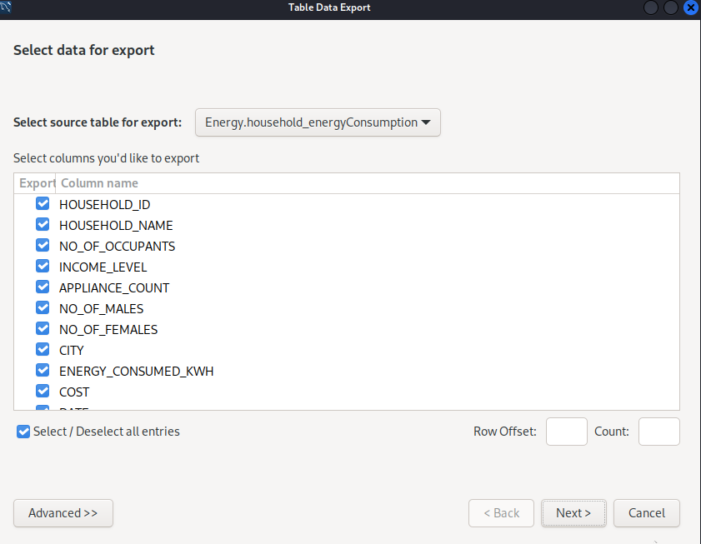

1. The dialogue box below will be displayed**.** Click on the **Browse** button and select your preferred storage location for the data to export and the name for the file.

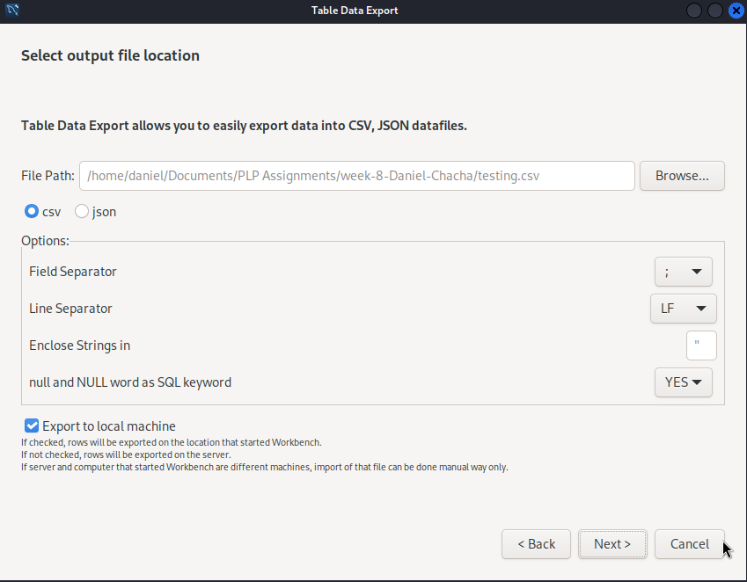

1. Below the textbox is a radio with two choices; **csv** and **json.** Select the **csv** option. Click **Next.**
2. The dialogue box below will be displayed. Click **Next.** The data in the database will be exported to the location you specified earlier in your local machine.

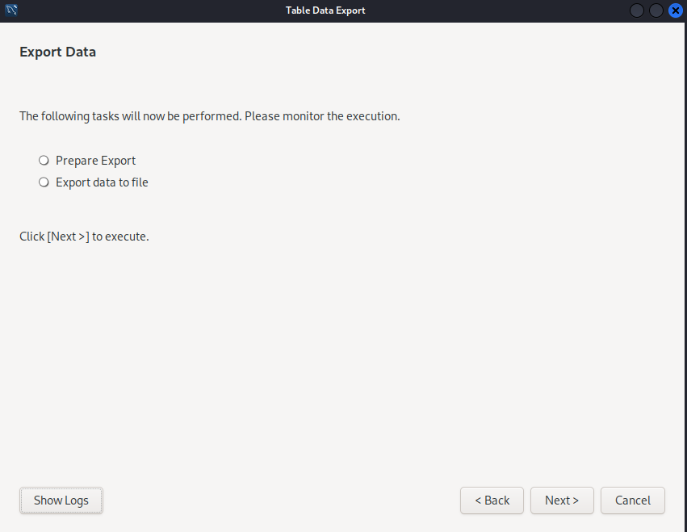

1. Exit MySQL Workbench once the process is finished.
2. Using **File Explorer ,** navigate to the location you saved the exported data.
3. Right click on the file and select **Open With.**
4. From the dropdown menu that appears, select **MS Excel.**
5. This will open the file in MS Excel. Rename it to **.xlsx** format and you can now manipulate your data.