**ENTITY RELATION DIAGRAM**

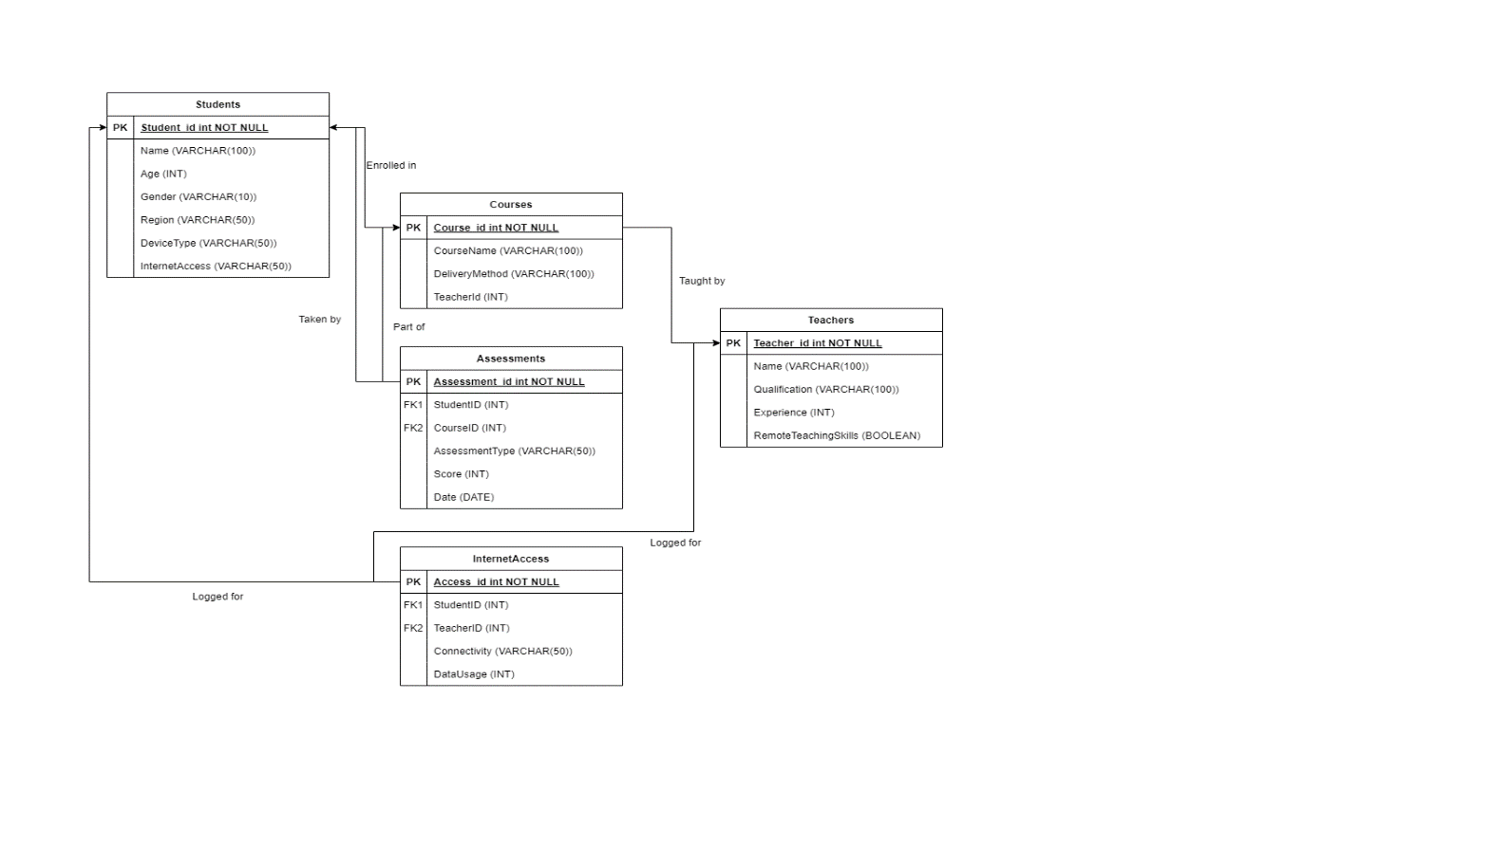

Figure 1 Entity Diagram