Linux practical on putty -4

1)Ping command:

Ping is sort form of packed internet grouper.this command mainly used for chacking .the network connective among host & sarver.the ping command take the url or ip adderess as input and transfore the data package to specified adderss alongwith the ping masege than it will get a replay form host/sarvar .

Syntax:-ping hostname ipaddaress

Ping google .com

2)ssh command:

Ssh standes for secure shell.it I a protocol used to securely conput to a remote server or sysrem.ssh is secure in the sense .that it transfers the host and the client .it transfers inputs from the client to the host and runs at TCP|IP port22.

Syntax:ssh command username host

Ex:-ssh user_ name@host (IP|woman name)

3)ftp command :

File transfer portocal.

(remove this command ctrl+z)

4)vi editor(visual editor):

Vi editor using we can editand existing fill a create a new file from scratch.

Syntax:vi filename

~(a news line)

i(used to insert)

qi (quit without saving changes)

:wq- write &quit (save &exit )

command mode:

to enter into the command mode or any other mode its required pressing Esc key.

Insert mode:this mode enable you to insert text into file to come in insert mode simply insert to press ‘i’ key.

Last line mode:last line mode is inwork by typing a colun(:) why vi command in the command mode.

k-move the curser of one line above.

j- move the curser of one line down.

h- move the curser to the left

l- move the curser to the right

0/-position curser of the beggning of the line.

H- move to the top of the screen.

M-move to the medial of the screen

L-move to the bottom of the screen

$-position curser end of line

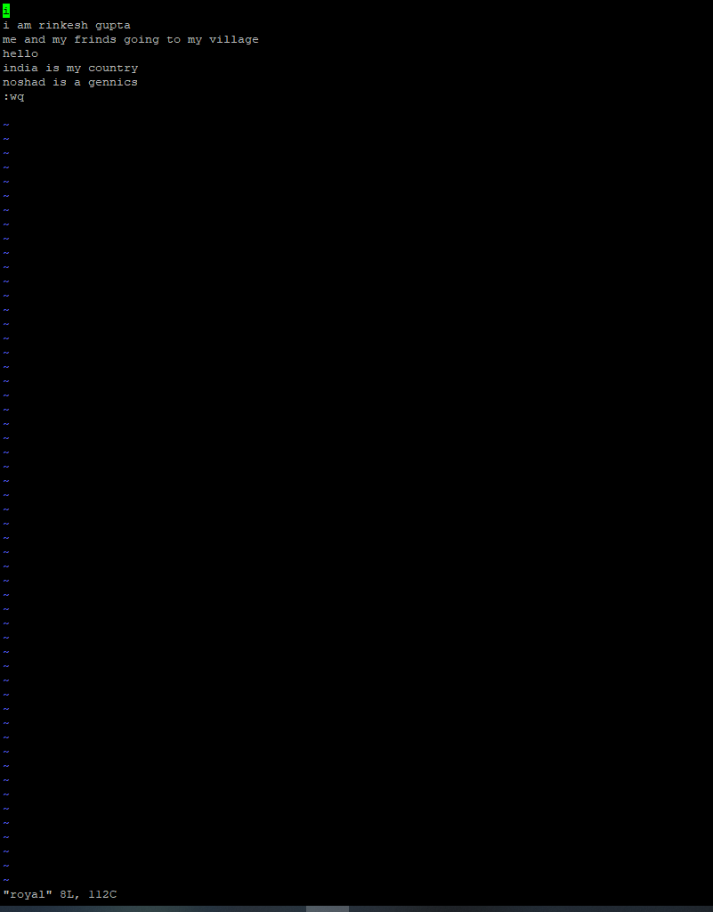

5)sed command:

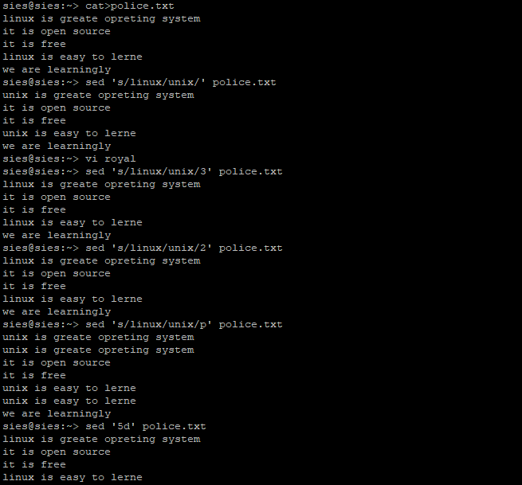

6)awk command :

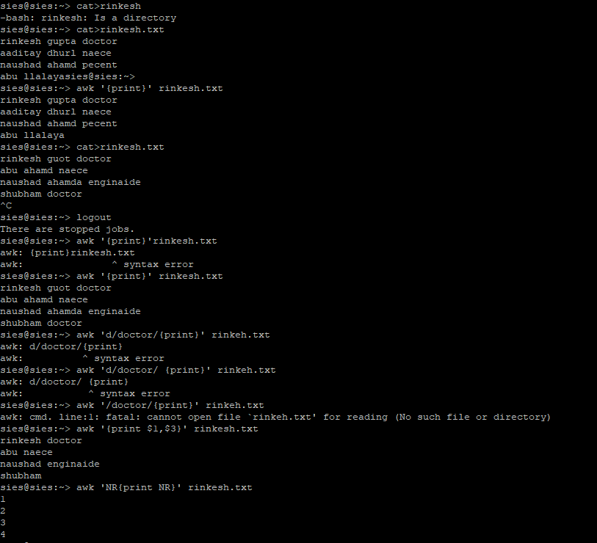

7)ps command :(process sates command is used to display information related to the process .

Synax:-ps –l

PID-uniq procees id.

TTY-treminal type.

TIME-mount of cpu in minunte &second that process is running.than you have CMD-nano of command that large the process .

Syntax:-ps –A

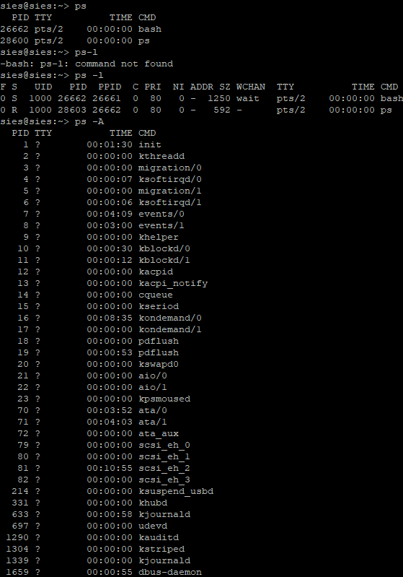8)kill command :-

this is treminat the process and display available you can used.

9) command:-

Sh:

Nice:

Batch:

At: