**Proposal:**

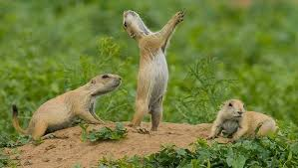

Cameron Powers, 5/10/17

High-level description: I will be analyzing the prairie dog colonies data from the Boulder Open Data project in an attempt to identify prairie dog colonies via aerial images, clustering the different areas together and predict the perimeter and areas for each cluster.

I am going to be presenting my work in a presentation/slides fashion.

Possibilities:

-NAIP images which have a one-meter resolution and should contain the metadata need for the geo-reference and allow for band manipulation for easier identification of colonies and training, debating if I should use all bands or a single band (grey scale) for simplicity.

-Ping the GE URL for each coordinate and take a screenshot. This technique would result in higher resolution; it appears to be 1ft by 1ft pixels but trying to verify this.

Data:

Boulder Prairie Dog Data:

<https://bouldercolorado.gov/open-data/city-of-boulder-osmp-prairie-dog-colonies/>

Image Data Sets via EE:

<https://earthengine.google.com/datasets/>

Pipeline:

I am still trying to decide on a technique on how to identify the colonies, my first thought is to train a neural network on a large set of images containing prairie dog colonies. Please give me some insight if you feel there is a more appropriate way to accomplish this. I want my neural network to identify these mounds in the image and return the location in the image.

Once I have these locations I will use hierarchical clustering to group together the colony/colonies. I want to use this type of clustering so I don’t have to define the possible number of colonies within one photo before hand. Once they are clustered I am hoping to use shapely to define the boundaries to and ultimately calculate the perimeter and area.

Possible Issues:

There are many possible issues that could arise, for one I am not sure exactly how to get the neural network to identify these mounds. If I can get it to identify the mounds I will be using imagery that is highly magnified (containing only partial areas) when ultimately I want to predict the area of the whole group of mounds (less magnified images). I am unsure how to verify how well my neural net is classifying these mounds without visualizing conformation, would I have to count the mounds? All of these issues would have to be solved now. Training my model on less magnified images could solve the magnification issue, but this might affect the models ability to pick up mounds.

Goals:

In the time frame we have I hope to train a neural net to identify prairie dog colonies and be able to cluster the different colonies into groups at a minimum. I am shooting for a completed project, that being one which can make predictions about the area and perimeter.

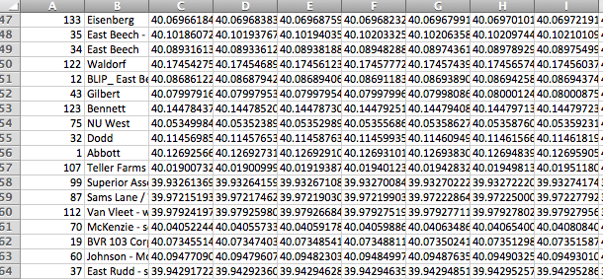

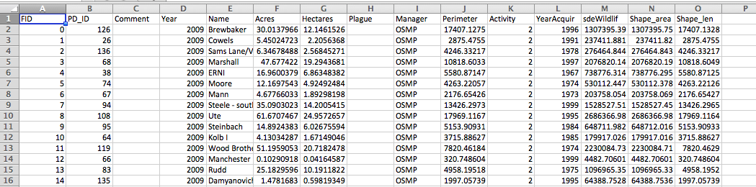

My back up project is with New Belgium:

The goal will be to identify taster flavor specializations for each employee, mapping out what compounds they struggle with and others they excel with. I would present my work in a slide/presentation style. My next step would be to obtain the data from Matt if necessary. I have spoken with Matt and he is waiting to hear from me if my other project falls through in order to obtain the data for the project.