Mailing List Import Function

The import function works by reading in a CSV file (can be created/edited/viewed in Excel or even Notepad). For an example file, please click the link below the file upload box labeled “Download an example .csv file.” This file will show you the format that the importer is expecting.

Looking into this file, we see that the first row of entries is the header fields. This is important because the import feature will always skip the first row of entries when importing because it assumes them to be the header row. While you are not required to put the header line in any sort of format, please make sure that it exists, otherwise you will lose a data record.

The first column in the file is where you will want to enter all the e-mail address of subscribers you want to add to your mailing list. While you should verify the validity of the e-mail addresses before using the tool, the importer will catch most invalid formats of e-mail addresses and spit them back out to you after execution for you to fix.

The second column is the format of the Newsletter that will be sent to each individual user. Currently there are only three choices for this column: HTML, TEXT, or MULTIPART (all of which are case insensitive). If you are unsure of what format the user would like to receive their e-mail in, TEXT is a safe choice as all e-mail clients will be able to read it. Entering in any other option than those listed will result in the user not being imported, which you will be informed of after execution.

The final column is used to determine whether the user is active or not. This should always be set to TRUE, unless you want to keep a log of users that were once subscribed to the mailing list, but have since unsubscribed. Setting this field to FALSE will import the e-mail address into the database, but it will not be visible from the manager, nor will the address receive e-mails. Any other values for this field will once again throw an error after execution and will result in the user not being imported.

Now that you have familiarized yourself with the .csv file, you can create your own, or modify the example one and save it to your computer somewhere. Once you have finished with it, click the Browse... button on the import tool and navigate to the .csv file you want to import. After that click Import. Your screen should look similar to the one shown below (screenshot is from executing the example .csv file):

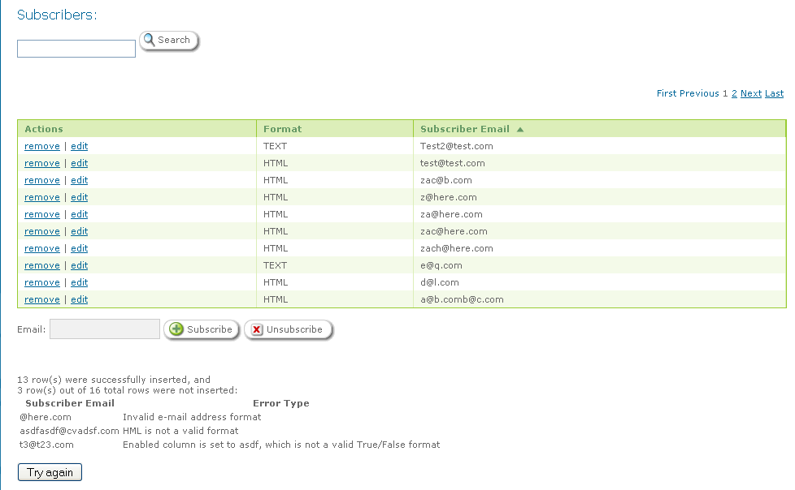
As you can see, the subscriber table was automatically filled and subscribers that were entered into the .csv file incorrectly are displayed in the error table (blown up below):

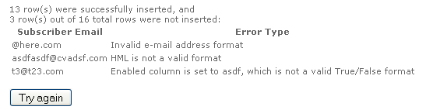
The “Try again” button will take you back to the original import screen, so that you can fix the incorrect entries and then reimport the list (don't worry about deleting the entries that were successfully imported, the tool won't reimport them).

