
MD.070 Application Extension
Technical Design
Inventory_Item_Code_Check

Prepared by
Author: Anupam Chaudhari
Creation Date: 19th Jul, 2019
Last Updated: -- -- ----
Document Ref: N.A
Version: 1.1
Oracle IT Developer: Oracle IT Developer.doc

Document Control

Change Record
10
Date | Author | Version | Change Reference
Date | Name | 1.1 | No

Reviewers

Name | Position
Arvind Sargam

Distribution

Copy No. | Name | Location

Note To Holders:
If you receive an electronic copy of this document and print it out, please write your name on the equivalent of the cover page, for document control purposes.
If you receive a hard copy of this document, please write your name on the front cover, for document control purposes.

Contents
Document Control 2
Technical Overview 5
Approach 5
Module List 5
Requirement 6
Requirement Logic 6
Steps 6
Open and Closed Issues for this Deliverable 11
Open Issues 11
Closed Issues 11
Requirement in MSME VENDOR INVOICES Report
Requirement Logic and Find Excel sheet
Steps – Customized a existing Table, Package, Rdf, RTF template and Find Scripts
Request Navigation

To update the table of contents, put the cursor anywhere in the table and press [F9]. To change the number of levels displayed, select the menu option Insert>Index and Tables, make sure the Table of Contents tab is active, and change the Number of Levels to a new value.

Technical Overview
This document defines the technical components required to implement concurrent request, Inventory_Item_Code_Check. This Application Extension Technical Design document complements the Application Extension Functional Design document for Inventory_Item_Code_Check and you should consider the set to be the complete detailed design.

Approach
If the Functional Design included a Technical Overview section, duplicate that information here and add additional details.

Module List

Workflow

Inventory_Item_Code_Check -> Concurrent request in HUBTOWN Inventory Super User Responsibility.
As per requirement, Concurrent request create new item in item definition with attribute value is Yes or update the existing items attribute value where attribute value dose not exist.

Requirement
- Pick the all item from inventory from master item project.
- Find the item such that either item not exist in item definition or attribute values of item from item definition is not Yes.
- Create the new item in item definition if not exist or update existing item , if there corresponding attribute value is null from item definition.

Requirement Logic
- As per Requirement select required item from master inventory item table.
- Insert or update them in item definition respective table.
- Attribute value field of each item under recoverable attribute code must be Yes for corresponding project..

Steps

Step-1:- As per Requirement required item are picked from master inventory item table.
Table Name | Select | Insert | Update | Delete
XXACL_PN_BUILD_ADD_DET | X
APPS.MTL_SYSTEM_ITEMS_B | Y | N | N | N
Pick the data in View
View : Inventory_item_v

From aboe view we can take sorted data as per requirement.
Script: select m.inventory_item_id, m.organization_id, m.SEGMENT1
from mtl_system_items_b m
where m.organization_id = 161
and m.inventory_item_id not in ( select v.inventory_item_id
from Inventory_item_V v
where V.organization_id = p_project_id )
Step-2:- Based on Requirement create a new Package.
Package Name | Execute | Update | Delete | Insert Values into a Table
XXACL_PN_BUILD_ADD_DET | X
APPS.XXACL_INVENTORY_ITEM_UPD.XXACL_INVENTORY_ITEM_UPD_SP | Y | Y | N | Y
Script:
CREATE OR REPLACE PACKAGE APPS.xxacl_inventory_item_upd as
procedure xxacl_inventory_item_upd_sp(errbuf OUT VARCHAR2, retcode OUT VARCHAR2, p_org_id IN number, p_project_id IN number );
END;
/
Step-3:- Create new procedure under package to perform the creation or updation of item.
CREATE OR REPLACE PACKAGE APPS.xxacl_inventory_item_upd as
procedure xxacl_inventory_item_upd_sp(errbuf OUT VARCHAR2, retcode OUT VARCHAR2, p_org_id IN number, p_project_id IN number );
END;
/

Step-4:-
- Create Executable for procedure
Executable : Inventory Item Code Flag Check
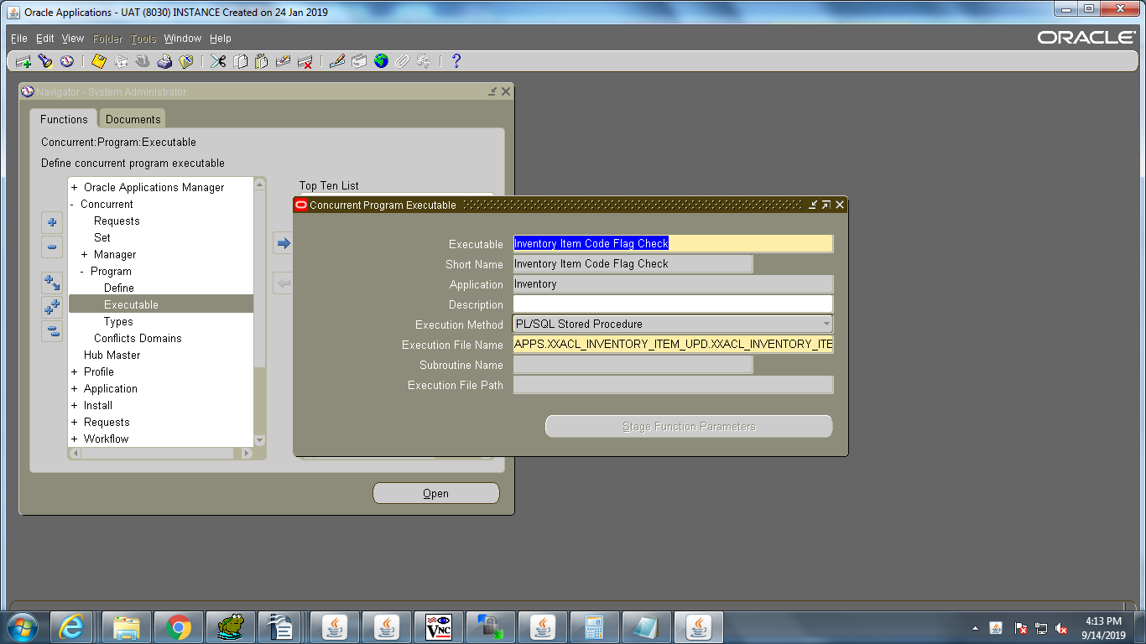
- Create Value sets for both parameter
For Organization_id :Operating_units
Create View for retrieve sorted Organization Unit details
XXACL_INV_ATTR_ORG_V
Scripts : CREATE OR REPLACE FORCE VIEW apps.xxacl_inv_attr_org_v (comp_id,
comp_name,
location_id
)
AS
SELECT DISTINCT (comp_id), comp_name, location_id
FROM ppl_project_list_v
ORDER BY comp_id;

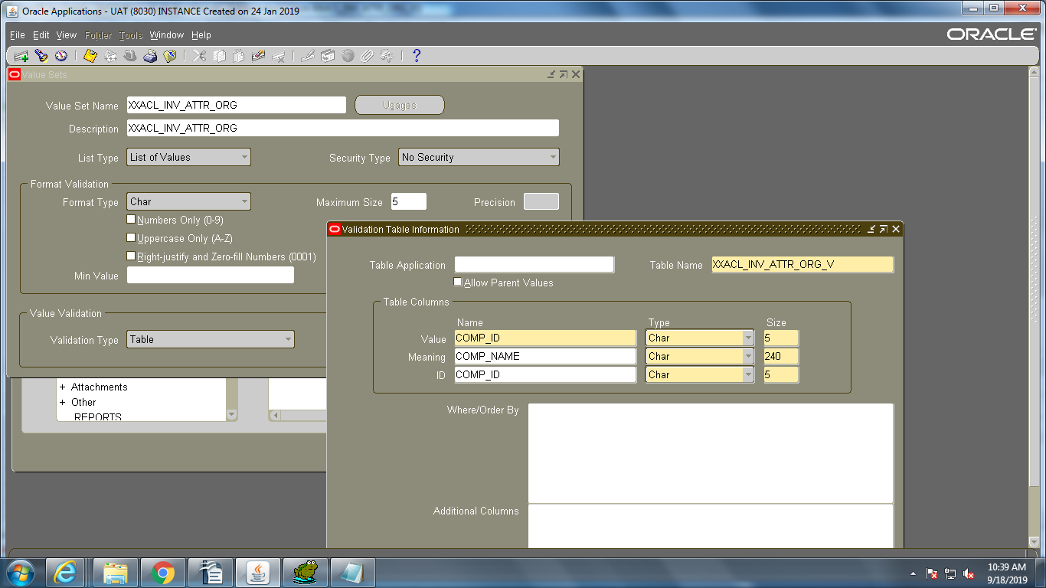

For Project_id :Projects_unit

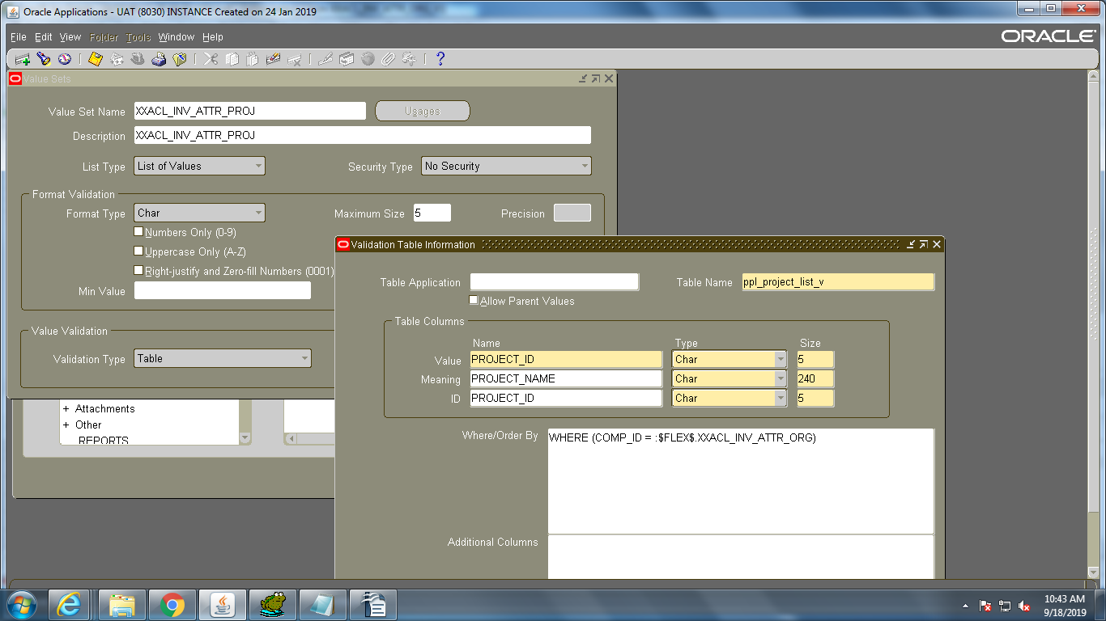

- Create Concurrent program
Program : Inventory_Item_Code_Check
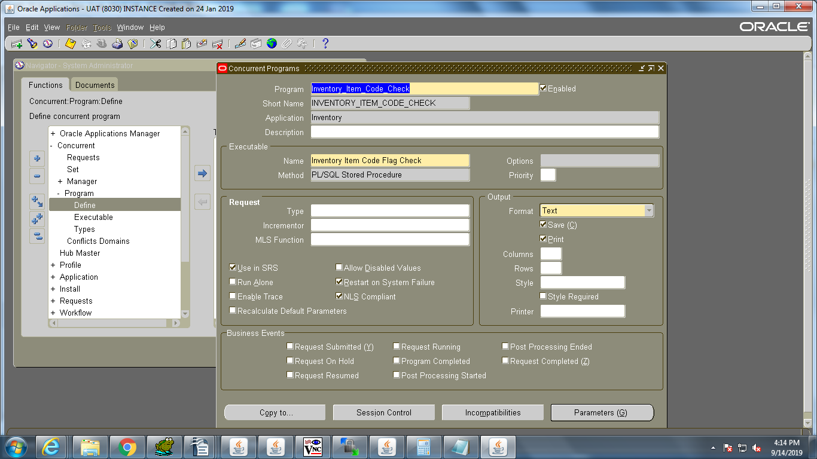
- Create two parameter one for organization_id and another for project_id
- For Organization_id : Attache value set Operating_Units
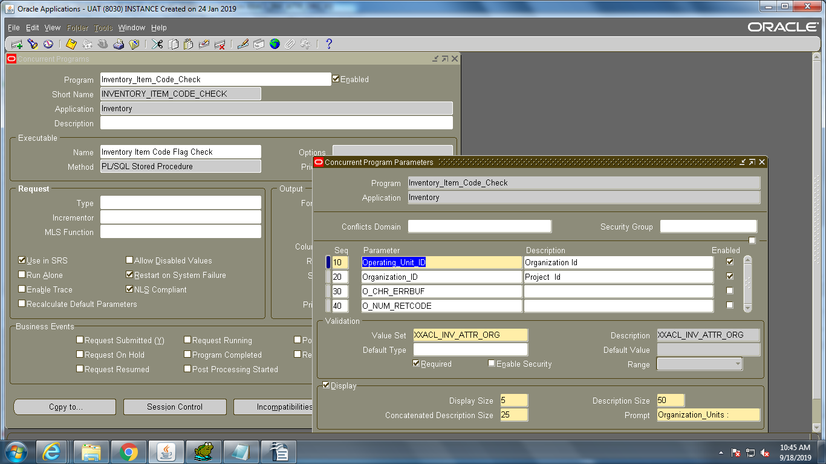

- Project_id: Attache value set Project_Units
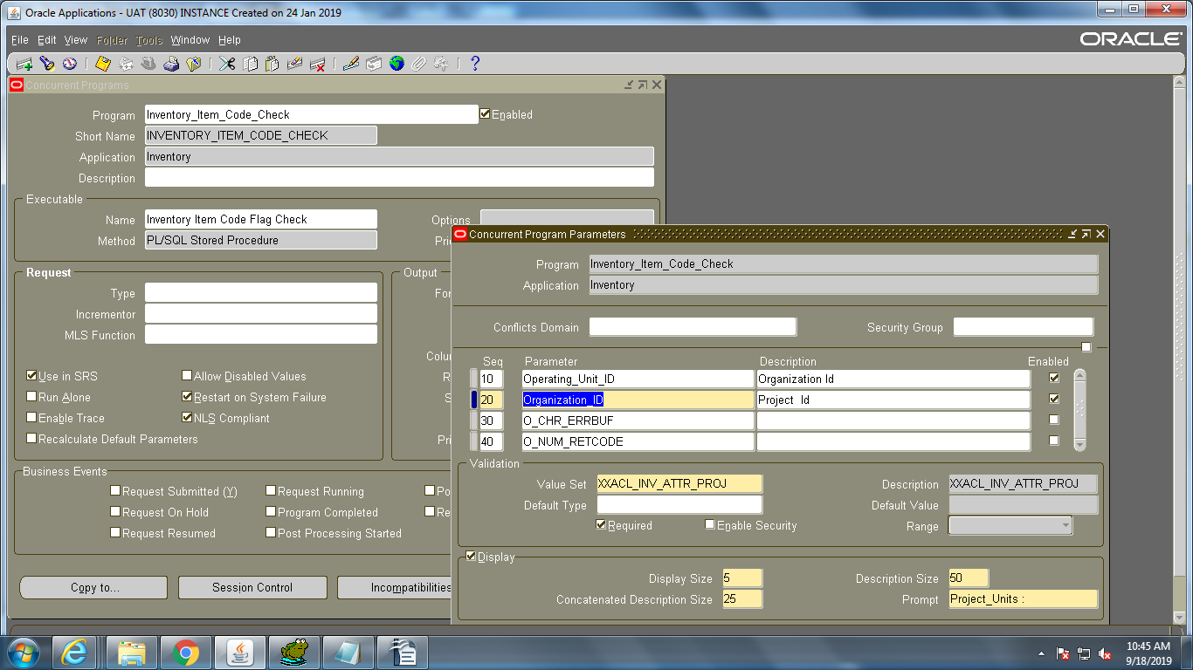

- Add concurrent program in request group:
Request Group : Inventory_Item_Code
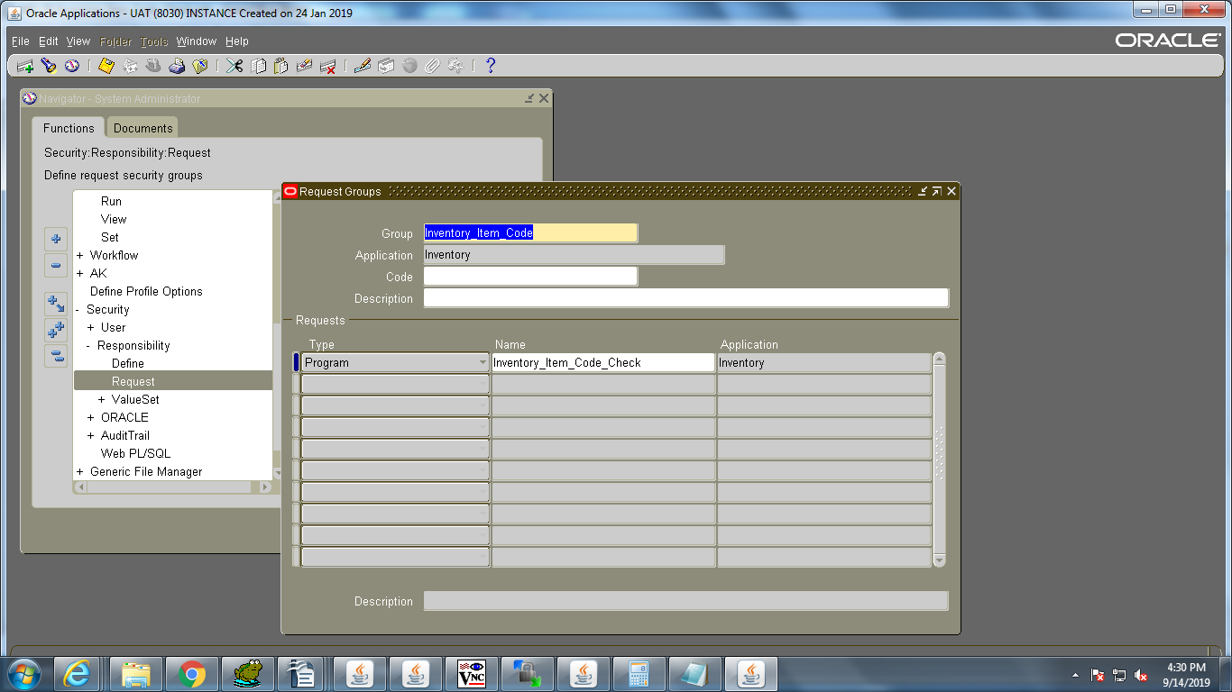
- And assign the request group to Responsibility.
Responsibility : HUBTOWN Inventory Super User

Step-5:- Created item header data should be found in table
select * from JAI_ITEM_TEMPL_HDR
Step-6:- Created item details data should be found in table
select * from JAI_ITEM_TEMPL_DTLS

Request Navigation

Navigation
->Go to Responsibility HUBTOWN Inventory Super User
->Click on View
->Click on Requests
-> Submit a new request

Request Name : Inventory_Item_Code_Check

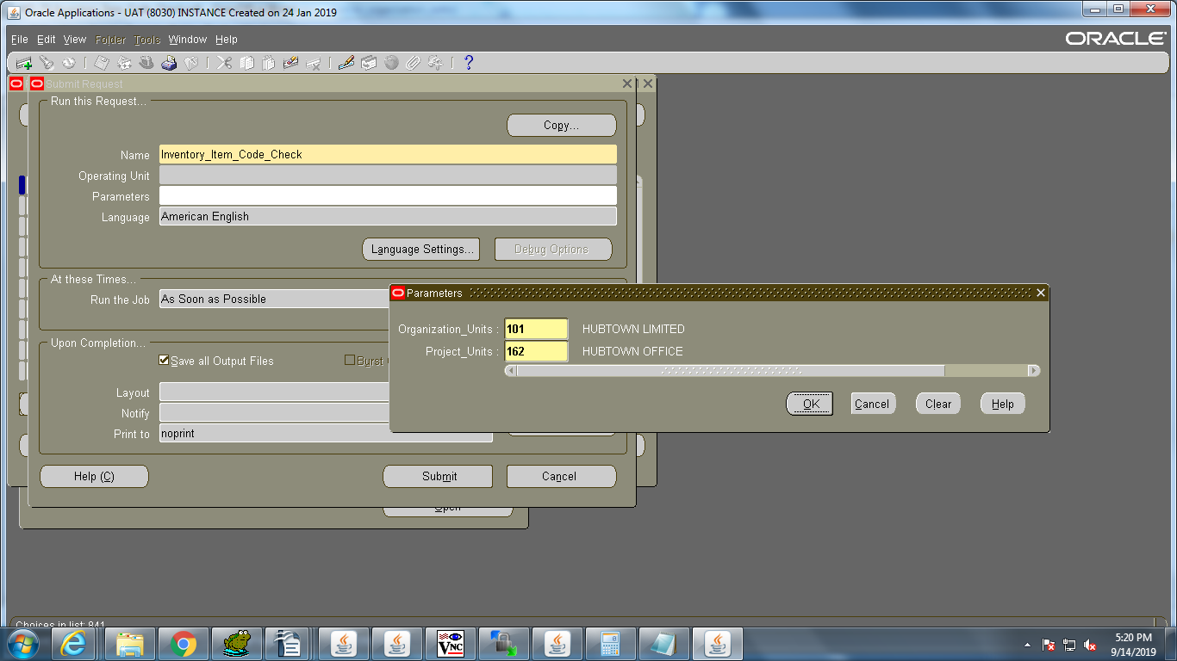

- Fill the parameters
Operating Unit : Select respective organization from LOV
Project Id : Select respective project from LOV
- submit the Request.

Open and Closed Issues for this Deliverable
Add open issues that you identify while writing or reviewing this document to the open issues section. As you resolve issues, move them to the closed issues section and keep the issue ID the same. Include an explanation of the resolution.
When this deliverable is complete, any open issues should be transferred to the project- or process-level Risk and Issue Log (PJM.CR.040) and managed using a project level Risk and Issue Form (PJM.CR.040). In addition, the open items should remain in the open issues section of this deliverable, but flagged in the resolution column as being transferred.

Open Issues

ID | Issue | Resolution | Responsibility | Target Date | Impact Date

Closed Issues

ID | Issue | Resolution | Responsibility | Target Date | Impact Date

