**Software Testing and Quality Assurance_102**

**Instructor:** Maen Mohammad

**By**: Mujahid Alzahrani 202100239

**Homework 1**

**Life cycle of a Bug:**

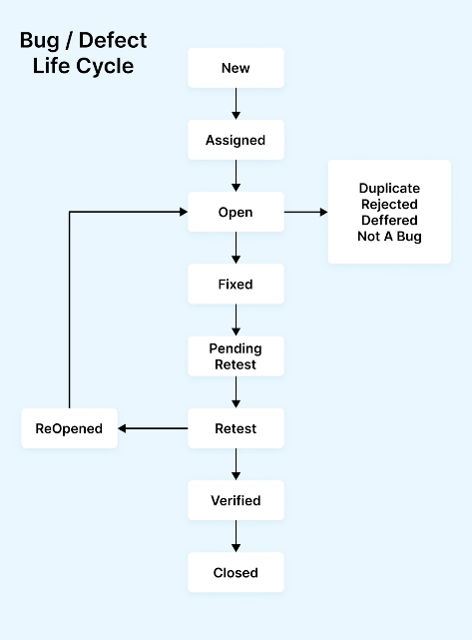

*Picture taken from LambdaTest’s website*

The **bug life cycle** is the journey that a bug in a software goes through, starting from when it is found until it is solved. LambdaTest explains that this cycle helps teams follow each bug step by step.

Here are the main stages:

* **New** – The tester finds a bug and reports it in the tracking system.
* **Assigned** – The bug is given to a developer to look into.
* **Open** – The developer starts working on the bug.

1. **Duplicate** – The same bug was already reported before.
2. **Rejected** – It is not actually a bug.
3. **Deferred** – The bug will be fixed later.
4. **Not a Bug** – The behavior is expected, not an error.

* **Fixed** – The developer fixes the bug and updates the status.
* **Pending Retest** – The fix is ready, waiting for the tester to check it.
* **Retest** – The tester checks if the bug is really fixed.
* **Verified** – If the bug is gone, the tester confirms the fix.
* **Closed** – The bug is completely solved and closed.
* **Reopened** – If the bug is still there, it is sent back to the developer and **“Open”** stage gets repeated.

This cycle keeps bugs organized, helps teams know who is working on them, and makes sure problems are not left behind.

Reference:

LambdaTest. *Bug Life Cycle in Software Testing*. [https://www.lambdatest.com/learning-hub/bug-life-cycle](https://www.lambdatest.com/learning-hub/bug-life-cycle?utm_source=chatgpt.com)