JIRA IMPLEMENTATION – SMARTBITE PROJECT

Objective
Jira was used to manage and track user stories in an Agile environment. The objective was to organize requirements, plan sprint execution, and monitor task progress effectively.

Project Overview
SmartBite is an online food ordering system that allows users to browse food items, place orders, apply discounts, make payments, and manage cancellations and refunds.

Steps Performed
- Created user stories based on functional requirements
- Added user stories to the backlog
- Created Sprint 1 for planned execution
- Moved user stories from backlog to Sprint 1
- Started the sprint
- Tracked progress using the board (To Do, In Progress, Done)

User Stories Created
Story ID | User Story | Priority | Story Points
SB-2 | As a user, I want to log in so that I can access my account | High | 3
SB-3 | As a user, I want to place an order | High | 5
SB-4 | As a user, I want to apply discount | Medium | 3
SB-5 | As a user, I want to make payment | High | 5
SB-6 | As a user, I want to cancel order | Medium | 2
SB-7 | As a user, I want refund processing | Medium | 3

Epic Mapping
User stories were grouped under the following Epics:
- User Login → User Management
- Place Order → Order Management
- Apply Discount, Make Payment → Payment & Billing
- Cancel Order, Refund Processing → Order Cancellation

Sprint Details
- Sprint Name: SB Sprint 1
- Duration: 1 May – 15 May
- Total Stories: 6
- Total Story Points: 21

Workflow Status
- To Do → Task not started
- In Progress → Task is being worked on
- Done → Task completed

Screenshots
Figure 1: Backlog View
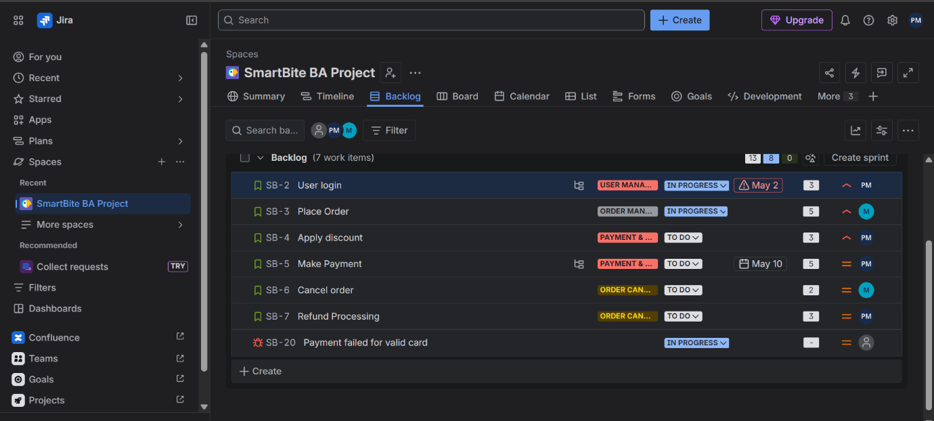

Figure 2: Sprint View
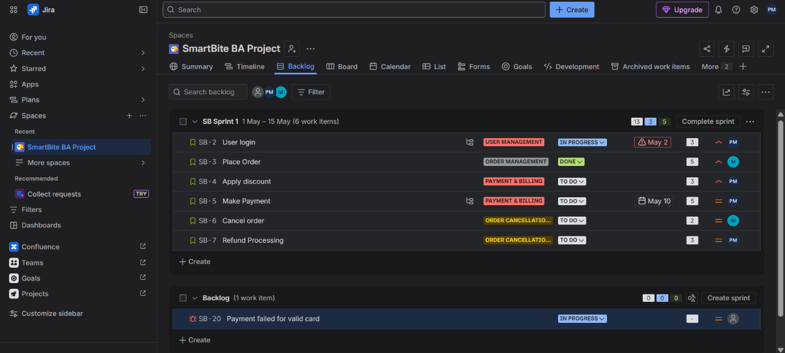

Figure 3: Board View
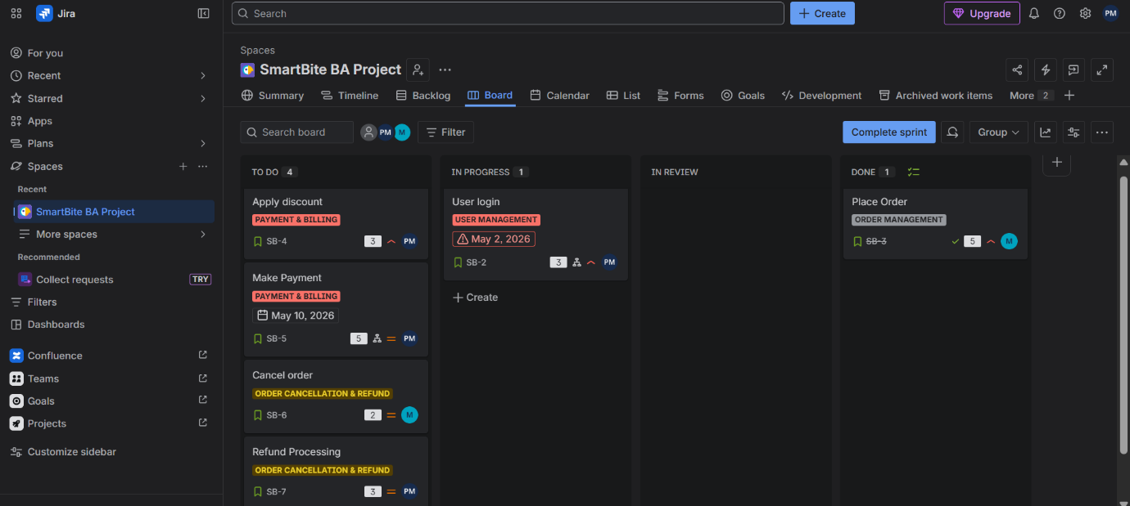

Tools Used
- Jira (Agile Project Management)
- Microsoft Excel (User Story Preparation)
- Microsoft Word (Documentation)

Conclusion
Jira was effectively used to manage requirements, plan sprint activities, and track task progress. It provided clear visibility into workflow status and improved coordination among stakeholders.

Learning Outcome
- Gained hands-on experience in Agile methodology
- Learned backlog management and sprint planning
- Understood story point estimation
- Practiced real-time Jira workflow usage

