SMARTBITE – WIREFRAME DOCUMENTATION

1. INTRODUCTION
The SmartBite Wireframe Documentation provides a visual representation of the SmartBite food ordering application screens.
Wireframes are low-fidelity UI designs used to:
- Understand screen layout
- Visualize user interaction
- Define navigation flow
- Assist developers before implementation
This documentation helps stakeholders, developers, testers, and designers understand the overall structure of the SmartBite application.

2. OBJECTIVE
The objective of this document is to:
- Design the user interface structure
- Improve communication between stakeholders and developers
- Define user navigation flow
- Support application development and testing

3. TOOLS USED
Tool | Purpose
Figma | Creating Wireframes
Draw.io | Process Flow Design
MS Word | Documentation
PNG Export | Sharing Screens

4. WIREFRAME FILES CREATED
Wireframe ID | File Name
WF_01 | WF_01_Login_Screen
WF_02 | WF_02_Signup_Screen
WF_03 | WF_03_Home_Page
WF_04 | WF_04_Food_Menu_Screen
WF_05 | WF_05_Checkout_Screen
WF_06 | WF_06_Payment_Screen
WF_07 | WF_07_Order_Confirmation

5. WIREFRAME DESIGN STANDARDS
UI Element | Usage
Rectangle | Input fields and cards
Rounded Rectangle | Buttons
Text Tool | Labels and headings
Icons | Navigation and actions
Frame | Mobile screen structure

WF_01 – LOGIN SCREEN

Purpose
Allows users to securely log into the SmartBite application.

Features Included
- Application title
- Email input field
- Password input field
- Login button
- Forgot Password option
- Sign Up option

User Flow
- User enters email
- User enters password
- User clicks Login
- System validates credentials
- User redirected to Home Page

Shapes Used
Shape | Purpose
Rectangle | Input fields
Rounded Rectangle | Login button
Text | Labels and headings

Attached Files
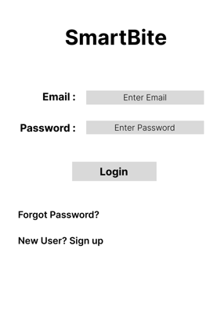

WF_02 – SIGNUP SCREEN

Purpose
Allows new users to create an account in SmartBite.

Features Included
- Full Name field
- Email field
- Mobile Number field
- Password field
- Confirm Password field
- Sign Up button

User Flow
- User enters registration details
- User clicks Sign Up
- System validates information
- Account gets created successfully

Shapes Used
Shape | Purpose
Rectangle | Input fields
Rounded Rectangle | Signup button
Text | Labels

Attached Files
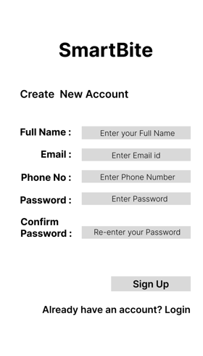

WF_03 – HOME PAGE

Purpose
Displays food categories, restaurant recommendations, and navigation options.

Features Included
- Search bar
- Restaurant cards
- Food categories
- Offers banner
- Navigation menu

User Flow
- User opens application
- User browses food categories
- User selects restaurant

Shapes Used
Shape | Purpose
Rectangle | Restaurant cards
Text | Category labels
Icons | Navigation

Attached Files
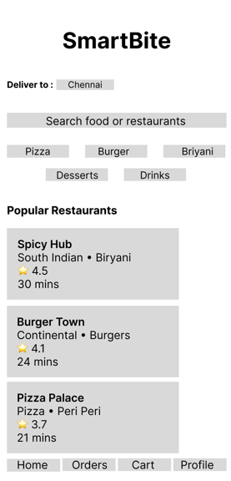

WF_04 – FOOD MENU SCREEN

Purpose
Displays food items available in a selected restaurant.

Features Included
- Restaurant name
- Food item list
- Price details
- Add to Cart button
- Food descriptions

User Flow
- User selects restaurant
- User views menu items
- User adds items to cart

Shapes Used
Shape | Purpose
Rectangle | Food cards
Rounded Rectangle | Add to Cart button
Text | Item names and prices

Attached Files
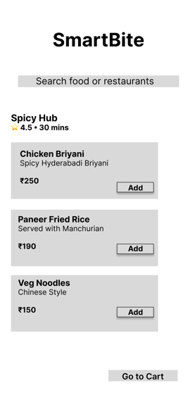

WF_05 – CHECKOUT SCREEN

Purpose
Allows users to review cart items and place order.

Features Included
- Cart items
- Quantity controls
- Coupon section
- Price summary
- Delivery address
- Place Order button

User Flow
- User reviews cart items
- User applies coupon
- User verifies total amount
- User clicks Place Order

Shapes Used
Shape | Purpose
Rectangle | Cart item cards
Rounded Rectangle | Place Order button
Text | Price and address details

Attached Files
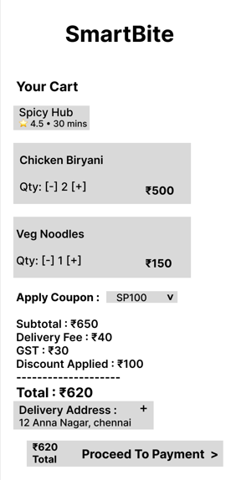

WF_06 – PAYMENT SCREEN

Purpose
Allows users to complete payment using different payment methods.

Features Included
- UPI payment option
- Debit/Credit Card option
- Cash on Delivery option
- Pay Now button

User Flow
- User selects payment method
- User enters payment details
- User clicks Pay Now
- Payment processed successfully

Shapes Used
Shape | Purpose
Rectangle | Input fields
Radio Button | Payment selection
Rounded Rectangle | Pay Now button

Attached Files
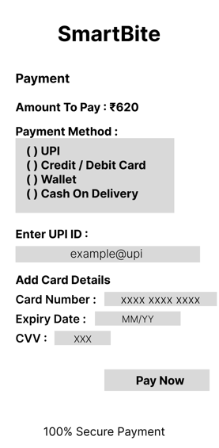

WF_07 – ORDER CONFIRMATION SCREEN

Purpose
Displays successful order confirmation after payment completion.

Features Included
- Success message
- Order ID
- Estimated delivery time
- Back to Home button

User Flow
- Payment completed
- Order ID generated
- Confirmation displayed to user

Shapes Used
Shape | Purpose
Icon | Success indication
Text | Order details
Rounded Rectangle | Navigation button

Attached Files
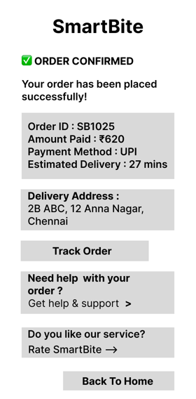

6. BENEFITS OF WIREFRAMING
- Improves requirement understanding
- Helps visualize application flow
- Reduces development confusion
- Enhances UI planning
- Supports stakeholder communication

7. CONCLUSION
The SmartBite Wireframes provide a structured visual design of the application screens and user interactions.
These wireframes help:
- Understand application navigation
- Improve UI planning
- Support development activities
- Assist testing and validation
- Create a professional Business Analyst portfolio project
The wireframes act as the foundation for future UI design and application implementation.

