**Pablo  
Mansilla  
Ojeda**

Software Engineer, Universidad Austral de Chile

Master in Technological Innovation and Entrepreneurship (c),   
Universidad Federico Santa María

Santiago Centro, Santiago, Chile

+569-82150949

pablo@ppamo.cl

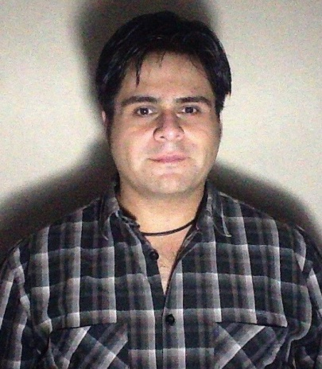

**Objectives**

I enjoy the design and implementation of technological projects, especially over the Internet, always generating products and services user friendly and useful.

**Education**

**2013:** Silicon Valley Immersion, at Universidad de San Francisco.  
**Main Fields*:*** *Innovation and Entrepreneurship in Silicon Valley, Foreign Entrepreneurship in San Francisco, Open Innovation.*

**2013:** Master in Technological Innovation and Entrepreneurship at Universidad Técnica Federico Santa María.  
**Main Fields*:*** *Innovation Management, Entrepreneurship, Intrapreneurship, Design of products and services, Knowledge Management.*

**2010:** Workshop on Management of Information Technology Projects at Universidad Técnica Federico Santa María. **Main Fields*:*** *Requirements Management, scope and change control, PMBOK Model.*

**2009:** Postgrade Diploma at Universidad de Chile, Experimental Photographical Creation. **Main Fields*:*** *Photography, Art Theory, Experimental Creation.*

**2007:** Bachelor's degree in Computer Science, at Universidad Austral de Chile, Campus Puerto Montt*.***Main Fields*:*** *Software Design and Implementation, Projects Management, Research and Development.*

**Experience**

**June 2011 / October 2011:**  Technical Leader at Idontek Ltda. I co-found this failed Startup, where I design and setup an e-platform for the management and generation of software projects, using Open Source tools like SugarCRM, SVN, Redmine, etc. The startup was part of the Microsoft's BizSpark program.

**May 2010 / May 2012:** Work at Mercatus Chile S.A. as External Software Engineer, designing and developing new components to old systems, most of the work was done on .Net, SQL Server 2005 & 2008 and Reporting Services.

**April 2010 / Present:** Work at Belltech S.A. as Functional Analyst and Software Engineer, designing and developing software projects for their clients and improvements in the process inside the organization. Most of the external development was realized using Microsoft Framework .Net, mostly connecting the client’s data sources with the ATM machines from Belltech. Also I worked at the Telephony Department designing and developing integration tools over Linux, using BASH and MYSQL. I design and implement the Continuous Integration platform using TFS, Teamcity, Redmine, Moodle.

**August 2007 / January 2008:** Teacher for ‘Seminario de Investigación Tecnológica’ (Technological Research Seminar) in the Computer Engineering career at Universidad Austral de Chile, where we research on robotic developments, creating new versions of our initial project, also design a framework for hardware integration using Mono, called MonoBOTICS.

**August 2006 / April 2007:** Work in my Seminar for the Degree in Computer Engineering. The project consisted of the generation of a Platform for Automated Network Management, Oriented to Small and Medium Enterprises, which was designed and implemented on Linux, using Fedora, Mono on Apache and Firebird for data persistence.

**April 2006 / April 2010:** Continue with the same roles than ARMPRO in Mercatus Chile S.A. as Software Engineer and Systems Administrator. As developer I worked on several Web projects over Microsoft Framework .Net, version 3.5, 4.0 and SQL Server 2005, SQL Server 2008, Reporting Services and DotNetNuke framework. On the System Administration I design and implement the migration of our servers from Linux to Microsoft. I also worked on the migration of our virtualization servers, from VMWare Server to ESXi. I participate also in the design and implementation of our Continuous Integration Services using Vault Source Control, Fogbugz, CrouseControl, FxCop, TypeMock, Watin, Nant, MBUnit, TestDriven .Net among other tools.

**August 2004 / January 2005:** Teacher for ‘Seminario de Investigación Tecnológica’ (Technological Research Seminar) in the Computer Engineering career at Universidad Austral de Chile, where we research on robotic developments, creating our own robot using PC parts (PCbot) working in a Linux environment. My focus was the design and implementation of the software architecture, generating tools and drivers to handle the pieces of hardware that we created.

**April 2004 / March 2006:** I Worked in ARMPRO (Aquaculture Resource Management Ltda) as Software Developer working mostly on Microsoft based Web projects, I also worked as System Administrator in a Linux based environment, using VMWare Server as virtualization platform. This company was acquired by Mercatus Chile in March 2006.