**Host a Website on Amazon S3**



**Prerana**

**P**

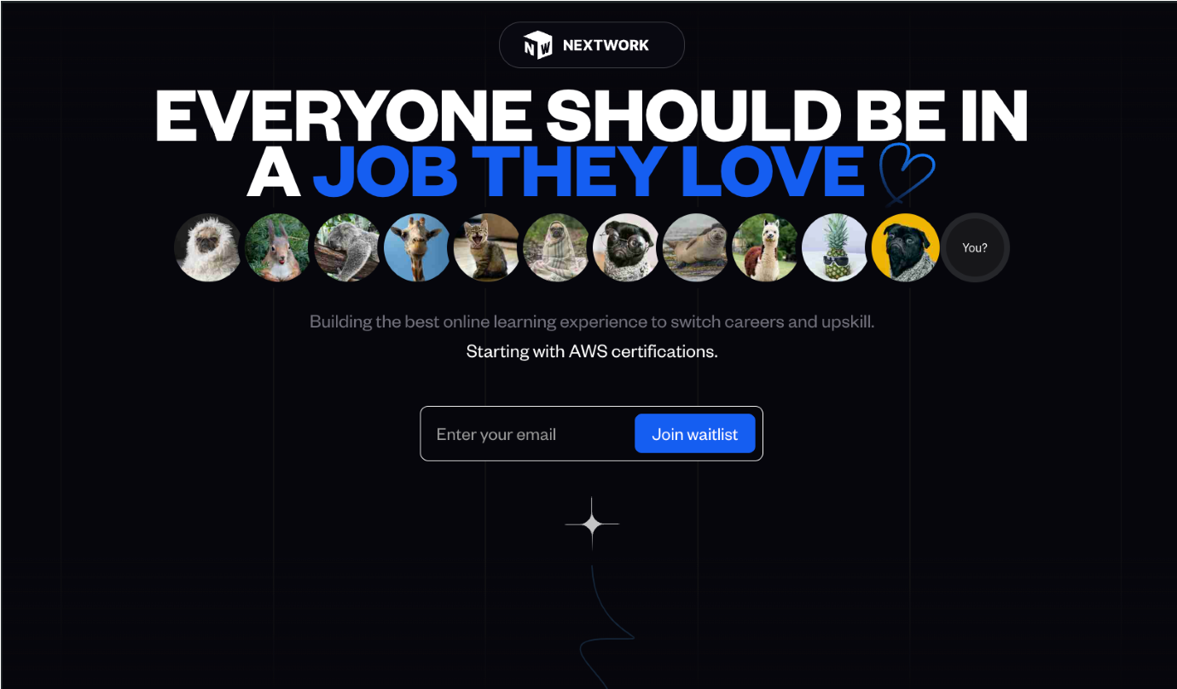

**Introducing Today's Project!**

# What is Amazon S3

# Amazon S3 (Simple Storage Service) is a cloud storage service offered by AWS (Amazon Web Services). It allows users to store and retrieve large amounts of data, such as files, documents, images, and videos, in the cloud. S3 is scalable, meaning it can handle any amount of data, and it is designed for durability, with data replicated across multiple locations to ensure it is not lost.

# S3 stores data in buckets, which act like folders. Each bucket can hold an unlimited number of objects (files). S3 supports different storage classes, allowing users to choose the most cost-effective option depending on how frequently the data is accessed. For example, frequently accessed data can be stored in the Standard storage class, while infrequently accessed data can be stored in the more affordable S3 Glacier class.

# S3 is widely used because of its versatility and integration with other AWS services. It is commonly used for backup, disaster recovery, content distribution, and hosting static websites. It offers high availability, security (with access control, encryption, and monitoring), and seamless integration with services like AWS Lambda and Amazon CloudFront.

# Its cost-effectiveness and ease of scaling make S3 useful for companies of all sizes, from startups to large enterprises, for storing and managing data efficiently without having to invest in physical storage infrastructure.

# How I used Amazon S3 in this project

I used Amazon S3 to host a website by uploading my site's files (HTML, CSS, JavaScript) to an S3 bucket. S3 allows for static website hosting, so I enabled that feature, set the correct permissions to make the content publicly accessible, and configured the bucket to serve the website. This way, users could access the site through the S3 URL. S3’s scalability and low cost made it an ideal choice, allowing me to manage and distribute content without the need for additional infrastructure.

**One thing I didn't expect in this project was...**

Despite following the instructions for hosting a website on Amazon S3, I encountered a 403 (Forbidden) status code. It was a valuable learning experience, highlighting the importance of correctly configuring permissions and bucket policies to ensure proper access to the site’s content.

**This project took me...**

# This project took me around 30-35 minutes to complete, even without extensive knowledge of Amazon S3. Despite the learning curve, I managed to set up and host the website effectively, demonstrating that S3 can be used efficiently with a basic understanding of its features and configurations.

# How I Set Up an S3 Bucket

Creating the S3 bucket took me around 2 minutes. The process was straightforward, involving basic steps like naming the bucket and configuring initial settings. This quick setup highlighted how efficiently S3 can be used for storage and hosting, even for users with minimal experience.

I chose the Asia (Mumbai) region for my S3 bucket because it is geographically closer to me. Selecting a nearby region helps reduce latency and improves the performance of accessing and managing data, ensuring a faster and more efficient experience for both me and my users.

S3 bucket names are globally unique! This means each bucket name must be unique across all AWS accounts worldwide. No two buckets can have the same name, ensuring a distinct namespace for each bucket and avoiding conflicts or overlaps in storage locations.

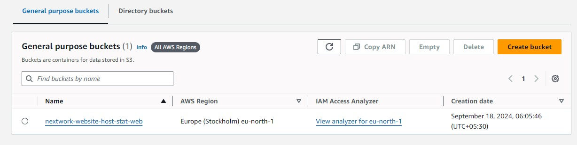

# Upload Website Files to S3

## index.html and image assets

I uploaded two files to my S3 bucket – they were index.html and a folder containing JavaScript and CSS files. This setup allowed me to host the complete static website with all necessary components for proper functionality and styling.

Both files are necessary for this project as index.html serves as the main webpage, while the folder contains images, JavaScript, and CSS files needed for styling and interactivity. Together, they create a complete static website experience.

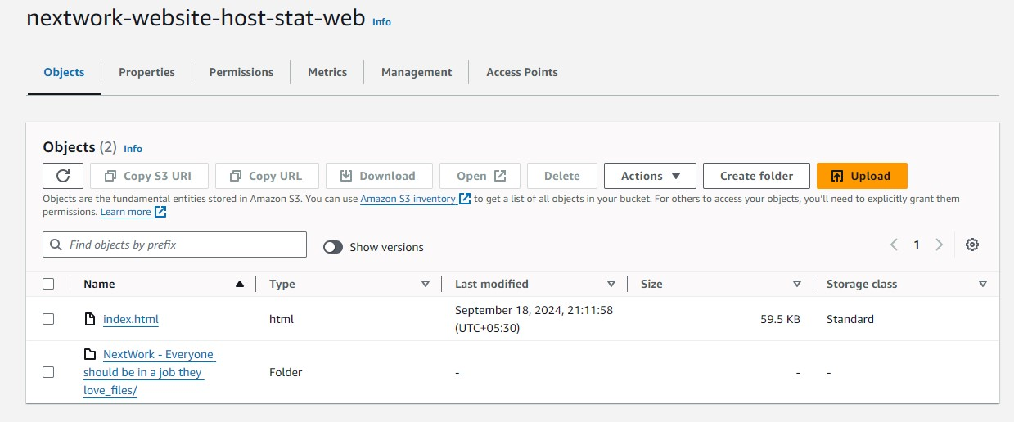

# Static Website Hosting on S3

Website hosting means storing and serving website files, such as HTML, CSS, and JavaScript, on a server. It makes your site accessible on the internet, allowing users to view and interact with it through their web browsers.

To enable website hosting with my S3 bucket, I accessed the bucket settings, selected the "Static website hosting" option, and specified the index document (e.g., index.html). I also configured permissions to make the content publicly accessible.

## Access Control Lists ACL

An Access Control List (ACL) in Amazon S3 is used to specify permissions for buckets and objects. Enabling ACL allows you to control who can read, write, or manage your data by defining access levels for specific users or groups.

# Bucket Endpoints

Once static website hosting is enabled, S3 produces a bucket website endpoint URL, which is a unique web address that allows users to access your hosted website directly. This URL points to the root of your static site files

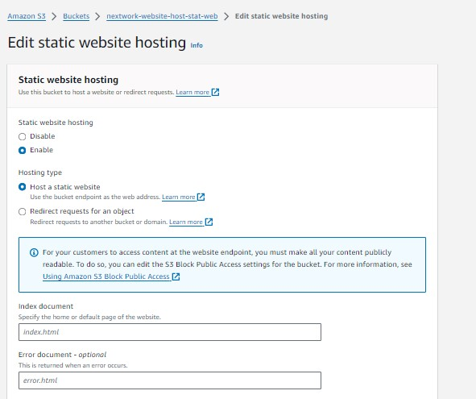

**An error!**

When I first visited the bucket endpoint URL, I saw a 403 error. This meant access was forbidden, likely due to incorrect permissions or bucket policy settings preventing the content from being displayed properly.

The reason for this error was that the Access Control List (ACL) settings did not have the "Make public" option selected. This prevented the content from being accessible publicly, resulting in the 403 error.

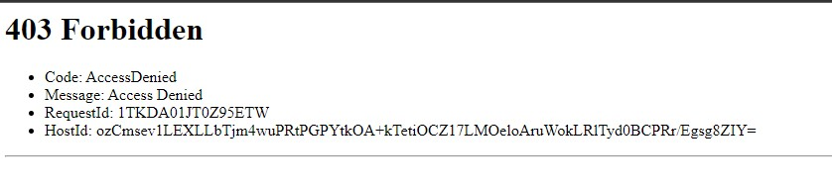

**Success!**

To Resolve the issue i went to objects and selected the index.html and folder and choose the action as Make public using ACL.