|  |  |
| --- | --- |
| **Prema G**  **Data Analyst** | |
| Address:  **Block-20,**  **Hari ohm Mahalakshmi Nagar,**  **Arcot, Ranipet - 632503.**  Email:[**premarprpprema@gmail.com**](mailto:premarprpprema@gmail.com)  Ph. No: **8778760947** |

**OBJECTIVE__________________________**

Seeking a challenging and learning position to extract meaning from and interpret various types of data utilizing the up-to-date technologies and resources.

**EXPERIENCE_________________________**

**Fresher** – Eager to apply my data analysis skills in a dynamic environment.

**EDUCATION__________________________**

|  |
| --- |
| **Master of Science in Computer Science**  Thiruvalluvar University.  July 2022 – May 2024 |
| **Bachelor of Science in Computer Science**  Thiruvalluvar University.  Oct 2019 – May 2022 |

**STRENGTH___________________________**

**Analytical Thinking**

**icons8-communication-48.png Effective Communication**

**icons8-team-collaboration-48.png Team Collaboration**

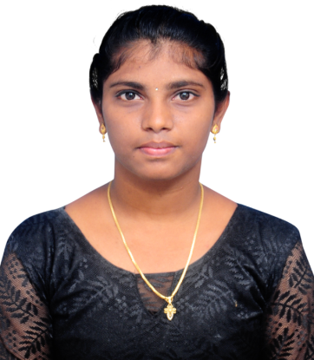

**SKILLS________________________________**

|  |
| --- |
| * **Data Cleaning** |
| * **Data Analysis** |
| * **Data Visualization** |
| * **SQL** |
| * **Tableau** |
| * **Python** |
| * **Statistics** |

**CERTIFICATION_______________________**

**Python Programming**

**Cloud Computing**

**PASSIONS______________________________**

**Data - Driven Storytelling**

**Continuous Learning**

**LANGUAGES___________________________**

**Tamil** – **Native**

**English** – **Upper Intermediate**

**WEBSITE______________________________**

icons8-link-48.png <https://prema-website.vercel.app>