CVA6 flat synthesis on nangate45: stock vs parallel abc_new
Work log for running CVA6 flat on the nangate45 platform and comparing stock Yosys abc_new with the parallel abc_new patch, 6 Nov 2026.

Summary
CVA6 runs flat on nangate45 with no changes to the RTL or the ORFS scripts. Two new config files are enough. Across four clean runs (stock, parallel, parallel, stock), the parallel abc_new produced a byte-identical netlist and cut synthesis time by about 10 %. The whole-synthesis wall time fell from 3154 s to 2835 s on average, and abc_new itself from 1914 s to 1631 s (15 %, 1.17×). Peak memory stayed at 1.35–1.38 GB.
No run in this set was disturbed: the guest kernel logged no VM pause or stall in any of the four. That makes this the cleanest A/B so far. On asap7 flat, two of six runs were spoiled by a laptop sleep and a host stall.

Design and platform
Item | Value
Design | CVA6, cv32a65x configuration (32-bit, no FPU, no MMU, 2 KiB I-cache, hpdcache D-cache), top cva6, clock clk_i
RTL | OpenROAD-flow-scripts/flow/designs/src/cva6 (same sources as the asap7 runs)
Platform | nangate45 (NangateOpenCellLibrary_typical.lib, NAND2_X1 = 0.798 µm²)
SRAMs | 8 macros: 2 each of fakeram45_64x256 (33,990 µm²), _128x64 (5,480 µm²), _64x28 (1,241 µm²), _64x25 (1,241 µm²)
Base config | designs/nangate45/cva6/config.mk as shipped with ORFS
Constraints | designs/nangate45/cva6/constraint.sdc: 1.0 ns clock on clk_i, input delay 0.46 ns, output delay 0.11 ns, max fanout 10
Frontend | slang (SYNTH_HDL_FRONTEND = slang), canonicalize script removes rvfi_probes_o
Synthesis | flat (SYNTH_HIERARCHICAL = 0), SWAP_ARITH_OPERATORS = 1 (so ORFS maps with abc_new)
ABC setup | driver BUF_X1, load 3.898 fF, dont-use TAPCELL_X1 FILLCELL_X1 AOI211_X1 OAI211_X1
The CVA6 RTL instantiates the asap7 macro names (fakeram7_*) directly. The nangate45 design supplies designs/nangate45/cva6/macros.v, which defines each fakeram7_* module as a wrapper around the matching fakeram45_* macro, with the write mask tied high.

Tools
Side | Yosys | Path
Stock | 0.69+274 (git 7513f8df8) | /usr/local/bin/yosys
Parallel | 0.69+280 (git 7b7e811cb, branch abc-new-parallel-split) | yosys/build/yosys
OpenROAD 26Q4-271-g0907a8656e. The parallel build is the stock base plus six commits: a shared ABC exit status check in abc9_exe, abc9_exe -prepare / -collect modes, parallel mapping of independent modules, stable box ids between prepare and collect, removal of leftover $input_port cells, and largest-module-first scheduling. Its job count (-j) defaults to the number of cores (8).
Machine: VirtualBox VM, 8 vCPUs, 10.5 GB RAM, Ubuntu 24.04, kernel 7.0.0-42, on a laptop.

Setup steps
- Checked what ORFS already had. designs/nangate45/cva6/config.mk exists in the full ORFS clone and defaults to flat synthesis (SYNTH_HIERARCHICAL is unset; ORFS default 0). The repo’s vendored orfs/flow slice ships only platforms/asap7, so run_cva6_asap7.sh can’t target nangate45; the GUI and ab_bench use the full clone at OpenROAD-flow-scripts/flow, which has platforms/nangate45.
- Added two configs in designs/nangate45/cva6/: config_flat_stock.mk and config_flat_parallel.mk. Each includes the stock config.mk and sets FLOW_VARIANT (flat_stock / flat_parallel) and SYNTH_HIERARCHICAL = 0 explicitly. Nothing else changes, so the two sides differ only in which Yosys binary runs.
- Checked the configs resolve. make print-… for both: PLATFORM nangate45, SYNTH_HIERARCHICAL 0, SWAP_ARITH_OPERATORS 1, results in results/nangate45/cva6/flat_{stock,parallel}, the four fakeram45 libraries in ADDITIONAL_LIBS.
- Checked the GUI lists them. The Flow Runner’s design scan (discover() in orfs_app.py) reports nangate45 as available with cva6 configs config.mk, config_flat_parallel.mk, config_flat_stock.mk.
- Smoke test. Ran only the canonicalize step (make … do-yosys-canonicalize) with stock Yosys: exit 0 in 90 s, peak 281 MB. All 8 macros resolved to fakeram45 cells. One RTL warning (asynchronous load value missing for variable csr_throttle_q, hwpf_stride.sv:158), which the asap7 runs also show.
- Made the A/B bench platform-aware. ab_bench/bench.sh gained PLATFORM (default asap7): it now uses designs/$PLATFORM, platforms/$PLATFORM and {results,logs,reports,objects}/$PLATFORM/cva6, passes DRV_PLATFORM to the GUI driver, and writes to ab_bench/bench_flat_nangate45/.
- Started the bench at 09:47 on 6 Nov: PLATFORM=nangate45 ./bench.sh flat.

How each run is done
bench.sh runs stock, parallel, parallel, stock (A/B/B/A), so slow drift in machine speed hits both sides equally. Before each run it deletes that side’s results, logs, reports and objects, reads all design, platform and script files plus both Yosys binaries once to warm the file cache, syncs, and waits 30 s.
Each run goes through the ORFS Flow Runner GUI, driven by ab_bench/drive_ab.py. It selects platform, design, config, 8 cores, “Continue” and “synth”; sets Yosys in the Tools dialog; presses Run; samples whole-machine CPU and the run’s memory every 5 s; and saves screenshots of the Tools dialog, the Debug tab, the ready state, the run in progress (every 10 min), the Logs tab, the finished run, the Reports tab and the final Debug tab.
After each run the bench copies the logs, synth_stat.txt and the netlist sha1 (whole file and body without the header line) into ab_bench/bench_flat_nangate45/runN_side/.
ab_bench/compare.py then builds the table and checks the VM’s kernel journal for pauses or stalls during each run (RCU stalls, soft lockups, clocksource watchdog gaps, clock jumps). A run that lost more than 60 s is left out of the timing comparison. This came from the asap7 runs, where a laptop sleep and a host stall each spoiled a run.

Run log
All on 6 Nov 2026. “Stalls” is what the VM’s kernel journal logged during the run.
Run | Side | Started | Finished | Exit | Stalls
1 | stock | 09:48 | 10:41 | 0 | none
2 | parallel | 10:42 | 11:28 | 0 | none
3 | parallel | 11:29 | 12:18 | 0 | none
4 | stock | 12:19 | 13:10 | 0 | none

Results
Run | Wall (s) | Yosys (s) | abc_new (s) | Rest of Yosys (s) | Peak mem (MB)
1, stock | 3211 | 3160 | 1903 | 1257 | 1377
2, parallel | 2769 | 2736 | 1570 | 1166 | 1382
3, parallel | 2901 | 2865 | 1692 | 1173 | 1372
4, stock | 3097 | 3061 | 1925 | 1136 | 1350
Stock mean | 3154 | 3110 | 1914 | 1196 | 1364
Parallel mean | 2835 | 2801 | 1631 | 1170 | 1377
Change (s) | −319 | −309 | −283 | −26 | +13
Change (%) | −10.1 % | −9.9 % | −14.8 % | −2.2 % | +1.0 %
“Wall” is from pressing Run in the GUI to the end of make synth. “Yosys” and abc_new come from the 1_2_yosys.log timing lines. “Rest of Yosys” is Yosys minus abc_new; it runs the same code in both builds, so its ±60 s spread is the machine’s run-to-run noise.
By pair: runs 1 and 2 differ by −443 s (−13.8 %), runs 3 and 4 by −197 s (−6.3 %). Both pairs favour the parallel build, and the spread between them is about the size of the noise in the rest of Yosys.
Quality of results: identical in all four runs.
Metric | All four runs
Netlist (1_2_yosys.v without its header line) | sha1 6754270bcb6f…
Cells | 86,905 (8 of them SRAM macros)
Area (synth_stat.txt) | 238,682.56 µm², of which 83,902.21 µm² SRAM macros and 43,757 µm² sequential (18.3 %)
Logic area without macros | 154,780 µm², about 194 kGE (NAND2_X1 = 0.798 µm²)
Flip-flops | 8,498 (6,635 DFFR_X1, 1,820 DFF_X1, 43 DFFS_X1)
Largest cell type | MUX2_X1, 21,799 cells
Modules mapped by abc_new | 65: cva6 (the whole CPU) and 64 arithmetic operator wrappers
OpenROAD 1_synth | 86,905 instances, 238,683 µm², 0 flow errors

Why the parallel build is faster here
Flat synthesis leaves one large module, cva6, plus 64 small ALU_* operator wrappers. cva6 uses 16 of them (the Han-Carlson adders); the other 48 are alternative adder architectures (Brent-Kung, Sklansky, Kogge-Stone) that ORFS keeps for later swapping. cva6 can’t be mapped until the 16 it uses are done.
The stock abc_new handles one module at a time: prepare it on the main thread, run ABC, wait, read the result back, then move to the next. The parallel build prepares every module whose submodules are done, hands the ABC runs to 8 worker threads, and reads results back in the original module order, so the output doesn’t depend on which ABC finishes first. In the run 2 log, all 64 ALU wrappers are prepared and sent to ABC first; cva6 is prepared and launched as soon as its 16 adders are collected, and the results of the 48 alternatives are collected after it.
So the saving comes from overlapping ABC runs with each other and with main-thread work. The single ABC run on cva6 (the ABC phase spans 1,084 s in run 1 and 1,064 s in run 2, from the 5 s CPU samples) is not split: one module is one ABC process. Yosys doesn’t log per-module times, so the 283 s can’t be split exactly between those overlaps.

Comparison with asap7 flat
 | nangate45 flat | asap7 flat (4–5 Nov)
Constraint | 1.0 ns (ORFS default) | 5.0 ns (relaxed constraint_hier.sdc)
Cells | 86,905 | 100,089
Logic size | about 194 kGE | about 140–210 kGE
Stock wall (s) | 3211, 3097 | 2936, 3770 (2 of 3 runs usable)
Parallel wall (s) | 2769, 2901 | 2789, 3078 (2 of 3 runs usable)
Runs spoiled by VM stalls | 0 of 4 | 2 of 6
abc_new gain | −15 % (mean of 2 vs 2) | −7 % (cleanest pair)
Netlists identical stock vs parallel | yes | yes
The asap7 number rests on fewer clean runs and a noisier machine, so the two percentages shouldn’t be read as a difference between the platforms.

Screenshots
Taken by the bench from the Flow Runner window during runs 1 (stock) and 2 (parallel). Every screenshot of all four runs is in ab_bench/bench_flat_nangate45/.
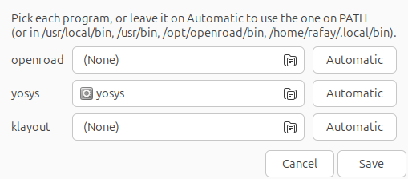
Figure 1. Tools dialog with stock Yosys selected
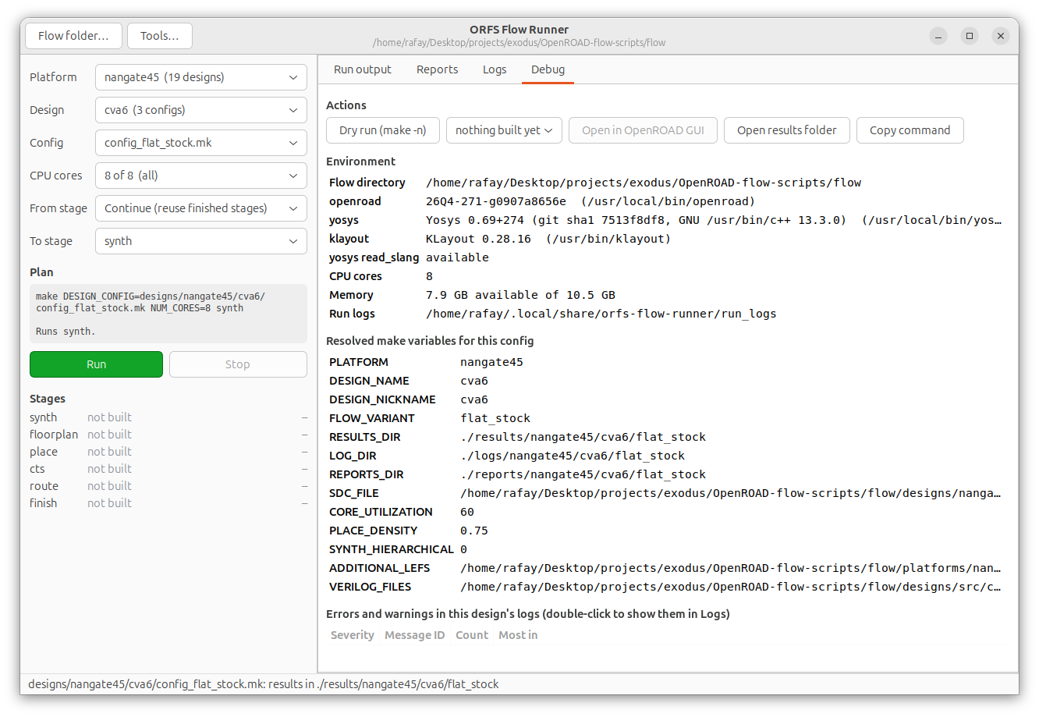
Figure 2. Debug tab before the run: nangate45, config_flat_stock.mk, SYNTH_HIERARCHICAL 0, Yosys 0.69+274
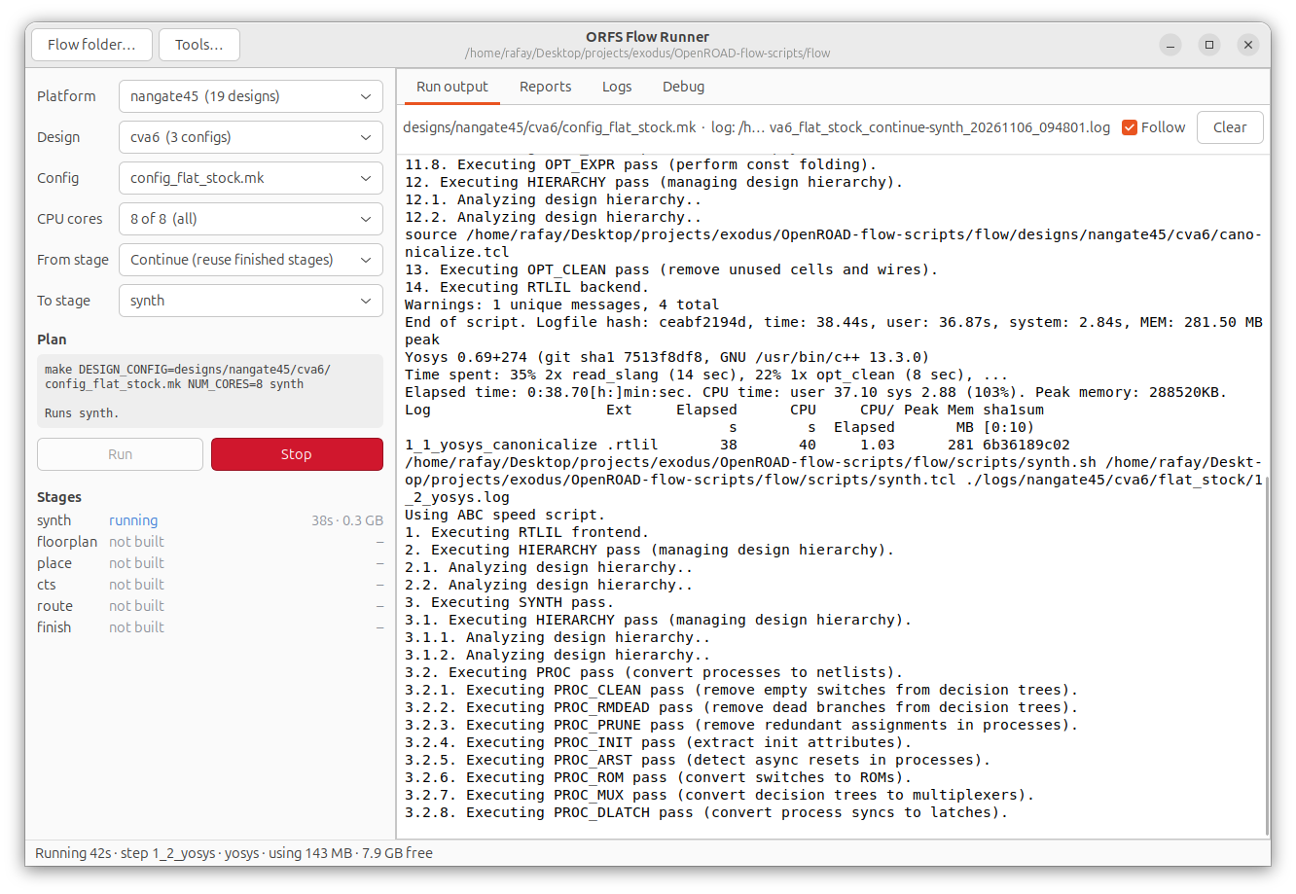
Figure 3. Synthesis running
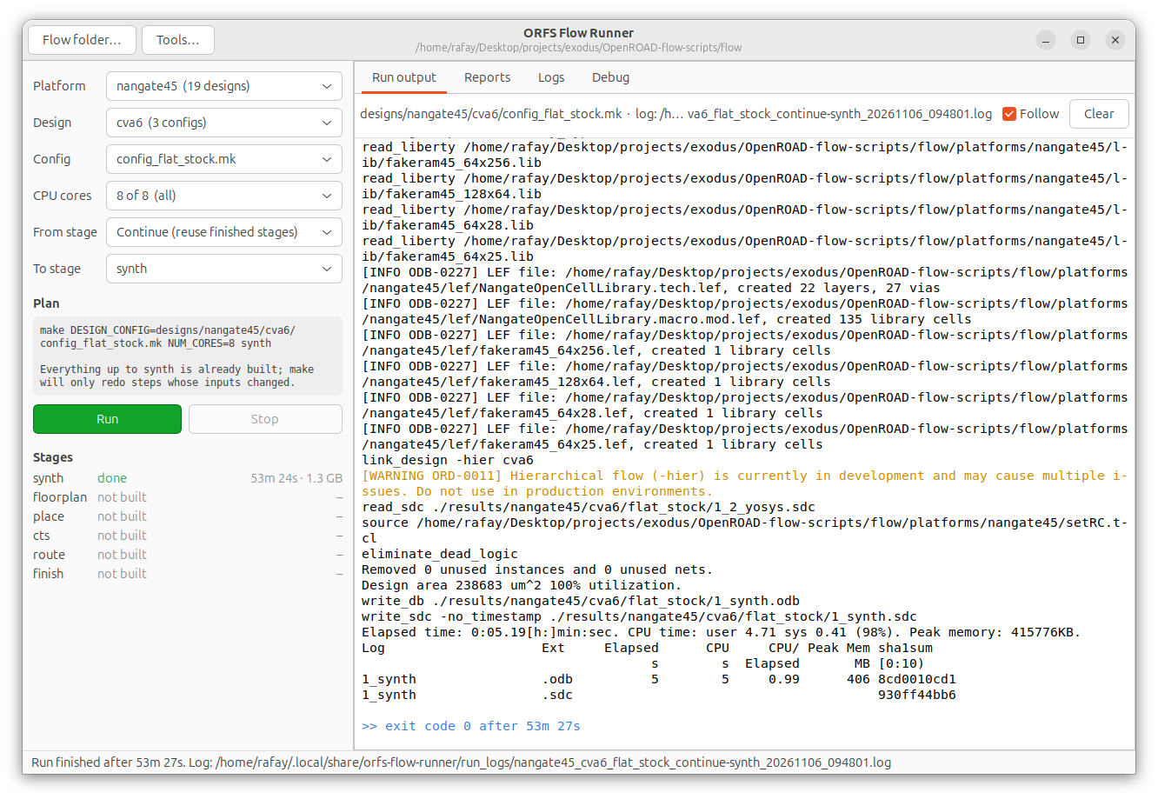
Figure 4. Finished after 53 m 27 s, design area 238,683 µm²
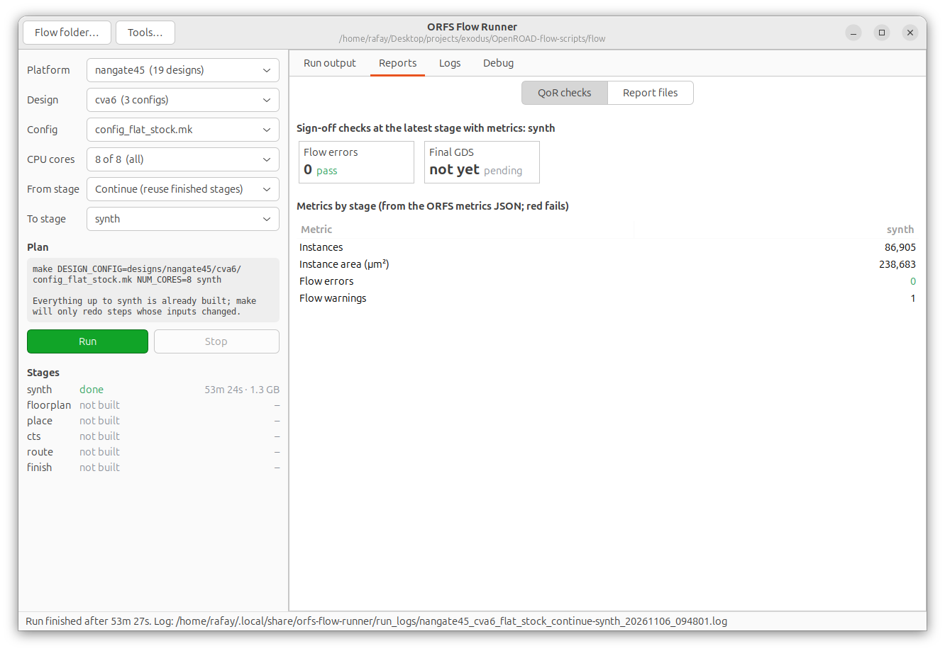
Figure 5. QoR checks: 86,905 instances, 0 flow errors
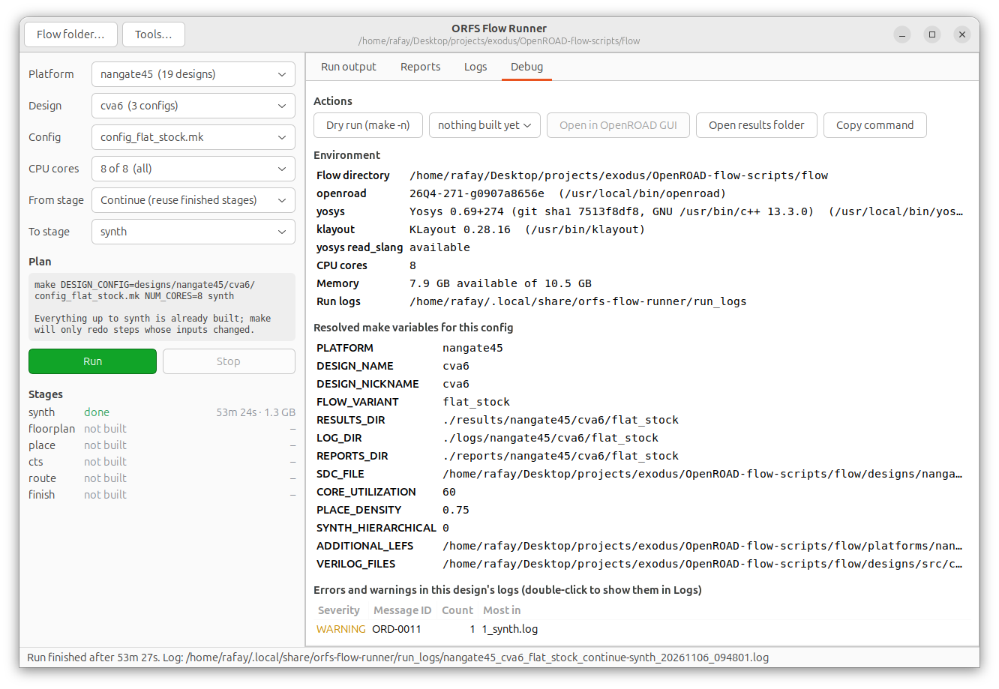
Figure 6. Debug tab after the run
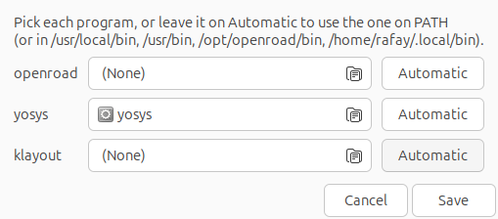
Figure 7. Tools dialog with yosys/build/yosys selected
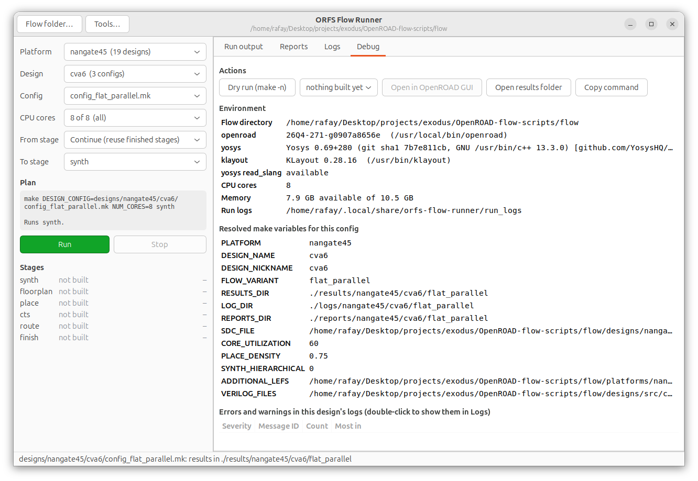
Figure 8. Debug tab: config_flat_parallel.mk, Yosys 0.69+280
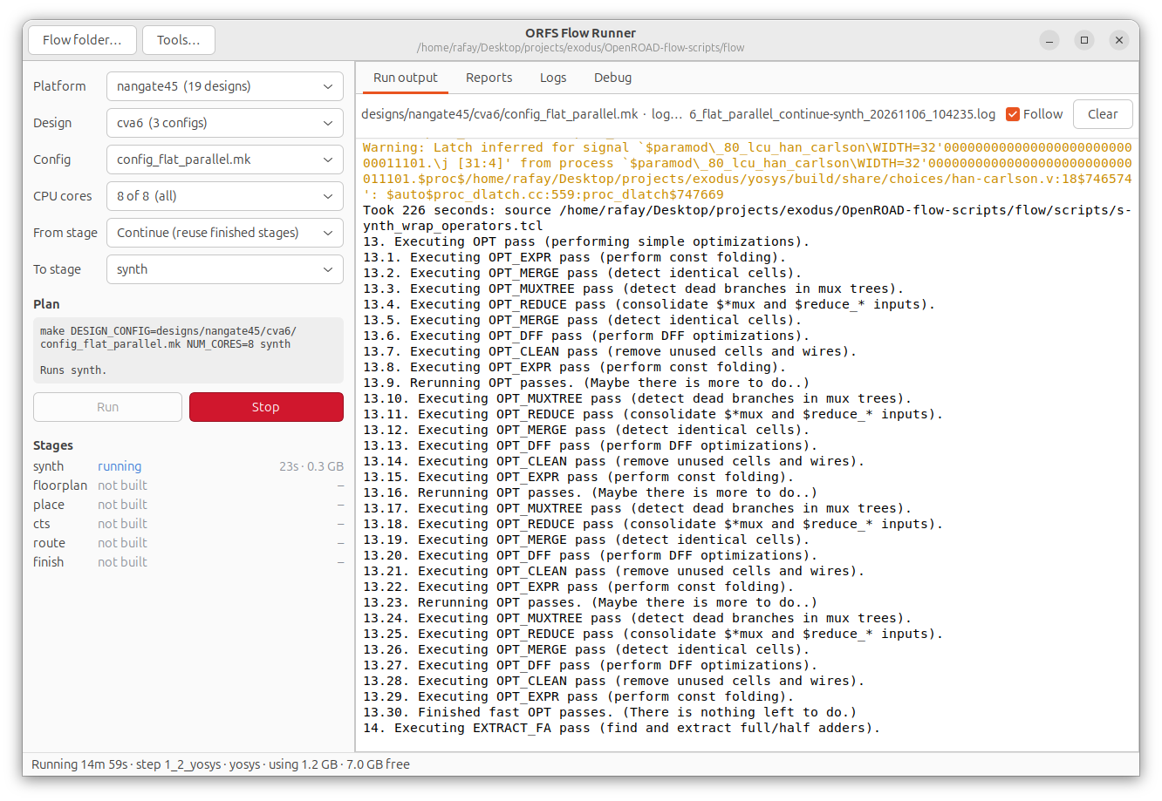
Figure 9. Running at 15 min, in extract_fa
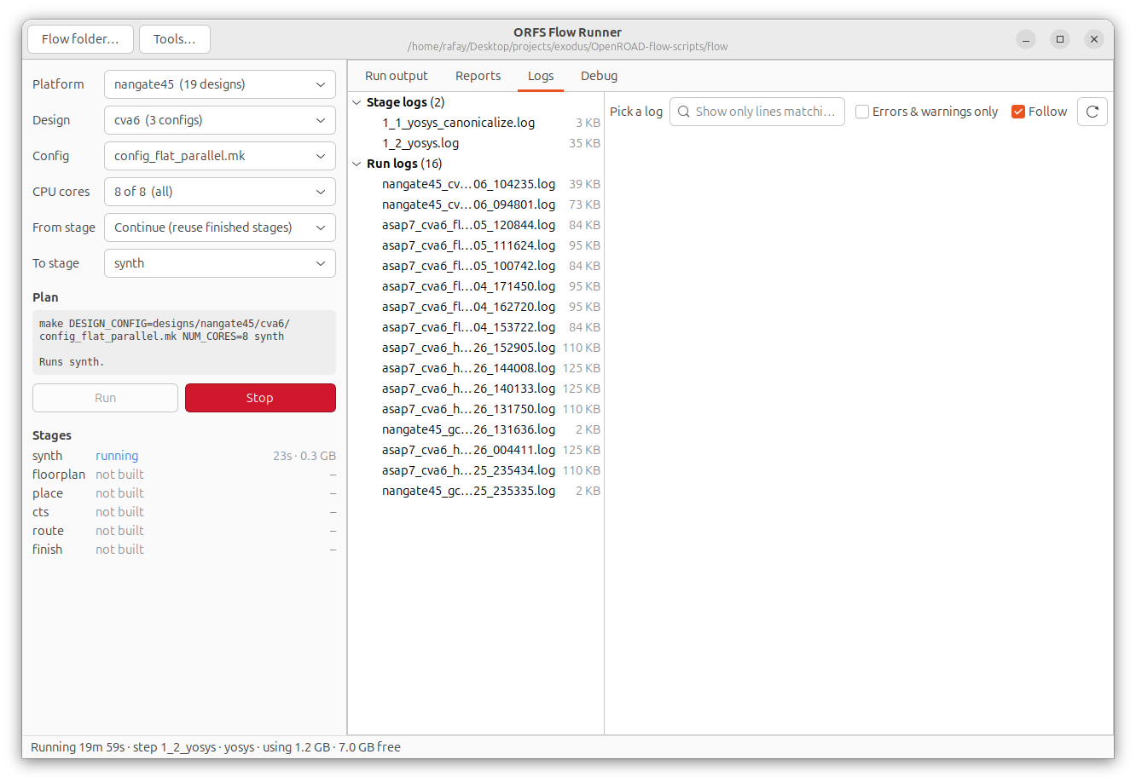
Figure 10. Logs tab with stage and run logs
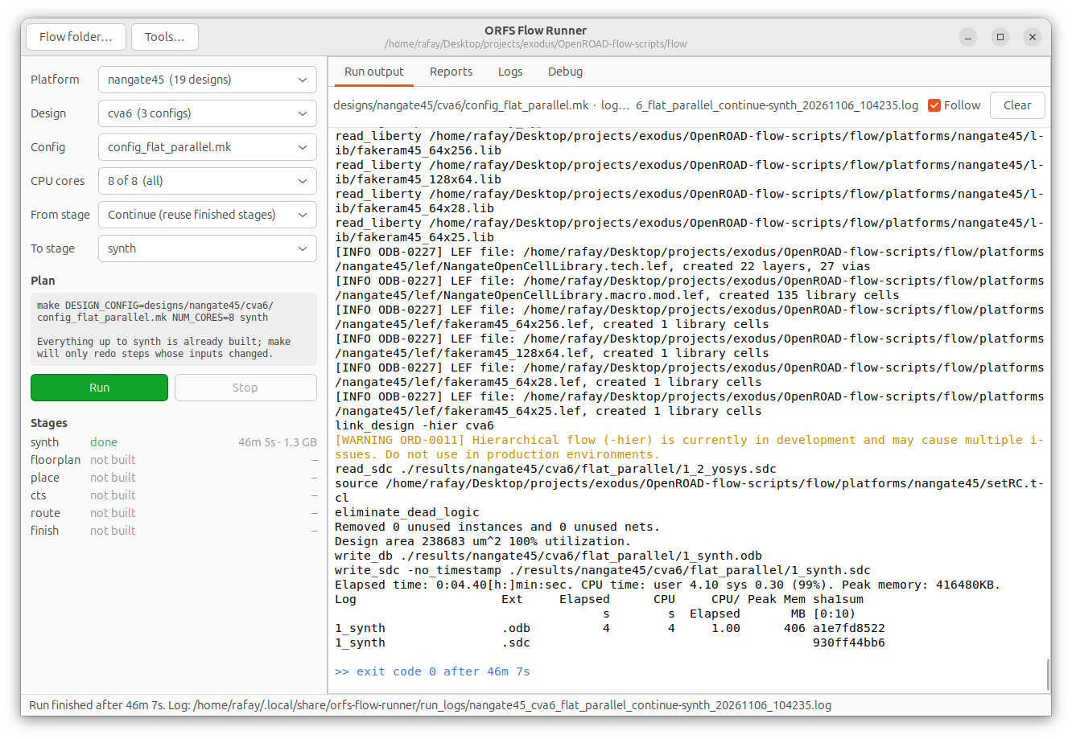
Figure 11. Finished after 46 m 7 s
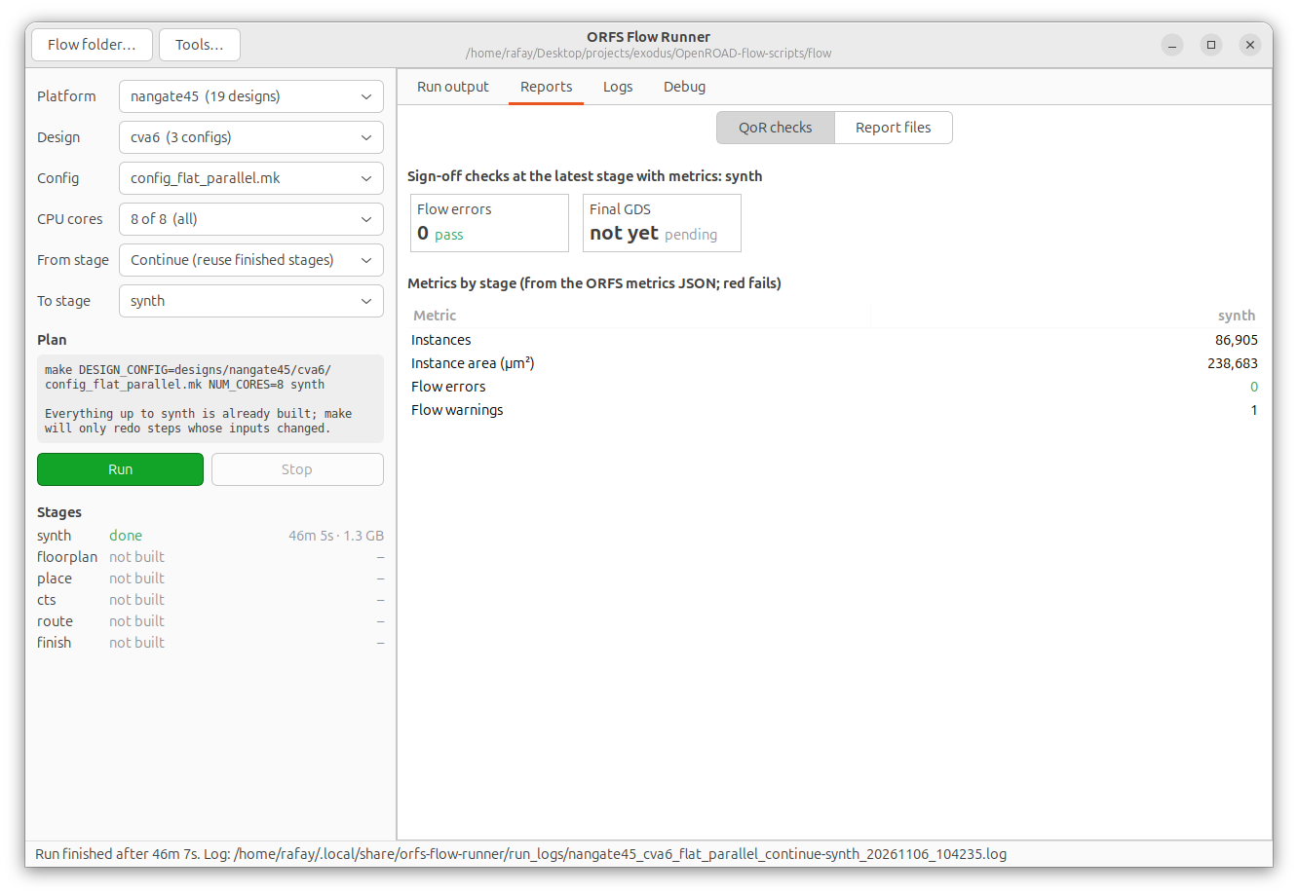
Figure 12. QoR checks: same 86,905 instances and 238,683 µm²
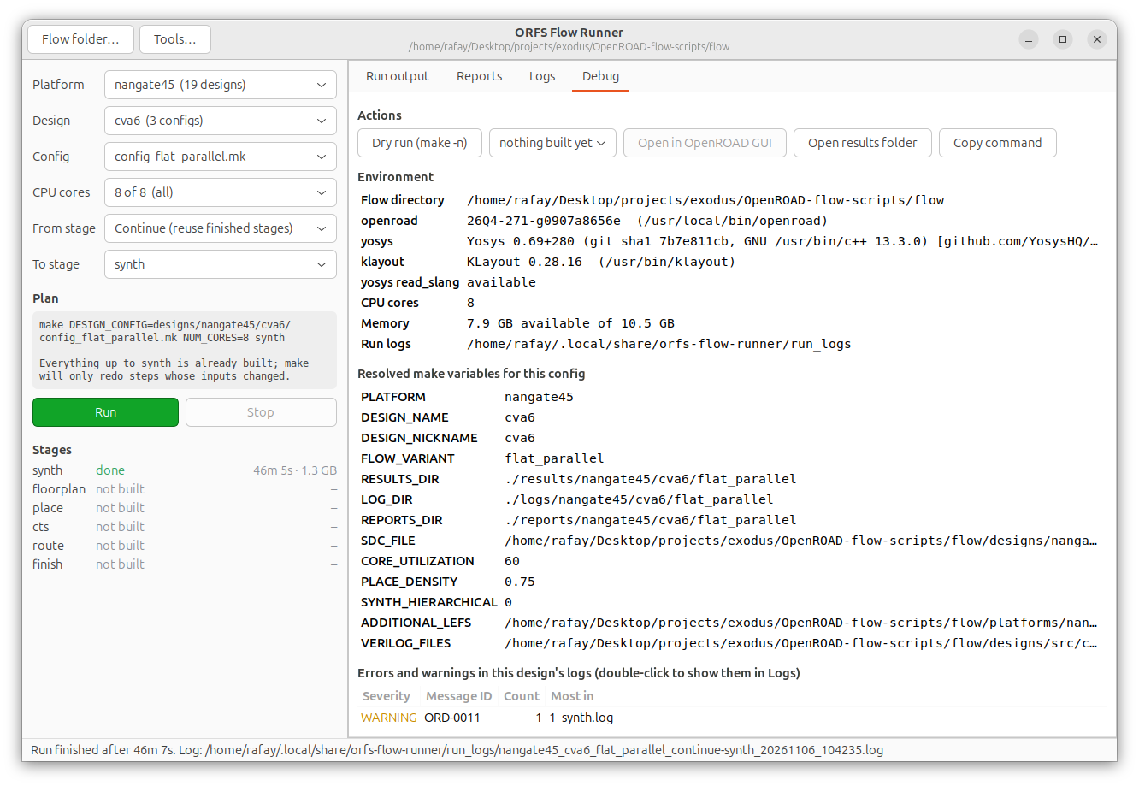
Figure 13. Debug tab after the run

Reproduce
cd ab_bench
PLATFORM=nangate45 ./bench.sh flat # A/B/B/A, about 3.5 h; GUI screenshots saved
python3 compare.py bench_flat_nangate45 # table, stall check, bench_flat_nangate45/summary.json
To run one side by hand, in the Flow Runner pick nangate45 / cva6 / config_flat_stock.mk (or config_flat_parallel.mk), set Yosys in Tools…, and run to synth. From a terminal:
cd OpenROAD-flow-scripts/flow
OPENROAD_EXE=$(command -v openroad) YOSYS_EXE=/usr/local/bin/yosys \
make DESIGN_CONFIG=designs/nangate45/cva6/config_flat_stock.mk synth

Files
Path | What
OpenROAD-flow-scripts/flow/designs/nangate45/cva6/config_flat_stock.mk | new: stock side config
OpenROAD-flow-scripts/flow/designs/nangate45/cva6/config_flat_parallel.mk | new: parallel side config
ab_bench/bench.sh | changed: PLATFORM, SPECS, N0 options
ab_bench/compare.py | new: summary table and VM-stall check
ab_bench/bench_flat_nangate45/ | per-run logs, stats, netlist hashes, CPU samples, 62 screenshots
reports/cva6_nangate45_flat_snaps/ | the 13 screenshots listed above

Next steps
- Floorplan through route on nangate45 haven’t been run. The 1.0 ns clock is far beyond what nangate45 reaches, so repair_timing would struggle in the same way it did on asap7 at 910 ps; a relaxed SDC is the first thing to add before running past synthesis.
- A hierarchical nangate45 A/B (SYNTH_HIERARCHICAL = 1) would show how the gain compares when abc_new has several large independent modules to map instead of one.

